vWeightlifting Queenslandv
.

Vol 9 No 3 Sept 2001
The Official Journal of the Queensland Weightlifting Association Inc.
PO Box 1056, Capalaba, Qld 4157
Tel: (07) 3823 1377 Fax: (07) 3823 1371

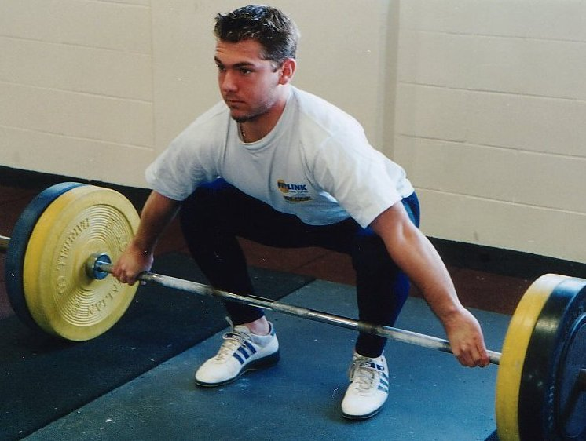
Nudgee lifter David DeRose is really making a mark on Queensland's weightlifting scene lately. David has been lifting for just over a year and recently won the U20 National Championship (77kg class) and a couple of weeks later attained 'A' Grade with a 230kg total in the 69kg class.
Goodwill Games 5
Goodwill Games Results 6
National U20 and Open Championships 7
Interview with John Yamasaki 11
Qualifying Standards 12
Mt. Isa Weightlifting Club 18
Days Gone By 19

Meandering Thoughts 20
Trevor Walz's Story 22
Raising Weightlifting's Profile 23
Notices 24
Competition Rules 25
Support your Sport 25
Queensland Records 27
Proudly Supported by:




Queensland Weightlifting Association Inc.
Office: The Velodrome, The Sleeman Sports Complex,
Chandler 4155
Postal Address: PO Box 1056, Capalaba 4157
Telephone: (07) 3823 1377
Facsimile: (07) 3823 1371
Email: qwa@powerup.com.au
Web Site: http://www.qwa.org
Executive Director: Ian Moir
Administrative Officer: Kylie Booth
Development Officer: Scott Robinson
Newsletter Editor: Angela Wydall (angie@powerup.com.au)

The QWA Management Committee

Patron: Bert Hobl
President: Barry Harden
Vice President: Mike Keelan
Secretary: Jo Garner
Treasurer: Ross Gagliardi
Executive Officer: Greg Hobl
Executive Officer: Peter Thomsen
Executive Officer: Kylie Booth
Executive Officer: Brad Monk

Acknowledgement - Sponsors of the QWA
The Queensland Weightlifting Association is extremely appreciative of the financial assistance provided by the following:

Queensland Government –Sport and Recreation Queensland

CoolSpeak.Com (http://www.coolspeak.com)

Acknowledgement - Corporate Members

Gremel Promotions

Acknowledgement - Photographic Services

Be Seen Photographics

Disclaimer
The views represented in this publication do not necessarily reflect those of the editor or of the Officers or Management Committee of the QWA.

QWA 2001 Competition Calendar

<TBODY>Date | Competition | Location
August 24 | TWA Open Club Competition | Toowoomba
August 24 | Cougars Club Open Competition | Chandler
August 29 – Sept 1 | Goodwill Games | Brisbane
September 8 | Qld Masters H/cap Final | Sunshine Coast
September 22 | QWA League Final | Chandler
September 23-29 | World Masters Championships | Kefalonia
September 28 | Cougars Club Open Competition | Chandler
October 5-7 | Oceania and South Pacific Senior Championships | New Zealand
October 6 | Sunshine Coast Club Open Competition | Sunshine Coast
October 12 | TWA Open Club Competition | Toowoomba
October 20-21 | National Team Challenge | Adelaide
November 3 | Qld All Schools Championships | Brisbane
November <SMALL>4 - 11 </SMALL> | World Championships | <SMALL>Turkey </SMALL>
November 9 - 11 | Junior International Competition | Greece
November 17 | QWA Annual Awards
November 24 | Queensland 2000 | Brisbane
December 1 | Sunshine Coast Club Open Competition | Sunshine Coast
December 7 | TWA Open Club Competition | Toowoomba
December 8 | Cougars Club Open Competition | Chandler
December 8-9 | Junior Oceania Championships | Kiribati</TBODY>

2002 Preliminary Calendar

<TBODY>Date | Competition | Location
Mar 2 | Boroondara Invitational | Melbourne
Mar/April | Suncorp North Qld Games | Mt Isa
April | Australian U16 U18 Championships | Sydney
May 4 | Commonwealth Games Trials | Melbourne
TBC | World University Championships | TBC
June | Australian Masters Championships | Melbourne
June/July | World Junior Championships | Kathmandu, Nepal
25 July - 4 Aug | Commonwealth Games | Manchester England
TBC | Australian U20 and Open Championships | Adelaide
October 7-13 | World Masters Games | Melbourne
TBC | World Championships | Warsaw, Poland
TBC | National Age Group Team Challenge | Melbourne

2001 Goodwill Games
by Ian Moir

It is Monday the 3rd of September, two days after the conclusion of the weightlifting competition of the 2001 Goodwill Games, and I still do not yet fully appreciate the enormity of the event that has just taken place in Brisbane.

It’s easy to quote the official statistics – 31 competitors representing 15 nations in four bodyweight categories conducted over three days of competition that produced five World Records – but these figures don’t begin to tell the story of the 2001 Goodwill Games weightlifting competition. These achievements were the icing on a cake whose ingredients were hard work, diligence, dedication, friendship, and most of all, a love of our great sport that is shared by the many people who came together to create the cohesive team of competent operators who produced an almost flawless weightlifting competition at the 2001 Goodwill Games.

My involvement in the Goodwill Games began in mid 1999, when the newly appointed CEO of 2001 Goodwill Games Brisbane (GWGB), Campbell Rose, and GWGB’s Manager of Sport, Michelle Tribe, came to the QWA’s office for preliminary discussions about the event. At that time, more than two years ago, it was recognised that although all the various Goodwill Games events were to be conducted by the relevant National Sporting Federations, the support of Queensland’s weightlifting fraternity would be a critical factor in the eventual success of the 2001 Goodwill Games weightlifting competition.

Throughout 1999 and 2000, I continued to liaise with GWGB on behalf of the AWF and was appointed to the position of competition manager in December last year. From the beginning of 2001 the countdown to 7:00pm on the 30th of August – weightlifting’s “zero hour” – was a constant ticking in the background of the normal business conducted by the QWA’s Executive Director. My final “big” meeting with GWGB came on the 20th of June, a few weeks prior to an incredible number of deadlines. Following that meeting there were technical plans to finalise, positions to be allocated to volunteers and officials, rosters to be drafted, equipment to be sourced, bank accounts to be established, travel and accommodation arrangements to be made, and problems to be solved. No wonder the ensuing weeks passed in what seemed like the blink of an eye.

And then suddenly, we were there. Standing in the Great Hall of the Brisbane Convention & Exhibition Centre (BCEC), which had been transformed into one of the finest weightlifting auditoriums ever seen anywhere in the world. The stage was set for an incredible week of weightlifting, the like of which had never been seen in Brisbane before. By that comment I mean no disrespect to the weightlifting competition of the 1982 Commonwealth Games, but considering the competitors listed in the results accompanying this account, I believe it to be a valid claim.

The USA team arrived a couple of days earlier than expected, but a few ‘phone calls saw their immediate training needs accommodated by the Cougars club at Chandler. By the night of Sunday the 26th of August, right on schedule, we had constructed the training area at BCEC that would double as the warm up room during competition, and early the next day a steady stream of athletes including Olympians, World Championship medallists, and World Record holders began to flow through the training hall, providing a rare opportunity for Queensland’s state and national champions to get closer to some of the world’s best lifters than they ever imagined they would.

By Wednesday night, the field of play was ready to open for business, and most of the 26 weightlifting volunteers assembled in the Great Hall to spend a few hours getting the feel of the place and rehearsing for the big show. The announcers checked their levels (whatever that means!), the loaders practiced on centre stage, the marshals and scoreboard operators familiarised themselves with their work stations and equipment, and I got so nervous that I couldn’t stand still for a second.

Three months ago I wrote to the AWF President, Sam Coffa, to report on the progress of preparations for the 2001 Goodwill Games. In that report, I expressed my utmost confidence in the members of the team that would produce the weightlifting competition of the 2001 Goodwill Games, and as each piece of the event fell into place and the whole show began to unfold, it became obvious to all that my confidence was well founded. Judging by the congratulations conveyed to us by so many people, from Sam Coffa (IWF & AWF) and Attilla Adamfi (IWF), Dragomir Cioroslin (USAWF), Robert Kabbas (AWF), Mike Plant and David Raith (GWG Inc), and from Queensland Premier Peter Beatty, there was not much that we did that wasn’t perfect, and I was so proud to accept those congratulations on behalf of our team. As I said to many people over the last week, “I have a lot of help from a lot of good friends”.

In conclusion, I feel compelled to acknowledge the support and contributions of those friends, old and new, who delivered the “damn fine weightlifting competition” that I promised in a short speech to the 500 or so people assembled in the BCEC Plaza Ballroom on the Sunday before the Games began:

From 2001 Goodwill Games Brisbane: Michelle Tribe, Steve Kettner and Dana Uglow. From the GWGB BCEC venue management team: Charles Quelch, Michael Lonergan, Ian Robertson and Peter Ninkovic. From GWGB Athlete Services and Transport: Kim Stanton and Kim Chang.

From the IWF: Technical Officials Sam Coffa (AUS), Rock Huh (KOR), Ernest Sarkisov (RUS), Roger Sedeki (USA), Lyn Cameron (NZL), Max Ryan (AUS), Shokr Fallah (AUS), Robert Henderson (AUS), Maurie Carmichael (AUS), Pedro Sanchez (AUS), Jenny Sanchez (AUS), and Barry Harden (AUS).

And of course the backbone of the operation, our volunteers:
The presentation team – Mike Keelan (announcer), Kylie Booth (presentation assistant), and Melissa Nightingale (assembly marshal).
The loaders – Scott Robinson, Peter Foster, Paul McBride, Deborah Lovely, Brad Monk, and Kristie Amadio.
The scoreboard operators – Jo Garner, Paul Wheeler, Darcy Craddock, John Yamasaki, Ben Turner, and David DeRose.
The marshals – Peter Thomsen and Phill Maunder (attempt cards), John Nightingale and Peter Mancuso (warm up scoreboard).
The weigh-in attendants – Debra Keelan and Keith Forbes.
The warm-up room attendants – Lawrie Townsend, Greg Hobl, and Harry Grzes.
The sport information officer – Ken McDonald.
The training attendant – Joel Wilson

Thank you one and all for writing another glorious chapter in the history of weightlifting in Queensland, and Australia.

Goodwill Games Results
Country Name Snatch CJ Total

Women's + 75 kg
USA HAWORTH, Cheryl 127.5 155.0 282.5 GR
RUS KHOMITCH, Albina 125.0 142.5 267.5
HUN VARGA, Viktoria 115.0 145.0 260.0
TPE HSIAO-LIEN, Chen 110.0 145.0 255.0
COL DELGADO, Carmenza 110.0 140.0 250.0
NZL BAKER, Olivia 100.0 130.0 230.0
AUS PILEGGI, Caroline 100.0 125.0 225.0
SVK KOVACOVA, Zuzana 80.0 100.0 180.0

Men's 85 kg
AUS CHAKHOYAN, Sergo 181.5 210.0 390.0
BUL DOBREV, Milen 167.5 202.5 370.0
GEO ASANIDZE, George 170.0 195.0 365.0
USA CHAPLIN III, Oscar 165.0 195.0 360.0
CUB QUIROGA, Ernesto 155.0 202.5 357.5
POL SIEMION, Krzysztof 155.0 192.5 347.5
RUS ZHUKOV, Sergei 155.0 192.5 347.5
FIN HARTIKAINEN, Tiro 140.0 165.0 305.0

Women's 69 kg
RUS POPOVA, Valentina 113.5 143.5 255.0 WR
HUN KRUTZLER, Eszter 105.0 132.5 237.5
HUN MARKUS, Erzsebet 105.0 125.0 230.0
POL MISTERSKA, Dominika 92.5 120.0 212.5
POL PREI, Beata 85.0 110.0 195.0
USA BLASKOWSKI, Stacie 87.5 105.0 192.5
AUS PHILLIPS, Amanda 82.5 107.5 190.0

Men's + 105 Kg
IRI REZAZADEH, Hossein 195.0 235.0 430.0
LAT SCERBATIHS, Victor 195.0 232.5 427.5
POL NAJDEK, Pawel 175.0 232.5 407.5
RUS GLUSHKO, Vladimir 185.0 220.0 405.0
HUN STARK, Tibor 180.0 220.0 400.0
POL DOLEGA, Robert 180.0 212.5 392.5
USA HAMMAN, Shane -- 225.0 225.0
AUS MARTIN, Anthony -- 200.0 200.0

2001 National Open & U20 Championships
11 – 12 AUGUST 2001
NSW STATE SPORTS CENTRE

2001 saw the QWA achieve its best result at a National Open & U20 Championship, winning the team events for Open Women, Under 20 Women, and Under 20 Men. In addition, Queensland athletes won the awards for Best Female Under 20 (Amanda Phillips) and Best Male Under 20 (Damon Kelly).

This outstanding result was achieved by a combination of factors that led to an extremely well prepared team travelling to Sydney to meet the challenges of the 2001 National Open & Under 20 Championships held in the NSW State Sports Centre at Homebush Bay. The QWA selectors had nominated the best possible team combinations and all of those athletes and coaches who were selected accepted their positions. This meant that Queensland was represented by a strong force of athletes who had been well prepared by their respective club coaches, and who were supported by an experienced and cohesive coaching team. And these “sporting” qualities were backed-up by the administration department of the QWA which provided all team members with timely and relevant information on all aspects of the event.

A snapshot of the Queensland Team’s performance :

Open Women – 7 lifters; 2 Gold; 3 Silver; 1 Bronze
Open Men – 8 lifters; 1 Silver; 3 Bronze
Under 20 Women – 7 lifters; 4 Gold; 1 Silver; 1 Bronze
Under 20 Men – 8 lifters; 4 Gold; 2 Silver; 1 Bronze

Results

Name | Born | State | B/wt | Snatch | C&J | Total | U20 | Sen
48kg
LATIF, Nadeene | 1978 | NSW | 47.66 | 60.0 | 75.0 | 135.0 |  | 1
JONES, Karuna | 1975 | QLD | 46.82 | 55.0 | 67.5 | 122.5 |  | 2
BANHAM, Margaret | 1977 | WA | 46.84 | 47.5 | 52.5 | 100.0 |  | 3
BOWER, Sherri | 1986 | QLD | 47.20 | 45.0 | 52.5 | 97.5 | 1
ENGELHARDT, Nilani | 1975 | SA | 46.32 | 45.0 | 50.0 | 95.0 |  | 4
WILSON, Tennille | 1988 | TAS | 43.80 | 40.0 | 47.5 | 87.5 | 2 | 5
53kg
LEE, Seen | 1982 | VIC | 52.56 | 67.5 | 77.5 | 145.0 | 1 | 1
RUSH, Rebecca | 1982 | TAS | 51.98 | 55.0 | 75.0 | 130.0 | 2 | 2
QUINELL, Coral | 1953 | NT | 52.48 | 52.5 | 67.5 | 120.0 |  | 3
TSOUKALIS, Maria | 1987 | NT | 52.96 | 52.5 | 60.0 | 112.5 | 3 | 4
58kg
BARKER, Natasha | 1970 | NSW | 56.78 | 82.5 | 100.0 | 182.5 |  | 1
LEWIS, Debbie | 1981 | SA | 57.46 | 70.0 | 85.0 | 155.0 | 1 | 2
AMADIO, Kristie | 1985 | QLD | 57.28 | 67.5 | 82.5 | 150.0 | 2 | 3
LOY, Diana | 1965 | QLD | 57.24 | 62.5 | 80.0 | 142.5 |  | 4
WHITE, Jacquie | 1982 | VIC | 56.96 | 65.0 | 75.0 | 140.0 | 3 | 5
CROSSWELL, Tara | 1985 | TAS | 54.68 | 57.5 | 75.0 | 132.5 | 4 | -
WILLIAMS, Katherine | 1985 | SA | 56.20 | 47.5 | 62.5 | 110.0 | 5 | 6
DEWAR, Jade | 1984 | NSW | 55.40 | 45.0 | 60.0 | 105.0 | 6
BROOKE, Rebecca | 1987 | NT | 55.72 | 50.0 | 55.0 | 105.0 | 7 | 7
BATSIUA, Tyoni – Guest | 1981 | NRU | 57.90 | 70.0 | 85.0 | 155.0
63kg
NIGHTINGALE, Melissa | 1981 | QLD | 62.42 | 72.5 | 85.0 | 157.5 | 1 | 1
SAWON, Nicole | 1978 | SA | 62.48 | 65.0 | 87.5 | 152.5 |  | 2
O’MEARA, Kelly | 1982 | VIC | 60.40 | 57.5 | 72.5 | 130.0 | 2 | 3
BOURNE, Rebecca | 1980 | WA | 62.72 | 55.0 | 65.0 | 120.0 |  | 4
69kg
PHILLIPS, Amanda | 1981 | QLD | 68.08 | 83.0 | 107.5 | 190.0 | 1 | 1
CONSTANTINIDIS, Maria | 1983 | NSW | 67.16 | 62.5 | 72.5 | 125.0 | 2 | 2
CUNNINGHAM, Shari | 1985 | QLD | 68.00 | 52.5 | 62.5 | 115.0 | 3
DEIRERAGIA, Sheba - Guest | 1986 | NRU | 63.24 | 80.0 | 95.0 | 175.0
75kg
WILLIAMS, Saree | 1976 | VIC | 75.00 | 80.0 | 100.0 | 180.0 |  | 1
LOVELY, Deborah | 1983 | QLD | 74.42 | 82.5 | 95.0 | 177.5 | 1 | 2
STRANAN, Sarah | 1981 | VIC | 71.00 | 80.0 | 92.5 | 172.5 | 2 | 3
WALLER, Danielle | 1965 | WA | 73.62 | 72.5 | 82.5 | 155.0 |  | 4
ADORNI, Alexandra | 1977 | NSW | 74.24 | 70.0 | 80.0 | 150.0 |  | 5
MEADTH, Victoria | 1976 | NSW | 72.90 | 60.0 | 75.0 | 135.0 |  | 6
SCOTT, Sharyn | 1971 | NT | 74.72 | 55.0 | 75.0 | 130.0 |  | 7
DIRINGA, Mary – Guest | 1983 | NRU | 73.88 | 75.0 | 95.0 | 170.0
RAIDINEN, Ejab - Guest | 1986 | NRU | 70.12 | 70.0 | 95.0 | 165.0
PURCELL, Carolyn - Guest | 1973 | ACT | 73.08 | 65.0 | 80.0 | 145.0
75+kg
PILEGGI, Caroline | 1977 | WA | 86.58 | 100.0 | 127.5 | 227.5 |  | 1
BETHUNE, Melissa | 1979 | QLD | 151.62 | 90.0 | 105.0 | 195.0 |  | 2
BOUTROS, Jamila | 1984 | NSW | 101.22 | 80.0 | 90.0 | 170.0 | 1 | 3
BORG, Lindsay | 1982 | NSW | 94.66 | 72.5 | 90.0 | 162.5 | 2 | 4
BATES, Sarah | 1984 | SA | 89.02 | 70.0 | 85.0 | 155.0 | 3 | 5
NEVILLE, Laura | 1981 | VIC | 110.60 | 65.0 | 82.5 | 147.5 | 4 | 6
MARKS, Rebecca | 1984 | QLD | 86.78 | 60.0 | 75.0 | 135.0 | 5
PEO, Sheeva - Guest | 1976 | NRU | 86.86 | 0.0 | 0.0 | 0.0 |  | </TBODY>

MEN
56kg
BURDEN, Chris | 1970 | SA | 56.00 | 75.0 | 100.0 | 175.0 |  |  | 1
MCLAUGHLIN, Liam | 1982 | VIC | 55.78 | 70.0 | 87.5 | 157.5 | 2
VASILIADES, Kostas | 1985 | NSW | 52.96 | 65.0 | 92.5 | 157.5 | 1 |  | 2
HULLEZA, Michael | 1984 | WA | 52.96 | 60.0 | 85.0 | 145.0 | 3 |  | 3
HEWKINS, Troy | 1986 | QLD | 50.26 | 60.0 | 80.0 | 140.0 | 4
BASILE, Paul | 1982 | VIC | 49.26 | 60.0 | 77.5 | 137.5 | 5
KELSEY, Austin | 1986 | SA | 56.00 | 52.5 | 70.0 | 122.5 | 6
VASILIADES, William | 1987 | NSW | 52.50 | 50.0 | 65.0 | 115.0 | 7
62kg
YAGCI, Mehmet | 1972 | NSW | 57.50 | 95.0 | 115.0 | 210.0 |  |  | 1
SARKISIAN, David | 1986 | VIC | 61.44 | 87.5 | 110.0 | 197.5 | 1 |  | 2
YAMASAKI, John | 1984 | QLD | 61.42 | 80.0 | 97.5 | 177.5 | 2 |  | 3
KOPCZYNSKI, Alex | 1981 | SA | 61.44 | 75.0 | 100.0 | 175.0 | 3 |  | 4
KATZ, Samuel | 1983 | VIC | 61.14 | 70.0 | 90.0 | 160.0 | 4
JACQUIER, Tyson | 1985 | SA | 60.78 | 62.5 | 77.5 | 140.0 | 5
DAGEAGO, Willen - Guest | 1983 | NRU | 61.12 | 95.0 | 130.5 | 225.00
69kg
VANDEN ENDE, Garth | 1980 | WA | 66.60 | 110.0 | 140.0 | 250.0 |  |  | 1
THOMAS, David | 1977 | VIC | 68.58 | 95.0 | 127.5 | 222.5 |  |  | 2
WILSON, Joel | 1986 | QLD | 67.46 | 97.5 | 122.5 | 220.0 | 1 |  | 3
TURNER, Ben | 1984 | QLD | 67.52 | 92.5 | 125.0 | 217.5 | 2 |  | 4
BURDON, David | 1983 | TAS | 68.22 | 90.0 | 115.0 | 205.0 | 3
77kg
BLYTHMAN, Craig | 1970 | VIC | 76.88 | 135.0 | 165.0 | 300.0 |  |  |  | 1
TASOULIS, Theo | 1978 | NSW | 76.90 | 105.0 | 150.0 | 255.0 |  |  |  | 2
MATEOS, Paul | 1980 | VIC | 76.36 | 105.0 | 140.0 | 245.0 |  |  |  | 3
KLINKERT, Michael | 1980 | SA | 76.98 | 100.0 | 130.0 | 230.0 |  |  |  | 4
De ROSE, David | 1982 | QLD | 71.86 | 100.0 | 127.5 | 227.5 | 1 |  |  | 5
McCOY, Simon | 1983 | VIC | 72.84 | 95.0 | 125.0 | 220.0 | 2
LATIF, Adam | 1984 | NSW | 74.36 | 90.0 | 115.0 | 205.0 | 3
KLINKERT, Daniel | 1985 | SA | 75.28 | 77.5 | 95.0 | 172.5 | 4
CIANCIO, Christopher | 1984 | VIC | 73.50 | 100.0 | 0.0 | 0.0
DALSANTO, Max | 1985 | SA | 74.58 | 0.0 | 110.0 | 0.0
DOWEIYA, Renos – Guest | 1983 | NRU | 76.08 | 0.0 | 145.0 | 0.0
JEREMIAH, Rutherford – Guest | 1982 | NRU | 75.20 | 110.0 | 150.0 | 260.0
PETERS, Yukio - Guest | 1984 | NRU | 70.78 | 120.0 | 160.0 | 280.0
McNALLY, Brendan - Guest | 1978 | NSW | 76.00 | 100.0 | 120.0 | 220.0
85kg
HALDUN, Stephen | 1970 | VIC | 82.36 | 125.0 | 155.0 | 280.0 |  |  | 1
MURPHY, Keith | 1978 | VIC | 84.90 | 125.0 | 155.0 | 280.0 |  |  | 2
WILLIAMS, Matthew | 1980 | TAS | 84.94 | 127.5 | 152.5 | 280.0 |  |  | 3
MAUNDER, Phil | 1965 | SA | 83.46 | 95.0 | 122.5 | 217.5 |  |  | 4
MORTIMORE, Sam | 1982 | VIC | 82.30 | 95.0 | 120.0 | 215.0 |  | 2
POWER, Jason | 1982 | QLD | 77.10 | 95.0 | 120.0 | 215.0 |  | 1
KOLOKAS, John | 1984 | SA | 84.98 | 85.0 | 110.0 | 195.0 |  | 3 | 5
WOJKOWSKI, Tomasz | 1971 | NT | 80.14 | 0.0 | 115.0 | 0.0
SUSANTO, Daniel | 1984 | NSW | 84.40 | 85.0 | 0.0 | 0.0
DETENAMO, Quincy - Guest | 1979 | NRU | 84.20 | 125.0 | 165.0 | 290.0
COOK, Marcus - Guest | 1982 | NRU | 84.04 | 115.0 | 145.0 | 260.0
94kg
PILEGGI, Michael | 1975 | WA | 93.66 | 135.0 | 157.5 | 292.5 |  |  | 1
CHANDLER, Ken | 1976 | QLD | 93.44 | 120.0 | 155.0 | 275.0 |  |  | 2
FIAY, Martin | 1970 | NSW | 93.56 | 115.0 | 150.0 | 265.0 |  |  | 3
MONTALDO, Robbie | 1984 | WA | 88.52 | 120.0 | 130.0 | 250.0 |  | 1 | 4
STREVETT, Luke | 1983 | WA | 91.60 | 110.0 | 125.0 | 235.0 |  | 2
BUTLER, Robert | 1982 | QLD | 90.26 | 100.0 | 117.5 | 217.5 |  | 3
LOCKHEAD, Steve | 1970 | SA | 93.60 | 85.0 | 110.0 | 195.0 |  |  | 5  </TBODY>
105kg
LAYCOCK, Ron | 1965 | NSW | 101.38 | 122.5 | 170.0 | 292.5 |  | 1
McDOWALL, Andrew | 1980 | WA | 94.76 | 115.0 | 155.0 | 270.0 |  | 2
WHEELER, Paul | 1971 | QLD | 100.66 | 120.0 | 150.0 | 270.0 |  | 3
McDONALD, Adam | 1964 | QLD | 103.26 | 112.5 | 142.5 | 255.0 |  | 4
SHMAIT, Abdallah | 1983 | NSW | 102.42 | 95.0 | 125.0 | 220.0 | 1 | 5
HARRIS, William | 1985 | NSW | 101.04 | 80.0 | 105.0 | 185.0 | 2
105+kg
MARTIN, Anthony | 1979 | WA | 145.98 | 160.0 | 207.5 | 367.5 |  | 1
HOCKING, Corran | 1980 | VIC | 147.12 | 162.5 | 205.0 | 367.5 |  | 2
RAE, Chris | 1980 | SA | 138.96 | 157.5 | 200.0 | 357.5 |  | 3
FRY, Tim | 1977 | VIC | 112.64 | 140.0 | 172.5 | 312.5 |  | 4
KELLY, Damon | 1983 | QLD | 142.20 | 132.5 | 177.5 | 310.0 | 1 | 5
BEST, Nathan | 1969 | NSW | 121.50 | 120.0 | 167.5 | 287.5 |  | 6
DERRICK, Jonathan | 1984 | VIC | 139.00 | 110.0 | 130.0 | 240.0 | 2 | </TBODY>

Queensland's 2001 National Champions

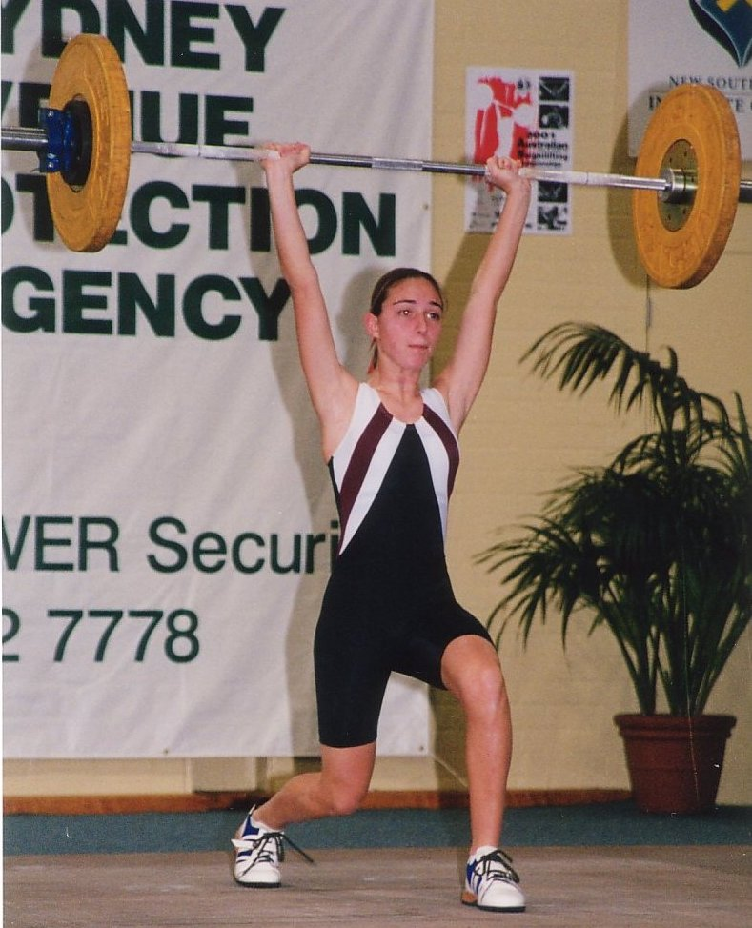  Sheridan Bower. 48kg, U20. | 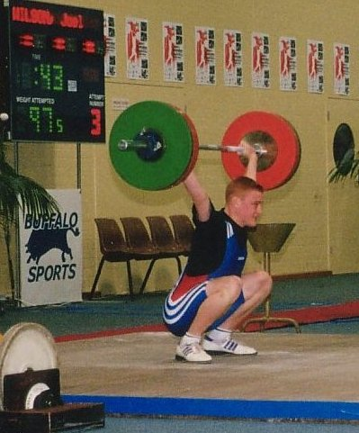  Joel Wilson. 69kg, U20.
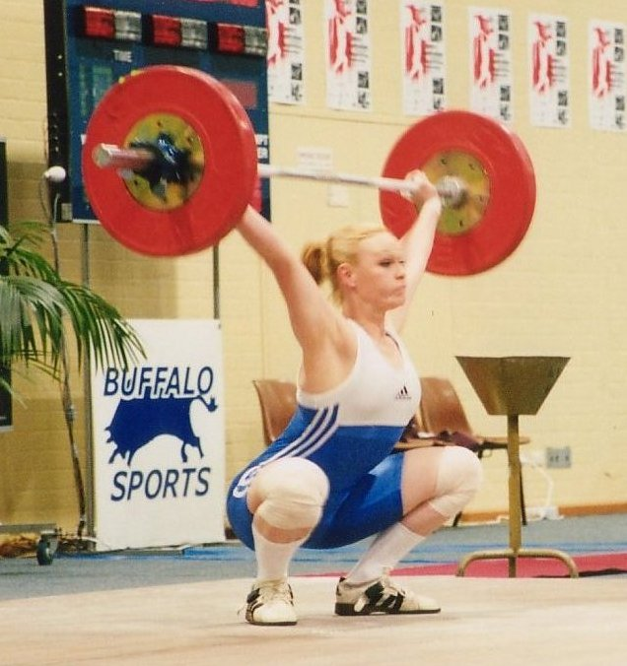  Melissa Nightingale. 63kg Open & U20. | 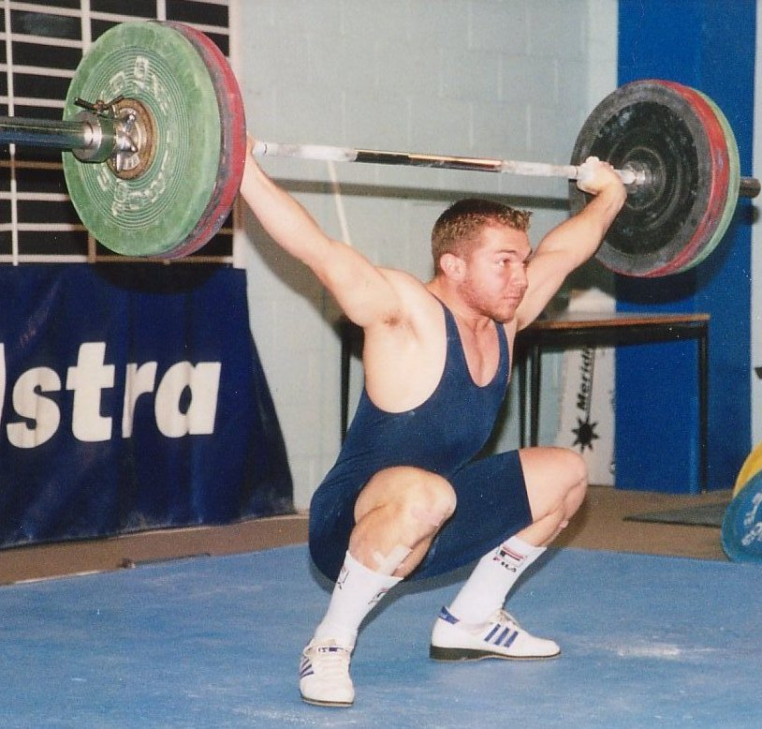  David DeRose. 77kg, U20.
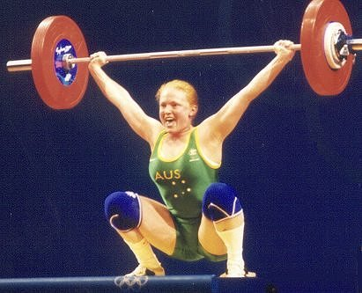  Amanda Phillips. 69kg Open & U20. | 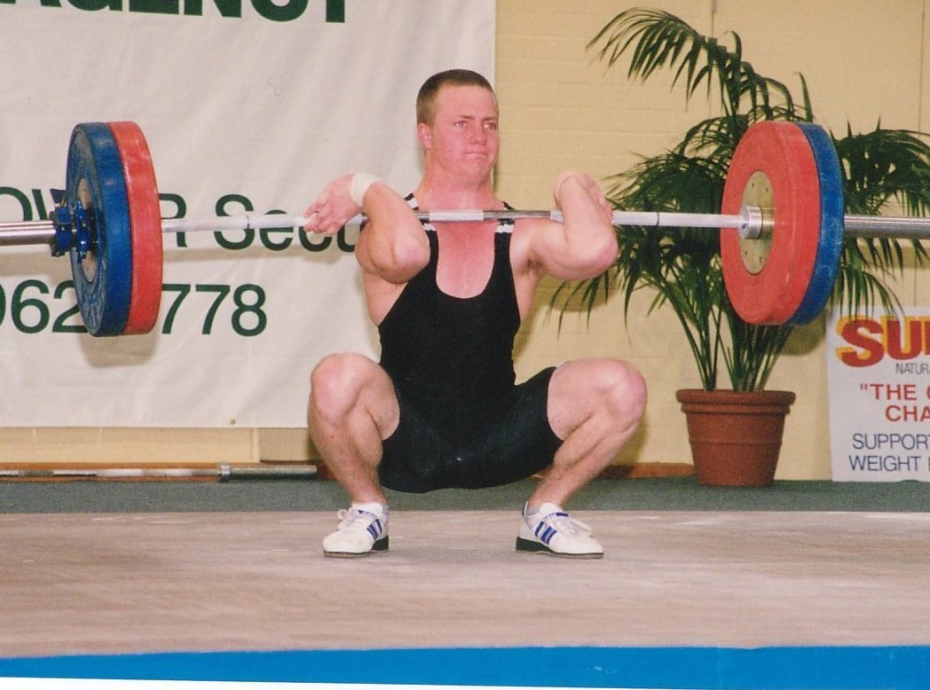  Jason Power. 85kg, U20.
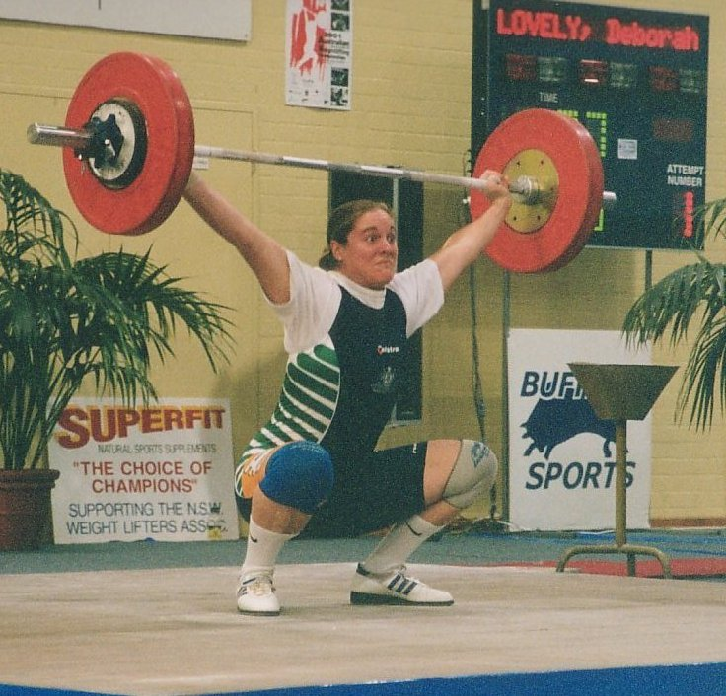  Deborah Lovely. 75kg, U20. | 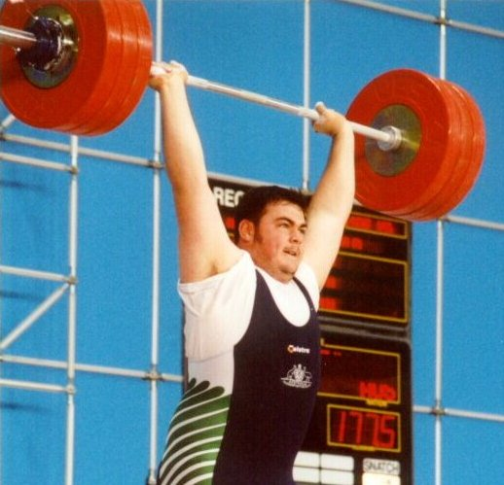  Damon Kelly. 105+kg, U20.

Interview with John Yamasaki

How did you get invloved in weightlifting and how long have you been training?
I got into weightlifting by the TID program when Scott came to Mt Gravatt High School and did some testing. I'v been training for one year and one month.

What does a typical month's training involve for you?
I train 4 days a week. Each day I train 1 1/2 to 2 1/2 hours.

What are your likes and dislikes about weightlifting?
I like the competition, getting a PB and travelling. I also like the friendliness of the gym and outside of the gym. I dislike the hard training you have to put in to be a good weightlifter. But its worth it.

What do you hope to acheive in weightlifting in the short and long term?
For short terms I would like to get B grade and to get some records (state and Australian). For long terms I would like to represent Australia at World Championships and go to the Olympics.

What are your interests outside weightlifting?

I've been in a number of sports such as baseball for 6 years. Gymnastics for 3 years, but I've been around gymnastics my whole life, trampolining for 3 years and men's softball for 1 season. I was selected to represent Queensland at the trampolining National Championships last year but was not able to compete due to injury (I broke my ankle and had to have surgery).

I like going out with my friends on weekends. I like riding with my friends to Mt Cootha and other long distance riding.

</DIV>

AWF Qualifying Totals for National Squads and Teams
and Classification Standards

CLASSIFICATION STANDARDS 2001 – MALE
 | ELITE |  | A Grade |  | B Grade |  | C Grade |  | D Grade
47 | ..... |  | ..... |  | ..... |  | 120.0 |  | 105.0
51 | ..... |  | ..... |  | ..... |  | 132.5 |  | 115.0
56 | 222.5 |  | 190.0 |  | 165.0 |  | 145.0 |  | 127.5
62 | 245.0 |  | 210.0 |  | 182.5 |  | 160.0 |  | 140.0
69 | 267.5 |  | 230.0 |  | 200.0 |  | 175.0 |  | 152.5
77 | 290.0 |  | 250.0 |  | 215.0 |  | 190.0 |  | 165.0
85 | 307.5 |  | 265.0 |  | 230.0 |  | 202.5 |  | 175.0
94 | 322.5 |  | 277.5 |  | 240.0 |  | 212.5 |  | 185.0
105 | 337.5 |  | 290.0 |  | 250.0 |  | 225.0 |  | 192.5
Over 105 | 350.0 |  | 300.0 |  | 260.0 |  | 230.0 |  | 200.0

CLASSIFICATION STANDARDS 2001 – FEMALE
 | ELITE |  | A Grade |  | B Grade |  | C Grade |  | D Grade
40 | ..... |  | ..... |  | ..... |  | 85.0 |  | 72.5
44 | ..... |  | ..... |  | ..... |  | 92.5 |  | 80.0
48 | 135.0 |  | 120.0 |  | 110.0 |  | 100.0 |  | 85.0
53 | 145.0 |  | 130.0 |  | 117.5 |  | 105.0 |  | 90.0
58 | 152.5 |  | 137.5 |  | 125.0 |  | 112.5 |  | 95.0
63 | 160.0 |  | 142.5 |  | 130.0 |  | 117.5 |  | 100.0
69 | 167.5 |  | 150.0 |  | 135.0 |  | 122.5 |  | 105.0
75 | 172.5 |  | 155.0 |  | 140.0 |  | 125.0 |  | 107.5
Over 75 | 185.0 |  | 165.0 |  | 150.0 |  | 135.0 |  | 115.0

NOTE The above totals are the AWF Qualifying Totals until the end of December 2001. For the review of all AWF Squads to be conducted on December 31, 2001, the current Qualifying Totals (above) will be the standards used for selection.

International Events 2001 / 2002
<TBODY>October 5-7 | Oceania & South Pacific Championship | Auckland, New Zealand
November 4-11 | World Championships | Antalya, Turkey
December 6 - 8 | Junior Oceania Championships | Kiribati
March 2 | 2002 International Invitational Event | Melbourne, Victoria
April | Oceania & South Pacific Championship | Fiji
May 4 | 2002 Commonwealth Games Team Selection Trials | Melbourne, Victoria
TBC | 2002 World University Championships | TBC
May/June | 2002 World Junior Championships | Kathmandu, Nepal</TBODY>

2001 Oceania & South Pacific Championships – Auckland, New Zealand - October 5 - 7
The minimum standard required to be considered for selection in the 2001 Oceania & South Pacific Championships team is "Elite" (2001 AWF Standards). Potential team members will be ranked according to their percentage over the qualifying totals. Achievement of these totals does not mean automatic team selection and a full team may not be selected for this event. The following will be taken into account when selecting the team:-
Results from:- all National & State Calendar events held between February 12, 2001 and August 13, 2001
2001 World Championships – Antalya, Turkey - November 4 - 11
The minimum standard required to be considered for selection in the 2001 World Championships team is "Elite" (2001 AWF Standards). Potential team members will be ranked according to their percentage over the qualifying totals. Achievement of these totals does not mean automatic team selection and a full team may not be selected for this event. The following will be taken into account when selecting the team:-
Results from:- all National & State Calendar events held between February 12, 2001 and August 13, 2001
2001 Junior Oceania Championships – Kiribati – December 6-8
The minimum standard required to be considered for selection in the 2001 Junior Oceania Championships Team is "B" Grade (2001 AWF Standards). Potential team members will be ranked according to their percentage over the qualifying totals. Achievement of these totals does not mean automatic team selection and a full team may not be selected for this event. The following will be taken into account when selecting the team.
Results from:- all National & State Calendar events held between January 1, 2001 and September 30, 2001

Qualifying Totals for Australian Teams (January 1, 2002 to December 31, 2002)
CLASSIFICATION STANDARDS 2002 - 2004 – MALE
 | Elite |  | International |  | A Grade |  |  | B Grade |  |  |  |  |  | C Grade |  |  |  |  |  |  |  |  | D Grade
47 | ..... |  | ..... |  | ..... |  |  | ..... |  |  |  |  |  | 132.5 |  |  |  |  |  |  |  |  | 115.0
51 | ..... |  | ..... |  | ..... |  |  | ..... |  |  |  |  |  | 142.5 |  |  |  |  |  |  |  |  | 125.0
56 | 240.0 |  | 207.5 |  | 200.0 |  |  | 175.0 |  |  |  |  |  | 155.0 |  |  |  |  |  |  |  |  | 135.0
62 | 260.0 |  | 225.0 |  | 217.5 |  |  | 190.0 |  |  |  |  |  | 167.5 |  |  |  |  |  |  |  |  | 147.5
69 | 280.0 |  | 242.5 |  | 235.0 |  |  | 205.0 |  |  |  |  |  | 182.5 |  |  |  |  |  |  |  |  | 160.0
77 | 300.0 |  | 260.0 |  | 252.5 |  |  | 220.0 |  |  |  |  |  | 195.0 |  |  |  |  |  |  |  |  | 170.0
85 | 317.5 |  | 275.0 |  | 265.0 |  |  | 232.5 |  |  |  |  |  | 205.0 |  |  |  |  |  |  |  |  | 180.0
94 | 332.5 |  | 287.5 |  | 277.5 |  |  | 242.5 |  |  |  |  |  | 215.0 |  |  |  |  |  |  |  |  | 187.5
105 | 347.5 |  | 300.0 |  | 290.0 |  |  | 252.5 |  |  |  |  |  | 225.0 |  |  |  |  |  |  |  |  | 197.5
Over 105 | 367.5 |  | 317.5 |  | 307.5 |  |  | 267.5 |  |  |  |  |  | 237.5 |  |  |  |  |  |  |  |  | 210.0

CLASSIFICATION STANDARDS 2002 – 2004 – FEMALE
 | Elite |  | International |  | A Grade |  |  | B Grade |  |  |  |  |  | C Grade |  |  |  |  | D
40 | ..... |  | ..... |  | ..... |  |  | ..... |  |  |  |  |  | 87.5 |  |  |  |  | 75.0
44 | ..... |  | ..... |  | ..... |  |  | ..... |  |  |  |  |  | 95.0 |  |  |  |  | 82.5
48 | 152.5 |  | 135.0 |  | 127.5 |  |  | 117.5 |  |  |  |  |  | 102.5 |  |  |  |  | 87.5
53 | 162.5 |  | 145.0 |  | 137.5 |  |  | 125.0 |  |  |  |  |  | 110.0 |  |  |  |  | 92.5
58 | 172.5 |  | 152.5 |  | 145.0 |  |  | 132.5 |  |  |  |  |  | 115.0 |  |  |  |  | 100.0
63 | 180.0 |  | 160.0 |  | 150.0 |  |  | 137.5 |  |  |  |  |  | 120.0 |  |  |  |  | 102.5
69 | 190.0 |  | 167.5 |  | 157.5 |  |  | 145.0 |  |  |  |  |  | 125.0 |  |  |  |  | 107.5
75 | 195.0 |  | 172.5 |  | 162.5 |  |  | 147.5 |  |  |  |  |  | 130.0 |  |  |  |  | 112.5
Over 75 | 207.5 |  | 185.0 |  | 175.0 |  |  | 160.0 |  |  |  |  |  | 140.0 |  |  |  |  | 120.0

NOTE The above totals are the AWF Qualifying Totals until the end of December 2002. The Qualify Totals for 2003 will be reviewed during September 2002. The above standards will be the standards used for the review of all selected AWF Squads conducted during 2002.

2002 Boroondara Invitational Event - Melbourne Victoria – March 2
Participation in the Boroondara Invitational Event will be by invitation only. The organising committee reserves the right to invite lifters in consultation with the AWF. The following will be taken into account when inviting lifters to participate:-
Results from:- all National & State Calendar events held between August 1, 2001 and January 31, 2002

2002 Commonwealth Games Team Selection Trials – Melbourne Victoria - May 4
AS PER PREVIOUSLY CIRCULATED QUALIFYING PROCEDURE

2002 Oceania & South Pacific Championships – Fiji - April
The minimum standard required to be considered for selection in the 2002 Oceania & South Pacific Championships team is "International" Grade (2002 AWF Standards). Potential team members will be ranked according to their percentage over the qualifying totals. Achievement of these totals does not mean automatic team selection and a full team may not be selected for this event. The following will be taken into account when selecting the team:-
Results from:- all National & State Calendar events held between October 1, 2001 and March 2, 2002

2002 World University Championships – (TBC)
The minimum standard required to be considered for selection in the 2002 World University Games team is "International" Grade (2002 AWF Standards). Potential team members will be ranked according to their percentage over the qualifying totals. Achievement of these totals does not mean automatic team selection and a full team may not be selected for this event. The following will be taken into account when selecting the team:-
Results from:- all National & State Calendar events held between December 1, 2001 and March 31, 2002 (to be confirmed once final date for the event is known)

2002 World Junior Championships – Kathmandu, Nepal – May/June (TBC)
The minimum standard required to be considered for selection in the 2002 World Junior Championships team is "International" Grade (2002 AWF Standards). Potential team members will be ranked according to their percentage over the qualifying totals. Achievement of these totals does not mean automatic team selection and a full team may not be selected for this event. The following will be taken into account when selecting the team. Results from all National & State Calendar events held between December 1, 2001 and April 30, 2002 (to be confirmed once final date for the event is known)

PLEASE NOTE
All future team members may be asked to contribute to their own participation in National teams depending on levels of funding and sponsorship available to the AWF. Funding levels and the maximum number of athletes to be selected for all 2002 AWF Teams will be circulated to all State/Territory Associations by December 31, 2001.
Only results achieved at National & State Calendar Events listed on the AWF or State Association calendars in January 2002 will be considered as qualifying totals for AWF teams and squads.

Australian "Elite" Squad – July 1, 2001 – December 31, 2001
The Australian "Elite" Squad will consist of up to 12 male and 11 female lifters who have exceeded the AWF "Elite" standard (2001 AWF Standards). Ranking will be based on the percentage each athlete achieves over the AWF "Elite" standard (2001 AWF Standards). The Squad will be reviewed at the end of December 2001. The December review will use the new AWF 2002 qualifying standards. The standard to be used for the Australian "Elite" Squad will be "Elite" standard.

<TBODY>MALE
Rank | Athlete |  | State | Total | Class | % of qualifying
1 | Sergo Chakhoyan | ** | Vic | 375.0 | 85 | 121.95%
2 | Alex Karapetyn | ** | Vic | 360.0 | 94 | 111.63%
3 | Anthony Martin | ** | WA | 375.0 | 105+ | 107.14%
4 | Corran Hocking | ** | Vic | 370.0 | 105+ | 105.71%
5 | Simon Heffernan | ** | Vic | 330.0 | 94 | 102.33%
6 | Craig Blythman | ** | Vic | 295.0 | 77 | 101.72%
7 | Robert Campbell | ** | NSW | 307.5 | 85 | 100.00%
FEMALE
1 | Natasha Barker | ** | NSW | 170.0 | 53 | 117.24%
2 | Caroline Pileggi | ** | WA | 205.0 | 75+ | 110.81%
3 | Amanda Phillips | ** | Qld | 182.5 | 69 | 108.96%
4 | Meagan Warthold | ** | NSW | 165.0 | 58 | 108.20%
5 | Saree Williams |  | Vic | 190.0 | 75+ | 102.70%
6 | Sarah Stranan |  | Vic | 170.0 | 69 | 101.49%
7 | Deborah Lovely |  | Qld | 175.0 | 75 | 101.45%
8 | Nadine Latif |  | NSW | 135.0 | 48 | 100.00%</TBODY>
# Squad based on results achieved January 1, 2001 to June 30, 2001 and ranked according to percentage over the qualifying standard
** 2002 Commonwealth Games Squad Member (plus Damian Brown, Yurik Sarkisian, Kiril Kounev & Mehmet Yagci)

Australian Junior Commonwealth Games Squad – July 1, 2001 – December 31, 2001
The AJCGS Squad has been selected with the following being taken into consideration:-
- The aims of the AJCGS program being
- to assist junior athletes to gain international competition experience overseas so that they understand the conditions and environment which they will face as seniors;
- to assist those junior athletes who have potential to be selected in future Australian Commonwealth Games teams
- Junior athletes to have the potential to be selected in the 2002 and/or 2006 Commonwealth Games Team.
- Junior athletes to be in the top junior age group in their respective sports although this can be varied depending on the sport (AWF policy - Under 23 – born 1978 or later)
- Perceived potential to win a medal at the 2002 and or 2006 Commonwealth Games
- Dedication to training
- Physiological & Psychological potential
- Standard in other Commonwealth Countries

The AJCGS Squad will consist of up to 8 male and 7 female athletes who have exceeded the AWF "A" Grade standard (2001 AWF Standards) and are not in the AWF 2002 Commonwealth Games Squad. Ranking will be based on the percentage each athlete achieves over the AWF "A" Grade standard (2001 AWF Standards). The Squad will be reviewed at the end of December 2001. The December review will use the new AWF 2002 qualifying standards. The standard to be used for the AJCGS Squad will be "International" standard.

<TBODY>MALE
Rank | Athlete | State | Total | Class | % of qualifying
1 | Keith Murphy | Vic | 310.0 | 94 | 111.71%
2 | Matthew Williams | Tas | 280.0 | 85 | 105.66%
3 | Garth vanden Ende | WA | 240.0 | 69 | 104.35%
4 | Chris Eastwell | WA | 287.5 | 94 | 103.60%
5 | Damon Kelly | Qld | 310.0 | 105+ | 103.33%
6 | Andrew McDowall | WA | 282.5 | 94 | 101.80%
7 | Paul Mateos | Vic | 250.0 | 77 | 100.00%
7 | Theo Tasoulis | NSW | 250.0 | 77 | 100.00%
FEMALE
1 | Sarah Stranan | Vic | 170.0 | 69 | 113.33%
2 | Deborah Lovely | Qld | 175.0 | 75 | 112.90%
3 | Nadine Latif | NSW | 135.0 | 48 | 112.50%
4 | Melissa Bethune | Qld | 180.0 | 75+ | 109.09%
5 | Debbie Lewis | SA | 150.0 | 58 | 109.09%
5 | Melissa Nightingale | Qld | 155.0 | 63 | 108.77%
7 | Seen Lee | Vic | 147.5 | 58 | 107.27%</TBODY>
# Squad based on results achieved January 1, 2001 to June 30, 2001 and ranked according to percentage over the qualifying standard

AWF Junior Squad – July 1, 2001 – December 31, 2001
The AWF Junior Squad will consist of up to 12 male and 11 female lifters who have exceeded the AWF "A" Grade standard (2001 AWF Standards). Ranking will be based on the percentage each athlete achieves over the AWF "A" Grade standard (2001 AWF Standards). The Squad will be reviewed at the end of December 2001. The December review will use the new AWF 2002 qualifying standards. The standard to be used for the AWF Junior Squad will be "A" Grade.

<TBODY>MALE
Rank | Athlete | State | Total | Class | % of qualifying
1 | Damon Kelly | Qld | 310.0 | 105+ | 103.33%
FEMALE
1 | Amanda Phillips | Qld | 182.5 | 69 | 121.67%
2 | Sarah Stranan | Vic | 170.0 | 69 | 113.33%
3 | Deborah Lovely | Qld | 175.0 | 75 | 112.90%
4 | Debbie Lewis | SA | 150.0 | 58 | 109.09%
5 | Melissa Nightingale | Qld | 155.0 | 63 | 108.77%
6 | Seen Lee | Vic | 147.5 | 58 | 107.27%
7 | Kristie Amadio | Qld | 145.0 | 58 | 105.45%
8 | Rebecca Rush | Tas | 135.0 | 53 | 103.85%
9 | Lindsay Borg | NSW | 170.0 | 75+ | 103.03%
10 | Jamila Boutros | NSW | 167.5 | 75+ | 101.52%
11 | Jacquie White | Vic | 137.5 | 58 | 100.00%</TBODY>
# Squad based on results achieved January 1, 2001 to June 30, 2001 and ranked according to percentage over the qualifying standard

TEAM NOMINATION CRITERIA
2002 Commonwealth Games - Manchester England July 25 – August 4
<TBODY>  CLASS | MEN'S 2002 COMMONWEALTH GAMES TEAM SELECTION TRIALS QUALIFYING TOTALS | CLASS | WOMEN'S 2002 COMMONWEALTH GAMES TEAM SELECTION TRIALS QUALIFYING TOTALS
56 KG | 232.5 | 48 KG | 142.5
62 KG | 252.5 | 53 KG | 152.5
69 KG | 272.5 | 58 KG | 160.0
77 KG | 292.5 | 63 KG | 167.5
85 KG | 307.5 | 69 KG | 175.0
94 KG | 322.5 | 75 KG | 182.5
105 KG | 337.5 | 75 + KG | 195.0
105 + KG | 357.5 |  | </TBODY>

The totals set above are the minimum standard required to compete in the Team Selection Trials to be held in Melbourne on May 4th, 2002 and are the minimum standard to be considered for nomination by the AWF to the Australian Commonwealth Games Association for selection in the 2002 Commonwealth Games Team. The AWF reserves the right to invite non qualified lifters to compete at the 2002 Commonwealth Games Team Selection Trials if it can be shown that the non qualified athlete can win a medal at the 2002 Commonwealth Games.

In order to compete in the AWF Commonwealth Games Team Selection Trials, these totals must be achieved in official AWF (State or National Calendar) or International events between May 5th, 2001 and April 14th, 2002. The minimum standards have been based on 360 Sinclair points for men and 195 Sinclair points for women. Achievement of these totals does not mean automatic team nomination. Final Team selection will be based on the ability of any athlete to win a medal at the 2002 Commonwealth Games. This will be judged according to the most recent and up-to-date Commonwealth Ranking information available to the AWF selectors at the time of the selection trials. These rankings will be based on two lifters per nation and include known results between May 5th, 2001 and April 14th, 2002. A copy of the rankings will be circulated to all eligible lifters and their coaches after the closing date for qualification for the trials (April 15th, 2002).

Assessment of the athlete’s ability to win a medal will be based on results from the competitions listed below, with the Commonwealth Games Team Selection Trials being the primary event. In the event of two lifters being equally ranked, the results achieved at the trials will be taken as the primary result.
Results from:- the 2001 World Weightlifting Championships
the 2002 Boroondara Invitational Tournament
and the 2002Commonwealth Games Team Selection Trials

CLASSIFICATION STANDARDS 2002 - 2004 – MALE
 | Elite |  | International |  | A Grade |  | B Grade |  | C Grade |  | D Grade
47 | ..... |  | ..... |  | ..... |  | ..... |  | 132.5 |  | 115.0
51 | ..... |  | ..... |  | ..... |  | ..... |  | 142.5 |  | 125.0
56 | 240.0 |  | 207.5 |  | 200.0 |  | 175.0 |  | 155.0 |  | 135.0
62 | 260.0 |  | 225.0 |  | 217.5 |  | 190.0 |  | 167.5 |  | 147.5
69 | 280.0 |  | 242.5 |  | 235.0 |  | 205.0 |  | 182.5 |  | 160.0
77 | 300.0 |  | 260.0 |  | 252.5 |  | 220.0 |  | 195.0 |  | 170.0
85 | 317.5 |  | 275.0 |  | 265.0 |  | 232.5 |  | 205.0 |  | 180.0
94 | 332.5 |  | 287.5 |  | 277.5 |  | 242.5 |  | 215.0 |  | 187.5
105 | 347.5 |  | 300.0 |  | 290.0 |  | 252.5 |  | 225.0 |  | 197.5
Over 105 | 367.5 |  | 317.5 |  | 307.5 |  | 267.5 |  | 237.5 |  | 210.0

CLASSIFICATION STANDARDS 2002 - 2004 – FEMALE
 | Elite |  | International |  | A Grade |  | B Grade |  | C Grade |  | D Grade
40 | ..... |  | ..... |  | ..... |  | ..... |  | 87.5 |  | 75.0
44 | ..... |  | ..... |  | ..... |  | ..... |  | 95.0 |  | 82.5
48 | 152.5 |  | 135.0 |  | 127.5 |  | 117.5 |  | 102.5 |  | 87.5
53 | 162.5 |  | 145.0 |  | 137.5 |  | 125.0 |  | 110.0 |  | 92.5
58 | 172.5 |  | 152.5 |  | 145.0 |  | 132.5 |  | 115.0 |  | 100.0
63 | 180.0 |  | 160.0 |  | 150.0 |  | 137.5 |  | 120.0 |  | 102.5
69 | 190.0 |  | 167.5 |  | 157.5 |  | 145.0 |  | 125.0 |  | 107.5
75 | 195.0 |  | 172.5 |  | 162.5 |  | 147.5 |  | 130.0 |  | 112.5
Over 75 | 207.5 |  | 185.0 |  | 175.0 |  | 160.0 |  | 140.0 |  | 120.0

National Event |  |  |  |  |  |  |  |  |  |  |  |  |  | Standard Required
NATIONAL OPEN CHAMPIONSHIPS |  |  |  |  |  |  |  |  |  |  |  |  |  |  |  |  |  | "A" GRADE
NATIONAL UNDER 20 CHAMPIONSHIPS |  |  |  |  |  |  |  |  |  |  |  |  |  |  |  |  |  | "B" GRADE
NATIONAL UNDER 18 CHAMPIONSHIPS |  |  |  |  |  |  |  |  |  |  |  |  |  |  |  |  |  | "C" GRADE
NATIONAL UNDER 16 CHAMPIONSHIPS |  |  |  |  |  |  |  |  |  |  |  |  |  |  |  |  |  | "D" GRADE

Conditions:
- For all National Championships each State/Territory Association is entitled to be represented by at least a full team. Should a State/Territory have more than a full team qualified, then they may all compete and the State/Territory must nominate the lifters to count in the point scoring before the start of the championships.
- If non qualified lifters are entered in the championships [as per point 1], then they must compete in the bodyweight class in which they have been entered. At the Australian Open and Under 20 Championships, the minimum standard for non-qualified lifters is 70% of the qualification standard. There is no minimum for Australian Under 16 & 18 Championships.
- Qualified lifters may compete in a higher or lower bodyweight class than the one in which they have been entered provided they nominate their weight class at the technical meeting.
- Standards to be reviewed at the end of 2002. Any changes to be communicated to member Associations.

PLEASE NOTE THAT IN LINE WITH IWF RULES
- Competitors are no longer allowed to compete in a higher class should they fail to make weight in the class for which they have been entered. The final opportunity to change classes [up or down] will be at the technical meeting before the competition. Where a technical meeting is not held before the championships, the competition secretary must arrange to be present half an hour before the first weigh in to accept final nominations for ALL classes.
- Fourth attempts are no longer allowed.

Mt Isa Weightlifting Club
By Peter Langdon

The Mt Isa weightlifting club started as the brainchild of Sgt. Allan Dredge , manager of the Mt isa PCYC , with a keen interest in the sport and having completed a level 1 coaching course many years previous Allan saw the oppotunity to start a club in Mt Isa. Several of our regular gym members were approached to do a level 1 course and Allan organised to fly Mike Keelan up to hopefully instil some of his vast knowledge and his enthusiasm to give us a starting point.

Mt Isa being a fairly small city of some 16000 people with a fairly itinerant population , due to the large scale mining in the area attracting many short term contractors and their families , initial interest was fairly low , but with some gentle encouragement we soon had a small group of lifters ranging from 13 to 35 years old.

The PCYC gym having been developed in its beginning as a powerlifting gym , we had mainly power racks and benches dominating the floor space , but with some careful shuffling we had the floor space that we needed. Then with a kind donation of some Olympic style plates from Ian Moir and the QWA we were underway.

The first couple of club competitions were well received by the lifters and their supporters so enthusiasm remained high with all lifters striving to reach higher goals with every opportunity. This culminated in our club having 3 lifters selected for the Qld U16 team to compete at the national junior titles, with only 2 competing with one injured (due to trying to ride his skateboard down a flight of stairs) we acheived one national gold medal in the 94kg class and a creditable 4th in a fairly hotly contested 77 kg class. Congratulations go to Lawrence Cunado and Daniel Ayres for these achievements.

Recently we have made 2 new training platforms,( to cover the holes that Joel Wilson left in our floor , Doesn't matter mate we'll be in our new building soon). With a new PCYC building being constructed we should be able to expand our equipment and space and maybe attract some more competitors to this great sport.

In the next 12 months many of you will no doubt meet some of our lifters and coaches as we endeavor to compete in as many competitions within the state and hopefully with more representatives at a national level. The only limiting factor to these plans is the horendous cost of air fares from Mt Isa to anywhere.

A hearty invitation is extended to all Qld lifters to come to Mt Isa to compete in the Suncorp NQ games on the easter long weekend in 2002, we are hoping to attract lifters from the Northern Territory and maybe even Papua New Guinea.

Many thanks have to go to Sgt Allan Dredge and the many people who gladly volunteer their time to help with our competitions and our fund raising. A very big thanks go to Ian Moir and to Mike Keelan for the continued support that they have given weightlifting in Mt Isa .

Hope to meet some more of you soon !

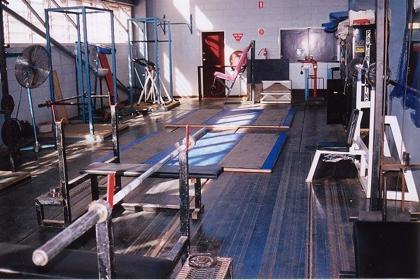

Facilities at the Mt Isa weightlifting club.

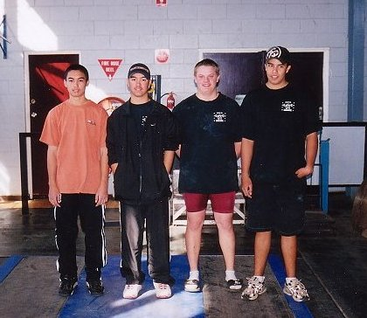
Weightlifters at the Mt Isa gym.
L-R : Calvin Cadman , Tane Cadman , Daniel Ayres and Lawrence Cunado.

Days Gone By
Program of the 1949 Australian Championships
Thanks to Ken McDonald for supplying this

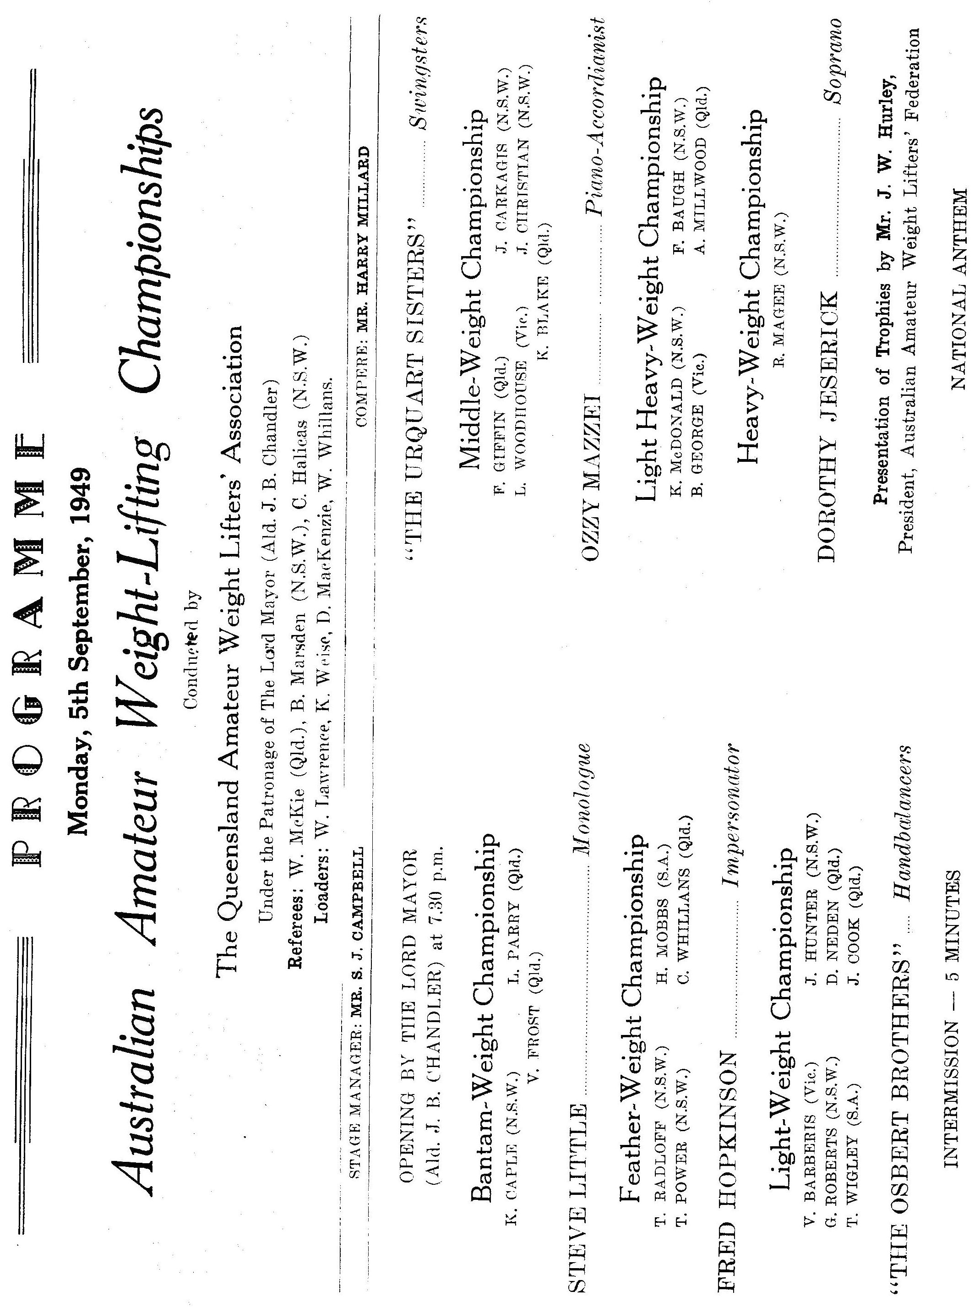

Meandering Thoughts
By Scott Robinson
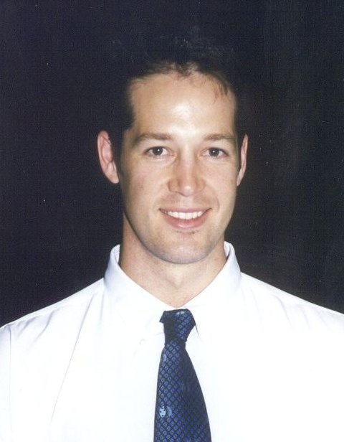
Hi Everyone. For those of you who do not know me, I am in my third year as the QWA Development Officer on a part time basis. My other occupation is as a massage therapist, where I work at St Lucia Sports & Rehab, and with the Brisbane Lions AFL club. Originally from the Eastern suburbs of Melbourne, I am 31 and have 3 children under the age of 4! Whilst I have not ever competed in Weightlifting I have used Olympic lifts to complement the boxing I did compete in for 11 years. Amongst other sports, I also played AFL for 10 years, which I suppose is average for anyone growing up in Victoria.

Follow me now as I go off in a tangent as something else just popped into my thought process. I was at the Cougars Club during a comp last year and Steve and Michelle Kettner were in the audience. I had seen Michelle and Steve compete on different occasions without them ever knowing me. Well I thought I would go and introduce myself as they looked a bit in need of company. Michelle looked so familiar, yet I was not sure whether she just looked like someone I knew. After a few minutes talking with Michelle, we discovered that we both went to school together and lived only houses away during our childhood!
I also remember as a child, playing amongst friends and when one of us attempted to do something seemingly impossible in terms of lifting or moving a heavy object, someone would sarcastically say, “who do you think you are?……Kabbas?!” I didn’t know who he was, I just knew he lifted big weights.
So it is strange how your life twists and turns, sort of like this rambling you are now reading!

How did I get into Weightlifting? Well there is a story to that question too. After some 10 years of trying commercial gyms, and trying weights programs from somebodies brother’s best friend’s sister, who knows this guy, who apparently trained someone famous for strength and power, and finding them all non-conducive to my sport, I read a story in the local paper. Hmmm, I thought, how many Keelans are there in the phone book? Only two! I phoned the closest one, and spoke to a very casual sounding Pommy guy named Mike. After telling him my needs for strength and power without gaining size, and many “Ah yeahs”, “no worries”, and, “that’s not a problem”, I made arrangements to meet at the Chandler gym. I got off the phone and said to my partner, Mandy, “This guy sounds so casual, I hope he isn’t another joker who promises results he can’t achieve.” Anyway, I obviously found the right fella, and still have so much more to learn from him.

This year I was fortunate enough to be chosen as the Qld Assistant Coach to the women’s team, which was a great experience. The best thing about Weightlifting competitions is that no matter who you are, everyone in the crowd wants to see big weights lifted. As a competitor, you should be able to use that fact to your advantage. It is not like football or boxing where half the crowd wants you to lose, and lose badly.

In the past two years, the QWA has unearthed such talents as, Kyle Woodlock, George Mylne, Susan Graham, Ben Turner, Robert Butler, John Yamasaki, Shari Cunningham, Sheridan Bower, Rebecca Marks, Kristie Amadio, Troy Hewkins, and Bianca Gastberger. These students have dedicated themselves to training and have all represented Qld at Junior and or Senior Level. Most of them also hold State and or National Records.

The QWA supported Development Squads have already begun this year with the Sunshine Coast, Toowoomba and Chandler Clubs. I would like all of our new Development Squad members to take a look at the following for inspiration; Joel Wilson started training 3 years ago at the age of 12. At his first competition he lifted 20 and 30kg. Now he is lifting 97.5 and 125kg. As a 14-year-old, Kristie Amadio first competed 2 years ago with lifts of 22.5 and 35kg. Now she lifts 67.5 and 83kg. Both of these athletes are very dedicated and their improvements reflect this. You too, can achieve if you dedicate yourselves.

So anyway, that is about all of my thoughts for now. I would just like to thank all the coaches I have ever had in all the different sports I have played. I have to thank the QWA for taking a chance on me and employing me as the QWA Development Officer as I do really love this sport. I love finding new talent and getting them started in this great sport. I also need to thank both Mike and Miles for all their help and advice. I must also thank the parents who have trusted us in teaching their children, thanks for bringing them each week. Finally I must thank my partner, Mandy, and our 3 sweet little energy balls for allowing me the time to coach and be obsessed by this sport. Thanks.

Trevor Walz's story
Joe McLucas took weight training at Wavell High School on Wednesday afternoons. I applied to do weights in 1967 but was knocked back due to numbers and other reasons. Joe had come from Banyo High school where he had introduced weight training prior to 1960. Joe now lives in Rockhampton and still does his weights at age 90.

In 1968 Pat Pacey and Geoff Duncan took over the gym and I managed to get a foot in the door being a Grade 11 student. Mick Reilly (who did weights in previous years) and myself formed a friendship and subsequent interest in weight training. That year in about April/May we went to a comp at the Sportsmans Gym in the Valley and watched our first comp on a Saturday afternoon. The following month we lifted in our first comp on 5th June 1968. Later that year I remember watching the State Titles with Nev Pery who was preparing for The Olympics in Mexico Cty. I remember Clarrie Schultz, Ray Chant (the giant), Marty Williamson, Neil McCoy (Marty's side kick), Alan Drew, Merv Stacey to name a few.

Bob Henderson spent time giving us help at the Wavell School gym.

Mal came along later that year and a group consisting of myself, Mick, Mal, Mark Barry and Peter Frostick began serious training. We trained mostly at the Wavell Gym but most Saturday afternoons we went to either my garage or Peter's place and had our own private comp. In those days there were usually two comps a month at the Sportsman's. There was an Olympic comp and a Strength Set spaced about two weeks apart.

I remember Frank Stanfield leaving his impression at the Sportsmans Gym one day by overbalancing and crashing through a fibro wall while warming up for the snatches.

Complan was the go to put on weight. It was a skim milk based food for babies and convalescing people. Later the Uni gym purchased bulk skim milk powder as a cheaper substitute. I later found out this powder was normally sold by Caboolture Co-Op as pig food. It worked!!

Geoff Duncan had a secret brew of lemon juice and honey for after training. He used this when he did boxing when he was younger.

I was selected for a number of interstate comps. These were usually comps in Sydney and held at the Police Boys Clubs at Glebe. Bob Taylor and Bruce Walsh were the organisers in Sydney. We always travelled by train. The student train fair to Sydney return was something like $15 (cheap!!). Bob Henderson accompanied us on a number of trips. The Sydney team came up and competed against us in around 1970/71. Mark Livingstone was the gun featherweight then and I came second to him. His father owned a sports shop in Sydney and I bought a lifting suit off him. I used the same suit the other day (June 2001) at the Aussie Masters at Marcoola. I think Nick Trefellis and Noel Matis were lifters who came up that weekend.

In 1973 I went to the National Juniors in Launcetson. I was billetted by Bonnie Ellis. I had a great tussle with Greg Maguire. The chief referee who was doing his referee exam signalled for me to press the weight before I
stood out of the clean. I was not given another attempt. I missed the second over the back. I jumped to 115kG for the third. If I missed I knew I would take an early shower. I was behind the eight ball because I relied on a big press. I got 115kG. I had planned to do 120kG. Although leading after the press Greg (a good snatcher) caught me in the snatches. At the end I had to clean and jerk 142.5kG while weighing 71kg. I cleaned it, jerked it to arms length but could not recover. Runner up once again. My jerk on the day of 137.5 was a PB by 5kG.

Peter Phillips (1972 Olympian) was one of the side referees for that comp. I also remember that day a man called Cliff Joyce who was a wrestler. He knew I was from Queensland so he told me to take a long hot shower to start my warm up. It really worked. Cliff died some years later of cancer and I remember seeing results of the Cliff Joyce memorial competition during the 1980's.

Later when at the University Club, we always travelled to Sydney and Melbourne by car for inter-varsity. It was usually in Frank Stanfield's 1963 EJ wagon with a Toyota Crown Overdrive gearbox and 17inch wheels on the back or in Alex Osipovitch's Mazda 1500 which would sit on 100mph. Alex would get in the car in Brisbane and drive non-stop to Melbourne. Frank Stanfield took the wheel as we set off home from Melbourne in 1971. As we travelled to the outskirts about 5:00pm, Frank and Alex decided to do a spot of sightseeing via the Jindabyne road to Thredbo. Thus we were crammed three abreast when we arrived at Thredbo at 3:am, having slithered all over a greasy unpaved road in the early spring thaw in pitch darkness. At least the hydro power stations were well-lit. At one stage Frank accidentally knocked the light-switch off as the speedo showed 90mph (144 km/hr) and the ensuing scramble to relight the headlights was funny only because we were drunk. Frank finally found them as we headed towards a farm gate.

These comps were the annual inter-varsity comps which in the early to mid 1970's were of the same standard as the National Open Titles. There were Olympians and National champs lifting in them.

After finishing university I worked in Toowoomba for two years (1975 to 1976). There I found a gym run by Jimmie Slater who was a retired spray painter. The building was a World War 2 timber hall owned by the National Fitness organisation. Jimmie could do pushups with his hands extended in front of his head. Try it. It is impossible. Jim was 65 years old. Jim had a bar something like an olympic bar with steel discs. I managed to clean 152.5kg on this bar while the possums in the rafters watched. The place really stunk. One night I came in and one of the baby possums had fallen on the bar and was dead.

When I moved to Emerald I had already retired from lifting. I still took my weights with me to Emerald over the 1000km in my 1946 Hudson. It was the only car that would carry them. When I heard about the Masters in 1994 I decided to have a go. I set up my weights in the shed down the back near the chook pen and there it all started again. My two sons, Andrew and John, who were 9 and 7 years old at the time started lifting and lifted in a couple of comps in Rockhampton with Bob Kennedy. John and Andrew both went on to become Australian 100m freestyle champions and used weight training for their power development. John still swims and lifts weights and last April again won the 100m Australian Title for his age.

In Rocky I am involved heavily with the boys' sports. I get little time to train even though I still have my weights set up at home and there is a gym at work. A couple of months prior to a comp I would probably train 2 to 3 times a week for about 30 minutes a session. I have found that if you have limited time to train then at least work on flexibility.

Trevor (Australian Master’s Champion 85kg 45-49yr Group)

Raising Weightlifting’s Profile
By Ian Moir

In the aftermath of an event such as the recent 2001 Goodwill Games, many people reflect on the differences between the GWG weightlifting competition staged at the Brisbane Convention & Exhibition Centre and something like the Queensland Championships.

The final session of the 2001 Goodwill Games Weightlifting competition played to a full house in the BCEC’s Great Hall. Over 1,700 ticket holders, plus numerous corporate guests and VIP’s, were entertained and enthralled by the 69kg women and +105kg men on that first Saturday afternoon of September, and I dare say that many of those present had never seen a live weightlifting competition before.

Of course we can only dream of having access to an event budget the size of the Goodwill Games’, and opportunities to conduct major international weightlifting events in Queensland are few and far between, but there are other avenues for promoting our sport that become available on a fairly regular basis.

At least a few times each year organisations such as the Queensland Olympic Council (QOC) and the Australian Commonwealth Games Association (ACGA), and various City Councils, invite sporting organisations to participate in promotional activities that they organise. The value of these opportunities to gain public exposure should never be underestimated, and capitalising on them in the past has led to weightlifting being presented in a variety of seemingly unlikely places, such as the 3rd floor of the Myer Centre and other suburban shopping malls, the Toowoomba Show Grounds, Kedron-Wavell Services Club, BCEC’s Plaza Ballroom foyer, the Telstra Building in Roma Street, and most recently South Bank Parklands, where Mike Keelan, Melissa Nightingale and Jessica Keelan (yes, Jessica aged 9), provided a display of weightlifting for one of the QOC’s sponsors, MBF.

In relative terms, weightlifting is a small sport in Queensland. Fortunately, thanks to our high achieving athletes, coaches and officials, and those members who regularly give up their time to participate in public demonstrations, coupled with the maintenance of good relationships with a host of sport-related organisations, the QWA enjoys a much greater profile than the size of our membership base alone could ever provide. And having a good profile is all important when it comes to being taken seriously as a sport, and being considered for inclusion in events such as the Goodwill Games, World Masters Games, Commonwealth Games, and even the Olympic Games.

So whenever the opportunity arises, I recommend that all members get out there in the public domain and promote their own sport and their own achievements, because the benefits that will flow back to weightlifting, and weightlifters, are well worth it. And of course, Mike Keelan and I are always up for a bit of public spruiking on the subject.

NOTICES

- Congratulations to Ian Moir and Mike Keelan on their recent election to the Board of the Australian Weightlifting Federation.

- The QWA Annual Awards dinner will be on November 17th. Mark it in your diary. Further details will be mailed later.

- Congratulations to Debbie Keelan and Ian Moir - they both recently took their refereeing upgrade exam to upgrade from National to International referees.

- New lifting suits availale from the QWA - $75.

- Referee Course. Sunday 4th November at QWA headquarters, Chandler.

- Contact the QWA for availability of "Fascination Weightlifting CD-ROMs". The CDs contain several years of Olympics/Worlds results, video sequences of the lifts, technical/biomechanical analysis of lifts, information on the competitions and their participants.

Competition Rules

Many newcomers to the sport of weightlifting wonder why some lifts are failed by the referees when the lifter has successfully got the barbell overhead. The referees handbook clearly states the rules for successful / failed lifts as follows.

GENERAL RULES FOR ALL LIFTS
- The technique known as "hooking" is permitted. It consists of covering the last joint of the thumb with the other fingers of the same hand at the moment of gripping the bar.
- In all lifts, the referees must count as "No lift" any unfinished attempt in which the bar has reached the height of the knees.
- After the referees signal to lower the barbell, the lifter must lower it in front of the body and not let it drop either deliberately or accidentally. The grip on the bar may be released when it has passed the level of the waist.
- A competitor who cannot fully extend the elbow due to anatomical deformation, must report this fact to the three referees and the jury before the start of competition.
- The use of grease, oil, water, talcum or any similar lubricant on the thighs is forbidden. Lifters are not permitted to have any substance on their thighs when arriving in the competition area. A lifter who uses any lubricant is ordered to remove it. During the removal the clock goes on.
- The use of chalk (magnesium) on the thighs etc is permitted.

INCORRECT MOVMENTS AND POSITIONS FOR ALL LIFTS
- Pulling from the hang.
- Touching the platform with any part of the body other than the feet.
- Uneven or incomplete extension of the arms at the finish of the lift.
- Pause during extension of the arms.
- Finishing with a press-out.
- Bending and extending the elbows during recovery.
- Leaving the platform during the execution of the lift i.e. touching the area outside the platform with any part of the body.
- Replacing the barbell on the platform before the referees' signal.
- Dropping the barbell after the referees' signal.
- Failing to finish with and the barbell and feet in line and parallel to the line of the trunk.
- Failing to replace the complete barbell on the platform i.e. the complete barbell must first touch the platform.

INCORRECT MOVEMENTS FOR THE SNATCH
- Pause during lifting the barbell.
- Touching the head of the lifter with the bar.

INCORRECT MOVEMENTS FOR THE CLEAN
- Placing the bar on the chest before turning the elbows.
- Touching the thighs or the knees with the elbows or the upper arms.

INCORRECT MOVEMENTS FOR THE JERK
- Any apparent effort of jerking which is not completed. This includes lowering the body or bending the knees.
- Any deliberate oscillation of the barbell to gain advantage. The athlete and barbell have to become motionless before starting the jerk.

Support your Sport
By QWA President, Barry Harden

It has been a very successful year for Queensland on the National and International stage. Not for a long time have I heard the subject of weightlifting coming up in conversations in the general public. For that I would like to thank everyone involved, lifters, coaches, parents and anyone else who helped.

I hopefully will be repeating the above statement in detail at the QWA Awards night. Unfortunately, in past years the Awards night has not been well attended which is a shame. It is the format to thank those that have achieved great things throughout the year. Please don’t think because you are not in line for an award that you will not have a good time. It is an opportunity for you to thank your coach, our club, your training partner and anyone else who had a hand in seeing that you had every opportunity to excel. Queensland Weightlifting has much to be proud of, let’s celebrate it together. Help us treat the QWA Awards night and the recipients with the respect they deserve. Join us in the celebrations. Ensure your Club has booked its table. Make November 17 a date to remember.

As I have previously mentioned Queensland Weightlifting has much to be proud of. We have proven that we are a force in Australian Weightlifting and you have the opportunity to see Queenslands best compete against each other in, what I believe is the most exciting competition in Australian Weightlifting, the Queensland 2000. It is the only event of its type in Australia. $2000 will be fought over in a sudden death competition. Last years' was magnificent. Unfortunately, the only thing to mar this great event was the lack of support by our own weightlifting family. I would like you all to use this event as an opportunity to introduce your friends and family to this great sport. It is an ideal situation as it is designed for the audience. All lifters lift their 1st attempt, then their 2nd and 3rd. This way the audience can tell who is in front after each round of attempts. The competition is quick, the results/points are up dated on a TV screen for the audience to see and the outcome can be nail biting stuff.

So be proud of your sport, show it off, or at the very least support the sport by supporting your fellow lifters and say thank you for the opportunities that the sport has given you this year.

The Queensland 2000 - November 24.

Queensland Records

Open Female 48Kg
Snatch | Qld Record Standard | 55.0 | - | -
Clean and Jerk | Karuna Jones | 67.5 | 11/08/01 | Homebush
Total | Karuna Jones | 122.5 | 11/08/01 | Homebush
Open Female 53Kg
Snatch | Justine Hartwig | 65.0 | 6/05/00 | Sunshine Coast lifting Club
Clean and Jerk | Justine Hartwig | 87.5 | 6/05/00 | Sunshine Coast lifting Club
Total | Justine Hartwig | 152.5 | 6/05/00 | Sunshine Coast lifting Club
Open Female 58Kg
Snatch | Angela Wydall | 72.5 | 11/07/98 | Toowoomba Qld
Clean and Jerk | Angela Wydall | 85.0 | 21/02/98 | Toowoomba, Qld
Total | Angela Wydall | 157.5 | 11/07/98 | Toowoomba Qld
Open Female 63Kg
Snatch | Amanda Phillips | 82.5 | 15/09/00 | Sydney
Clean and Jerk | Amanda Phillips | 107.5 | 15/09/00 | Sydney
Total | Amanda Phillips | 190.0 | 15/09/00 | Sydney
Open Female 69Kg
Snatch | Amanda Phillips | 83.0 | 11/08/01 | Homebush
Clean and Jerk | Amanda Phillips | 107.5 | 11/08/01 | Homebush
Total | Amanda Phillips | 190.0 | 11/08/01 | Homebush
Open Female 75Kg
Snatch | Deborah Lovely | 82.5 | 1/07/01 | Greece
Clean and Jerk | Amanda Phillips | 105.0 | 6/11/99 | Chandler
Total | Amanda Phillips | 185.0 | 26/11/99 | Athens Greece
Open Female 75+Kg
Snatch | Melissa Bethune | 95.0 | 12/05/00 | Nauru
Clean and Jerk | Melissa Bethune | 117.5 | 29/01/00 | Nauru
Total | Melissa Bethune | 212.5 | 12/05/00 | Nauru
U20 Female 48Kg
Snatch | Qld Record Standard | 47.5 | - | -
Clean and Jerk | Qld Record Standard | 60.0 | - | -
Total | Qld Record Standard | 107.5 | - | -
U20 Female 53Kg
Snatch | Qld Record Standard | 57.5 | - | -
Clean and Jerk | Qld Record Standard | 67.5 | - | -
Total | Qld Record Standard | 125.0 | - | -
U20 Female 58Kg
Snatch | Kristie Amadio | 67.5 | 1/07/01 | Greece
Clean and Jerk | Kristie Amadio | 83.0 | 16/06/01 | Toowoomba
Total | Kristie Amadio | 150.0 | 11/08/01 | Homebush
U20 Female 63Kg
Snatch | Amanda Phillips | 82.5 | 15/09/00 | Sydney
Clean and Jerk | Amanda Phillips | 107.5 | 15/09/00 | Sydney
Total | Amanda Phillips | 190.0 | 15/09/00 | Sydney
U20 Female 69Kg
Snatch | Amanda Phillips | 83.0 | 11/08/01 | Homebush
Clean and Jerk | Amanda Phillips | 107.5 | 11/08/01 | Homebush
Total | Amanda Phillips | 190.0 | 11/08/01 | Homebush
U20 Female 75Kg
Snatch | Deborah Lovely | 82.5 | 1/07/01 | Greece
Clean and Jerk | Amanda Phillips | 105.0 | 6/11/99 | Chandler
Total | Amanda Phillips | 185.0 | 26/11/99 | Athens Greece
U20 Female 75+Kg
Snatch | Melissa Bethune | 92.5 | 4/12/99 | Chandler
Clean and Jerk | Melissa Bethune | 115.0 | 16/10/99 | Chandler Brisbane
Total | Melissa Bethune | 205.0 | 20/11/99 | Chandler
U18 Female 40Kg
Snatch | Qld Record Standard | 32.5 | - | -
Clean and Jerk | Qld Record Standard | 40.0 | - | -
Total | Qld Record Standard | 72.5 | - | -
U18 Female 44Kg
Snatch | Emma Bauer | 28.0 | 17/02/01 | Toowoomba
Clean and Jerk | Emma Bauer | 38.0 | 3/03/01 | Chandler
Total | Qld Record Standard | 65.0 | - | -
U18 Female 48Kg
Snatch | Sheridan Bower | 45.0 | 11/08/01 | Homebush
Clean and Jerk | Desiree Gagliardi | 55.5 | 20/11/99 | Chandler
Total | Kerry Timms | 97.5 | 11/07/98 | Toowoomba Qld
U18 Female 53Kg
Snatch | Kristie Amadio | 50.0 | 8/07/00 | Sleeman Sports Center
Clean and Jerk | Kristie Amadio | 67.5 | 4/08/00 | South Bank Brisbane
Total | Kristie Amadio | 117.5 | 4/08/00 | South Bank Brisbane
U18 Female 58Kg
Snatch | Kristie Amadio | 67.5 | 1/07/01 | Greece
Clean and Jerk | Kristie Amadio | 83.0 | 16/06/01 | Toowoomba
Total | Kristie Amadio | 150.0 | 11/08/01 | Homebush
U18 Female 63Kg
Snatch | Melissa Nightingale | 67.5 | 13/08/99 | Melbourne
Clean and Jerk | Melissa Nightingale | 82.5 | 13/08/99 | Melbourne
Total | Melissa Nightingale | 150.0 | 13/08/99 | Melbourne
U18 Female 69Kg
Snatch | Amanda Phillips | 80.0 | 5/09/98 | Sleeman Sports Complex Chandler
Clean and Jerk | Amanda Phillips | 105.0 | 2/07/99 | Savannah (USA)
Total | Amanda Phillips | 185.0 | 2/07/99 | Savannah (USA)
U18 Female 75Kg
Snatch | Deborah Lovely | 82.5 | 1/07/01 | Greece
Clean and Jerk | Amanda Phillips | 105.0 | 6/11/99 | Chandler
Total | Amanda Phillips | 185.0 | 26/11/99 | Athens Greece
U18 Female 75+Kg
Snatch | Deborah Lovely | 85.0 | 27/01/01 | Nauru
Clean and Jerk | Deborah Lovely | 100.5 | 28/07/01 | Toowoomba
Total | Deborah Lovely | 185.0 | 27/01/01 | Nauru
U16 Female 40Kg
Snatch | Erika Yamasaki | 32.5 | 4/11/00 | Toowoomba
Clean and Jerk | Qld Record Standard | 40.0 | - | -
Total | Qld Record Standard | 70.0 | - | -
U16 Female 44Kg
Snatch | Emma Bauer | 28.0 | 17/02/01 | Toowoomba
Clean and Jerk | Emma Bauer | 38.0 | 3/03/01 | Chandler
Total | Qld Record Standard | 65.0 | - | -
U16 Female 48Kg
Snatch | Sheridan Bower | 45.0 | 11/08/01 | Homebush
Clean and Jerk | Desiree Gagliardi | 55.5 | 20/11/99 | Chandler
Total | Desiree Gagliardi | 97.5 | 4/12/99 | Chandler
U16 Female 53Kg
Snatch | Kristie Amadio | 50.0 | 8/07/00 | Sleeman Sports Center
Clean and Jerk | Kristie Amadio | 67.5 | 4/08/00 | South Bank Brisbane
Total | Kristie Amadio | 117.5 | 4/08/00 | South Bank Brisbane
U16 Female 58Kg
Snatch | Kristie Amadio | 67.5 | 1/07/01 | Greece
Clean and Jerk | Kristie Amadio | 83.0 | 16/06/01 | Toowoomba
Total | Kristie Amadio | 150.0 | 11/08/01 | Homebush
U16 Female 63Kg
Snatch | Kristie Amadio | 60.0 | 28/07/01 | Toowoomba
Clean and Jerk | Kristie Amadio | 75.0 | 28/07/01 | Toowoomba
Total | Kristie Amadio | 135.0 | 28/07/01 | Toowoomba
U16 Female 69Kg
Snatch | Rachel Trigger | 55.0 | 9/12/00 | Chandler
Clean and Jerk | Rachel Trigger | 70.0 | 9/12/00 | Chandler
Total | Rachel Trigger | 125.0 | 9/12/00 | Chandler
U16 Female 75Kg
Snatch | Deborah Lovely | 62.5 | 20/11/99 | Chandler
Clean and Jerk | Deborah Lovely | 85.0 | 20/11/99 | Chandler
Total | Deborah Lovely | 147.5 | 20/11/99 | Chandler
U16 Female 75+Kg
Snatch | Deborah Lovely | 70.0 | 4/12/99 | Chandler
Clean and Jerk | Deborah Lovely | 87.5 | 4/12/99 | Chandler
Total | Deborah Lovely | 157.5 | 4/12/99 | Chandler
Open Men 56Kg
Snatch | Qld Record Standard | 85.0 | - | -
Clean and Jerk | Qld Record Standard | 105.0 | - | -
Total | Qld Record Standard | 190.0 | - | -
Open Men 62Kg
Snatch | Qld Record Standard | 95.0 | - | -
Clean and Jerk | Brad Peters | 120.0 | 27/06/98 | Sleeman Sports Complex, Chandler
Total | Qld Record Standard | 210.0 | - | -
Open Men 69Kg
Snatch | David DeRose | 105.0 | 24/08/01 | Chandler
Clean and Jerk | Ben Turner | 128.5 | 24/08/01 | Chandler
Total | Qld Record Standard | 230.0 | - | -
Open Men 77Kg
Snatch | Alex Goodyear | 117.5 | 18/04/98 | Toowoomba
Clean and Jerk | Alex Goodyear | 142.5 | 18/04/98 | Toowoomba
Total | Alex Goodyear | 260.0 | 18/04/98 | Toowoomba
Open Men 85Kg
Snatch | Alex Goodyear | 122.5 | 27/06/98 | Sleeman Sports Complex, Chandler
Clean and Jerk | Qld Record Standard | 145.0 | - | -
Total | Alex Goodyear | 267.5 | 8/05/99 | Toowoomba
Open Men 94Kg
Snatch | Qld Record Standard | 125.0 | - | -
Clean and Jerk | Ken Chandler | 155.0 | 11/08/01 | Homebush
Total | Qld Record Standard | 277.5 | - | -
Open Men 105Kg
Snatch | Qld Record Standard | 130.0 | - | -
Clean and Jerk | Qld Record Standard | 160.0 | - | -
Total | Qld Record Standard | 290.0 | - | -
Open Men 105+Kg
Snatch | Anthony Martin | 155.0 | 9/05/98 | Nudgee
Clean and Jerk | Anthony Martin | 200.0 | 5/09/98 | Sleeman Sports Complex Chandler
Total | Anthony Martin | 355.0 | 5/09/98 | Sleeman Sports Complex Chandler
U20 Men 56Kg
Snatch | Fred Buchanan | 77.5 | 13/06/98 | Midland PCYC, Perth
Clean and Jerk | Fred Buchanan | 97.5 | 17/10/98 | Chandler Brisbane
Total | Fred Buchanan | 175.0 | 17/10/98 | Chandler Brisbane
U20 Men 62Kg
Snatch | Qld Record Standard | 82.5 | - | -
Clean and Jerk | Qld Record Standard | 100.0 | - | -
Total | Qld Record Standard | 182.5 | - | -
U20 Men 69Kg
Snatch | David DeRose | 105.0 | 24/08/01 | Chandler
Clean and Jerk | Ben Turner | 128.5 | 24/08/01 | Chandler
Total | David DeRose | 230.0 | 24/08/01 | Chandler
U20 Men 77Kg
Snatch | Jason Power | 102.5 | 18/11/00 | Chandler
Clean and Jerk | Jason Power | 130.0 | 21/10/00 | Malvern Victoria
Total | Jason Power | 230.0 | 21/10/00 | Malvern Victoria
U20 Men 85Kg
Snatch | Tim Oberg | 112.5 | 21/02/98 | Toowoomba, Qld
Clean and Jerk | Tim Oberg | 140.0 | 14/03/98 | Chandler, Qld
Total | Tim Oberg | 250.0 | 21/02/98 | Toowoomba, Qld
U20 Men 94Kg
Snatch | Tim Oberg | 115.0 | 5/09/98 | Sleeman Sports Complex Chandler
Clean and Jerk | Tim Oberg | 142.5 | 20/09/98 | Alexandra Hills Hotel, Redlands Qld
Total | Tim Oberg | 252.5 | 1/08/98 | Lakes Resort Hotel, Adelaide, SA
U20 Men 105Kg
Snatch | Qld Record Standard | 112.5 | - | -
Clean and Jerk | Qld Record Standard | 137.5 | - | -
Total | Qld Record Standard | 250.0 | - | -
U20 Men 105+Kg
Snatch | Anthony Martin | 155.0 | 9/05/98 | Nudgee
Clean and Jerk | Anthony Martin | 200.0 | 5/09/98 | Sleeman Sports Complex Chandler
Total | Anthony Martin | 355.0 | 5/09/98 | Sleeman Sports Complex Chandler

U18 Men 47Kg
Snatch | Troy Hewkins | 52.5 | 7/10/00 | Chandler
Clean and Jerk | Troy Hewkins | 70.0 | 4/11/00 | Toowoomba
Total | Troy Hewkins | 122.5 | 4/11/00 | Toowoomba
U18 Men 51Kg
Snatch | Troy Hewkins | 60.0 | 19/05/01 | Chandler
Clean and Jerk | Troy Hewkins | 80.0 | 11/08/01 | Homebush
Total | Troy Hewkins | 140.0 | 11/08/01 | Homebush
U18 Men 56Kg
Snatch | Fred Buchanan | 77.5 | 13/06/98 | Midland PCYC, Perth
Clean and Jerk | Fred Buchanan | 97.5 | 17/10/98 | Chandler Brisbane
Total | Fred Buchanan | 175.0 | 17/10/98 | Chandler Brisbane
U18 Men 62Kg
Snatch | Cameron Andersen | 80.0 | 29/01/00 | Nauru
Clean and Jerk | Cameron Andersen | 100.0 | 29/01/00 | Nauru
Total | Cameron Andersen | 180.0 | 29/01/00 | Nauru
U18 Men 69Kg
Snatch | Joel Wilson | 97.5 | 11/08/01 | Homebush
Clean and Jerk | Ben Turner | 128.5 | 24/08/01 | Chandler
Total | Ben Turner | 225.0 | 24/08/01 | Chandler
U18 Men 77Kg
Snatch | Jason Power | 102.5 | 18/11/00 | Chandler
Clean and Jerk | Jason Power | 130.0 | 21/10/00 | Malvern Victoria
Total | Jason Power | 230.0 | 21/10/00 | Malvern Victoria
U18 Men 85Kg
Snatch | Qld Record Standard | 90.0 | - | -
Clean and Jerk | Qld Record Standard | 112.5 | - | -
Total | Qld Record Standard | 202.5 | - | -
U18 Men 94Kg
Snatch | Qld Record Standard | 95.0 | - | -
Clean and Jerk | Qld Record Standard | 117.5 | - | -
Total | Qld Record Standard | 212.5 | - | -
U18 Men 105Kg
Snatch | Qld Record Standard | 100.0 | - | -
Clean and Jerk | Qld Record Standard | 125.0 | - | -
Total | Qld Record Standard | 225.0 | - | -
U18 Men 105+Kg
Snatch | Damon Kelly | 132.5 | 11/08/01 | Homebush
Clean and Jerk | Damon Kelly | 180.0 | 16/06/01 | Toowoomba
Total | Damon Kelly | 310.0 | 16/06/01 | Toowoomba
U16 Men 47Kg
Snatch | Troy Hewkins | 52.5 | 7/10/00 | Chandler
Clean and Jerk | Troy Hewkins | 70.0 | 4/11/00 | Toowoomba
Total | Troy Hewkins | 122.5 | 4/11/00 | Toowoomba
U16 Men 51Kg
Snatch | Troy Hewkins | 60.0 | 19/05/01 | Chandler
Clean and Jerk | Troy Hewkins | 80.0 | 11/08/01 | Homebush
Total | Troy Hewkins | 140.0 | 11/08/01 | Homebush
U16 Men 56Kg
Snatch | Matthew Cornes | 68.0 | 17/10/98 | Chandler Brisbane
Clean and Jerk | Dion Wood | 82.5 | 9/05/98 | Nudgee
Total | Dion Wood | 150.0 | 9/05/98 | Nudgee
U16 Men 62Kg
Snatch | Dion Wood | 72.5 | 13/06/98 | Midland PCYC, Perth
Clean and Jerk | Joel Wilson | 100.0 | 7/10/00 | Chandler
Total | Dion Wood | 160.0 | 13/06/98 | Midland PCYC, Perth
U16 Men 69Kg
Snatch | Joel Wilson | 97.5 | 11/08/01 | Homebush
Clean and Jerk | Joel Wilson | 122.5 | 11/08/01 | Homebush
Total | Joel Wilson | 220.0 | 11/08/01 | Homebush
U16 Men 77Kg
Snatch | John Ryan | 78.0 | 14/12/99 | Toowoomba
Clean and Jerk | Jason Power | 102.5 | 7/11/98 | Toowoomba
Total | Jason Power | 177.5 | 7/11/98 | Toowoomba
U16 Men 85Kg
Snatch | Qld Record Standard | 80.0 | - | -
Clean and Jerk | Mark Newman | 100.0 | 7/11/98 | Toowoomba
Total | Qld Record Standard | 175.0 | - | -
U16 Men 94Kg
Snatch | Qld Record Standard | 85.0 | - | -
Clean and Jerk | Qld Record Standard | 100.0 | - | -
Total | Qld Record Standard | 185.0 | - | -
U16 Men 105Kg
Snatch | Bryan Fischer | 92.5 | 28/08/99 | Chandler
Clean and Jerk | Bryan Fischer | 112.5 | 4/12/99 | Chandler
Total | Bryan Fischer | 202.5 | 28/08/99 | Chandler
U16 Men 105+Kg
Snatch | Damon Kelly | 102.5 | 20/11/99 | Chandler
Clean and Jerk | Damon Kelly | 127.5 | 20/11/99 | Chandler
Total | Damon Kelly | 230.0 | 20/11/99 | Chandler

