vWeightlifting Queenslandv
. 

Nov 2002
The Official Journal of the Queensland Weightlifting Association Inc.
PO Box 1056, Capalaba, Qld 4157
Tel: (07) 3823 1377 Fax: (07) 3823 1371

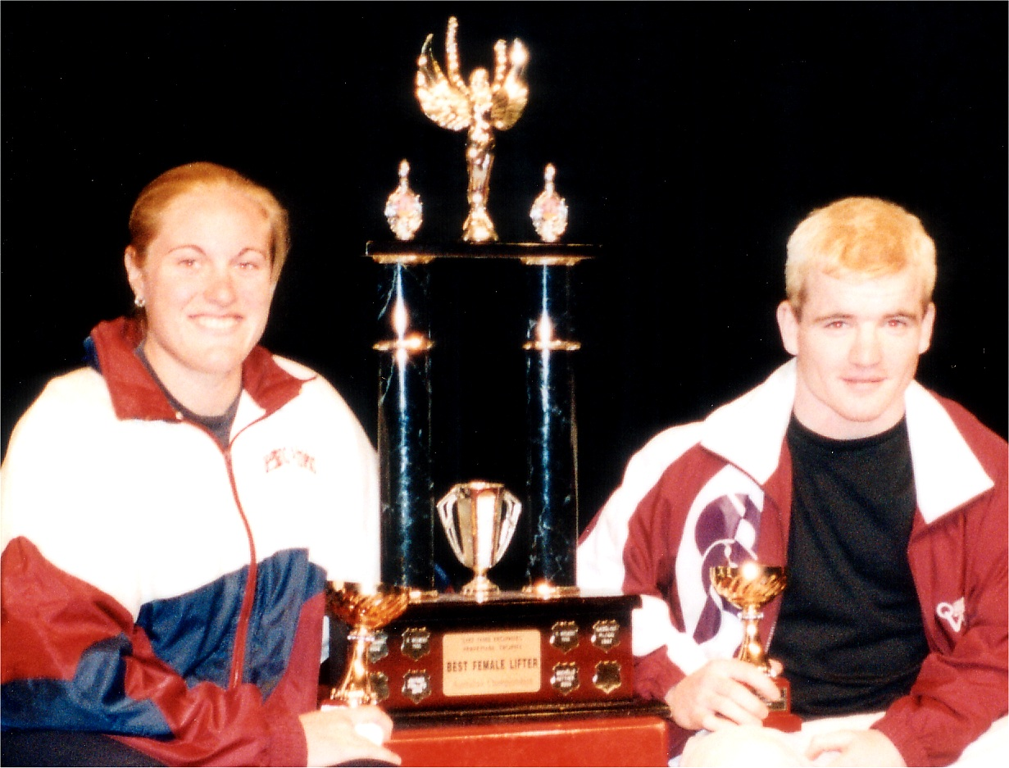
Best lifters at the 2002 National Championships were Queensland’s Deborah Lovely and Ben Turner. Both will be lifting at the World Championships in Poland this month.

From the QWA Office 5 World Masters Games Results 12
National Championships Report 4 QWA 2002 League Final 18
National Championships Results 7 Queensland All Schools Results 19
Congratulations and Notices 11 Queensland Records 21
Proudly Supported by:




Queensland Weightlifting Association Inc.
Office: The Velodrome, The Sleeman Sports Complex,
Chandler 4155
Postal Address: PO Box 1056, Capalaba 4157
Telephone: (07) 3823 1377
Facsimile: (07) 3823 1371
Email: qwa@powerup.com.au
Web Site: http://www.qwa.org
Executive Director: Ian Moir
Administrative Officer: Kylie Booth
Development Officer: Scott Robinson
Newsletter Editor: Angela Wydall

The QWA Management Committee

Patron: Bert Hobl
President: Mike Keelan
Vice President: Greg Hobl
Secretary: Kylie Booth
Treasurer: Corran Amadio
Executive Officer: Ross Gagliardi
Executive Officer: Barry Harden
Executive Officer: Tanya Harden
Executive Officer: Daryll Hawkins

QWA Mission Statement
"To promote and develop all aspects of the sport of weightlifting in Queensland."

Acknowledgement - Sponsors of the QWA
The Queensland Weightlifting Association is extremely appreciative of the assistance provided by the following:

Queensland Government –Sport and Recreation Queensland
Major Sports Facilities Authority

Qantm

Acknowledgement - Corporate Members

Gremel Promotions

Disclaimer
The views represented in this publication do not necessarily reflect those of the editor or of the Officers or Management Committee of the QWA.

QWA / AWF Competition Calendar 2002

October 18 | TWA Open Club Competition | Toowoomba
October 26 | QWA League Final | Chandler
November 2 | Qld All Schools Championships | Toowoomba
November 9 | Qld Masters H/cap Final | Sunshine Coast
November 10 | Nudgee Open Club Competition | Nudgee
November 17 – 24 | World Championships | Warsaw, Poland
November 29 | Cougars Open Club Competition | Chandler
November 29  November 30 | TWA Open Club Competition  Queensland 2000 | Toowoomba  South Bank, Brisbane
December 7 | Sunshine Coast Open Club Competition | Sunshine Coast
December 8 | Nudgee Open Club Competition | Nudgee
December 14 | Mount Isa Open Club Competition | Mount Isa
December 14 – 15 | Oceania & South Pacific Junior Championships | Melbourne, Vic
December 21 | Cougars Open Club Competition | Chandler

Draft 2003 Competition Calendar

January 11 – 12 Australian Youth Olympic Festival Sydney

February 15 QWA League Round 1 & Masters H/cap Round 1 TBC

March 8 Qld Under 16 & Under 18 Championships TBC

March 7 – 9 Kosice Grand Prix Junior International Kosice, Slovakia

April 10 – 12 Oceania & South Pacific Championships Tonga

April TBC National Under 16 & Under 18 Championships Adelaide

May 17 QWA League Round 2 & Masters H/cap Round 2 TBC

May 25 – June 1 World Junior Championships Monterey, Mexico
June TBC Mermet Cup AUS vs USA USA

June 21 Qld U20 & Senior Championships TBC
June 26 - 29 World University Championships Pavia, Italy

July 12 Qld Masters Championships TBC

August 23 QWA League Round 3 & Masters H/cap Round 3 TBC

September 6 – 7 National U20 & Open Championships Melbourne

September 27 Qld Masters H/cap Final TBC

October National Age Group Team Challenge TBC

October 18 – 19 National Masters Championships Sydney
TBC IWF World Masters Championships TBC

October 25 QWA League Final TBC

November 1 Qld All Schools Championships TBC
November 11 – 21 World Championships Vancouver, Canada

November 29 Queensland 2000 TBC
December 8 – 9 Oceania Junior Championships Niue Island

The closing date for entries for all QWA events is 15 days prior to the competition date.
The closing date for entries for all National events is 28 days prior to the competition date.
The minimum qualifying standard for entry in the Queensland Open Championships is C Grade.
The minimum qualifying standard for entry in the Queensland Under 20 Championships is D Grade.
There is no minimum qualifying standard for Queensland Under 16, Under 18, School or Masters Championships.
The qualifying period for the Queensland Open & Under 20 Championships is 6th June 2002 – 6th June 2003
The qualifying period for the Queensland 2000 Tournament is 1st January 2003 – 30th September 2003
Queensland Teams for the 2002 National Open & Under 20 Championships will be selected according to the QWA Selection Policy taking into consideration results from all state, national and international events held between 1st January 2003 and 28th July 2003.

From the QWA Office
By Ian Moir, QWA Executive Director

Perhaps the title of this piece should be “From the NEW QWA Office”, because we are now settled into our new location at The Sleeman Centre. The new office, while only the width of a brick wall away from the old office, is streets ahead in terms of size, ventilation and natural light. In addition to an increase in general floor space, we now have a comfortable meeting room which has already been put to use by the QWA Management Committee and the Cougars Club Committee, and it has also served for meetings with officers of Sport & Recreation Queensland (SRQ). The renovation of the rooms which now house our office were completed at minimal expense to the QWA, with all work being carried out by myself and John Nightingale.

Sporting Organisations in Queensland generally regard the August – September period as “crunch time”. Literally for Rugby League and AFL, whose finalists clash on the field, and figuratively for the rest of us, as we address the terms of state government funding programs which we hope will support our operations and development for at least another year. The QWA will shortly enter the final period of our current three-year funding term and over the past couple of months, we have prepared our operational plan and budget for 2003, negotiated with SRQ to arrive at agreed KPI (key performance indicators, for those strong enough not to have succumbed to the daily use of jargon and acronyms), updated our entry in the Government’s Sport & Recreation Organisational Database, gathered together data and information to construct our acquittal reports for the previous twelve months, and lodged plans and funding applications for two new projects to begin next year. One of these projects is a pilot for the development of weightlifting within schools with an exclusively female student population, and the other project aims to include the pioneering coach of the Mount Isa club, Peter Langdon, in the Qld Government’s new Rural / Regional Coach Mentor Program. It would be a bit premature to go into more detail about these projects, as the applications are yet to be assessed by SRQ, however if they become a reality, they will be of great practical benefit to the QWA in those targeted areas.

Of course, while all of these administrative tasks require a great deal of attention from the QWA’s staff and Management Committee, the actual sport of weightlifting goes on. Just a few weeks ago the QWA was represented by a team of 20 lifters, four coaches and a manager at the National Open & Under 20 Championships, in Adelaide. A detailed report of the event appears elsewhere in this edition of Weightlifting Queensland, but I would like to make mention of a particular aspect of the Queensland Team’s performance. Aside from the actual lifting, which was outstanding, the Queensland Team displayed a great sense of camaraderie. At every session in which a Queenslander competed, there was a sizeable group of maroon-clad supporters in the audience, urging their team mates on. This action, coupled with the new uniform lifting costume sported by all team members on the platform and the uniform tracksuit worn by most at presentations, made the Queenslanders stand out as a cohesive, supportive and proud team. Hopefully, all of those involved with future teams will make a conscious effort to keep this spirit alive, for the benefit and enjoyment of all concerned.

With the national championships behind us for another year, our focus turns to events closer to home, including the Masters League Final, Queensland 2000, and Qld All Schools Championships. So, even though the return of warm weather brings with it thoughts of lazy summer days, there is still plenty of weightlifting to enjoy before this year is out.

National Open & Under 20 Championships

This year’s National Open & Under 20 Championships were held in Adelaide on the 20th – 22nd September. The Queensland contingent included 20 lifters, 1 manager, 4 coaches and 4 referees. John and Vivien Nightingale, Anthony Salsone and Lachlan Hoole also went along to support the team.

The South Australian Weightlifting Association set the scene for an interesting and highly enjoyable event by deviating from the “normal” run of things and scheduling Premier sessions on the Friday and Saturday nights and engaging the services of Bob Kennett, a professional presentation manager whom many in the QWA remembered from his work with the 2001 Goodwill Games in Brisbane and the 2000 Sydney Olympics.

The Championships opened at the Novotel Adelaide Hotel on Friday night with the men’s 77kg and 85kg A Group. David DeRose was the first of the Queenslander’s to compete and he lifted well to secure the open silver medal and defend his National Junior Championship title. The B Group for 77kg and 85kg men was conducted on Saturday afternoon and James Turner, thoroughly enjoying his first national championships, achieved new PB’s on his way to fifth place in the open competition. Steady lifting from Bowen Stuart saw him win the silver medal for under 20.

Saturday’s first session included four Queensland lifters. Karuna Jones made the long haul down from Japan, where she is currently working, and the effort was certainly worth it for her first national championship gold medal, in the 48kg category, plus a couple of Queensland open records to boot. Erika Yamasaki also competed in the 48kg class, winning the junior championship and taking the silver medal in the open competition, behind Karuna. Erika also set new Queensland records in the U20, U18 and U16 age groups. More medals came Queensland’s way in the 53kg category, with Emily Jones winning silver in both open and under 20 age groups and Sherry Bower taking the bronze in the under 20’s with an equal total to Emily’s, at a slightly higher bodyweight.

Competing in the 62kg category, John Yamasaki won silver medals in the open and under 20 competition and delighted the audience by performing a reverse somersault before exiting the platform. Victoria’s David Sarkisian also drew a gasp from the crowd when he suffered a black out during his second clean. Shaken but unhurt, David contemplated returning for his third attempt at a national record but, perhaps wisely, decided to forgo it, having already won the category by a considerable margin.

The 58kg and 63kg women were up next and although there was a slight hiccup late in this session due to an error in loading the bar which led to two lifters repeating attempts at the corrected weight, Diana Loy maintained her focus in a close contest between the three front-runners in the 58kg class. Diana placed second to Tasmania’s Tara Crosswell by 2.5kg and finished ahead of South Australia’s Debbie Lewis on bodyweight. Tammie Bower did well in her first national junior championship, taking the bronze medal at under 20. Christina Watkins engaged in a tight battle for third place in the 63kg category, under 20, and finished just out of the medals but only 2.5kg behind the bronze position.

Saturday night’s session was billed as the Premier Event of the championships and the curtain went up on the 105kg and +105kg categories after the spectator area had been transformed into a formal dinner setting with tables mostly occupied by people who had not had much experience with weightlifting “in the flesh”, but who were looking forward to an entertaining night out. And entertaining it was, with good food, good drink and good lifting. In the 105’s, Paul Wheeler led South Australian Caleb Loades on bodyweight for third place after the snatch. Paul consolidated this performance by out-lifting Caleb in the clean & jerk to secure the bronze medal. Peter Foster turned it on as usual in the +105kg category, approaching every attempt with fire in his belly and a full head of steam. Damon Kelly gave a great performance, lifting new personal bests to win the junior championship and place second in the open division behind Olympian and Commonwealth Games medallist, Chris Rae.

Sunday began with the 69kg men’s category which contained two Queenslander’s. Ben Turner was the favourite, on the back of his 280kg total one week earlier. Although unable to repeat the 120kg snatch from that previous performance, the Queensland manager and coaches calculated that Ben needed a 160kg clean & jerk to beat South Australia’s Chris Rae for the title of Best Open Male Lifter, and he set out to do just that. Ben succeeded with 160kg and a 275kg total, winning the open and under 20 categories and the Best Lifter (male) in open and under 20 age groups. Adon McCallum was the youngest lifter in this class, indeed the youngest male in the championships, and he gained valuable experience, finishing fourth in the under 20 championship and achieving new personal bests in snatch and total.

The final session for women followed, with the 69kg, 75kg and +75kg categories lifting together. Tanya Harden, 69kg class, overcame a shaky start in the snatch to perform better in the clean & jerk, finishing in fifth place. Melissa Nightingale had a comfortable win in the open section of the 69kg category. Likewise, Deborah Lovely in the 75’s. Deborah also won the Best Lifter trophies for both open and under 20 categories, making a clean sweep of these awards by Queensland lifters.

The last session of the championships was the men’s 94kg category. Robert Butler fought hard with Robbie Montaldo for the junior championship. Rob Butler’s PB snatch of 102.5kg gave him the edge over the lighter Western Australian and he secured the gold medal with his second clean & jerk.

Following hot on the heels of the Commonwealth Games, the absence of a number of Australia’s “big guns” at this year’s championships was noticeable. But that didn’t detract too much from what was a very enjoyable event. All of Queensland’s lifters performed extremely well, and the team shields for Open Women and Under 20 Men made the return journey to the Sunshine State.

Aside from the lifters, a number of Queensland officials also played an important part in the championships. Ian Moir, Kylie Booth and Angela Wydall refereed and Kylie and Angela were successful in their examination for the International Category 2 Referee licence. In addition, Mike Keelan and Ian Moir were announcers during the event and Amanda Phillips assisted in an official capacity at weigh-ins.

All in all, the 2002 National Open and Under 20 Championships were very successful for Queensland and much of this success can be attributed to the dedication and professionalism of the coaching and management team. Coordinated by Head Coach Miles Wydall, the assistant coaches, Peter Thomsen, Scott Robinson and Mike Keelan, together with Team Manager Greg Hobl, maintained regular communication with each other, and with the lifters and their respective club coaches in the lead up to the event. Once in Adelaide, a number of team meetings and coaching meetings were held, so that everyone was kept fully aware of every aspect of the event and of the performances expected from the lifters. Demonstrating, once again, the high level of support provided to Queensland teams by the QWA through the efforts of these skilled volunteer coaches and managers.

With this year’s national championships now behind us, it’s time to look ahead and prepare to go around again in 2003, when the National U16 & U18 Championships will be held in Adelaide in April, and the Open & U20 Championships will be in Melbourne in September.

Results of 2002 National Championships
Adelaide, Sept 20-22

LIFTER | YOB | State |  | B/WT |  | SNATCH | JERK |  |  |  | TOTAL |  |  |  |  | Place |  |  |  |  |  |  |  |  |  | Sin Score
FEMALE
48 kg Category |  |  |  |  |  |  |  |  |  |  |  |  |  |  |  | OP |  |  |  |  | U20
JONES, KARUNA | 75 | QLD |  | 47.10 |  | 57.5 | 72.5 |  |  |  | 130.0 |  |  |  |  | 1 |  |  |  |  |  |  |  |  |  | 181.39
YAMASAKI, ERIKA | 87 | QLD |  | 46.50 |  | 47.5 | 67.5 |  |  |  | 115.0 |  |  |  |  | 2 |  |  |  |  | 1 |  |  |  |  | 162.05
MACKEN, MARY | 61 | NSW |  | 47.60 |  | 40.0 | 55.0 |  |  |  | 95.0 |  |  |  |  | 3 |  |  |  |  |  |  |  |  |  | 131.50
WILSON, TENNILLE | 88 | TAS |  | 48.00 |  | 42.5 | 52.5 |  |  |  | 95.0 |  |  |  |  | 4 |  |  |  |  | 2 |  |  |  |  | 130.68
LATIF, NADEENE | 78 | NSW |  | 47.72 |  | 0.0 | Withdrawn |  |  |  | 0.0 |  |  |  |  |  |  |  |  |  |  |  |  |  |  | 0.00
53 kg Category
RUSH, REBECCA | 82 | TAS |  | 52.92 |  | 57.5 | 75.0 |  |  |  | 132.5 |  |  |  |  | 1 |  |  |  |  | 1 |  |  |  |  | 170.17
JONES, EMILY | 82 | QLD |  | 50.50 |  | 45.0 | 62.5 |  |  |  | 107.5 |  |  |  |  | 2 |  |  |  |  | 2 |  |  |  |  | 142.53
BOWER, SHERRY | 86 | QLD |  | 52.08 |  | 47.5 | 60.0 |  |  |  | 107.5 |  |  |  |  |  |  |  |  |  | 3 |  |  |  |  | 139.54
EDGE, JESSICA | 86 | SA |  | 52.90 |  | 45.0 | 55.0 |  |  |  | 100.0 |  |  |  |  |  |  |  |  |  | 4 |  |  |  |  | 128.46
LEE, SEEN | 82 | VIC |  | 52.30 |  | 0.0 | Withdrawn |  |  |  | 0.0 |  |  |  |  |  |  |  |  |  |  |  |  |  |  | 0.00
58 kg Category
CROSSWELL, TARA | 85 | TAS |  | 57.64 |  | 62.5 | 82.5 |  |  |  | 145.0 |  |  |  |  | 1 |  |  |  |  | 1 |  |  |  |  | 176.56
LOY, DIANA | 65 | QLD |  | 57.34 |  | 65.0 | 77.5 |  |  |  | 142.5 |  |  |  |  | 2 |  |  |  |  |  |  |  |  |  | 174.05
LEWIS, DEBBIE | 81 | SA |  | 57.46 |  | 62.5 | 80.0 |  |  |  | 142.5 |  |  |  |  | 3 |  |  |  |  |  |  |  |  |  | 173.83
O'GRADY, JOANNA | 82 | WA |  | 56.66 |  | 52.5 | 65.0 |  |  |  | 117.5 |  |  |  |  | 4 |  |  |  |  | 2 |  |  |  |  | 144.54
BOWER, TAMMIE | 87 | QLD |  | 56.54 |  | 47.5 | 60.0 |  |  |  | 107.5 |  |  |  |  |  |  |  |  |  | 3 |  |  |  |  | 132.40
WILLIAMS, KATHERINE | 85 | SA |  | 56.12 |  | 45.0 | 52.5 |  |  |  | 97.5 |  |  |  |  | 5 |  |  |  |  | 4 |  |  |  |  | 120.63
TYSON, RACHEL | 85 | TAS |  | 55.78 |  | 55.0 | 0.0 |  |  |  | 0.0 |  |  |  |  |  |  |  |  |  |  |  |  |  |  | 0.00
63 kg Category
WHITE, JACQUIE | 82 | VIC |  | 62.30 |  | 77.5 | 90.0 |  |  |  | 167.5 |  |  |  |  | 1 |  |  |  |  | 1 |  |  |  |  | 195.38
SAWON, NICOLE | 78 | SA |  | 62.32 |  | 72.5 | 87.5 |  |  |  | 160.0 |  |  |  |  | 2 |  |  |  |  |  |  |  |  |  | 186.60
BOURNE, REBECCA | 80 | WA |  | 62.34 |  | 62.5 | 80.0 |  |  |  | 142.5 |  |  |  |  | 3 |  |  |  |  |  |  |  |  |  | 166.16
O'MEARA, KELLY | 82 | VIC |  | 62.80 |  | 57.5 | 75.0 |  |  |  | 132.5 |  |  |  |  | 4 |  |  |  |  | 2 |  |  |  |  | 153.92
ASHLIN, ALARNA | 89 | TAS |  | 62.02 |  | 55.0 | 67.5 |  |  |  | 122.5 |  |  |  |  | 5 |  |  |  |  | 3 |  |  |  |  | 143.22
WATKINS, CHRISTINA | 88 | QLD |  | 60.90 |  | 52.5 | 67.5 |  |  |  | 120.0 |  |  |  |  |  |  |  |  |  | 4 |  |  |  |  | 141.66
69 kg Category
NIGHTINGALE, MELISSA | 81 | QLD |  | 65.86 |  | 80.0 | 92.5 |  |  |  | 172.5 |  |  |  |  | 1 |  |  |  |  |  |  |  |  |  | 195.76
PURCELL, CAROLYN | 73 | ACT |  | 68.10 |  | 70.0 | 82.5 |  |  |  | 152.5 |  |  |  |  | 2 |  |  |  |  |  |  |  |  |  | 170.44
MYERS, JENNA | 86 | TAS |  | 68.80 |  | 62.5 | 87.5 |  |  |  | 150.0 |  |  |  |  | 3 |  |  |  |  | 1 |  |  |  |  | 166.90
CONSTANTINIDIS, MARIA | 83 | NSW |  | 68.20 |  | 62.5 | 85.0 |  |  |  | 147.5 |  |  |  |  | 4 |  |  |  |  | 2 |  |  |  |  | 164.75
HARDEN, TANYA | 78 | QLD |  | 65.38 |  | 60.0 | 80.0 |  |  |  | 140.0 |  |  |  |  | 5 |  |  |  |  |  |  |  |  |  | 159.43
75 kg Category
LOVELY, DEBORAH | 83 | QLD |  | 74.32 |  | 92.5 | 100.0 |  |  |  | 192.5 |  |  |  |  | 1 |  |  |  |  | 1 |  |  |  |  | 207.71
STRANAN, SARAH | 81 | VIC |  | 71.96 |  | 85.0 | 90.0 |  |  |  | 175.0 |  |  |  |  | 2 |  |  |  |  |  |  |  |  |  | 191.15
VAN TIENEN, BELINDA | 86 | TAS |  | 72.60 |  | 67.5 | 85.0 |  |  |  | 152.5 |  |  |  |  | 3 |  |  |  |  | 2 |  |  |  |  | 166.00
75+ kg Category
WILLIAMS, SAREE | 76 | VIC |  | 76.56 |  | 80.0 | 95.0 |  |  |  | 175.0 |  |  |  |  | 1 |  |  |  |  |  |  |  |  |  | 186.87
BATES, SARAH | 84 | SA |  | 94.88 |  | 75.0 | 100.0 |  |  |  | 175.0 |  |  |  |  | 2 |  |  |  |  | 1 |  |  |  |  | 177.30
NEVILLE, LAURA | 81 | VIC |  | 112.92 |  | 70.0 | 87.5 |  |  |  | 157.5 |  |  |  |  | 3 |  |  |  |  |  |  |  |  |  | 157.50
LIFTER | YOB | State |  | B/WT |  | SNATCH | JERK |  |  |  | TOTAL |  |  |  |  | Place |  |  |  |  |  |  |  |  |  | Sin Score
MALE
56 kg Category |  |  |  |  |  |  |  |  |  |  |  |  |  |  |  | OP |  |  |  |  | U20
BURDEN, CHRIS | 70 | SA |  | 55.52 |  | 80.0 | 102.5 |  |  |  | 182.5 |  |  |  |  | 1 |  |  |  |  |  |  |  |  |  | 283.71
VASILIADES, KOSTA | 85 | NSW |  | 54.90 |  | 70.0 | 100.0 |  |  |  | 170.0 |  |  |  |  | 2 |  |  |  |  | 1 |  |  |  |  | 266.83
62 kg Category
SARKISIAN, DAVID | 86 | VIC |  | 61.90 |  | 100.0 | 120.0 |  |  |  | 220.0 |  |  |  |  | 1 |  |  |  |  | 1 |  |  |  |  | 313.38
YAMASAKI, JOHN | 84 | QLD |  | 61.56 |  | 85.0 | 100.0 |  |  |  | 185.0 |  |  |  |  | 2 |  |  |  |  | 2 |  |  |  |  | 264.63
KATZ, SAM | 83 | VIC |  | 61.68 |  | 77.5 | 100.0 |  |  |  | 177.5 |  |  |  |  | 3 |  |  |  |  | 3 |  |  |  |  | 253.52
HAJDI-SOTERIOU, JOHN | 87 | SA |  | 60.92 |  | 57.5 | 70.0 |  |  |  | 127.5 |  |  |  |  |  |  |  |  |  | 4 |  |  |  |  | 183.85
69 kg Category
TURNER, BEN | 84 | QLD |  | 68.30 |  | 115.0 | 160.0 |  |  |  | 275.0 |  |  |  |  | 1 |  |  |  |  | 1 |  |  |  |  | 364.95
THOMAS, DAVID | 77 | VIC |  | 68.92 |  | 95.0 | 125.0 |  |  |  | 220.0 |  |  |  |  | 2 |  |  |  |  |  |  |  |  |  | 290.19
BRENTON, OWEN | 76 | SA |  | 67.28 |  | 90.0 | 110.0 |  |  |  | 200.0 |  |  |  |  | 3 |  |  |  |  |  |  |  |  |  | 268.17
CASTIGLIONE, ROBERT | 85 | WA |  | 66.86 |  | 85.0 | 107.5 |  |  |  | 192.5 |  |  |  |  | 4 |  |  |  |  | 2 |  |  |  |  | 259.24
McLAUGHLIN, LIAM | 82 | VIC |  | 68.20 |  | 87.5 | 105.0 |  |  |  | 192.5 |  |  |  |  |  |  |  |  |  | 3 |  |  |  |  | 255.72
McCALLUM, ADON | 88 | QLD |  | 68.30 |  | 75.0 | 95.0 |  |  |  | 170.0 |  |  |  |  |  |  |  |  |  | 4 |  |  |  |  | 225.61
77 kg Category
TASOULIS, THEO | 78 | NSW |  | 76.90 |  | 105.0 | 150.0 |  |  |  | 255.0 |  |  |  |  | 1 |  |  |  |  |  |  |  |  |  | 314.01
DE ROSE, DAVID | 82 | QLD |  | 71.44 |  | 107.5 | 132.5 |  |  |  | 240.0 |  |  |  |  | 2 |  |  |  |  | 1 |  |  |  |  | 309.18
KLINKERT, MICHAEL | 80 | SA |  | 76.80 |  | 105.0 | 132.5 |  |  |  | 237.5 |  |  |  |  | 3 |  |  |  |  |  |  |  |  |  | 292.69
SULLIVAN, MONTY | 76 | VIC |  | 76.06 |  | 100.0 | 120.0 |  |  |  | 220.0 |  |  |  |  | 4 |  |  |  |  |  |  |  |  |  | 272.67
TURNER, JAMES | 78 | QLD |  | 73.84 |  | 87.5 | 122.5 |  |  |  | 210.0 |  |  |  |  | 5 |  |  |  |  |  |  |  |  |  | 264.97
STUART, BOWEN | 86 | QLD |  | 72.28 |  | 85.0 | 110.0 |  |  |  | 195.0 |  |  |  |  |  |  |  |  |  | 2 |  |  |  |  | 249.34
BAYLY, PAUL | 74 | NSW |  | 75.76 |  | 80.0 | 112.5 |  |  |  | 192.5 |  |  |  |  | 6 |  |  |  |  |  |  |  |  |  | 239.14
JACQUIER, TYSON | 85 | SA |  | 75.18 |  | 80.0 | 100.0 |  |  |  | 180.0 |  |  |  |  |  |  |  |  |  | 3 |  |  |  |  | 224.64
85 kg Category
CAMPBELL, ROBERT | 72 | NSW |  | 84.88 |  | 130.0 | 160.0 |  |  |  | 290.0 |  |  |  |  | 1 |  |  |  |  |  |  |  |  |  | 338.49
MULDER, BEN | 78 | TAS |  | 84.16 |  | 120.0 | 165.0 |  |  |  | 285.0 |  |  |  |  | 2 |  |  |  |  |  |  |  |  |  | 334.09
McCOY, SIMON | 83 | VIC |  | 78.34 |  | 105.0 | 140.0 |  |  |  | 245.0 |  |  |  |  | 3 |  |  |  |  | 1 |  |  |  |  | 298.50
DALSANTO, MAX | 85 | SA |  | 80.20 |  | 102.5 | 125.0 |  |  |  | 227.5 |  |  |  |  |  |  |  |  |  | 2 |  |  |  |  | 273.57
ELLIS, ALON | 83 | VIC |  | 81.06 |  | 90.0 | 115.0 |  |  |  | 205.0 |  |  |  |  |  |  |  |  |  | 3 |  |  |  |  | 245.09
ZIVKOVIC, RICHARD | 86 | SA |  | 84.18 |  | 90.0 | 107.5 |  |  |  | 197.5 |  |  |  |  |  |  |  |  |  | 4 |  |  |  |  | 231.49
WILLIAMS, MATTHEW | 80 | TAS |  | 84.08 |  | 0.0 | 155.0 |  |  |  | 0.0 |  |  |  |  |  |  |  |  |  |  |  |  |  |  | 0.00
94 kg Category
KRAJEWSKI, LUKAS | 81 | VIC |  | 85.38 |  | 127.5 | 145.0 |  |  |  | 272.5 |  |  |  |  | 1 |  |  |  |  |  |  |  |  |  | 317.14
McDOWALL, ANDREW | 80 | WA |  | 88.28 |  | 120.0 | 150.0 |  |  |  | 270.0 |  |  |  |  | 2 |  |  |  |  |  |  |  |  |  | 309.19
KNOWLES, NIGEL | 80 | SA |  | 91.56 |  | 105.0 | 127.5 |  |  |  | 232.5 |  |  |  |  | 3 |  |  |  |  |  |  |  |  |  | 261.86
BUTLER, ROBERT | 82 | QLD |  | 90.78 |  | 102.5 | 125.0 |  |  |  | 227.5 |  |  |  |  | 4 |  |  |  |  | 1 |  |  |  |  | 257.21
MONTALDO, ROBERT | 84 | WA |  | 88.94 |  | 100.0 | 125.0 |  |  |  | 225.0 |  |  |  |  | 5 |  |  |  |  | 2 |  |  |  |  | 256.76
WRAGG, MATTHEW | 85 | VIC |  | 92.38 |  | 90.0 | 120.0 |  |  |  | 210.0 |  |  |  |  | 6 |  |  |  |  | 3 |  |  |  |  | 235.60
KLINKERT, DANIEL | 85 | SA |  | 86.22 |  | 95.0 | 112.5 |  |  |  | 207.5 |  |  |  |  |  |  |  |  |  | 4 |  |  |  |  | 240.32
MANN, MITCHIL | 87 | NSW |  | 91.42 |  | 85.0 | 105.0 |  |  |  | 190.0 |  |  |  |  |  |  |  |  |  | 5 |  |  |  |  | 214.14
KOLOKAS, JOHN | 84 | SA |  | 90.84 |  | 90.0 | Withdrawn |  |  |  | 0.0 |  |  |  |  |  |  |  |  |  |  |  |  |  |  | 0.00
105 kg Category
PILEGGI, MICHAEL | 75 | WA |  | 102.30 |  | 130.0 | 165.0 |  |  |  | 295.0 |  |  |  |  | 1 |  |  |  |  |  |  |  |  |  | 318.01
DUTHIE, CHRIS | 67 | SA |  | 104.12 |  | 125.0 | 162.5 |  |  |  | 287.5 |  |  |  |  | 2 |  |  |  |  |  |  |  |  |  | 308.06
WHEELER, PAUL | 71 | QLD |  | 98.44 |  | 120.0 | 145.0 |  |  |  | 265.0 |  |  |  |  | 3 |  |  |  |  |  |  |  |  |  | 289.71
LOADES, CALEB | 73 | SA |  | 104.70 |  | 120.0 | 140.0 |  |  |  | 260.0 |  |  |  |  | 4 |  |  |  |  |  |  |  |  |  | 278.07
SUSTANO, DANIEL | 84 | NSW |  | 98.10 |  | 90.0 | 120.0 |  |  |  | 210.0 |  |  |  |  | 5 |  |  |  |  | 1 |  |  |  |  | 229.89
REID, BRIAN | 82 | SA |  | 100.52 |  | 90.0 | 115.0 |  |  |  | 205.0 |  |  |  |  |  |  |  |  |  | 2 |  |  |  |  | 222.38
105+ kg Category
RAE, CHRIS | 80 | SA |  | 140.94 |  | 165.0 | 195.0 |  |  |  | 360.0 |  |  |  |  | 1 |  |  |  |  |  |  |  |  |  | 361.74
KELLY, DAMON | 83 | QLD |  | 137.20 |  | 150.0 | 190.0 |  |  |  | 340.0 |  |  |  |  | 2 |  |  |  |  | 1 |  |  |  |  | 342.56
BANDJAK, PETER | 70 | SA |  | 115.06 |  | 110.0 | 150.0 |  |  |  | 260.0 |  |  |  |  | 3 |  |  |  |  |  |  |  |  |  | 270.50
FALCONE, DANIEL | 85 | VIC |  | 147.60 |  | 102.5 | 140.0 |  |  |  | 242.5 |  |  |  |  | 4 |  |  |  |  | 2 |  |  |  |  | 242.89
FOSTER, PETER | 67 | QLD |  | 106.74 |  | 105.0 | 130.0 |  |  |  | 235.0 |  |  |  |  | 5 |  |  |  |  |  |  |  |  |  | 249.77
FALCONE, MATTHEW | 87 | VIC |  | 134.50 |  | 95.0 | 112.5 |  |  |  | 207.5 |  |  |  |  |  |  |  |  |  | 3 |  |  |  |  | 209.56
REFEREES: Alexandra Adorni (NSW), Angela Wydall (QLD), Julie Deer (SA), Kylie Booth (QLD), Bob Hemery (VIC)
Gino Fratangelo (TAS), Vlado Banjak (SA), Garrie Gilbert (WA), Ian Moir (QLD),David Richardson (SA),
Leo Ryan (VIC), Chris Michaelopoulos (NSW), Tony Villanti (VIC)
TEAM POINTS
OPEN MEN |  |  |  | OPEN WOMEN
1 - SA 54 points |  |  |  | 1 - QLD 52 points
2 - VIC 50 points |  |  |  | 2 - TAS 39 points
3 - QLD 49 points |  |  |  | 3 - VIC 36 points
4 - NSW 32 points |  |  |  | 4 - SA 24 points
5 - WA 25 points |  |  |  | 5 - WA 11 points
6 - TAS 7 points |  |  |  | 5 - NSW 11 points
 |  |  |  | 7 - ACT 7 points
UNDER 20 MEN |  |  |  | UNDER 20 WOMEN
1 – QLD 55 (First on countback) |  |  |  |  |  | 1 – TAS 47
2 – VIC 55 |  |  |  | 2 – QLD 42
3 – SA 35 |  |  |  | 3 – SA 19
4 – NSW 22 |  |  |  | 4 – VIC 16
5 – WA 14 |  |  |  | 5 – WA 7
 |  |  |  | 5 – NSW 7

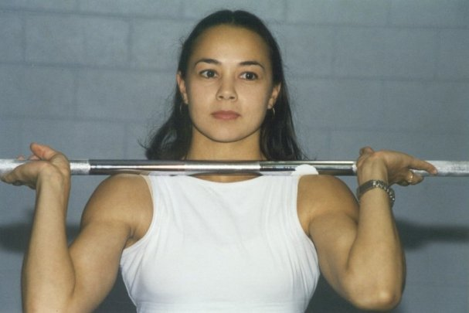  Karuna Jones. Gold medallist in the 48kg class. 57.5kg snatch, 72.5kg clean and jerk. | 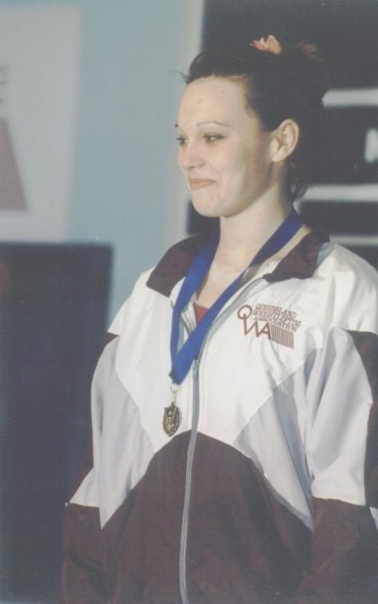  Melissa Nightingale. Gold medallist in the 69kg class. 80kg snatch, 92.5kg clean and jerk.
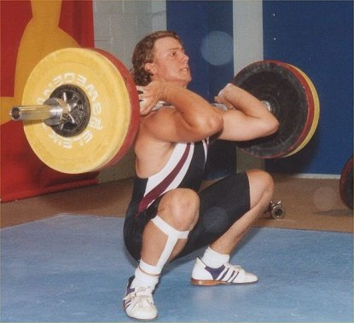
Robert Butler. U20 Gold medallist in the 94kg class. 102.5kg snatch, 125kg clean and jerk.

CONGRATULATIONS

- To Deborah Lovely, on her silver medal performance at the Commonwealth Games.
- To Amanda Phillips, on her 4th place at the Commonwealth Games.
- To Angela Wydall and Kylie Booth, on attaining their International Category 2 Referee qualifications.
- To Ben Turner, Amanda Phillips and Deborah Lovely, on being selected to represent Australia at the 2002 World Championships.
- To Bob Kennedy and Diana Loy, on breaking World Masters Records at the World Masters Games.
- To Ben Turner, Damon Kelly, John Yamasaki, David DeRose, Kristie Amadio and Deborah Lovely, on being selected to represent Australia at the 2002 Oceania Junior Championships.

NOTICES
Australian made QWA polo shirts, maroon and white, in a variety of sizes are now available from the QWA office. Price $40

Due to the hectic schedule at this time of year, the Annual QWA Awards function will be held early in 2003. More details soon.

Don't forget - The Queensland 2000 Tournament, Saturday 30th November, South Bank Piazza.

Days Gone By

In the past weightlifting included lifts which would seem weird and wacky nowadays. The following description of the “two hands to shoulder and bent press” appeared in Bob Hoffman’s 1939 book about weightlifting.

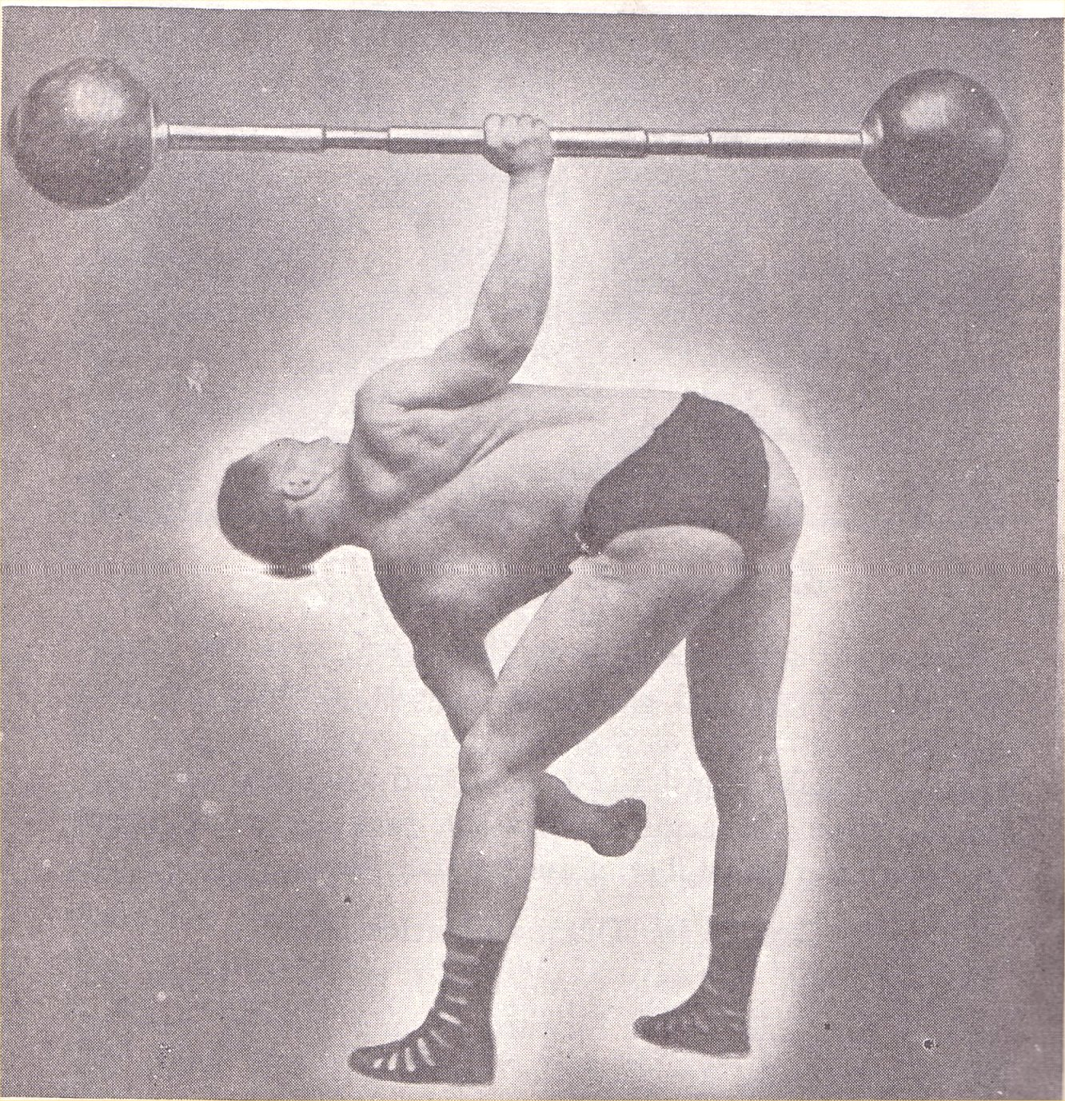
The barbell should be taken to the shoulder with two hands and without restriction as to method and, having transferred into one hand, shall be grasped in the center, be elevated to arms length by means of lateral pressure. During the press from the shoulder it shall be counted cause for disqualification should any part of the bell be brought into contact with the hip. At the conclusion of the lift the trunk shall be erect, the lifting arm and legs straight, and the heels on a line about sixteen inches apart.

World Masters Games
Melbourne Oct 9-15th

WOMEN
 |  |  | Weight | Bwt | Age | Year of |  |  |  |  | S-M-M
Name |  | Country | Class |  | Group | Birth | Sn | CJ | Total | Place | Total
Barbara | Conley | USA | 75 | 88.15 | 7 | 1935 | 30 | 40 | 70 | 1 | 123.5701
Dorothy | Gardner | USA | 63 | 61.6 | 6 | 1938 | 30 | 37.5 | 67.5 | 1 | 127.3554
Barbara | Boyer | USA | 69 | 65.35 | 5 | 1943 | 35 | 47.5 | 82.5 | 1 | 139.0732
Rhonda | Langford | USA | 58 | 56.05 | 4 | 1951 | 45 | 62.5 | 107.5 | 1 | 167.0469
Dominique | Renou | FRA | 58 | 56.75 | 4 | 1952 | 37.5 | 47.5 | 85 | 2 | 129.8412
Ludmila | Prohlova | CZE | 63 | 62.25 | 4 | 1952 | 40 | 50 | 90 | 1 | 130.5428
Magdalini | RoilidoTsits | GRE | 63 | 62.35 | 4 | 1951 | 32.5 | 40 | 72.5 | 2 | 106.0864
Jill | Milller | CAN | 69 | 64.8 | 4 | 1951 | 37.5 | 55 | 92.5 | 1 | 132.7629
Eugenia | Bekatorou | GRE | 69 | 67.65 | 4 | 1951 | 35 | 0 | 0 | - | 0
Bronwin | Carter | GBR | 75 | 73.95 | 4 | 1951 | 60 | 77.5 | 137.5 | 1 | 186.5398
Annegret | Rosengart | GER | 75 | 91.95 | 4 | 1948 | 32.5 | 45 | 77.5 | 1 | 104.1059
Tina | Ball | NZL | 48 | 47.95 | 3 | 1956 | 42.5 | 50 | 92.5 | 1 | 153.6971
Coral | Quinell | AUS | 53 | 52.35 | 3 | 1957 | 57.5 | 67.5 | 125 | 1 | 193.2265
Marga | Jorgensen | DEN | 58 | 53.1 | 3 | 1955 | 45 | 62.5 | 107.5 | 1 | 167.6424
Grace | Morrison | AUS | 63 | 60.55 | 3 | 1954 | 37.5 | 52.5 | 90 | 1 | 130.6658
Gaby | Forster | GER | 63 | 61.95 | 3 | 1957 | 37.5 | 47.5 | 85 | 2 | 118.8283
Victoria | Cabrera | ESA | 69 | 66.75 | 3 | 1956 | 47.5 | 65 | 112.5 | 1 | 153.1381
Gudrun | Schmidberg | GER | 48 | 47.75 | 2 | 1961 | 50 | 57.5 | 107.5 | 1 | 170.2739
Mary | Macken | AUS | 48 | 47.5 | 2 | 1961 | 45 | 55 | 100 | 2 | 159.0218
Aniela | Gregorek | USA | 48 | 47.45 | 2 | 1959 | 37.5 | 52.5 | 90 | 3 | 146.1058
Caroline | Charles | GBR | 53 | 52.05 | 2 | 1958 | 52.5 | 60 | 112.5 | 1 | 172.8248
Jacqueline | Simonsen | USA | 53 | 52.35 | 2 | 1961 | 45 | 57.5 | 102.5 | 2 | 152.0814
Anne | Lehman | USA | 58 | 57.3 | 2 | 1960 | 55 | 72.5 | 127.5 | 1 | 180.4037
Annette | Campbell | GBR | 63 | 61.8 | 2 | 1961 | 80 | 95 | 175 | 1 | 235.1186
Jami | Willette-Brown | USA | 63 | 59.55 | 2 | 1961 | 50 | 62.5 | 112.5 | 2 | 154.2154
Wendy | Rodgers | CAN | 69 | 63.2 | 2 | 1959 | 52.5 | 65 | 117.5 | 1 | 159.1809
Kim | Bytheway | AUS | 75 | 69.6 | 2 | 1958 | 47.5 | 57.5 | 105 | 1 | 137.5331
Sandra | Vokroj-Smith | GBR | 75 | 93.55 | 2 | 1962 | 72.5 | 90 | 162.5 | 1 | 187.4472
Veronica | Gozar-Car | USA | 48 | 47.5 | 1 | 1965 | 55 | 62.5 | 117.5 | 1 | 179.1941
Diana | Loy | AUS | 58 | 57.05 | 1 | 1965 | 60 | 70 | 130 | 1 | 175.1822
Ana | Ramirez | ESA | 58 | 55.45 | 1 | 1965 | 50 | 65 | 115 | 2 | 157.6718
Angela | Wydall | AUS | 63 | 59.05 | 1 | 1967 | 65 | 82.5 | 147.5 | 1 | 189.8696
Susan | Agrios | CAN | 63 | 60.4 | 1 | 1967 | 42.5 | 67.5 | 110 | 2 | 139.8308
Monica | Cook | AUS | 63 | 61.5 | 1 | 1964 | 47.5 | 57.5 | 105 | 3 | 137.2414
Corinne | Grotenhuis | USA | 69 | 66.7 | 1 | 1965 | 67.5 | 82.5 | 150 | 1 | 186.1473
Danielle | Waller | AUS | 75 | 87.85 | 1 | 1965 | 70 | 92.5 | 162.5 | 1 | 183.699
Olena | Tkachuk | UKR | 75 | 80.35 | 1 | 1965 | 70 | 90 | 160 | 2 | 185.0753
Christine | Chioffi | USA | 75 | 87.15 | 1 | 1967 | 47.5 | 60 | 107.5 | 3 | 118.6411

MEN

 |  |  | Weight | Bwt | Age | Year of |  |  |  |  | S-M-M
Name |  | Country | Class |  | Group | Birth | Sn | CJ | Total | Place | Total
Ferenc | Szabo | HUN | 56 | 54.7 | 10 | 1919 | 30 | 32.5 | 62.5 | 1 | 311.5515
Charlie | Henderson | AUS | 62 | 59.4 | 10 | 1922 | 57.5 | 62.5 | 120 | 1 | 471.0571
Vladimir | Younger | AUS | 62 | 60.75 | 10 | 1912 | 27.5 | 30 | 57.5 | 2 | 296.7224
Ernest (Ted) | Denne | NZL | 69 | 68.55 | 10 | 1921 | 37.5 | 42.5 | 80 | 1 | 301.7257
Rupert | Howes | AUS | 85 | 81.2 | 10 | 1922 | 50 | 60 | 110 | 1 | 350.6769
Harrison | Skeete | USA | 94 | 87.2 | 10 | 1921 | 52.5 | 70 | 122.5 | 1 | 402.0036
Chuck | Meole | USA | 94 | 88.85 | 10 | 1915 | 30 | 30 | 60 | 2 | 240.3066
Jack | Lano | USA | 105 | 102.65 | 10 | 1922 | 40 | 60 | 100 | 1 | 287.3738
Wayne | Oyafuso | USA | 56 | 54.95 | 9 | 1924 | 30 | 37.5 | 67.5 | 1 | 249.624
Eddie | Owada | USA | 62 | 58.4 | 9 | 1925 | 37.5 | 47.5 | 85 | 1 | 285.2576
Antonin | Spacil | CZE | 69 | 62.25 | 9 | 1925 | 35 | 30 | 65 | 1 | 207.5293
Morris | Bruk | RSA | 77 | 73.9 | 9 | 1926 | 45 | 55 | 100 | 1 | 275.429
Hisata | Muto | JPN | 85 | 79.45 | 9 | 1926 | 32.5 | 27.5 | 60 | 1 | 158.3969
Philip | Skarin | USA | 94 | 91.65 | 9 | 1924 | 45 | 60 | 105 | 1 | 278.737
Yutaka | Nakashima | JPN | 62 | 60.15 | 8 | 1931 | 55 | 72.5 | 127.5 | 1 | 371.727
Pedro | Serrano | PUR | 62 | 60.2 | 8 | 1931 | 57.5 | 70 | 127.5 | 2 | 371.4854
Vassili | Zoubov | RUS | 62 | 61.25 | 8 | 1931 | 50 | 70 | 120 | 3 | 344.9783
Howard | Cohen | USA | 69 | 67.1 | 8 | 1932 | 65 | 85 | 150 | 1 | 389.5052
Roy | Kerol | DEN | 69 | 65.25 | 8 | 1930 | 50 | 60 | 110 | 2 | 309.4094
Albert | Kozemov | RUS | 77 | 75.7 | 8 | 1932 | 77.5 | 85 | 162.5 | 1 | 390.4063
Donald | Buchanan | CAN | 77 | 76.3 | 8 | 1931 | 55 | 65 | 120 | 2 | 297.1984
Gwilym | Parry | GBR | 77 | 74.4 | 8 | 1931 | 45 | 60 | 105 | 3 | 264.0082
Leslie | Green | GBR | 77 | 76 | 8 | 1931 | 50 | 55 | 105 | 4 | 260.6544
George | KwanPingHo | HKG | 77 | 76.35 | 8 | 1929 | 0 | 0 | 0 | - | 0
Petro | Bazioutchenk | UKR | 85 | 80.55 | 8 | 1930 | 67.5 | 90 | 157.5 | 1 | 387.9051
Klaus | Orbergfell | GER | 85 | 83.7 | 8 | 1931 | 62.5 | 92.5 | 155 | 2 | 364.7843
Gonzalo | Gonzalez | USA | 85 | 81.25 | 8 | 1932 | 57.5 | 75 | 132.5 | 3 | 305.8227
John | McBay | AUS | 85 | 82.4 | 8 | 1930 | 57.5 | 75 | 132.5 | 4 | 322.3885
Kurt | Corfitsen | DEN | 85 | 84.25 | 8 | 1930 | 45 | 70 | 115 | 5 | 276.6139
Richard | Judd | USA | 94 | 87.7 | 8 | 1932 | 77.5 | 95 | 172.5 | 1 | 383.0327
Wallace | Underhill | USA | 94 | 89.1 | 8 | 1929 | 55 | 75 | 130 | 2 | 309.3534
George | Manly | USA | 94 | 86.25 | 8 | 1929 | 50 | 70 | 120 | 3 | 290.0083
Nixon | Munly | USA | 94 | 85.3 | 8 | 1929 | 45 | 65 | 110 | 4 | 267.2981
George | Macinko | USA | 105 | 98.9 | 8 | 1931 | 62.5 | 90 | 152.5 | 1 | 333.1873
Kurt | Rosenberger | GER | 105 | 94.25 | 8 | 1928 | 50 | 70 | 120 | 2 | 282.0596
Anton | Huber | AUT | 105 | 95.45 | 8 | 1930 | 55 | 65 | 120 | 3 | 272.627
Albinas- | Nauseda | LTU | 56 | 53.9 | 7 | 1937 | 47.5 | 60 | 107.5 | 1 | 280.4618
Tanto | Gardjito | INA | 56 | 55.8 | 7 | 1937 | 45 | 55 | 100 | 2 | 253.2523
Arne | Norrback | SWE | 62 | 60.85 | 7 | 1937 | 65 | 85 | 150 | 1 | 354.172
Precious | McKenzie | NZL | 62 | 61.25 | 7 | 1936 | 60 | 85 | 145 | 2 | 347.9292
Alexander | Diepold | GER | 62 | 61.15 | 7 | 1937 | 60 | 82.5 | 142.5 | 3 | 335.1893
Walter | Imahara | USA | 69 | 65.4 | 7 | 1937 | 82.5 | 95 | 177.5 | 1 | 397.2097
Hiroshi | Koga | JPN | 69 | 67.5 | 7 | 1937 | 72.5 | 92.5 | 165 | 2 | 361.1378
Feliks | Binkowski | POL | 69 | 68.5 | 7 | 1936 | 70 | 90 | 160 | 3 | 354.112
Horst | Nitschke | GER | 69 | 66.9 | 7 | 1937 | 52.5 | 67.5 | 120 | 4 | 264.2747
Houssam | Agha | LIB | 69 | 66.75 | 7 | 1933 | 52.5 | 57.5 | 110 | 5 | 275.2589
Emery | Chevrier | CAN | 77 | 74.95 | 7 | 1936 | 90 | 113 | 202.5 | 1 | 423.0828
Masaki | Maekawa | JPN | 77 | 75.05 | 7 | 1937 | 72.5 | 90 | 162.5 | 2 | 332.1325
Alexander | Hart | GBR | 77 | 74.75 | 7 | 1937 | 65 | 85 | 150 | 3 | 307.3265
Chris | Holt | AUS | 77 | 76.4 | 7 | 1936 | 60 | 80 | 140 | 4 | 289.1818
Herbert | Schutz | GER | 77 | 76.5 | 7 | 1937 | 52.5 | 65 | 117.5 | 5 | 237.44
Josep | Schaumann | AUT | 85 | 82.2 | 7 | 1934 | 65 | 92.5 | 157.5 | 1 | 333.0577
Bill | Despard | GBR | 85 | 83.25 | 7 | 1935 | 72.5 | 85 | 157.5 | 2 | 319.1568
Helmut | Aselmeyer | GER | 85 | 84.55 | 7 | 1936 | 60 | 70 | 130 | 3 | 254.0533
Trevor | Lovatt | NZL | 85 | 81.5 | 7 | 1934 | 55 | 72.5 | 127.5 | 4 | 270.8471
Wolfgang | Sadowski | GER | 94 | 91.7 | 7 | 1937 | 87.5 | 110 | 197.5 | 1 | 363.6704
Heinz | Kuhn | GER | 94 | 92.35 | 7 | 1937 | 75 | 103 | 177.5 | 2 | 325.8375
Johann | Ehlenz | GER | 94 | 93.95 | 7 | 1935 | 67.5 | 82.5 | 150 | 3 | 287.2143
Roger | Aner | FRA | 94 | 92.85 | 7 | 1934 | 55 | 70 | 125 | 4 | 249.3596
Gunther | Mose | GER | 105 | 95 | 7 | 1936 | 90 | 108 | 197.5 | 1 | 365.915
Mikhail | Konstantinov | RUS | 105 | 104.1 | 7 | 1936 | 80 | 90 | 170 | 2 | 304.3996
Joseph | De Luca | USA | 105 | 98.15 | 7 | 1937 | 62.5 | 80 | 142.5 | 3 | 255.159
Kurt | Schenk | SWZ | 105 | 94.5 | 7 | 1937 | 50 | 67.5 | 117.5 | 4 | 213.6009
Lev | Nikiforov | RUS | 105 | 133 | 7 | 1936 | 77.5 | 108 | 185 | 1 | 312.6606
Joachim | Mittmann | GER | 105 | 105.5 | 7 | 1936 | 75 | 108 | 182.5 | 2 | 325.3433
Oldrich | Lexa | CZE | 105 | 108.2 | 7 | 1933 | 77.5 | 100 | 177.5 | 3 | 348.6801
Barry | Reilly | AUS | 105 | 105.4 | 7 | 1937 | 62.5 | 87.5 | 150 | 4 | 261.8853
Yasuhiro | Nagaho | JPN | 56 | 55.4 | 6 | 1941 | 62.5 | 80 | 142.5 | 1 | 340.8966
Friedrich | Niedermayr | AUT | 56 | 55.55 | 6 | 1940 | 50 | 60 | 110 | 2 | 266.8181
Zul | Dalkhjav | MGL | 62 | 61 | 6 | 1942 | 57.5 | 75 | 132.5 | 1 | 288.0175
Takeshi | Sekino | JPN | 62 | 60.55 | 6 | 1939 | 55 | 65 | 120 | 2 | 275.3852
Tadashi | Mano | JPN | 69 | 67.55 | 6 | 1941 | 87.5 | 95 | 182.5 | 1 | 374.8335
Kozo | Katsuragaw | JPN | 69 | 67.75 | 6 | 1938 | 77.5 | 95 | 172.5 | 2 | 370.1496
Byamba | Tsegmed | MGL | 69 | 68 | 6 | 1941 | 67.5 | 90 | 157.5 | 3 | 322.0173
Melvyn | Barton | GBR | 69 | 68.75 | 6 | 1939 | 55 | 85 | 140 | 4 | 292.9941
Erling | Bell | DEN | 69 | 67.7 | 6 | 1941 | 62.5 | 72.5 | 135 | 5 | 276.8517
Billy | Caball | IRE | 69 | 67.25 | 6 | 1942 | 55 | 75 | 130 | 6 | 263.1182
Piotr | Kowalewski | POL | 77 | 76.4 | 6 | 1942 | 85 | 103 | 187.5 | 1 | 349.7494
Sekio | Takahasi | JPN | 77 | 75.9 | 6 | 1938 | 80 | 100 | 180 | 2 | 359.1775
Roy | Davies | AUS | 77 | 76 | 6 | 1940 | 67.5 | 90 | 157.5 | 3 | 304.8562
William (Bill) | Barton | GBR | 77 | 76.25 | 6 | 1939 | 72.5 | 85 | 157.5 | 4 | 308.7483
Evgueni | Tchernogriv | RUS | 77 | 77 | 6 | 1940 | 57.5 | 82.5 | 140 | 5 | 268.9124
Gisbert | Rybarczyk | GER | 77 | 74.65 | 6 | 1941 | 57.5 | 75 | 132.5 | 6 | 255.0851
Edgar | Zimpel | GER | 77 | 76.1 | 6 | 1939 | 0 | 0 | 0 | - | 0
Friedrich | Steiner | AUT | 85 | 82.5 | 6 | 1939 | 97.5 | 120 | 217.5 | 1 | 408.0489
Valeri | Krouchlinsk | RUS | 85 | 84.15 | 6 | 1942 | 90 | 113 | 202.5 | 2 | 358.2316
Clarry | Parsons | NZL | 85 | 83.35 | 6 | 1941 | 72.5 | 100 | 172.5 | 3 | 312.1464
Barry | Allen | AUS | 85 | 82.25 | 6 | 1940 | 65 | 90 | 155 | 4 | 287.0294
Hirosi | Saski | JPN | 85 | 81.95 | 6 | 1941 | 60 | 80 | 140 | 5 | 255.5942
Rudolf | Sauerbeck | GER | 94 | 89.8 | 6 | 1939 | 90 | 120 | 210 | 1 | 377.9221
Yasumasa | Omori | JPN | 94 | 88.25 | 6 | 1940 | 82.5 | 100 | 182.5 | 2 | 326.2847
Manfred | Werra | GER | 94 | 92.15 | 6 | 1940 | 80 | 103 | 182.5 | 3 | 319.9587
Bejlegard | Petersen | DEN | 94 | 89.7 | 6 | 1939 | 77.5 | 100 | 177.5 | 4 | 319.5968
Stanley | Wheaton | USA | 94 | 90.95 | 6 | 1938 | 65 | 85 | 150 | 5 | 272.4663
Richard | Freund | USA | 94 | 93.15 | 6 | 1942 | 62.5 | 77.5 | 140 | 6 | 236.171
Wolfgang | Kolditz | GER | 94 | 88.25 | 6 | 1940 | 57.5 | 80 | 137.5 | 7 | 245.8309
Francois | Ortiz | FRA | 105 | 94.5 | 6 | 1939 | 90 | 115 | 205 | 1 | 360.8203
Vladinir | Jaros | CZE | 105 | 101.8 | 6 | 1942 | 90 | 105 | 195 | 2 | 317.752
Johann | Schipany | AUT | 105 | 95.6 | 6 | 1938 | 67.5 | 80 | 147.5 | 3 | 262.301
Gunter | Schmolke | GER | 105 | 106.5 | 6 | 1938 | 85 | 100 | 185 | 1 | 316.4064
Peter | Phillips | AUS | 105 | 118.6 | 6 | 1942 | 70 | 90 | 160 | 2 | 249.3595
Yukuhiro | Suzuki | JPN | 56 | 55.05 | 5 | 1947 | 70 | 80 | 150 | 1 | 317.094
Karel | Prohl | CZE | 62 | 61.15 | 5 | 1947 | 82.5 | 103 | 185 | 1 | 359.0852
Isamu | Sunabe | JPN | 62 | 59.25 | 5 | 1947 | 80 | 85 | 165 | 2 | 328.2717
Jan | Helebrant | CZE | 62 | 61.95 | 5 | 1946 | 70 | 85 | 155 | 3 | 305.384
Michael | Mahoney | USA | 62 | 59.9 | 5 | 1946 | 62.5 | 75 | 137.5 | 4 | 278.0403
Jan-Ove | Henriksson | SWE | 62 | 61.5 | 5 | 1945 | 60 | 70 | 130 | 5 | 263.6961
Siyanyambuu | Dorjkhand | MGL | 62 | 61.9 | 5 | 1946 | 70 | 0 | 0 | - | 0
Bob | Kennedy | AUS | 69 | 68.8 | 5 | 1946 | 80 | 108 | 187.5 | 1 | 342.6891
Nikolai | Koudlai | RUS | 69 | 68.45 | 5 | 1944 | 75 | 97.5 | 172.5 | 2 | 331.22
Tokuya | Adachi | JPN | 69 | 67.05 | 5 | 1947 | 75 | 95 | 170 | 3 | 308.4591
Maxwell | Bristow | AUS | 69 | 66.8 | 5 | 1944 | 70 | 90 | 160 | 4 | 312.4152
Ken | Miller | CAN | 69 | 68.3 | 5 | 1947 | 70 | 87.5 | 157.5 | 5 | 282.1757
Mikhail | Mertzanidis | GRE | 69 | 68.7 | 5 | 1945 | 67.5 | 82.5 | 150 | 6 | 280.9634
Zbigniew | Makowski | POL | 77 | 75.55 | 5 | 1947 | 90 | 110 | 200 | 1 | 335.9765
Romas | Matazinska | LTU | 77 | 69.7 | 5 | 1944 | 85 | 113 | 197.5 | 2 | 374.6518
Siegfried | Rosengart | GER | 77 | 76.25 | 5 | 1944 | 85 | 108 | 192.5 | 3 | 345.1978
Akihiko | Takeshita | JPN | 77 | 70.85 | 5 | 1943 | 80 | 95 | 175 | 4 | 335.4512
Josef | Nosicky | CZE | 77 | 76.35 | 5 | 1947 | 75 | 100 | 175 | 5 | 292.1497
Horace | Moseley | GBR | 77 | 76.2 | 5 | 1944 | 75 | 95 | 170 | 6 | 304.968
Arne | Hovlid | SWE | 77 | 76.3 | 5 | 1947 | 75 | 95 | 170 | 7 | 283.912
Bob | Henderson | AUS | 77 | 76.4 | 5 | 1943 | 70 | 85 | 155 | 8 | 283.5697
Kenji | Watanabe | JPN | 77 | 74.6 | 5 | 1946 | 0 | 0 | 0 | - | 0
Gerhard | Sturm | GER | 85 | 84.4 | 5 | 1947 | 82.5 | 115 | 197.5 | 1 | 312.1017
George | Capsis | AUS | 85 | 84.35 | 5 | 1947 | 82.5 | 113 | 195 | 2 | 308.2436
Tom | Constantini | AUS | 85 | 83.6 | 5 | 1947 | 77.5 | 100 | 177.5 | 3 | 281.8638
Francois | Bigot | FRA | 85 | 77.55 | 5 | 1947 | 80 | 95 | 175 | 4 | 289.5097
Ray | Louden | AUS | 85 | 83.4 | 5 | 1945 | 70 | 87.5 | 157.5 | 5 | 262.8414
Milos | Trnka | AUS | 85 | 82.9 | 5 | 1943 | 65 | 90 | 155 | 6 | 271.0141
Laurence | McConnell | IRE | 94 | 94 | 5 | 1945 | 110 | 140 | 250 | 1 | 394.5044
Walter | Schuessler | GER | 94 | 93.35 | 5 | 1943 | 90 | 123 | 212.5 | 2 | 351.264
Richard | Herrick | USA | 94 | 93.35 | 5 | 1945 | 62.5 | 80 | 142.5 | 3 | 225.5265
Stefan | Jakobsson | SWE | 105 | 94.75 | 5 | 1947 | 118 | 145 | 262.5 | 1 | 393.3421
Pierre | Le Bailly | FRA | 105 | 94.35 | 5 | 1944 | 80 | 105 | 185 | 2 | 298.0633
Robert | Chandler | USA | 105 | 107.35 | 5 | 1945 | 97.5 | 125 | 222.5 | 1 | 334.5059
Johann | Lichtenwort | AUT | 105 | 129.95 | 5 | 1947 | 95 | 118 | 212.5 | 2 | 291.1273
Hiroshi | Sako | JPN | 56 | 55.75 | 4 | 1951 | 70 | 85 | 155 | 1 | 301.3522
Roger | Crabtree | AUS | 56 | 54.55 | 4 | 1949 | 60 | 85 | 145 | 2 | 295.8917
Hidetoshi | Ichikawa | JPN | 56 | 55.6 | 4 | 1949 | 65 | 80 | 145 | 3 | 291.1087
Kohei | Fujiwara | JPN | 62 | 61.45 | 4 | 1951 | 80 | 100 | 180 | 1 | 323.5766
John | Cramer | USA | 62 | 61.15 | 4 | 1952 | 65 | 85 | 150 | 2 | 268.0738
Patrick | Atteridge | GBR | 69 | 68.45 | 4 | 1952 | 82.5 | 110 | 192.5 | 1 | 317.0742
Jiri | Mandat | CZE | 69 | 66.95 | 4 | 1952 | 85 | 105 | 190 | 2 | 317.7533
Jurgen | Wunderlich | GER | 69 | 67.8 | 4 | 1951 | 87.5 | 100 | 187.5 | 3 | 313.8539
Kunio | Murakami | JPN | 69 | 67.35 | 4 | 1949 | 85 | 100 | 185 | 4 | 320.5106
Anton | Kittenberge | AUT | 69 | 68.05 | 4 | 1949 | 82.5 | 97.5 | 180 | 5 | 309.6425
Takato | Takakura | JPN | 69 | 68.4 | 4 | 1949 | 80 | 100 | 180 | 6 | 308.5639
Jean Claude | Corezet | FRA | 69 | 68.55 | 4 | 1949 | 75 | 100 | 175 | 7 | 299.548
Masao | Otaka | JPN | 69 | 66.65 | 4 | 1949 | 72.5 | 80 | 152.5 | 8 | 266.13
Jiri | Brodsky | CZE | 69 | 65.55 | 4 | 1950 | 65 | 85 | 150 | 9 | 260.3544
Sharav | Enhsaikhan | MGL | 69 | 68.9 | 4 | 1948 | 0 | 0 | 0 | - | 0
Guennadi | Mourachov | RUS | 77 | 76.65 | 4 | 1950 | 103 | 123 | 225 | 1 | 352.8273
Jurgen | Greiner | GER | 77 | 71.75 | 4 | 1951 | 100 | 123 | 222.5 | 2 | 358.7332
Takashi | Okada | JPN | 77 | 74.5 | 4 | 1948 | 95 | 115 | 210 | 3 | 347.5945
Reinhard | Kossmann | GER | 77 | 76.4 | 4 | 1948 | 90 | 118 | 207.5 | 4 | 338.3213
Noel | Matis | AUS | 77 | 75.6 | 4 | 1950 | 72.5 | 113 | 185 | 5 | 292.4765
Anatoly | Belkov | RUS | 85 | 84.6 | 4 | 1951 | 105 | 125 | 230 | 1 | 337.4791
Konstadinos | Dudulakis | GRE | 85 | 84.15 | 4 | 1951 | 87.5 | 113 | 200 | 2 | 294.2546
Inge | Falth | SWE | 85 | 84.25 | 4 | 1948 | 85 | 110 | 195 | 3 | 301.3468
Franz | Fischer | AUT | 85 | 84.2 | 4 | 1949 | 70 | 85 | 155 | 4 | 234.8814
Chris | Dariotis | USA | 94 | 90 | 4 | 1949 | 110 | 138 | 247.5 | 1 | 363.2133
Gerd | Kleinschmi | GER | 94 | 92.15 | 4 | 1952 | 110 | 130 | 240 | 2 | 335.0507
Preben | Krebs | DEN | 94 | 93.4 | 4 | 1951 | 95 | 130 | 225 | 3 | 315.312
Jean-Paul | Belmas | FRA | 94 | 93.15 | 4 | 1949 | 90 | 125 | 215 | 4 | 310.7751
Yuichi | Yabuta | JPN | 94 | 85.9 | 4 | 1949 | 90 | 115 | 205 | 5 | 307.557
Iain | Douglas | CAN | 94 | 93.8 | 4 | 1949 | 85 | 100 | 185 | 6 | 266.6248
Willis | Garland | USA | 105 | 100.9 | 4 | 1952 | 120 | 130 | 250 | 1 | 336.6313
Yoshiaki | Shimosaka | JPN | 105 | 102.9 | 4 | 1949 | 100 | 120 | 220 | 2 | 306.023
Serguei | Lazarev | RUS | 105 | 105.65 | 4 | 1949 | 110 | 150 | 260 | 1 | 358.4878
Jerzy | Gregorek | USA | 62 | 61.65 | 3 | 1954 | 85 | 100 | 185 | 1 | 324.0744
Alain | Belli | FRA | 62 | 61.55 | 3 | 1957 | 75 | 97.5 | 172.5 | 2 | 294.902
Eiji | Murai | JPN | 62 | 61.5 | 3 | 1953 | 72.5 | 95 | 167.5 | 3 | 295.8834
Makoto | Ohtsuka | JPN | 62 | 57.8 | 3 | 1957 | 80 | 85 | 165 | 4 | 296.4372
Walter | Kretz | GER | 62 | 61.55 | 3 | 1954 | 65 | 85 | 150 | 5 | 263.0889
Andrew | Seaber | GBR | 69 | 67.6 | 3 | 1956 | 100 | 115 | 215 | 1 | 346.8239
Harald | Herberg | GER | 69 | 68.5 | 3 | 1954 | 97.5 | 115 | 212.5 | 2 | 345.0592
Jorg | Rast | GER | 69 | 68.35 | 3 | 1954 | 77.5 | 100 | 177.5 | 3 | 288.6545
Burkhard | Duderstadt | GER | 69 | 68.95 | 3 | 1955 | 67.5 | 90 | 157.5 | 4 | 252.754
Jean | Curatolo | FRA | 77 | 76.8 | 3 | 1956 | 92.5 | 120 | 212.5 | 1 | 316.0852
Klaus | Foster | GER | 77 | 76.95 | 3 | 1955 | 95 | 118 | 212.5 | 2 | 318.3417
Ralf | Muller | GER | 77 | 75.1 | 3 | 1957 | 90 | 120 | 210 | 3 | 313.3919
Claes | Inge | SWE | 77 | 76.2 | 3 | 1953 | 95 | 113 | 207.5 | 4 | 317.008
Michael | Harada | USA | 85 | 83.3 | 3 | 1957 | 105 | 130 | 235 | 1 | 330.9394
Joe | Delago | USA | 85 | 84.8 | 3 | 1953 | 105 | 130 | 235 | 2 | 338.6426
Haruhiko | Osawa | JPN | 85 | 83.45 | 3 | 1953 | 100 | 115 | 215 | 3 | 312.3652
Robert | Mitchell | AUS | 85 | 84.45 | 3 | 1955 | 85 | 120 | 205 | 4 | 291.9506
Hekmat | Areya | LIB | 85 | 83.85 | 3 | 1955 | 92.5 | 108 | 200 | 5 | 285.8658
Richard | Odor | USA | 85 | 83.85 | 3 | 1954 | 80 | 115 | 195 | 6 | 280.7803
Ralf | Scott | SWE | 94 | 91.75 | 3 | 1957 | 120 | 140 | 260 | 1 | 349.6189
Eleftherios | Tzougaraki | GRE | 94 | 89 | 3 | 1957 | 105 | 135 | 240 | 2 | 327.1855
Noboru | Ueda | JPN | 94 | 87.6 | 3 | 1956 | 100 | 125 | 225 | 3 | 312.1336
John | Collins | GBR | 94 | 91.8 | 3 | 1956 | 95 | 115 | 210 | 4 | 285.152
Peter | Erkelenz | GER | 94 | 85.1 | 3 | 1953 | 92.5 | 110 | 202.5 | 5 | 291.2928
Katuhiro | Okawa | JPN | 105 | 103.6 | 3 | 1955 | 130 | 160 | 290 | 1 | 378.8029
Rolf | Prim | SWE | 105 | 104.1 | 3 | 1954 | 130 | 140 | 270 | 2 | 354.7096
Gerhard | Moerth | AUT | 105 | 99.1 | 3 | 1957 | 118 | 140 | 257.5 | 3 | 335.5592
Johann | Lindwig | GER | 105 | 100.8 | 3 | 1956 | 105 | 145 | 250 | 4 | 326.9989
Gary | Langford | AUS | 105 | 104.3 | 3 | 1953 | 110 | 140 | 250 | 5 | 330.3655
Gerhard | Jeckel | AUT | 105 | 124.75 | 3 | 1954 | 128 | 153 | 280 | 1 | 350.8173
Nikolay | Shanin | RUS | 105 | 113.6 | 3 | 1956 | 125 | 143 | 267.5 | 2 | 337.0291
Dennis | Kinght | USA | 105 | 111.8 | 3 | 1957 | 110 | 145 | 255 | 3 | 319.4658
Peter | Del Santo | USA | 105 | 119.7 | 3 | 1953 | 105 | 143 | 247.5 | 4 | 314.7766
Jan | Hinrichsen | SWE | 105 | 135.45 | 3 | 1953 | 103 | 120 | 222.5 | 5 | 274.565
Andreas | Wagner | GER | 56 | 55.95 | 2 | 1962 | 82.5 | 110 | 192.5 | 1 | 337.7508
Yourik | Sarkisian | AUS | 62 | 61.35 | 2 | 1961 | 115 | 145 | 260 | 1 | 427.7002
Hayk | Kasyan | GER | 62 | 60.95 | 2 | 1961 | 75 | 97.5 | 172.5 | 2 | 285.1945
Andreas | Letz | GER | 69 | 63.25 | 2 | 1962 | 108 | 133 | 240 | 1 | 382.1205
Hiromi | Degawa | JPN | 69 | 67.35 | 2 | 1959 | 100 | 115 | 215 | 2 | 337.0517
Andreas | Kusterer | GER | 69 | 68 | 2 | 1961 | 90 | 110 | 200 | 3 | 305.352
Paul | McBride | AUS | 69 | 67.1 | 2 | 1958 | 82.5 | 103 | 185 | 4 | 293.9996
Alehander | Sorokin | RUS | 77 | 75.5 | 2 | 1962 | 105 | 140 | 245 | 1 | 346.4666
Sigeyuki | Simizu | JPN | 77 | 74.75 | 2 | 1961 | 100 | 115 | 215 | 2 | 308.8356
Vladyslav | Lysenko | UKR | 85 | 80.65 | 2 | 1962 | 113 | 135 | 247.5 | 1 | 337.067
Thorsten | Teichert | GER | 85 | 77.4 | 2 | 1962 | 105 | 133 | 237.5 | 2 | 330.9924
Christophe | Gay | FRA | 85 | 84 | 2 | 1962 | 113 | 125 | 237.5 | 3 | 316.5823
Dominique | Canivet | FRA | 85 | 81.3 | 2 | 1959 | 95 | 125 | 220 | 4 | 307.2465
Greg | Hobl | AUS | 85 | 79.85 | 2 | 1960 | 95 | 123 | 217.5 | 5 | 303.6005
Daniel | Pare | CAN | 85 | 81.85 | 2 | 1961 | 90 | 118 | 207.5 | 6 | 283.0707
Vassli | Zakharevitc | RUS | 94 | 88.2 | 2 | 1959 | 125 | 150 | 275 | 1 | 368.6085
Derrick | Crass | USA | 94 | 90.45 | 2 | 1960 | 110 | 140 | 250 | 2 | 327.8361
Serge | Chretien | CAN | 94 | 92.65 | 2 | 1959 | 105 | 135 | 240 | 3 | 314.6357
Leslie | Simonton | USA | 94 | 90.45 | 2 | 1958 | 95 | 125 | 220 | 4 | 294.7241
Frantz | Felicite | FRA | 94 | 93.65 | 2 | 1960 | 0 | 0 | 0 | - | 0
Johann | Leisser | AUT | 105 | 104.1 | 2 | 1958 | 128 | 160 | 287.5 | 1 | 364.4528
Serguei | Lopatine | RUS | 105 | 100.25 | 2 | 1961 | 128 | 158 | 285 | 2 | 354.9545
John | Donahue | USA | 105 | 102 | 2 | 1961 | 113 | 155 | 267.5 | 3 | 331.0935
Gavin | Taylor | NZL | 105 | 95.45 | 2 | 1960 | 118 | 135 | 252.5 | 4 | 323.5702
Leif | Soderlind | SWE | 105 | 103.95 | 2 | 1961 | 105 | 130 | 235 | 5 | 288.9752
Mikhail | Besperstov | RUS | 105 | 104.85 | 2 | 1959 | 100 | 125 | 225 | 6 | 281.4165
Andreas | Giesbrecht | GER | 105 | 104.85 | 2 | 1961 | 125 | 0 | 0 | - | 0
Ali | Choukeir | LIB | 105 | 135.55 | 2 | 1961 | 130 | 160 | 290 | 1 | 332.63
David | Venables | GBR | 105 | 119.25 | 2 | 1961 | 120 | 150 | 270 | 2 | 319.4513
Damien | Hewish | AUS | 56 | 55.45 | 1 | 1964 | 85 | 100 | 185 | 1 | 320.4429
Pascal | Arnou | FRA | 62 | 61.5 | 1 | 1966 | 90 | 110 | 200 | 1 | 311.2075
Hans | Werneburg | GER | 69 | 67.7 | 1 | 1965 | 85 | 120 | 205 | 1 | 301.0708
Kazem | Panjavi | GBR | 77 | 75.45 | 1 | 1966 | 125 | 160 | 285 | 1 | 385.801
Ralf | Klingschat | GER | 77 | 76.75 | 1 | 1966 | 108 | 125 | 232.5 | 2 | 311.57
Russ | Ward | GBR | 77 | 75.85 | 1 | 1966 | 100 | 125 | 225 | 3 | 303.6215
Anthony | Dove | AUS | 77 | 76.25 | 1 | 1967 | 97.5 | 118 | 215 | 4 | 285.2346
Erik | Sallwey | GER | 77 | 75.5 | 1 | 1966 | 97.5 | 115 | 212.5 | 5 | 287.5447
Dietmar | Kelemen | GER | 77 | 72.85 | 1 | 1964 | 82.5 | 100 | 182.5 | 6 | 258.4484
Christophe | Harand | FRA | 85 | 82.55 | 1 | 1966 | 128 | 150 | 277.5 | 1 | 357.1512
Alehei | Kourbanov | RUS | 85 | 84.2 | 1 | 1964 | 133 | 145 | 277.5 | 2 | 361.9732
Mario | Alas | ESA | 85 | 83 | 1 | 1964 | 108 | 143 | 250 | 3 | 328.5194
Andreas | Schreck | GER | 85 | 83.45 | 1 | 1967 | 110 | 140 | 250 | 4 | 315.5323
Josef | Kvapil | CZE | 85 | 83.55 | 1 | 1966 | 105 | 138 | 242.5 | 5 | 310.1574
Harvey | Goodman | AUS | 94 | 91.95 | 1 | 1967 | 143 | 178 | 320 | 1 | 385.642
Yuriy | Karpynsky | UKR | 94 | 93.1 | 1 | 1963 | 130 | 160 | 290 | 2 | 364.8037
Roman | Schinhan | AUT | 94 | 91.75 | 1 | 1964 | 115 | 145 | 260 | 3 | 325.6283
Darren | Holloway | GBR | 94 | 91.05 | 1 | 1966 | 105 | 133 | 237.5 | 4 | 291.485
Christos | Genatos | GRE | 94 | 93.55 | 1 | 1966 | 100 | 135 | 235 | 5 | 285.047
Apostolos | Votsis | GRE | 94 | 91.15 | 1 | 1966 | 92.5 | 0 | 0 | - | 0
Igor | Medvedev | RUS | 105 | 104.6 | 1 | 1964 | 138 | 175 | 312.5 | 1 | 372.1083
Peter | May | GBR | 105 | 96.15 | 1 | 1966 | 145 | 165 | 310 | 2 | 371.8001
Dmitri | Kozemov | RUS | 105 | 101.7 | 1 | 1964 | 123 | 168 | 290 | 3 | 348.6654
Chris | Duthie | AUS | 105 | 104.35 | 1 | 1967 | 125 | 165 | 290 | 4 | 332.8609
Zdenek | Mrozek | CZE | 105 | 99.35 | 1 | 1965 | 120 | 148 | 267.5 | 5 | 320.5755
Gary | Broomfield | NZL | 105 | 101.8 | 1 | 1966 | 105 | 145 | 250 | 6 | 293.4499
Hasanen | Al-Sheek | SYR | 105 | 107.6 | 1 | 1965 | 150 | 185 | 335 | 1 | 390.6866
Evgeny | Sypko | RUS | 105 | 119 | 1 | 1964 | 153 | 180 | 332.5 | 2 | 381.9179
George | Ikosidekas | AUS | 105 | 133.5 | 1 | 1963 | 148 | 178 | 325 | 3 | 369.6083
Vadym | Motyryev | UKR | 105 | 116.4 | 1 | 1965 | 135 | 168 | 302.5 | 4 | 345.1932
Julio | Melo | CHI | 105 | 117.7 | 1 | 1963 | 110 | 150 | 260 | 5 | 302.6298
Peter | Foster | AUS | 105 | 107.05 | 1 | 1967 | 108 | 130 | 237.5 | 6 | 270.3592

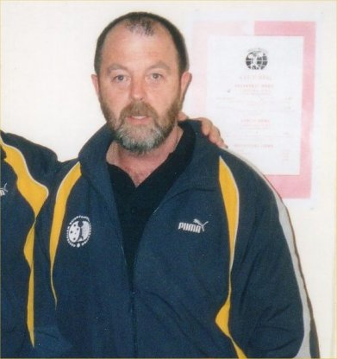  Lawrie Towsend, AWF Masters coordinator, at the World Masters Games Weightlifting Championships. | 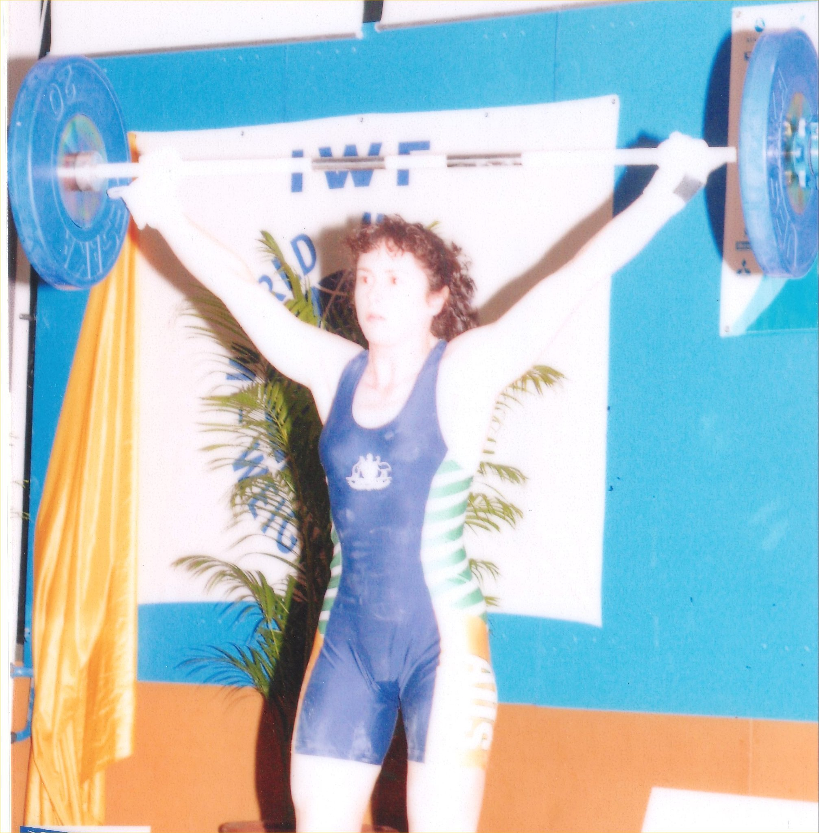  Angela Wydall – Gold in 63kg class and best female lifter in age group 1 with 65kg snatch, 82.5 clean and jerk.
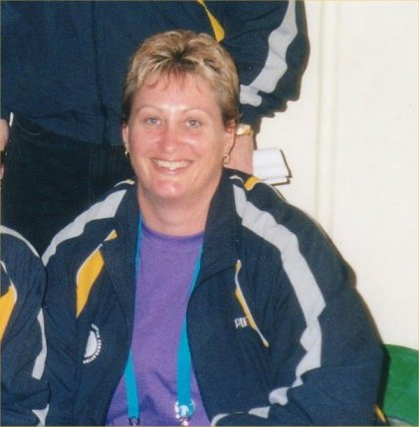  Deb Keelan put in a tremendous amount of work officating at the games and coaching the Australian athletes. | 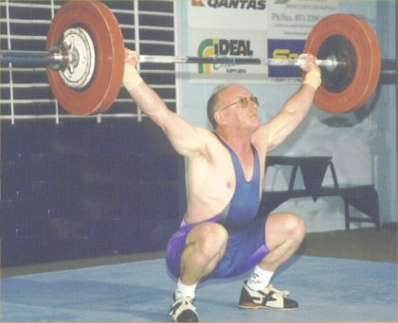  Bob Kennedy won gold in the 69kg division, age group 10 with a 6 out of 6 performance. 80kg snatch, 107.5kg clean and jerk.

QWA League Final
Cougars Weightlifting Club, Chandler Qld
26th October 2002

Name Born Club Bwt Snatch C & J Total Bonus Points
Division 1
Deborah Lovely 83 Cougars 78.10 90.0 110.0 200.0 21 87.667
Damon Kelly 83 Cougars 141.80 145.0 195.0 340.0 15 86.958
Melissa Nightingale 81 Cougars 65.30 77.5 95.0 172.5 11 76.714
Kristie Amadio 85 Cougars 60.95 67.5 87.5 155.0 12 75.918
David DeRose 82 Cougars 68.85 102.5 127.5 230.0 -11 53.336

Division 2
John Yamasaki 84 Cougars 61.85 87.5 107.5 195.0 10 70.000
Troy Hewkins 86 Windaroo 60.95 77.5 102.5 180.0 10 65.385
Peter Foster 67 Cougars 108.25 110.0 135.0 245.0 2 53.852

Division 3
Erika Yamasaki 87 Cougars 48.35 55.0 67.5 122.5 21 75.444
Andrew Kruger 76 Cougars 108.90 95.0 142.5 237.5 11 61.265
George Mylne 85 Toowoomba 67.60 80.0 110.0 190.0 6 59.147
Meg Soroka 86 Cougars 60.00 45.0 65.0 110.0 10 55.361
Bowen Stuart 86 Sunshine Coast 73.70 80.0 107.5 187.5 -8 41.669

Division 4
Greg Botha 86 Windaroo 67.10 72.5 97.5 170.0 21 68.552
Tammie Bower 87 Cougars 56.30 52.5 62.5 115.0 17 65.421
Liana Lambert 88 Cougars 56.90 47.5 60.0 107.5 15 60.263
Adon McCallum 88 Cougars 68.05 77.5 95.0 172.5 11 59.252
Emily Jones 82 Cougars 47.20 40.0 57.5 97.5 0 48.750

2002 Queensland All Schools Championships
Toowoomba Weightlifting Association, Toowoomba Qld
2nd November 2002

WOMEN

Name Born School Bwt Snatch C&J Total Sinclair Place
U16 Open
40kg Category
Jessica Keelan 91 St Luke's 33.10 20.0 25.0 45.0 86.766 1 1
48kg Category
Melinda Janke 87 Toowoomba 46.40 40.0 57.5 97.5 137.622 1 1
53kg Category
Erika Yamasaki 87 Mt Gravatt 48.50 55.0 70.0 125.0 170.628 1 1
Sherry Bower 86 Capalaba 53.00 50.0 60.0 110.0 141.129 2 2
58kg Category
Tammie Bower 87 Capalaba 56.50 47.5 62.5 110.0 135.541 1 1
Liana Lambert 88 Wynnum 56.90 45.0 55.0 100.0 122.698 2 2
Tiarna Crevola 86 Toowoomba 53.30 20.0 27.5 47.5 60.716 3 3
63kg Category
Kristie Amadio 85 Moreton Bay 60.20 70.5 82.5 152.5 181.165 1
Christina Watkins 88 Gympie 61.40 --- 65.0 --- 0.000 - -
69kg Category
Holly Collyer 88 Nambour 67.20 --- Withdrew --- 0.000 - -
75kg Category
Rhiannan Patching 89 Windaroo 74.60 32.5 32.5 65.0 70.041 1 1
75+kg Category
Meghan Blunderfield 86 Harristown 114.00 47.5 60.0 107.5 107.500 1 1

MEN

Name Born School Bwt Snatch C&J Total Sinclair Place
U16 Open
47kg Category
Darryl Hockins 88 Haristown 45.20 27.5 30.0 57.5 108.274 1 1
51kg Category
Kurt Woodlock 88 Toowoomba 48.80 35.0 50.0 85.0 148.425 1 1
56kg Category
Josh Brady 88 Iona College 54.20 42.5 57.5 100.0 158.703 1 1
Adam McLean 87 Windaroo 55.20 40.0 55.0 95.0 148.415 2 2
Scott Alcorn 86 Toowoomba 55.50 40.0 55.0 95.0 147.732 3 3
Craig Nolan 87 Windaroo 54.50 35.0 57.5 92.5 146.100 4 4
Tom McCosker 88 Burnside 54.70 40.0 50.0 90.0 141.704 5 5
62kg Category
Troy Hewkins 86 Windaroo 60.90 80.5 100.0 180.0 259.619 1 1
Anthony Salsone 87 Iona College 60.50 75.0 95.0 170.0 246.452 2 2
Kyle Woodlock 85 Toowoomba 58.30 70.0 95.0 165.0 246.336 3
Chris Davis 85 St Laurence's 61.20 55.0 70.0 125.0 179.609 4
Brendan Kennedy 85 St Laurence's 61.80 55.0 70.0 125.0 178.274 5
Matthew Edgley 86 ACGS 59.60 50.0 70.0 120.0 176.023 3 6
Luke Mainas 85 St Laurence's 60.30 --- 70.0 --- 0.000 - -
69kg Category
George Mylne 85 Toowoomba 68.70 77.5 107.5 185.0 244.546 1
Adon McCallum 88 Iona College 67.30 80.0 95.0 175.0 234.603 1 2
Chris Power 85 St Laurence's 67.40 72.5 100.0 172.5 231.014 3
Greg Botha 86 Windaroo 66.80 67.5 92.5 160.0 215.607 2 4
Michael Corkran (G) 85 St Laurence's 63.10 55.0 67.5 122.5 171.994 - -
Nicholas Conias 85 ACGS 68.40 50.0 70.0 120.0 159.095 5
David Dyer 88 ACGS 67.00 47.5 55.0 102.5 137.836 3 6
Dimitri Conias 86 ACGS 66.60 40.0 50.0 90.0 121.534 4 7
Ryan McDowell 88 Toowoomba 63.60 32.5 40.0 72.5 101.199 5 8
77kg Category
Bowen Stuart 86 Siena College 72.80 85.0 115.0 200.0 254.585 1 1
Peter Hegarty 85 St Laurence's 78.80 70.0 90.0 160.0 194.294 2
Brett Wheldon 86 ACGS 72.30 60.0 80.0 140.0 178.985 2 3
Ryan Stephens 86 St Laurence's 72.40 62.5 77.5 140.0 178.829 3 4
Christian Villalobos 85 ACGS 72.10 55.0 70.0 125.0 160.089 5
Steven Davies 88 St James 77.00 50.0 60.0 110.0 135.354 4 6
85kg Category
Robert Bird 85 ACGS 82.00 70.0 92.5 162.5 193.083 1
Luke Gardner 88 Alex Hills 83.10 67.5 82.5 150.0 176.989 1 2
Jon Meiers 87 Windaroo 84.80 62.5 82.5 145.0 169.327 2 3
John Mangifesta 86 St Laurence's 81.50 57.5 80.0 137.5 163.911 3 4
Andrew Harald 85 ACGS 83.90 60.0 75.0 135.0 158.505 5
Matthew Wright 85 St Laurence's 82.70 50.0 75.0 125.0 147.862 6
94kg Category
Matthew Bennett 85 St Laurence's 88.50 60.0 85.0 145.0 165.853 1
Nathan Tessman 85 St Laurence's 92.40 60.0 75.0 135.0 151.444 2
Kelvin Rushworth 86 ACGS 92.40 57.5 75.0 132.5 148.639 1 3
James Hatzis 88 St Laurence's 93.50 50.0 55.0 105.0 117.194 2 4
105+kg
Brett Cherry 86 Toowoomba 110.90 47.5 55.0 102.5 107.703 1 1

Best Lifter Awards
 | Under 16 | Open
Male | Troy Hewkins | Troy Hewkins
Female | Erika Yamasaki | Kristie Amadio

Team Championship

Women | Points | Men | Points
Capalaba State High School | 53 | Toowoomba State High School | 130
Toowoomba State High School | 51 | Windaroo Valley State High School | 120
St Luke’s Catholic School | 28 | St Laurence’s College - A | 117
Mt Gravatt State High School | 28 | Anglican Church Grammar School - A | 116
Moreton Bay College | 28 | St Laurence’s College - B | 88
Windaroo Valley State High School | 28 | Anglican Church Grammar School - B | 80
Wynnum State High School | 25 | Iona College | 78
 |  | Sienna College | 28
 |  | Harristown State High School | 28
 |  | Alexandra Hills State High School | 25
 |  | Burnside State High School | 21

Queensland Records
As at 10 Nov 2002

Open Female 48Kg
Snatch | Karuna Jones | 57.5 | 16/03/2002 | Melbourne
Clean and Jerk | Karuna Jones | 72.5 | 20/09/2002 | Adelaide
Total | Karuna Jones | 130.0 | 20/09/2002 | Adelaide
Open Female 53Kg
Snatch | Justine Hartwig | 65.0 | 6/05/2000 | Sunshine Coast Weightlifting Club
Clean and Jerk | Justine Hartwig | 87.5 | 6/05/2000 | Sunshine Coast Weightlifting Club
Total | Justine Hartwig | 152.5 | 6/05/2000 | Sunshine Coast Weightlifting Club
Open Female 58Kg
Snatch | Angela Wydall | 72.5 | 11/07/1998 | Toowoomba Qld
Clean and Jerk | Angela Wydall | 85.0 | 21/02/1998 | Toowoomba, Qld
Total | Angela Wydall | 157.5 | 11/07/1998 | Toowoomba Qld
Open Female 63Kg
Snatch | Amanda Phillips | 82.5 | 15/09/2000 | Sydney
Clean and Jerk | Amanda Phillips | 107.5 | 15/09/2000 | Sydney
Total | Amanda Phillips | 190.0 | 15/09/2000 | Sydney
Open Female 69Kg
Snatch | Amanda Phillips | 83.0 | 11/08/2001 | Homebush
Clean and Jerk | Amanda Phillips | 107.5 | 11/08/2001 | Homebush
Total | Amanda Phillips | 190.0 | 11/08/2001 | Homebush
Open Female 75Kg
Snatch | Deborah Lovely | 95.0 | 3/08/2002 | Manchester
Clean and Jerk | Amanda Phillips | 110.0 | 24/11/2001 | Chandler
Total | Deborah Lovely | 202.5 | 3/08/2002 | Manchester
Open Female 75+Kg
Snatch | Melissa Bethune | 95.0 | 12/05/2000 | Nauru
Clean and Jerk | Melissa Bethune | 117.5 | 29/01/2000 | Nauru
Total | Melissa Bethune | 212.5 | 12/05/2000 | Nauru
U20 Female 48Kg
Snatch | Erika Yamasaki | 55.0 | 11/10/2002 | Chandler
Clean and Jerk | Erika Yamasaki | 67.5 | 20/09/2002 | Adelaide
Total | Erika Yamasaki | 120.0 | 11/10/2002 | Chandler
U20 Female 53Kg
Snatch | Qld Record Standard | 57.5 | - | -
Clean and Jerk | Erika Yamasaki | 70.0 | 2/11/2002 | Toowoomba
Total | Qld Record Standard | 125.0 | - | -
U20 Female 58Kg
Snatch | Kristie Amadio | 70.0 | 12/04/2002 | Chandler
Clean and Jerk | Kristie Amadio | 83.0 | 16/06/2001 | Toowoomba
Total | Kristie Amadio | 152.5 | 12/04/2002 | Chandler
U20 Female 63Kg
Snatch | Amanda Phillips | 82.5 | 15/09/2000 | Sydney
Clean and Jerk | Amanda Phillips | 107.5 | 15/09/2000 | Sydney
Total | Amanda Phillips | 190.0 | 15/09/2000 | Sydney
U20 Female 69Kg
Snatch | Amanda Phillips | 83.0 | 11/08/2001 | Homebush
Clean and Jerk | Amanda Phillips | 107.5 | 11/08/2001 | Homebush
Total | Amanda Phillips | 190.0 | 11/08/2001 | Homebush
U20 Female 75Kg
Snatch | Deborah Lovely | 95.0 | 3/08/2002 | Manchester
Clean and Jerk | Amanda Phillips | 110.0 | 24/11/2001 | Chandler
Total | Deborah Lovely | 202.5 | 3/08/2002 | Manchester
U20 Female 75+Kg
Snatch | Melissa Bethune | 92.5 | 4/12/1999 | Chandler
Clean and Jerk | Melissa Bethune | 115.0 | 16/10/1999 | Chandler Brisbane
Total | Melissa Bethune | 205.0 | 20/11/1999 | Chandler
U18 Female 40Kg
Snatch | Qld Record Standard | 32.5 | - | -
Clean and Jerk | Qld Record Standard | 40.0 | - | -
Total | Qld Record Standard | 72.5 | - | -
U18 Female 44Kg
Snatch | Erika Yamasaki | 42.5 | 15/12/2001 | Chandler
Clean and Jerk | Erika Yamasaki | 53.5 | 15/12/2001 | Chandler
Total | Erika Yamasaki | 95.0 | 15/12/2001 | Chandler
U18 Female 48Kg
Snatch | Erika Yamasaki | 55.0 | 11/10/2002 | Chandler
Clean and Jerk | Erika Yamasaki | 67.5 | 20/09/2002 | Adelaide
Total | Erika Yamasaki | 120.0 | 11/10/2002 | Chandler
U18 Female 53Kg
Snatch | Erika Yamasaki | 55.0 | 26/10/2002 | Chandler
Clean and Jerk | Erika Yamasaki | 70.0 | 2/11/2002 | Toowoomba
Total | Erika Yamasaki | 125.0 | 2/11/2002 | Toowoomba
U18 Female 58Kg
Snatch | Kristie Amadio | 70.0 | 12/04/2002 | Chandler
Clean and Jerk | Kristie Amadio | 83.0 | 16/06/2001 | Toowoomba
Total | Kristie Amadio | 152.5 | 12/04/2002 | Chandler
U18 Female 63Kg
Snatch | Kristie Amadio | 70.5 | 2/11/2002 | Toowoomba
Clean and Jerk | Kristie Amadio | 87.5 | 26/10/2002 | Chandler
Total | Kristie Amadio | 155.0 | 11/05/2002 | Chandler
U18 Female 69Kg
Snatch | Amanda Phillips | 80.0 | 5/09/1998 | Sleeman Sports Complex Chandler
Clean and Jerk | Amanda Phillips | 105.0 | 2/07/1999 | Savannah (USA)
Total | Amanda Phillips | 185.0 | 2/07/1999 | Savannah (USA)
U18 Female 75Kg
Snatch | Deborah Lovely | 85.0 | 22/09/2001 | Chandler
Clean and Jerk | Amanda Phillips | 105.0 | 6/11/1999 | Chandler
Total | Amanda Phillips | 185.0 | 26/11/1999 | Athens Greece
U18 Female 75+Kg
Snatch | Deborah Lovely | 87.5 | 28/09/2001 | Chandler
Clean and Jerk | Deborah Lovely | 100.5 | 28/07/2001 | Toowoomba
Total | Deborah Lovely | 187.5 | 28/09/2001 | Chandler
U16 Female 40Kg
Snatch | Erika Yamasaki | 32.5 | 4/11/2000 | Toowoomba
Clean and Jerk | Qld Record Standard | 40.0 | - | -
Total | Qld Record Standard | 70.0 | - | -
U16 Female 44Kg
Snatch | Erika Yamasaki | 42.5 | 15/12/2001 | Chandler
Clean and Jerk | Erika Yamasaki | 53.5 | 15/12/2001 | Chandler
Total | Erika Yamasaki | 95.0 | 15/12/2001 | Chandler
U16 Female 48Kg
Snatch | Erika Yamasaki | 55.0 | 11/10/2002 | Chandler
Clean and Jerk | Erika Yamasaki | 67.5 | 20/09/2002 | Adelaide
Total | Erika Yamasaki | 120.0 | 11/10/2002 | Chandler
U16 Female 53Kg
Snatch | Erika Yamasaki | 55.0 | 26/10/2002 | Chandler
Clean and Jerk | Erika Yamasaki | 70.0 | 2/11/2002 | Toowoomba
Total | Erika Yamasaki | 125.0 | 2/11/2002 | Toowoomba
U16 Female 58Kg
Snatch | Kristie Amadio | 67.5 | 1/07/2001 | Greece
Clean and Jerk | Kristie Amadio | 83.0 | 16/06/2001 | Toowoomba
Total | Kristie Amadio | 150.0 | 11/08/2001 | Homebush
U16 Female 63Kg
Snatch | Kristie Amadio | 70.0 | 3/11/2001 | Chandler
Clean and Jerk | Kristie Amadio | 83.0 | 3/11/2001 | Chandler
Total | Kristie Amadio | 152.5 | 3/11/2001 | Chandler
U16 Female 69Kg
Snatch | Rachel Trigger | 55.0 | 9/12/2000 | Chandler
Clean and Jerk | Rachel Trigger | 70.0 | 9/12/2000 | Chandler
Total | Rachel Trigger | 125.0 | 9/12/2000 | Chandler
U16 Female 75Kg
Snatch | Rachel Trigger | 68.0 | 13/09/2002 | Chandler
Clean and Jerk | Rachel Trigger | 90.0 | 13/09/2002 | Chandler
Total | Rachel Trigger | 157.5 | 13/09/2002 | Chandler
U16 Female 75+Kg
Snatch | Deborah Lovely | 70.0 | 4/12/1999 | Chandler
Clean and Jerk | Deborah Lovely | 87.5 | 4/12/1999 | Chandler
Total | Deborah Lovely | 157.5 | 4/12/1999 | Chandler
Open Men 56Kg
Snatch | Qld Record Standard | 85.0 | - | -
Clean and Jerk | Qld Record Standard | 105.0 | - | -
Total | Qld Record Standard | 190.0 | - | -
Open Men 62Kg
Snatch | Qld Record Standard | 95.0 | - | -
Clean and Jerk | Brad Peters | 120.0 | 27/06/1998 | Sleeman Sports Complex, Chandler
Total | Qld Record Standard | 210.0 | - | -
Open Men 69Kg
Snatch | Ben Turner | 120.0 | 13/09/2002 | Chandler
Clean and Jerk | Ben Turner | 160.0 | 13/09/2002 | Chandler
Total | Ben Turner | 280.0 | 13/09/2002 | Chandler
Open Men 77Kg
Snatch | Alex Goodyear | 117.5 | 18/04/1998 | Toowoomba
Clean and Jerk | Ben Turner | 147.5 | 20/04/2002 | Sydney NSW
Total | Alex Goodyear | 260.0 | 18/04/1998 | Toowoomba
Open Men 85Kg
Snatch | Alex Goodyear | 122.5 | 27/06/1998 | Sleeman Sports Complex, Chandler
Clean and Jerk | Qld Record Standard | 145.0 | - | -
Total | Alex Goodyear | 267.5 | 8/05/1999 | Toowoomba
Open Men 94Kg
Snatch | Ken Chandler | 125.5 | 24/11/2001 | Chandler
Clean and Jerk | Ken Chandler | 162.5 | 24/11/2001 | Chandler
Total | Ken Chandler | 287.5 | 24/11/2001 | Chandler
Open Men 105Kg
Snatch | Qld Record Standard | 130.0 | - | -
Clean and Jerk | Qld Record Standard | 160.0 | - | -
Total | Qld Record Standard | 290.0 | - | -
Open Men 105+Kg
Snatch | Anthony Martin | 155.0 | 9/05/1998 | Nudgee
Clean and Jerk | Anthony Martin | 200.0 | 5/09/1998 | Sleeman Sports Complex Chandler
Total | Anthony Martin | 355.0 | 5/09/1998 | Sleeman Sports Complex Chandler
U20 Men 56Kg
Snatch | Fred Buchanan | 77.5 | 13/06/1998 | Midland PCYC, Perth
Clean and Jerk | Fred Buchanan | 97.5 | 17/10/1998 | Chandler Brisbane
Total | Fred Buchanan | 175.0 | 17/10/1998 | Chandler Brisbane
U20 Men 62Kg
Snatch | John Yamasaki | 90.0 | 31/08/2002 | Toowoomba
Clean and Jerk | John Yamasaki | 107.5 | 7/06/2002 | Chandler
Total | John Yamasaki | 195.0 | 22/06/2002 | Chandler
U20 Men 69Kg
Snatch | Ben Turner | 120.0 | 13/09/2002 | Chandler
Clean and Jerk | Ben Turner | 160.0 | 13/09/2002 | Chandler
Total | Ben Turner | 280.0 | 13/09/2002 | Chandler
U20 Men 77Kg
Snatch | Ben Turner | 112.5 | 20/04/2002 | Sydney NSW
Clean and Jerk | Ben Turner | 147.5 | 20/04/2002 | Sydney NSW
Total | Ben Turner | 260.0 | 20/04/2002 | Sydney NSW
U20 Men 85Kg
Snatch | Tim Oberg | 112.5 | 21/02/1998 | Toowoomba, Qld
Clean and Jerk | Tim Oberg | 140.0 | 14/03/1998 | Chandler, Qld
Total | Tim Oberg | 250.0 | 21/02/1998 | Toowoomba, Qld
U20 Men 94Kg
Snatch | Tim Oberg | 115.0 | 5/09/1998 | Sleeman Sports Complex Chandler
Clean and Jerk | Tim Oberg | 142.5 | 20/09/1998 | Alexandra Hills Hotel, Redlands Qld
Total | Tim Oberg | 252.5 | 1/08/1998 | Lakes Resort Hotel, Adelaide, SA
U20 Men 105Kg
Snatch | Qld Record Standard | 112.5 | - | -
Clean and Jerk | Qld Record Standard | 137.5 | - | -
Total | Qld Record Standard | 250.0 | - | -
U20 Men 105+Kg
Snatch | Anthony Martin | 155.0 | 9/05/1998 | Nudgee
Clean and Jerk | Anthony Martin | 200.0 | 5/09/1998 | Sleeman Sports Complex Chandler
Total | Anthony Martin | 355.0 | 5/09/1998 | Sleeman Sports Complex Chandler
U18 Men 47Kg
Snatch | Troy Hewkins | 52.5 | 7/10/2000 | Chandler
Clean and Jerk | Troy Hewkins | 70.0 | 4/11/2000 | Toowoomba
Total | Troy Hewkins | 122.5 | 4/11/2000 | Toowoomba
U18 Men 51Kg
Snatch | Troy Hewkins | 62.5 | 22/09/2001 | Chandler
Clean and Jerk | Troy Hewkins | 80.0 | 11/08/2001 | Homebush
Total | Troy Hewkins | 142.5 | 22/09/2001 | Chandler
U18 Men 56Kg
Snatch | Fred Buchanan | 77.5 | 13/06/1998 | Midland PCYC, Perth
Clean and Jerk | Fred Buchanan | 97.5 | 17/10/1998 | Chandler Brisbane
Total | Fred Buchanan | 175.0 | 17/10/1998 | Chandler Brisbane
U18 Men 62Kg
Snatch | John Yamasaki | 90.0 | 31/08/2002 | Toowoomba
Clean and Jerk | John Yamasaki | 107.5 | 7/06/2002 | Chandler
Total | John Yamasaki | 195.0 | 22/06/2002 | Chandler
U18 Men 69Kg
Snatch | Ben Turner | 120.0 | 13/09/2002 | Chandler
Clean and Jerk | Ben Turner | 160.0 | 13/09/2002 | Chandler
Total | Ben Turner | 280.0 | 13/09/2002 | Chandler
U18 Men 77Kg
Snatch | Ben Turner | 112.5 | 20/04/2002 | Sydney NSW
Clean and Jerk | Ben Turner | 147.5 | 20/04/2002 | Sydney NSW
Total | Ben Turner | 260.0 | 20/04/2002 | Sydney NSW
U18 Men 85Kg
Snatch | Qld Record Standard | 90.0 | - | -
Clean and Jerk | Qld Record Standard | 112.5 | - | -
Total | Qld Record Standard | 202.5 | - | -
U18 Men 94Kg
Snatch | Qld Record Standard | 95.0 | - | -
Clean and Jerk | Qld Record Standard | 117.5 | - | -
Total | Qld Record Standard | 212.5 | - | -
U18 Men 105Kg
Snatch | Qld Record Standard | 100.0 | - | -
Clean and Jerk | Qld Record Standard | 125.0 | - | -
Total | Qld Record Standard | 225.0 | - | -
U18 Men 105+Kg
Snatch | Damon Kelly | 142.5 | 28/12/2001 | Tarawa, Kiribati
Clean and Jerk | Damon Kelly | 185.0 | 28/12/2001 | Tarawa, Kiribati
Total | Damon Kelly | 327.5 | 28/12/2001 | Tarawa, Kiribati
U16 Men 47Kg
Snatch | Troy Hewkins | 52.5 | 7/10/2000 | Chandler
Clean and Jerk | Troy Hewkins | 70.0 | 4/11/2000 | Toowoomba
Total | Troy Hewkins | 122.5 | 4/11/2000 | Toowoomba
U16 Men 51Kg
Snatch | Troy Hewkins | 62.5 | 22/09/2001 | Chandler
Clean and Jerk | Troy Hewkins | 80.0 | 11/08/2001 | Homebush
Total | Troy Hewkins | 142.5 | 22/09/2001 | Chandler
U16 Men 56Kg
Snatch | Troy Hewkins | 75.0 | 11/05/2002 | Chandler
Clean and Jerk | Anthony Salsone | 95.0 | 26/07/2002 | Chandler
Total | Anthony Salsone | 167.5 | 26/07/2002 | Chandler
U16 Men 62Kg
Snatch | Troy Hewkins | 80.5 | 2/11/2002 | Toowoomba
Clean and Jerk | Troy Hewkins | 102.5 | 26/10/2002 | Chandler
Total | Troy Hewkins | 180.0 | 26/10/2002 | Chandler
U16 Men 69Kg
Snatch | Joel Wilson | 107.5 | 16/02/2002 | Chandler
Clean and Jerk | Joel Wilson | 135.0 | 16/02/2002 | Chandler
Total | Joel Wilson | 242.5 | 16/02/2002 | Chandler
U16 Men 77Kg
Snatch | Joel Wilson | 100.0 | 23/03/2002 | Toowoomba
Clean and Jerk | Joel Wilson | 127.5 | 3/11/2001 | Chandler
Total | Joel Wilson | 225.0 | 3/11/2001 | Chandler
U16 Men 85Kg
Snatch | Qld Record Standard | 80.0 | - | -
Clean and Jerk | Mark Newman | 100.0 | 7/11/1998 | Toowoomba
Total | Qld Record Standard | 175.0 | - | -
U16 Men 94Kg
Snatch | Qld Record Standard | 85.0 | - | -
Clean and Jerk | Daniel Ayres | 100.5 | 15/12/2001 | Mount Isa PCYC
Total | Qld Record Standard | 185.0 | - | -
U16 Men 105Kg
Snatch | Bryan Fischer | 92.5 | 28/08/1999 | Chandler
Clean and Jerk | Bryan Fischer | 112.5 | 4/12/1999 | Chandler
Total | Bryan Fischer | 202.5 | 28/08/1999 | Chandler
U16 Men 105+Kg
Snatch | Damon Kelly | 102.5 | 20/11/1999 | Chandler
Clean and Jerk | Damon Kelly | 127.5 | 20/11/1999 | Chandler
Total | Damon Kelly | 230.0 | 20/11/1999 | Chandler

