vWeightlifting Queenslandv
.

Vol 10 No 4 Mar 2002
The Official Journal of the Queensland Weightlifting Association Inc.
PO Box 1056, Capalaba, Qld 4157
Tel: (07) 3823 1377 Fax: (07) 3823 1371

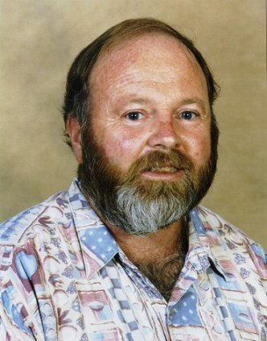
Bill Faulkner passed away on 28th January. Bill will be remembered for his generous nature, good humour and his passion for weightlifting and the QWA.
In Memory Of Bill Faulkner 6
QWA Office Report 7
On the road with the D.O. 8
QWA League & Masters League Round 1 9
World Masters Games Qualification 11
Masters Games Weightlifting News 13
Rule Changes 14
Weightlifting Officiating 13
Interview with Melissa Nightingale 15
Qualifying totals for Australian teams 15
Notices 21
Coach Update Requirements 21
QWA Coach Update Course 22
Queensland Masters Records 25
New QWA Logo 29
Proudly Supported by:




Queensland Weightlifting Association Inc.
Office: The Velodrome, The Sleeman Sports Complex,
Chandler 4155
Postal Address: PO Box 1056, Capalaba 4157
Telephone: (07) 3823 1377
Facsimile: (07) 3823 1371
Email: qwa@powerup.com.au
Web Site: http://www.qwa.org
Executive Director: Ian Moir
Administrative Officer: Kylie Booth
Development Officer: Scott Robinson
Newsletter Editor: Angela Wydall

The QWA Management Committee

Patron: Bert Hobl
President: Barry Harden
Vice President: Mike Keelan
Secretary: Jo Garner
Treasurer: Ross Gagliardi
Executive Officer: Greg Hobl
Executive Officer: Kylie Booth
Executive Officer: Brad Monk

QWA Mission Statement
"To promote and develop all aspects of the sport of weightlifting."

Acknowledgement - Sponsors of the QWA
The Queensland Weightlifting Association is extremely appreciative of the financial assistance provided by the following:

Queensland Government –Sport and Recreation Queensland
Brisbane City Council
QANTM
GREMEL Home Computer Services

Acknowledgement - Corporate Members

Gremel Promotions

Disclaimer
The views represented in this publication do not necessarily reflect those of the editor or of the Officers or Management Committee of the QWA.

QWA / AWF Competition Calendar 2002

February 10 | Nudgee Open Club Competition | Nudgee
February 16 | QWA League Round 1 & Masters H/cap Round 1 | Chandler
March 1 | TWA Open Club Competition | Toowoomba
March 2 | Mount Isa Open Club Competition | Mount Isa
March 9 | Sunshine Coast Open Club Competition | Sunshine Coast
March 10 | Nudgee Open Club Competition | Nudgee
March 16 – 17 | Mermet Invitational Cup & AUS vs USA | Melbourne, Vic
March 23 | Qld Under 16 & Under 18 Championships | Toowoomba
March 28 | Cougars Open Club Competition | Chandler
March 30 | Suncorp / Metway North Queensland Games | Mount Isa
April 12 | Cougars Open Club Competition | Chandler
April 12 – 13 | Oceania & South Pacific Championships | Fiji
April 13 | Qld Masters Championships | Chandler
April 14 | Nudgee Open Club Competition | Nudgee
April 19 | TWA Open Club Competition | Toowoomba
April 20 – 21 | National Under 16 & Under 18 Championships | Sydney, NSW
April 26 | Cougars Open Club Competition | Chandler
May 4 | Commonwealth Games Selection Trials | Melbourne, Vic
May 4 | Sunshine Coast Open Club Competition | Sunshine Coast
May 12 | Nudgee Open Club Competition | Nudgee
May 11 | QWA League Round 2 & Masters H/cap Round 2 | Chandler
May 18 | National Masters Championships | Melbourne, Vic
May 28 - June 5 | World Junior Championships | Kathmandu, Nepal
June 7 | TWA Open Club Competition | Toowoomba
June 12 | Nudgee Open Club Competition | Nudgee
June 14 | Cougars Open Club Competition | Chandler
June 15 | Mount Isa Open Club Competition | Mount Isa
June 22 | Qld U20 & Senior Championships | Chandler
June 28 – 30 | World University Championships | Ankara, Turkey
July 13 | Sunshine Coast Open Club Competition | Sunshine Coast
July 14 | Nudgee Open Club Competition | Nudgee
July 26 | Cougars Open Club Competition | Chandler
July 25 – August 4 | Commonwealth Games | Manchester, England
August 2 | TWA Open Club Competition | Toowoomba
August 3 | Mount Isa Open Club Competition | Mount Isa
August 11 | Nudgee Open Club Competition | Nudgee
August 31 | QWA League Round 3 & Masters H/cap Round 3 | Toowoomba
September 8 | Nudgee Open Club Competition | Nudgee
September 14 – 15 | National U20 & Open Championships | Adelaide, SA
September 20 | Cougars Open Club Competition | Chandler
September 22 | Sunshine Coast Open Club Competition | Sunshine Coast
September 28 | Qld Masters H/cap Final | Sunshine Coast
September 28 | Mount Isa Open Club Competition | Mount Isa
October 4 – 5 | National Age Group Team Challenge | TBC
October 4 – 13 | World Masters Games & World Masters Championships | Melbourne, Vic
October 13 | Nudgee Open Club Competition | Nudgee
October 18 | Cougars Open Club Competition | Chandler
October 18 | TWA Open Club Competition | Toowoomba
October 26 | QWA League Final | Chandler
November 2 | Qld All Schools Championships | Toowoomba
November 10 | Nudgee Open Club Competition | Nudgee
November 16 | QWA Annual Awards | Brisbane
November 17 – 24 | World Championships | Warsaw, Poland
November 29 | Cougars Open Club Competition | Chandler
November 30 | Queensland 2000 | Chandler
December 6 – 7 | Oceania & South Pacific Junior Championships | Nauru
December 7 | TWA Open Club Competition | Toowoomba
December 7 | Sunshine Coast Open Club Competition | Sunshine Coast
December 8 | Nudgee Open Club Competition | Nudgee
December 14 | Cougars Open Club Competition | Chandler
December 14 | Mount Isa Open Club Competition | Mount Isa

The closing date for entries for all QWA events is 15 days prior to the competition date.
The closing date for all National events is 28 days prior to the competition date.
The minumum qualifying standard for entry in the Queensland Open Championships is C Grade.
The minumum qualifying standard for entry in the Queensland Under 20 Championships is D Grade.
There is no minumum qualifying standard for Queensland Under 16, Under 18, School or Masters Championships.
The qualifying period for the Queensland Open & Under 20 Championships is 7 June 2001 – 7 June 2002.
The qualifying period for the Queensland 2000 Tournament is 1 January 2002 – 30 September 2002.
Queensland Teams for the 2002 National Open & Under 20 Championships will be selected according to the QWA Selection Policy taking into consideration results from all state, national and international events held between 1 January 2002 and 5 August 2002.

In Memory of Bill Faulkner

'Professor William (Bill) Faulkner passed away at his home at Oxenford, Qld at 12:20am on Monday 28 January 2002. Here, Mike Keelan remembers the ways in which Bill touched the lives of all those people in weightlifting who new him.'

**********************************************************

I first met Bill Faulkner in 1985 when we were both in Sydney performing voluntary coaching and managerial duties on behalf of our respective organisations, the QWA and ACTWA. Bill loved the camaraderie that is part of our great sport and after the weightlifting event found himself with others such as Cameron Menhenick, Danny Mauro, Bruce Walsh, Lyn Jones and myself in a Chinatown restaurant where we all had a great time getting to know a little more about each other and our respective weightlifting roles.

From that occasion I became a mate of Bill’s and always looked forward to Weightlifting events and the inevitable social interaction that followed including a `few’ cold beers, jokes and jibes, a number of yarns and solving the problems of the world that are so much easier to deal with over a bottle of Red.

Bill was such an easy bloke to get along with as he always displayed a warm, caring and friendly personality and other attributes which made him such a likeable bloke.

Bill openly demonstrated his passion for the `iron game’, which was a big part of his life along with his family and friends. Bill was a competitive weightlifter during his younger years in Lismore, NSW, and he continued to lift weights for personal fitness in various garages and gyms throughout the cities and towns where he lived with his wife Shirl and their 3 children.

Bill was very much a socialist and believed deep heartedly in equity and social justice and whenever a situation occurred that warranted action he would give it his complete attention to reach an agreeable outcome for all. Members of the QWA Committee were often treated to idealistic doctrine emanating from Marx or Lenin and one quote which stands out used by Bill was “ From each according to his ability; to each according to his need.”

As well as being an acclaimed academic in his professional field of tourism research, Professor Bill, like many of us, was a weightlifting volunteer through and through. He unselfishly gave his time and expertise as a coach, referee, committee member and weightlifting ambassador. Bill was instrumental in raising the profile of our sport at state and national levels. Bill’s roles included service as member of the AWF Executive Board, President of the ACTWA and QWA Vice-President. Bill was also quick to put up his hand for refereeing duties and also acted as a team manager at many national weightlifting events. One of Bill’s proudest moments was when his son Ben was selected to represent Australia against New Zealand in the mid 90’s, it just so happened that Bill’s hard work also cemented the sponsorship agreement between the QWA and Powerhouse Hotel where the successful event took place.

Bill played a major role in the development of Queensland weightlifting where he took on the portfolio of Club Development and he also attracted other knowledgeable people such as Lawrence Chalip, QWA President 1997 – 2000, to our sport. Bill was a strong advocate for our sport and whenever matters needed to be dealt with he was quick to offer his table by the pool at his home on the base of Tamborine Mountain. Bill was an excellent listener, lead lively debate, added touches of humour and had a tremendous capacity to condense proceedings into a nutshell that lead to agreement before the beer bottle tops were twisted and the BBQ cranked up.

I am forever grateful for knowing Bill and for sharing part of his life. Bill was a great friend to many people within the weightlifting family, a great role model, he left us with the legacy of his life – passion, humility, commitment, humour, sacrifice, tolerance, fairness, acknowledgement rather than judgement and love of family and friends.

Bill, we will always celebrate the good times we shared.

From the QWA Office
By Ian Moir, QWA Executive Director

2002 has begun and the QWA office is gearing up for what will be another busy year. No doubt the majority of QWA members are focusing their attention on the competition program ahead and, of course, providing a competition program is one of the QWA office’s main functions. But that’s not all that we do. In December last year, members received a survey form asking for opinions and comments about aspects of the association. Among other things, one of the comments made by a number of respondents was that they would like more information about the roles and duties of the QWA staff. And so here we go with the first instalment of what will be a regular feature in Weightlifting Queensland.

After returning to work in late January after a spot of R & R over the Christmas / New Year period, much of my time has been spent wrapping up the previous year. In preparation for the association’s Annual General Meeting in March, the records of the association’s financial accounts have been gathered together and delivered to the Auditor, and the final draft of the 2001 Annual Report is completed. Other tasks that have required attention were the finalisation of our contract with the Queensland Government in relation to the State Drug Testing program in which the QWA will participate again this year, the listing of members details for the first round of AWF capitations (national registration), the return of annual affiliation forms to organisations of which the QWA is a member – the AWF, the Sports Federation of Queensland, the Australian Commonwealth Games Association (Qld Division) and the Queensland Olympic Council –attending meetings of the Sports Federation of Queensland and the Australian Commonwealth Games Association (Qld Division), and liaising with the North Queensland Sports Foundation and the Mount Isa club about the Suncorp Metway North Queensland Games that are being held in Mount Isa at Easter.

Closer to home, I’ve been preparing information, reports and financial statements for the QWA Management Committee meetings and getting organised for the first event of the year – round one of the QWA League & Masters League. The format of the League competition requires the classification of lifters into Divisions according to their results from last year. This task is accomplished much quicker these days thanks to Miles Wydall’s fantastic work with the rankings on the QWA web site, which enables me to obtain and sort this information with a few clicks of the mouse. And as before any competition, there’s the usual job of collecting the entries and devising the competition timetable and schedule of officials, and liaising with the host club, in this case the Cougars, over the venue and equipment requirements.

On the financial front, with the assistance of Kylie Booth (QWA Administration Officer) we pay the accounts payable, receive the accounts receivable, meet the QWA’s GST reporting obligations to the tax office, manage the bank accounts and update the budget and cashflow forecast. In addition to tasks such as these, the QWA office receives many enquiries daily from members and the general public, and I try to answer these as quickly and informatively as I can. E-mail is a great form of communication which is being used increasingly and the QWA receives up to 30 messages a day from a variety of correspondents on a range of issues.

At the time of writing, the month of February was half over. It’s been a typically busy, but enjoyable start to the year. Before signing off until next time, I’ll provide answers to a few questions that I’ve been asked over the past few years.

Q: How much does the QWA pay me?
A: $37,000 p.a.

Q: Do I get paid overtime for working at night and week ends?
A: No. When I’m at competitions on weekends, like everyone else I’m there because I want to be there. Weightlifting is my sport as well as my job. As for attending meetings and functions at night, well that just goes with the territory. For most people, sport is something they do in their recreation time, so meetings are often only possible outside of the “9 to 5”. Sometimes, if I’ve been helping out at, say, a coaching course for a full weekend, I’ll take the following Monday off – as long as there isn’t anything that requires urgent attention and can’t be put off for another day.

Q: Do I work for the Cougars club?
A: No… and yes. I work for the QWA. That means I work for all clubs and all members, at the direction of the QWA Management Committee. Some confusion arises out of the fact that the QWA office and the Cougars club are under the same roof. But I don’t do any administrative work for the Cougars club, I don’t manage or supervise the Cougars gym, I don’t coach any lifters and I’m not a member of the Cougars club. In fact the only organisation that I am a member of is the QWA, oh… and the Hunter Valley Wine Society.

Q: When am I going to lose some weight?
A: When beer, wine and cheese are classified as prohibited substances.

On the road with the D.O.
By QWA Development Officer, Scott Robinson

As a part time (20hrs p/w) QWA Development Officer I have been busy organising 2002. The majority of my hours for the first two school terms are spent attending schools conducting the AWF Clean & Jerk competition. The clean & Jerk comp is a great way of introducing the sport of Weightlifting to around 2500 students in 30 Qld schools. The QWA uses this competition as a way of organising Development Squads for clubs.
As you can imagine, getting the school to accept a weightlifting competition is one of the most difficult parts of the job. However not nearly as difficult as actually contacting them. I am fortunate enough now that in my 4th year as QWA DO I have built up a good rapport with the teachers in our target areas. This saves me quite some time because contacting teachers is like trying to contact someone over a bad debt, they are just never available. This means I have to phone most schools around 3 or 4 times, and only in small windows of time, to book a day for the AWF National Clean and Jerk Competition. I average around 105 students per school.
My focus is not only on increasing participation in Weightlifting, but also increasing the knowledge base of all people involved in the sport by providing opportunities to attend updating courses. Coaches, athletes and parents can all benefit from information obtained by various specialists in sport. Over the last few years we have had courses where leaders in their field come together to share / exchange information with others in order to increase awareness of all aspects of sport. I have also been fortunate enough to be able to deliver a course specifically designed for school teachers, so that they may be better equipped to instruct their students in correct weightlifting techniques.

But it doesn’t all stop there. I know that Weightlifting is a great sport! And I am lucky enough to have a job where my objective is to prove that to as many people as possible.
Starting clubs at schools or in the community is another objective I am yet to achieve. So if you would like help in getting a new club up and going please do not hesitate to contact me. I also attend Wynnum SHS every Wednesday afternoon between 1 and 3pm taking afternoon sport where the students work through the QWA First Steps program. I coach some lifters at the Cougars Weightlifting Club, but this is for my own enjoyment and not included as part of the Dev Officers professional hours.
I have already confirmed attendance for the AWF National Clean & Jerk competition at the Schools listed below. If your school is not on the list and you would like me to attend your school, then contact me on 041 777 8085, or mascott1@bigpond.net.au
SCHOOL | PROPOSED DATE | SCHOOL | PROPOSED DATE | SCHOOL | PROPOSED DATE
Aboriginal/Islander Independent Community Sch | Not yet confirmed | Ipswich Grammar School | Tuesday 5th March | Nambour SHS | Tuesday 30thApril
Alexandra Hills SHS | Monday 17th June | Windaroo Valley SHS | Tuesday 19th March | Nudgee College | Not yet confirmed
Burnside SHS | Thursday 11th April | Wynnum North SHS | Tuesday 19th Feb | Rochedale SHS | Not yet confirmed
Capalaba SHS | Wednesday 27th Feb | Wynnum SHS | Tuesday 26th March | St EdmundsCollege | Not yet confirmed
Calamvale Community Coll | Tuesday 28th May | The Glennie School | Not yet confirmed | St Laurence's College | Thursday 2nd May
Centenary Heights HS | Thursday 16th May | Macgregor SHS | Tuesday 12th March | St Mary’s College | Tuesday 23rd April
Clairveaux McKillop College | Not yet confirmed | Mansfield SHS | Not yet confirmed | Sunshine Coast Grammar School | Thursday 28th Feb.
Harristown SHS | Thursday 6th June | Miami SHS | Thursday 7th March | Toowoomba SHS – Mt Lofty Campus | Thurs 21stMarch
Helensvale SHS | Thursday 14th March | Moreton BayCollege | Thursday 18th April | Toowoomba SHS – Wilsonton Campus | Thursday 14th February
Iona College | Not yet confirmed | Mt Gravatt SHS | Tuesday 16th April | Villanova College | Tuesday 14th May

QWA League and Masters League, Round 1
Cougars Weightlifting Club, Chandler, 16th Feb 2002

Name Born Club Bwt Snatch C & J Total Bonus Points

Division 1
Ben Turner 84 Cougars 69.00 110.0 150.0 260.0 21 93.727
Joel Wilson 86 Cougars 67.85 107.5 135.0 242.5 15 82.832
Kristie Amadio 85 Cougars 58.00 65.0 80.0 145.0 0 61.702
Damon Kelly 83 Cougars 140.30 135.0 170.0 305.0 -13 51.550
Diana Loy 65 UQ 57.85 65.0 77.5 142.5 1 Guest

Division 2
Patrick Alldridge 79 Cougars 69.45 90.0 107.5 197.5 21 73.667
Matt Turner 82 Cougars 75.60 85.0 135.0 220.0 11 69.667
Troy Hewkins 86 Cougars 55.50 72.5 90.0 162.5 15 68.279
John Yamasaki 84 Cougars 61.30 80.0 105.5 185.0 5 61.923
Greg Hobl 60 Toowoomba 78.90 97.5 120.0 217.5 3 58.063
Peter Foster 67 Cougars 111.80 110.0 135.0 245.0 6 57.852
Tanya Harden 78 Sunshine Coast 66.70 62.5 75.0 137.5 1 54.398

Division 3
Anthony Salsone 87 Cougars 55.75 65.0 82.5 147.5 21 69.361
John Hanlon 66 Cougars 88.85 85.0 117.5 202.5 15 63.503
Kyle Woodlock 85 Toowoomba 53.05 60.0 82.5 142.5 15 61.721
Rebecca Marks 84 Cougars 89.60 67.5 77.5 145.0 10 58.333
Andrew Kruger 76 Cougars 107.15 92.5 127.5 220.0 11 57.561
Ken Harvey 68 Mackay 104.30 87.5 112.5 200.0 11 56.455
George Mylne 85 Toowoomba 66.65 70.0 102.5 172.5 5 53.252
Bowen Stuart 86 Sunshine Coast 68.95 70.0 100.0 170.0 5 52.552
Paul McBride 58 Cougars 67.55 77.5 92.5 170.0 2 49.552
Sherry Bower 86 Cougars 49.50 40.0 55.0 95.0 5 47.222
Meg Soroka 73 Cougars 64.75 45.0 57.5 102.5 2 41.806

Division 4
Greg Botha 86 Windaroo 66.45 65.0 85.0 150.0 15 56.958
Adon McCallum 88 Cougars 67.95 67.5 80.0 147.5 15 56.259
Tammie Bower 87 Windaroo 58.40 37.5 47.5 85.0 21 56.052
Harry Grzes 56 Cougars 124.45 72.5 92.5 165.0 17 51.921
Adam McLean 87 Windaroo 53.15 35.0 50.0 85.0 15 42.869
Luke Gardner 88 Cougars 82.70 47.5 60.0 107.5 15 42.215
Sarah Martens 87 Cougars 52.90 25.0 35.0 60.0 15 41.667
Warwick Selvey 39 Gold Coast 102.15 67.5 82.5 150.0 1 35.091
Jo Garner 66 Cougars 79.25 32.5 47.5 80.0 1 27.667
Thomas Deacon 88 Windaroo 61.00 22.5 42.5 65.0 0 20.000
Emily Jones 82 Cougars 50.75 35.0 47.5 82.5 15 Guest
Duane Alldridge 87 Cougars 92.60 70.0 87.5 157.5 6 Guest

Referees: Debra Keelan (Cat 2), Ian Moir (Cat 2), Angela Wydall (Nat), Amanda Phillips (Nat), Ross Gagliardi (Nat), Keith Forbes (State), Scott Robinson (State), Vivien Nightingale (State), Ray Louden (State). *Barry Harden (Cat 2) - for national records.
Time Keeper: Vivien Nightingale, Kylie Booth.
M.C: Mike Keelan, Melissa Nightingale, Ian Moir
Records
Name | Cat | Lift | Weight | Age | Level
Troy Hewkins | 56kg | Snatch | 72.5 | U16 | Qld
Troy Hewkins | 56kg | Total | 162.5 | U16 | Qld
John Yamasaki | 62kg | Cl & Jk | 105.5 | U16 | Qld
John Yamasaki | 62kg | Cl & Jk | 105.5 | U18 | Qld
Ben Turner | 69kg | Snatch | 110.0 | U18 | Qld, Aus
Ben Turner | 69kg | Cl & Jk | 147.5 | U18 | Qld, Aus
Ben Turner | 69kg | Cl & Jk | 150.0 | U18 | Qld, Aus
Ben Turner | 69kg | Total | 260.0 | U18 | Qld, Aus
Ben Turner | 69kg | Snatch | 110.0 | U20 | Qld
Ben Turner | 69kg | Cl & Jk | 147.5 | U20 | Qld, Aus
Ben Turner | 69kg | Cl & Jk | 150.0 | U20 | Qld, Aus
Ben Turner | 69kg | Total | 260.0 | U20 | Qld, Aus
Ben Turner | 69kg | Snatch | 110.0 | Open | Qld
Ben Turner | 69kg | Cl & Jk | 150.0 | Open | Qld
Ben Turner | 69kg | Total | 260.0 | Open | Qld
Joel Wilson | 69kg | Snatch | 107.5 | U16 | Qld, Aus
Joel Wilson | 69kg | Cl & Jk | 135.0 | U16 | Qld, Aus
Joel Wilson | 69kg | Total | 242.5 | U16 | Qld, Aus

Masters League
Name Born Club Bwt Sn C& J Total Sinclair M/M Score
Men
John Hanlon 66 Cougars 88.85 85.0 117.5 202.5 231.196 251.310 3314.732
Peter Foster 67 Cougars 111.80 110.0 135.0 245.0 256.852 275.345 828.497
Harry Grzes 56 Cougars 124.45 72.5 92.5 165.0 168.700 203.621 359.496
Greg Hobl 60 Toowoomba 78.90 97.5 120.0 217.5 263.930 305.630 305.630
Paul McBride 58 Cougars 67.55 77.5 92.5 170.0 227.318 268.917 268.917
Warwick Selvey 39 Gold Coast 102.15 67.5 82.5 150.0 161.782 256.263 256.263
Women
Jo Garner 66 Cougars 79.25 32.5 37.5 70.0 73.917 80.348 80.348

QWA League Round 1: Record Breaking Performances

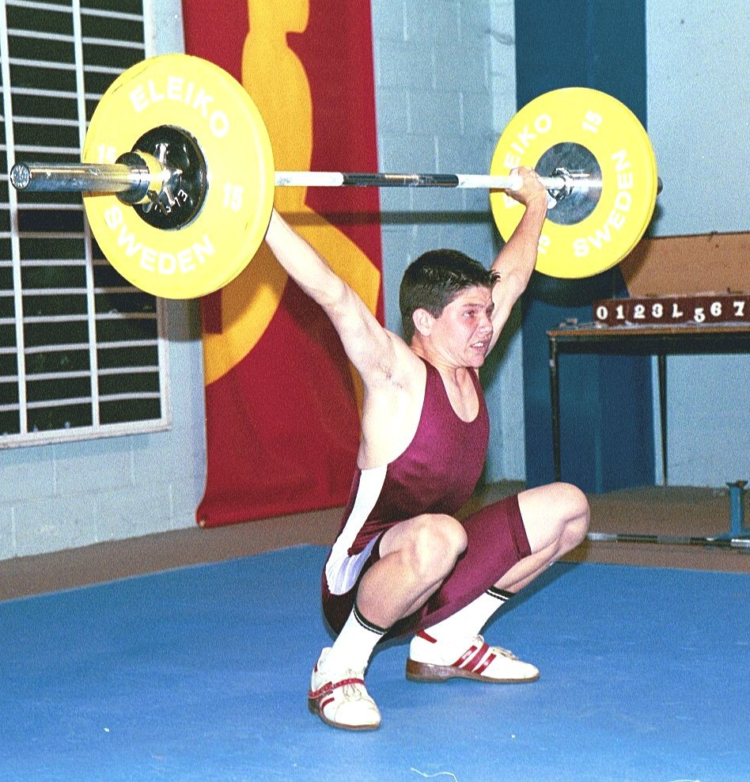  Troy Hewkins : 72.5 snatch, 162.5 total at 56kg. | 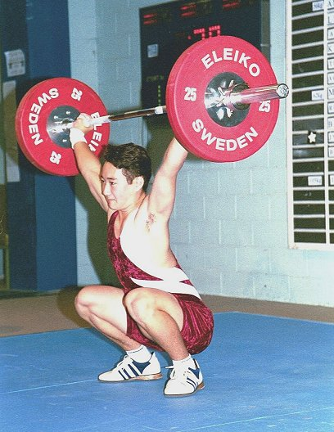  John Yamasaki : 105.5 clean & jerk at 62kg.

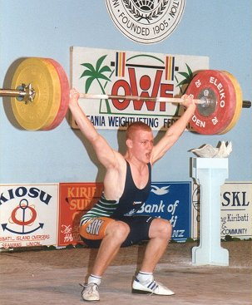  Joel Wilson : 107.5 snatch, 135 clean and jerk, 242.5kg total at 69kg. | 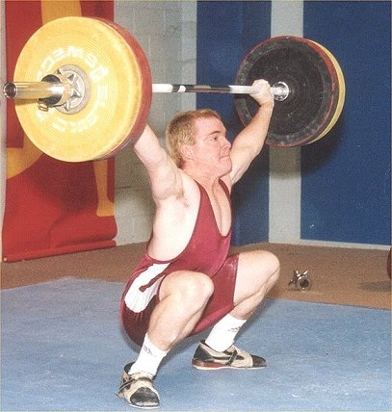  Ben Turner : 100kg snatch, 150kg clean and jerk, 260 total at 69kg.

World Masters Games Qualification

AWF Qualifying Criteria and minimum qualifying totals for the 2002 World Masters Games incorporating the IWF World Masters Championships. October 4-13, 2002.

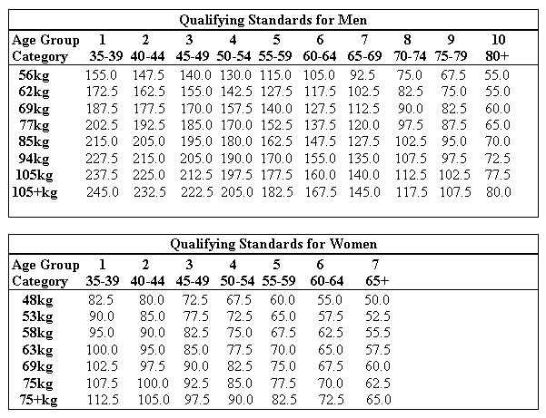The IWF World Master's Committee has allocated Australia 10 female and 20 male places to compete in the 2002 World Master's Games (WMG) Weightlifting, incorporating the IWF World Master's Championships.

The AWF may select up to 10 female and 20 male athletes to compete in the WMG and World Championships. Australian Master's will be ranked according to their SMM (Sinclair Melzer Malone) score with the best 10 female and 20 male athletes being nominated by the AWF Selection Panel to participate in the WMG and World Championships.

From this list of athletes, the AWF Selection Panel will nominate an official Australian Team of 8 male and 7 female athletes, based on their perceived ability to be the highest placed Australian athletes in the WMG & World Championships. This perceived ability will be based on the WMG final entry list and last years World Master's Championships final results. If two or more athletes are perceived to be able to place equally, then the AWF selectors will determine final nomination according to their SMM scores. This selection process will give the Australian Team its best chance of being highly competitive in the teams event.

The 10 female and 20 male athletes and the final Australian Team will be announced once it has been confirmed by the AWF Executive Board after the Australian Master's Championships in Melbourne (May 18th, 2002).

The SMM ranking system is the official system used by the IWF Master's Committee to assess lifters in all age groups at IWF World Championships. The minimum standard required to be considered for selection in the Australian Team is per the IWF World Master's Committee qualifying totals for the 2002 World Master's Games (above).

Results from the following will be taken into account when selecting lifters for the 2002 World Master's Games & World Championships Team:-

Results from:- all National & State Calendar events held between September 23, 2001 and May 18, 2002

* Note: If the IWF Master's quotas are not fully taken by nations, Australia may be allocated a further 10 male places to compete in the WMG and World Championships. If this does occur, the AWF will consider increasing the team size accordingly using the SMM ranking system.

If you require more information regarding this selection criteria, please contact AWF Master's Chairman, Lawrie Townsend lawrietownsend@bigpond.com or (07) 3267 0272 during business hours.

Masters Games Weightlifting News

Please see the AWF website (http://www.awfmasters.org) or contact our State Masters Coordinator, Barry Harden on 07 5445 0226 about how to enter your name for the WMG2002.

Please note: only totals completed between the 23rd.September 2001 and the 18th.May 2002 can be submitted for qualification for the World Masters Games 2002. That is, totals achieved between last years’ World Championships 2001 in Kefalonia and the 2002 Australian Championships in Melbourne on May 18th.2002. This is an IWF Masters Rule and the current SMM Ranking list posted on this website will be amended accordingly. At present there are only a handful who have qualified so don’t be caught out !!

Also Note: Lifters will no longer be required to lift in a Masters competition to qualify for the World Masters Games. This means, of course, that lifters still competing in senior events can use their totals to qualify.

Bob Hemery and his team are progressing very well towards this great event and they have recently secured the platform used at the Sydney 2000 Olympics.

Best wishes to all those who are training hard and make sure you get your qualifying total to your State Masters Coordinator so that it can be entered on the SMM Ranking list.

Weightlifting Officiating
By Ian Moir

I recently attended a function at which one of the guest speakers was a Queensland soccer referee who, at the age of 22, has been appointed to referee in this year’s World Cup. This is a great achievement for such a young referee and when asked about the events that led to him rising to the highest level of officiating in his sport, he told a story familiar to many sports officials. His first officiating experience came more than 10 years ago when he was at a soccer field waiting around for his own Under 11 game to start. Someone asked him if he would be a linesman for the Under 10’s match that preceded his own and so he picked up the flag, ran the line, enjoyed the experience, decided to become an official, and the rest as they say, is history – or at least it will be once he blows the whistle at the World Cup. During his speech he made this comment: “refereeing is my sport”. A simple enough statement, but one which became a topic of discussion among some of the people who lingered for the customary ‘networking’ session that follows such functions.

I gathered from discussions with other people involved in Queensland sport that officiating, or refereeing, is not generally regarded as a sporting activity unto itself. In the case of sports where officiating is a purely voluntary activity, such as weightlifting, officiating tends to be seen as a necessary function which provides athletes with the opportunity to compete – kind of like a community service. And I wondered why. More to the point, I wondered how that perception could be changed so that weightlifting officials would regard officiating as their sport.

Perhaps the answer lies in the way we promote officiating... or rather, don’t promote it. Generally, when recruiting officials we tend to look towards people already involved in other aspects of the sport. Often, athletes and coaches are targeted with the intention of pressing them into service as referees at the times that they are not either competing or coaching. This approach has left us with very few people whose only participation in weightlifting events is as an official – the specialists. Coaching, on the other hand, has been promoted very well and many people aspire to be coaches. Now, I’m not going to knock coaching – I used to be a coach and enjoyed it very much – but for many people, taking on the time-consuming commitments of coaching is simply not possible.

Officiating provides a real and valuable sporting experience. For officials there is great deal of satisfaction in knowing that they have performed their duties well, that they have applied the rules completely and evenly, and that they have ensured a ‘level playing field’ for all competitors. And of course, referees at competitions are guaranteed the best seats in the house.

All officials experience nervousness and uncertainty at the beginning of their careers. But these misgivings are quickly overcome with training and experience. The QWA conducts training courses for officials and as the pool of weightlifting officials grows, experienced referees will be able to sit alongside beginners at competitions and support them through the early stages of learning.

So, if you or someone you know, is looking for a sport that provides satisfaction and enjoyment through an activity of high intensity and short duration, why not consider weightlifting officiating?

Rule Changes
There have been changes to a few of the rules of weightlifting recently. The AWF Referee Handbook is currently being updated and will be reprinted shortly, but in the meantime here are two changes that officials and competitors should be aware of:

Order Of Weigh In
Competitors are called to weigh-in by the order of the lot draw, i.e. lowest to highest lot number. If a competitor is not present when they are called, they will be called again after all the other competitors have been called. In other words, they go to the bottom of the list.

But if a competitor is present for the weigh-in when they are called but does not weigh within the limits of their nominated category, they may return to be weighed again later, in which case they are the next competitor weighed upon their return.

This ruling is an amalgamation of two previous rules for weigh-in.

The Down Signal.
The signal to replace the barbell is given by the referees once the lifter has achieved a motionless position with the barbell overhead, their arms and legs fully extended, their feet on the same line and parallel to the plane of the trunk and the barbell. This rule has not changed, but an important consideration associated with it has.

When an electronic referee system is used, as it is at most QWA events, the “Down” signal is controlled by the referees’ decision. As soon as two of the three referees give an identical decision, either “good lift” or “no lift”, by pressing the appropriate button on their handset, the “Down” signal goes off automatically.

Previously, if a competitor finished a lift with their feet out of line and made no attempt to correct their position, referees were required to judge the attempt as “no lift”. The length of time a referee should allow for a lifter to correct the alignment of their feet was not specified in the rule book, and this led to confusion all round.

Now the rule is clear. For all attempts, referees must press the button for “no lift” the instant that they see a fault, but finishing with the feet out of line is not a fault unless the feet are not brought into line before the lifter replaces the bar after the “Down” signal. In other words, if a referee has not seen a fault during the execution of an attempt but the lifter’s feet are not in line at the finish, the referee must not press either button on their handset, but wait for the lifter to correct the alignment of their feet.

So the advice on this one is:
Referees
If you haven’t had cause to give a “no lift” decision during the attempt but the lifter has finished with their feet out of line, wait for as long as it takes them to bring their feet into line before pressing the “white” button.
Lifters
If you’re standing still with the barbell overhead waiting for the “Down” signal and it seems to be a long time coming, think about the position of your feet and make any necessary adjustment. Whatever you do, don’t replace the barbell before you hear the “Down” signal, as the referees will have to fail the attempt no matter how good it was up until that point.

Interview With Melissa Nightingale
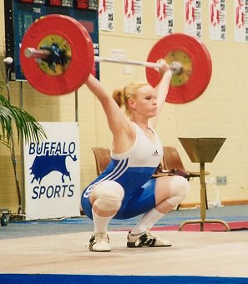
Melissa in action at the 2001 National Championships, where she won gold in the 63kg class.

How long have you been weightlifting and how did you get involved ?
I been lifting now for 4 and a half years. I got involved though a talent search program at the Queensland Academy of Sport.

What are your best performances and best moments in weightlifting ?
My best lifts to date are 75kg Snatch and 90kg Clean and Jerk, 165kg Total in the 63kg class. My best moment was probably qualifying for the World Junior Championships and also winning the Open national championships for the first time.
What inspires you in weightlifting ?
I'm always eager to improve, so when I see an improvement, that inspires me more than anything to keep going and strive for better results.

Tell us a bit about your training ? How often you train, favourite and least favourite exercises etc.
It depends on the competitions coming up but I usually train 5 times per week for about 3 hours at a time. My favourite exercise changes all the time but at the moment it probably would be Power Cleans, my least favourite exercise would have to be Back Squats.

What do you like to do when you are not lifting ?
I like to swim at least once a week, and also play indoor netball once a week, to keep me fit.

AWF Qualifying Totals for Australian Teams

(January 1, 2002 to December 31, 2002)

CLASSIFICATION STANDARDS 2002 - 2004 – MALE
 | ELITE | INTERNATL | A Grade |  |  | B Grade | C Grade |  |  | D Grade
47 | ..... | ..... |  | ..... | ..... |  |  | 132.5 | 115.0
51 | ..... | ..... |  | ..... | ..... |  |  | 142.5 | 125.0
56 | 240.0 | 207.5 |  | 200.0 | 175.0 |  |  | 155.0 | 135.0
62 | 260.0 | 225.0 |  | 217.5 | 190.0 |  |  | 167.5 | 147.5
69 | 280.0 | 242.5 |  | 235.0 | 205.0 |  |  | 182.5 | 160.0
77 | 300.0 | 260.0 |  | 252.5 | 220.0 |  |  | 195.0 | 170.0
85 | 317.5 | 275.0 |  | 265.0 | 232.5 |  |  | 205.0 | 180.0
94 | 332.5 | 287.5 |  | 277.5 | 242.5 |  |  | 215.0 | 187.5
105 | 347.5 | 300.0 |  | 290.0 | 252.5 |  |  | 225.0 | 197.5
Over 105 | 367.5 | 317.5 |  | 307.5 | 267.5 |  |  | 237.5 | 210.0

CLASSIFICATION STANDARDS 2002 – 2004 – FEMALE
 | ELITE | INTERNATL | A Grade |  |  | B Grade | C Grade |  |  |  |  | D Grade
40 | ..... | ..... |  | ..... | ..... |  |  | 87.5 |  |  | 75.0
44 | ..... | ..... |  | ..... | ..... |  |  | 95.0 |  |  | 82.5
48 | 152.5 | 135.0 |  | 127.5 | 117.5 |  |  | 102.5 |  |  | 87.5
53 | 162.5 | 145.0 |  | 137.5 | 125.0 |  |  | 110.0 |  |  | 92.5
58 | 172.5 | 152.5 |  | 145.0 | 132.5 |  |  | 115.0 |  |  | 100.0
63 | 180.0 | 160.0 |  | 150.0 | 137.5 |  |  | 120.0 |  |  | 102.5
69 | 190.0 | 167.5 |  | 157.5 | 145.0 |  |  | 125.0 |  |  | 107.5
75 | 195.0 | 172.5 |  | 162.5 | 147.5 |  |  | 130.0 |  |  | 112.5
Over 75 | 207.5 | 185.0 |  | 175.0 | 160.0 |  |  | 140.0 |  |  | 120.0
All standards are rounded to the nearest 2.5 kg.
NOTE: The Male standards are based on 370, 320, 310, 270, 240 and 210 Sinclair points. The Female Standards are based on 210, 185, 175, 160, 140 and 120 Sinclair points. For the 105+ kg class 140 kg bodyweight has been used as the determining factor. For the 75+ kg class 100 kg bodyweight has been used as the determining factor.

NOTE The above totals are the AWF Qualifying Totals until the end of December 2002. The Qualifying Totals for 2003 will be reviewed during September 2002. The above standards will be the standards used for the review of all selected AWF Squads conducted during 2002.

International Events 2002
March 16-17 | 2002 International Invitational Event | Melbourne, Victoria
April 12-13 | Oceania & South Pacific Championship | Fiji
May 4 | 2002 Commonwealth Games Team Selection Trials | Melbourne, Victoria
June 2- 9 | 2002 World Junior Championships | Katmandu, Nepal
June 28 –30 | 2002 World University Championships | Ankara, Turkey
July 25 - August 5 | Commonwealth Games | Manchester, England
November 17 - 24 | World Weightlifting Championships | Warsaw, Poland
December 6 - 7 | Oceania Junior Championships | Nauru
January 8 - 12 2003 | Australian Youth Olympic Festival | Sydney, Australia
March 2003 | Mermet Cup | USA

2002 Mermet Invitational Cup & Australia Vs USA - Melbourne Victoria – March 16 & 17
Participation in the Mermet Invitational Cup will be by invitation only. The organising committee reserves the right to invite lifters in consultation with the AWF. Lifters who have qualified for the Commonwealth Games Trials will receive automatic invitation to participate in this event. The minimum standard required to be considered for selection in the Australian Team to compete against the USA in this tournament is “International” Grade . Potential team members will be ranked according to their percentage over the qualifying totals. Achievement of these totals does not mean automatic team selection. The following will be taken into account when inviting lifters to participate and selecting the Australian Team:-

Results from:- all National & State Calendar events held between August 1, 2001 and January 31, 2002

2002 Commonwealth Games Team Selection Trials – Melbourne Victoria - May 4
AS PER AMENDED QUALIFYING BELOW

2002 Oceania & South Pacific Championships – Fiji - April 12 & 13
The minimum standard required to be considered for selection in the 2002 Oceania & South Pacific Championships team is “International" Grade. Potential team members will be ranked according to their percentage over the qualifying totals. Achievement of these totals does not mean automatic team selection and a full team may not be selected for this event. The following will be taken into account when selecting the team:-

Results from:- all National & State Calendar events held between October 1, 2001 and March 17, 2002

2002 World University Championships – Ankara, Turkey – June 28-30
The minimum standard required to be considered for selection in the 2002 World University Games team is “International” Grade . Potential team members will be ranked according to their percentage over the qualifying totals. Achievement of these totals does not mean automatic team selection and a full team may not be selected for this event. The following will be taken into account when selecting the team:-

Results from:- all National & State Calendar events held between December 1, 2001 and May 5, 2002

2002 World Junior Championships – Katmandu, Nepal – May 28-Jun 5
The minimum standard required to be considered for selection in the 2002 World Junior Championships team is “International” Grade . Potential team members will be ranked according to their percentage over the qualifying totals. Achievement of these totals does not mean automatic team selection and a full team may not be selected for this event. The following will be taken into account when selecting the team:-

Results from:- all National & State Calendar events held between December 1, 2001 and April 22, 2002

2002 World Weightlifting Championships – Warsaw, Poland – November 17 - 24
The minimum standard required to be considered for selection in the 2002 World Weightlifting Championships team is “Elite”. Potential team members will be ranked according to their percentage over the qualifying totals. Achievement of these totals does not mean automatic team selection and a full team may not be selected for this event. The following will be taken into account when selecting the team:-

Results from:- all National & State Calendar events held between March 1, 2002 and September 16, 2002

2002 Oceania Junior Championships – Nauru – December 6 - 7
The minimum standard required to be considered for selection in the 2002 Oceania Junior Championships team is “A” Grade. Potential team members will be ranked according to their percentage over the qualifying totals. Achievement of these totals does not mean automatic team selection and a full team may not be selected for this event. The following will be taken into account when selecting the team:-

Results from:- all National & State Calendar events held between April 1, 2002 and October 15, 2002

2003 Australian Olympic Youth Festival – Sydney, Australia – January 8 - 12

Standards qualifying and format of competition to be finalised with the Australian Olympic Committee by March 31st, 2002

2003 Mermet Cup – USA – March
The minimum standard required to be considered for selection in the 2003 Mermet Cup team is “International" Grade. Potential team members will be ranked according to their percentage over the qualifying totals. Achievement of these totals does not mean automatic team selection and a full team may not be selected for this event. The following will be taken into account when selecting the team:-

Results from:- all National & State Calendar events held between July 1, 2002 and December 31, 2002

PLEASE NOTE
All future team members may be asked to contribute to their own participation in National teams depending on levels of funding and sponsorship available to the AWF. Funding levels and the maximum number of athletes to be selected for all 2002 AWF Teams will be circulated to all State/Territory Associations by January 31, 2002.

Only results achieved at National & State Calendar Events listed on the AWF or State Association calendars in January 2002 will be considered as qualifying totals for AWF teams and squads.

Australian Commonwealth Games Squad (AWF Elite Squad) – January 1, 2002 – July 31, 2002

The 2002 Commonwealth Games Squad will consist of up to 8 male and 7 female lifters who have exceeded the AWF 2002 Commonwealth Games Team Selection Trials qualifying standard. Ranking will be based on the percentage each athlete achieves over this standard.

PLEASE NOTE
- Squad size is limited to 15 (Based on 8 men and 7 women). Where less than 8 men or 7 women have reached the qualifying total, the squad can include more athletes of either gender who have qualified, e.g. 10 men + 5 women, if only 5 women have qualified. The next 2 highest qualifiers from the men are then included to make up the fifteen.
- Squad to be monitored quarterly, with continued inclusion in the squad dependent on the athlete’s commitment to training and the AWF program. Athletes can be removed from the squad for any breaches of AWF rules.
- Payments are made quarterly unless otherwise specified.*

* Direct Athlete Support (DAS) will be available to support squad members’ preparation for the 2002 Commonwealth Games and will be paid quarterly in accordance with the information already circulated by the AWF office.

MALE
Rank | Athlete |  | State | Total | Class | % of qualifying
1 | Alex Karapetyn |  | Vic | 392.5 | 94 | 121.71%
2 | Yurik Sarkisian |  | Vic | 292.5 | 62 | 115.84%
3 | Chris Rae |  | SA | 390.0 | 105+ | 109.09%
4 | Kiril Kounev |  | Vic | 350.0 | 94 | 108.53%
5 | Corran Hocking |  | Vic | 377.5 | 105+ | 105.59%
6 | Craig Blythman |  | Vic | 300.0 | 77 | 102.56%
7 | Simon Heffernan |  | Vic | 322.5 | 94 | 100.00%
FEMALE
Rank | Athlete |  | State | Total | Class | % of qualifying
1 | Caroline Pileggi |  | WA | 232.5 | 75+ | 119.23%
2 | Natasha Barker |  | NSW | 182.5 | 58 | 114.06%
3 | Amanda Phillips |  | Qld | 192.5 | 69 | 110.00%
4 | Melissa Bethune |  | Qld | 202.5 | 75+ | 103.85%
5 | Meagan Warthold |  | NSW | 165.0 | 58 | 103.13%
6 | Seen Lee |  | Vic | 155.0 | 53 | 101.64%
7 | Deborah Lovely |  | Qld | 185.0 | 75 | 101.37%
# Squad based on results achieved July 1, 2001 to December 31, 2001 and ranked according to percentage over the qualifying standard

Australian Junior Commonwealth Games Squad (AWF Under 23 Squad) – January 1, 2002 – June 30, 2002

The AJCGS Squad has been selected with the following being taken into consideration:-
- The aims of the AJCGS program being
- to assist junior athletes to gain international competition experience overseas so that they understand the conditions and environment which they will face as seniors;
- to assist those junior athletes who have potential to be selected in future Australian Commonwealth Games teams
- Junior athletes who have the potential to be selected in the 2006 Commonwealth Games Team.
- Junior athletes to be in the top junior age group in their respective sports although this can be varied depending on the sport (AWF policy - Under 23 – born 1979 or later)
- Perceived potential to win a medal at the 2006 Commonwealth Games
- Dedication to training
- Physiological & Psychological potential
- Standard in other Commonwealth Countries

The AJCGS (AWF Under 23) Squad will consist of up to 8 male and 7 female athletes who have exceeded the AWF “International” Grade. Ranking will be based on the percentage each athlete achieves over the qualifying standard. The Squad will be reviewed at the end of June 2002.

MALE
Rank | Athlete | State | Total | Class | % of qualifying
1 | Chris Rae | SA | 390.0 | 105+ | 122.83%
2 | Corran Hocking | Vic | 377.5 | 105+ | 118.90%
3 | Damon Kelly | Qld | 327.5 | 105+ | 103.15%
4 | Ben Turner | Qld | 250.0 | 69 | 103.09%
4 | Garth vanden Ende | WA | 250.0 | 69 | 103.09%
6 | Matthew Williams | Tas | 282.5 | 85 | 102.73%

FEMALE
Rank | Athlete | State | Total | Class | % of qualifying
1 | Amanda Phillips | Qld | 192.5 | 69 | 114.93%
2 | Melissa Bethune | Qld | 202.5 | 75+ | 109.46%
3 | Deborah Lovely | Qld | 185.0 | 75 | 107.25%
4 | Seen Lee | Vic | 155.0 | 53 | 106.90%
5 | Melissa Nightingale | Qld | 165.0 | 63 | 103.13%
6 | Sarah Stranan | Vic | 177.5 | 75 | 102.90%
7 | Debbie Lewis | SA | 155.0 | 58 | 101.64%
# Squad based on results achieved July 1, 2001 to December 31, 2001 and ranked according to percentage over the qualifying standard

AWF Under 20 Squad – January 1, 2002 – June 30, 2002
The AWF Under 20 Squad will consist of up to 12 male and 11 female lifters who have exceeded the AWF “A” Grade standard. Ranking will be based on the percentage each athlete achieves over the qualifying standard. The Squad will be reviewed at the end of June 2002.

MALE
Rank | Athlete | State | Total | Class | % of qualifying
1 | Damon Kelly | Qld | 327.5 | 105+ | 106.50%
2 | Ben Turner | Qld | 250.0 | 69 | 106.38%
3 | Joel Wilson | Qld | 237.5 | 69 | 101.06%
FEMALE
Rank | Athlete | State | Total | Class | % of qualifying
1 | Deborah Lovely | Qld | 185.0 | 75 | 113.85%
2 | Seen Lee | Vic | 155.0 | 53 | 112.73%
3 | Jamila Boutros | NSW | 185.0 | 75+ | 105.71%
4 | Kristie Amadio | Qld | 150.0 | 58 | 103.45%
5 | Jacquie White | Vic | 155.0 | 63 | 103.33%
6 | Rebecca Rush | Tas | 140.0 | 53 | 101.97%
# Squad based on results achieved July 1, 2001 to December 31, 2001 and ranked according to percentage over the qualifying standard

AWF Under 18 Squad – January 1, 2002 – June 30, 2002
The AWF Under 18 Squad will consist of up to 12 male and 11 female lifters who have exceeded the AWF “B” Grade standard. Ranking will be based on the percentage each athlete achieves over the qualifying standard. The Squad will be reviewed at the end of June 2002.

MALE
Rank | Athlete | State | Total | Class | % of qualifying
1 | Ben Turner | Qld | 250.0 | 69 | 121.95%
2 | Joel Wilson | Qld | 237.5 | 69 | 115.85%
3 | David Sarkisian | Vic | 210.0 | 62 | 110.53%
4 | Robbie Montaldo | WA | 240.0 | 85 | 103.23%
5 | John Yamasaki | Qld | 190.0 | 62 | 100.00%

FEMALE
Rank | Athlete | State | Total | Class | % of qualifying
1 | Jamila Boutros | NSW | 185.0 | 75+ | 115.63%
2 | Kristie Amadio | Qld | 150.0 | 58 | 113.21%
3 | Tara Crosswell | Tas | 137.5 | 58 | 103.77%
4 | Jenna Meyers | Tas | 140.0 | 63 | 101.82%
5 | Sarah Bates | SA | 160.0 | 75+ | 100.00%
# Squad based on results achieved July 1, 2001 to December 31, 2001 and ranked according to percentage over the qualifying standard

AWF Under 16 Squad – January 1, 2002 – June 30, 2002
The AWF Under 16 Squad will consist of up to 12 male and 11 female lifters who have exceeded the AWF “C” Grade standard. Ranking will be based on the percentage each athlete achieves over the qualifying standard. The Squad will be reviewed at the end of June 2002.

MALE
Rank | Athlete | State | Total | Class | % of qualifying
1 | Joel Wilson | Qld | 237.5 | 69 | 130.14%
2 | David Sarkisian | Vic | 210.0 | 62 | 125.37%
3 | Troy Hewkins | Qld | 155.0 | 56 | 100.00%
FEMALE
Rank | Athlete | State | Total | Class | % of qualifying
1 | Jenna Meyers | Tas | 140.0 | 63 | 116.67%
2 | Camilla Fogagnolo | Tas | 135.0 | 69 | 108.00%
3 | Maria Tsoukalis | NT | 115.0 | 58 | 106.52%
4 | Belinda van Tienan | Tas | 125.0 | 69 | 100.00%
5 | Erika Yamasaki | Qld | 95.0 | 44 | 100.00%
# Squad based on results achieved July 1, 2001 to December 31, 2001 and ranked according to percentage over the qualifying standard

AWF National Coaches
Martin Leach | Luke Borreggine | Sevdalin Marinov

TEAM NOMINATION CRITERIA

2002 Commonwealth Games - Manchester England July 25 – August 4

CLASS | MEN'S 2002 COMMONWEALTH GAMES TEAM SELECTION TRIALS QUALIFYING TOTALS | CLASS | WOMEN'S 2002 COMMONWEALTH GAMES TEAM SELECTION TRIALS QUALIFYING TOTALS
56 KG | 232.5 | 48 KG | 142.5
62 KG | 252.5 | 53 KG | 152.5
69 KG | 272.5 | 58 KG | 160.0
77 KG | 292.5 | 63 KG | 167.5
85 KG | 307.5 | 69 KG | 175.0
94 KG | 322.5 | 75 KG | 182.5
105 KG | 337.5 | 75 + KG | 195.0
105 + KG | 357.5

The totals set above are the minimum standard required to compete in the Team Selection Trials to be held in Melbourne on May 4th, 2002 and are the minimum standard to be considered for nomination by the AWF to the Australian Commonwealth Games Association for selection in the 2002 Commonwealth Games Team. The AWF reserves the right to invite non qualified lifters to compete at the 2002 Commonwealth Games Team Selection Trials if it can be shown that the non qualified athlete can win a medal at the 2002 Commonwealth Games.

In order to compete in the AWF Commonwealth Games Team Selection Trials, these totals must be achieved in official AWF (State or National Calendar) or International events between May 5th, 2001 and April 14th, 2002. The minimum standards have been based on 360 Sinclair points for men and 195 Sinclair points for women. Achievement of these totals does not mean automatic team nomination.

Final Team selection will be based on the ability of any athlete to win a medal at the 2002 Commonwealth Games. This will be judged according to the most recent and up-to-date Commonwealth Ranking information available to the AWF selectors at the time of the selection trials. These rankings will be based on two lifters per nation and include known results between May 5th, 2001 and April 7th, 2002. A copy of the rankings will be circulated to all eligible lifters and their coaches after the closing date for qualification for the trials (April 8th, 2002).

Assessment of the athlete’s ability to win a medal will be based on results from the competitions listed below, with the Commonwealth Games Team Selection Trials being the primary event. In the event of two lifters being equally ranked, the results achieved at the trials will be taken as the primary result.

Results from:- the 2001 World Weightlifting Championships or
the 2001 SA Open Championships (2001 World Champs Team only) or
the 2001 Bruce Walsh Memorial - Sydney (2001 World Champs Team only)
the 2002 Mermet Invitational Tournament
the 2002 Oceania Championships
and the 2002 Commonwealth Games Team Selection Trials

NOTICES

- Level 1 Weightlifting Coaching course, Chandler, 27 & 28 April.
- Club referee course, Tuesday 9th April, 6.30pm, Chandler. Cost - FREE. Contact Ian Moir to register.
- Selection policies for QWA teams are available to everyone on our web site at www.qwa.org/articles/content.asp or by contacting the QWA office.
- Masters lifter Warick Selvey has also been exercising his vocal chords - he recently participated in the barber's shop quartet world championships in the USA, where he and his fellow singers placed 6th.
- Australian lifting suits can only be worn in QWA competitions by lifters who have actually been selected to represent Australia on a previous occasion.
- Loaders at QWA events - please wear covered in, non-slip shoes.
- Congratulations to Ben Turner, Melissa Nightingale, Amanda Phillips, Melissa Bethune and Mike Keelan (coach) on their selection in the Australian team for the Mermet Cup AUS v USA.
- The QWA web site now has a news section with up to the minute weightlifting information from Queensland and around Australia. Check it out at www.qwa.org/news/content.asp

Coach Update Requirements

Coaches must coach these number of hours :
Level 1 : 150hrs/year (3 hours/week)
Level 2 : 300hrs/year (6 hours/week)
Level 3 : 450hrs/year (8 hours/week)

In a 4 Year period coaches must complete the next level of accreditation or redo the current level.

Level 1 coaches must nurture at least 2 AWF capitated lifters who must compete in at least one AWF sanctioned competition within the first 2 years of course completion. Level 1 coaches must complete at least 4 hours study per year to mainain their creditation.

Level 2 coaches must nurture at least 2 AWF capitated lifters who must compete in at least 3 AWF sanctioned
competitions per year and reach a minimum of AWF C performance standard. Level 2 coaches must complete at least 8 hours study per year.

Level 3 coaches can nurture at least 3 lifters who compete at a minimum of A grade OR assist the AWF Coach education program for a minimum of 10 hours per year (eg. hands on course delivery or acting as a coach mentor).

QWA Coach Update Course

On the 23rd of February the QWA held it’s first coach updating course for 2002 with some very talented presenters.

Leo Isaac presented information regarding the technique of Snatch and Clean & Jerk in a video format. He was able to dissect each lift frame by frame and analyse faults and give methods of correction. Leo’s unique insight to Weightlifting technique enables coaches and athletes to view these skills in a different light.

Sandy Dawson, Physiotherapist, and the lady the Brisbane Lion’s AFL club affectionately call the ‘stretch queen’, took everyone through an invigorating stretching session. She advised on the importance of correct stretching technique. By the sounds of the ‘Ooohs and the Aaghs’, the benefits of stretching was only just becoming apparent to some.

Our third presenter, dietician of 14yrs, Julie Albrecht, helped dispel the myths on various methods of weight reduction and how they affect the body. Coaches, athletes and parents greatly benefited from the information she provided.

It was a long day for all involved, yet an informative day was had by all. The majority of the 28 people who attended were from a Weightlifing background.

The QWA would like to thank the presenters and participants for making the course such a success.

Below we have reprinted some of the nutrition notes:

Healthy Eating and Sporting Performance

Maximise Weight Lifting Performance

Right Fuel Mix

Hydration

Maintaining an appropriate weight to avoid inappropriate dietary restrictions

Protein

Practical tips

Protein needs can be met very easily via an adequate diet

Athletes need to be aware that supplements are not necessary to meet day to day needs

Athletes need to avoid ‘fad’ regimes that recommend the exclusion of dairy products or red meat

Keep the lines of communication open

Carbohydrate - Glycaemic Index

LOW

baked beans

wholegrain bread

pasta

porridge, Allbran, Special K

apple, cherries

milk & dairy products

basmati rice

HIGH

soft drink & cordial

Sports Drinks

jelly lollies

rockmelon, watermelon, pineapple

potato

white bread

Cornflakes, Coco Pops

Practical Tips

Make sure all competitors are aware of the sources of carbohydrate

Encourage consumption at every feeding

Encourage the addition of carbohydrate rather that the removal of a food a competitor enjoys

Provide carbohydrate at training and competition where possible

Fatigue

During high intensity exercise of short duration, fatigue is primarily caused by the gradual decline in ATP production or increase in ADP accumulation caused by the depletion of PCr and a fall in the rate of glycolysis

Dietary Cr supplementation has been shown to enhance intermittent HI exercise performance by increasing the initial PCr level and the rate of PCr resynthesis in recovery particularly in type II fibres

Hydration

Fluid Requirements 35 - 45 ml /kg/BW

Goal Replace 80% of loss

Exercise less than 1 hour - drink water, more than1 hour - drink sports drink

Post Exercise Drink at least 150% of fluid lost

Fluids Cool 15 - 22 c

Fluid

Minor fluid losses of 2 % of body weight can lead to reduced concentration, fatigue, nausea and vomiting

Fluids needs are variable and each competitor should determine their own requirements

Symptoms such as thirst, cramping and constipation should be prevented

Urine should be clear and of good volume

Assume that at least two litres will be required and preferably non caffeinated fluid

Pre-Event Eating - The day of Competition!

Functions

Carbohydrate stores should already by full

‘Top up’ available carbohydrate

Helps prevent hunger

Satisfies psychologically

Provides fluid

The Pre-Event Meal

Requirements & Timing

Carbohydrate containing

Low in fat and low in Glycaemic Index

Fluid containing

Familiar

Individual

Consume a high CHO meal/snack 2 - 3hours prior

Consume 500 - 1000 mls of fluid with the meal/snack and then 150 - 250 mls every 30 minutes leading up to your event

Examples

Breakfast cereal and low fat milk

Toast/crumpet/toasting muffins topped with jam, honey, vegemite, baked beans

Pancakes

Low fat Smoothie PLUS FLUID

Fruit

Low fat Yoghurt

Pasta topped with a tomato based sauce

Sustagen Sport

During Event Nutrition - Fluid

Fluid must be consumed as often as possible during play to prevent dehydration

Consume Water and Sports drinks regularly throughout the day

All athletes should drink enough to minimise total fluid loss

When the Event’s Over! - Recovery

The goal is to replace fluid and carbohydrate as quickly as possible after training & matches

Carbohydrate should be replaced within two hours of the completion of training & competition

Carbohydrate requirements are higher in the first 24 hrs after exercise

Consume 600 - 1000 mls sports drink within post your event

Replace fluid with a combination of water, Sports Drink, cordial and soft drink, drinking as much as you can comfortably tolerate during the next 1 - 2 hours

Consume a nourishing high CHO meal to replenish your fuel stores

Reducing Body Fat / Making Weight

Choose a body weight - healthy long term

Balanced diet - low to modest fat intake

Eat slightly less energy than burnt in training/competition - healthy body fat loss

Develop skills to assist you with eating out socially which should include treats

Appropriate training program - weight / aerobic

0.5 1.0 kg per week 2 - 5mm of fat each week

Train not more than 2.0 kg away from optimal competition weight

Weight should be checked weekly

Skinfold assessments should be performed regularly eg. 2 weekly

Individual targets should be set

Dietary fat and alcohol should be reduced

Training may need to modified to include more long duration aerobic work

Total volume of carbohydrate may need to be reduced

Competitors prone to gaining body fat should be encouraged to eat to true hunger

Consequences of Dehydration and Weight loss strategies

Moderate to severe dehydration: 5 - 10 %

Depleted CHO fuel in the muscles and liver - poor CHO intake & utilisation CHO during exercise to produce sweating

Protein loss - long term inadequate protein intake

Restricted growth and maturation

Inadequate nutrient intake

Changes in hormonal and metabolic function

Impaired immune function

Psychological disturbances - fatigue, anger, anxiety, depression and eating disorders

Julie Albrecht : Consultant Dietician - Nutritionist. B.Sc. Grad. Dip. Nut. Diet. A.P.D.
Tel : (07) 5597 4477

Queensland Masters Weightlifting Records

MEN
AGE | SNATCH |  |  |  |  |  |  | CLEAN & JERK |  |  |  |  |  | TOTAL
69 KG MEN
30-34
35-39 | L.Isaac | 90 kg |  | 21/03/98 | L.Isaac |  | 117.5 | 21/03/98 | L.Isaac |  | 207.5kg | 21/03/97
40-44
45-49 | B.Kennedy | 92.5 |  | 30/10/99 | B.Kennedy |  | 120.0 | 30/10/99 | B.Kennedy |  | 212.5 | 30/10/99
50-54 | B.Kennedy | 90.5 |  | 7/4/01 | B.Kennedy |  | 118.0 | 7/4/01 | B.Kennedy |  | 207.5 | 7/4/01
55-59
60-64
65-69
70-74 | V. Younger | 40 kg |  | 21/2/98 | V. Younger |  | 47.5 | 21/2/98 | V. Younger |  | 87.5 kg | 21/02/98
75 +
77 KG MEN | W.Cassidy | 100 |  | 10/7/99 | W.Cassidy |  | 120 | 10/7/99 | W.Cassidy |  | 220 | 10/7/99
30-34 | G.Hobl | 100kg |  | 31/10/98 | G.Hobl |  | 125.0 | 31/10/98 | G.Hobl |  | 225kg | 31/10/98
35-39 | P.McBride | 75.0 |  | 25/1/02 | P.McBride |  | 95.0 | 25/01/02 | P.McBride |  | 170.0 | 25/1/02
40-44 | L.Townsend | 72.5kg |  | 31/10/98 | L.Townsend |  | 97.5kg | 31/10/98 | L.Townsend |  | 170kg | 31/10/98
45-49 | Bob Kennedy | 90 kg |  | 31/10/98 | Bob Kennedy |  | 117.5 kg | 10/7/99 | Bob Kennedy |  | 207.5kg | 10/7/98
50-54 | R.Henderson | 77.5kg |  | 27/05/00 | R.Henderson |  | 97.5 | 15/4/00 | R.Henderson |  | 172.5 | 15/4/00
55-59 | K.Forbes | 60.0 |  | 7/4/01 | K.Forbes |  | 60.0 | 7/4/01 | K.Forbes |  | 120.0 | 7/4/01
60-64
65-69
70-74
75 +

85 KG MEN | NAME | WEIGHT | DATE | NAME | WEIGHT | DATE | NAME | WEIGHT | DATE
30-34
35-39 | G.Hobl | 100kg | 11/7/98 | G.Hobl | 125kg | 05/09/98 | G.Hobl | 220kg | 05/09/98
40-44 | G.Hobl | 105.0 | 18/11/00 | G.Hobl | 130.0 | 18/11/00 | G.Hobl | 235.0 | 18/11/00
45-49 | M.Irwin | 97.5kg | 27/6/98 | M.Irwin | 122.5 | 27/6/98 | M.Irwin | 220kg | 27/6/98
50-54 | R.Louden | 77.5kg | 2/10/99 | W.Odger | 100 | 22/4/00 | R.Louden | 172.5 | 2/10/99
55-59 | R.Henderson | 77.5kg | 24/7/99 | R.Henderson | 102.5k | 24/7/99 | R.Henderson | 180kg | 24/7/99
60-64
65-69
70-74
75 + | R. Howes | 65 kg | 21/1/98 | R. Howes | 92.5kg | 26/01/98 | R. Howes | 157.5kg | 21/1/98
94 KG MEN
30-34 | P.Thomsen | 105kg | 31/10/98 | P.Thomsen | 140kg | 31/10/98 | P.Thomsen | 245kg | 31/10/98
35-39 | P.Thomsen | 110kg | 10/7/99 | P.Thomsen | 146kg | 23/6/01 | P.Thomsen | 255kg | 10/7/99
40-44 | B.Harden | 92.5kg | 08/05/99 | B.Harden | 120kg | 27/5/00 | B.Harden | 212.5k | 27/5/00
45-49 | M.Irwin | 95.0 | 7/10/00 | M.Irwin | 120.0 | 7/10/00 | M.Irwin | 215.0 | 7/10/00
50-54 | B.Odger | 75kg | 27/6/98 | B.Odger | 100kg | 27/6/98 | B.Odger | 175kg | 27/6/98
55-59 | B.Sheehan | 80kg | 21/2/98 | B.Sheehan | 125kg | 21/2/98 | B.Sheehan | 205kg | 21/2/98
60-64
65-69
70-74
75 + | R.Howes | 65kg | R.Howes | R.Howes | 93kg | 27/6/98 | R.Howes | 157.5kg | 27/6/98

105 KG MEN | NAME | WEIGHT | DATE | NAME | WEIGHT | DATE | NAME | WEIGHT | DATE
30-34 | P.Foster | 107.5 | 15/4/00 | P.Foster | 130 | 15/4/00 | P.Foster | 237.5 | 15/4/00
35-39 | M.Duckworth | 115 | 15/4/00 | A.McDonald | 145 | 28/7/01 | A.McDonald | 257.5 | 23/6/01
40-44 | G.Barr | 65kg | 27/6/98 | G.Barr | 82.5kg | 27/6/98 | G.Barr | 147.5kg | 27/6/98
45-49 | G.Langford | 117.5 | 23/6/01 | G.Langford | 135.0 | 7/4/01 | G.Langford | 252.5 | 23/6/01
50-54
55-59 | R.Gagliardi | 75kg | 23/6/01 | E.Rush | 110kg | 18/05/99 | E.Rush | 180kg | 18/6/99
60-64 | W.Selvey | 67.5 | 8/09/01 | W.Selvey | 87.5 | 8/09/01 | W.Selvey | 155.0 | 8/9/01
65-69
70-74
75 +
105+ KG MEN
30-34
35-39 | P.Foster | 110.0 | 25/1/02 | P.Foster | 135.0 | 16/2/02 | P.Foster | 245.0 | 16/2/02
40-44 | H.Grzes | 80kg | 21/2/98 | H.Grzes | 100kg | 18/4/98 | H.Grzes | 180kg | 21/2/98
45-49 | B.Grzes | 75kg | 08/5/99 | B.Grzes | 107.5kg | 31/10/98 | B.Grzes | 180kg | 31/10/98
50-54 | B.Grzes | 73 | 8/9/01 | B.Grzes | 102.5 | 19/5/01 | B.Grzes | 175.0 | 19/5/01
55-59
60-64
65-69
70-74
75+

WOMEN
AGE | SNATCH |  |  |  |  | CLEAN & JERK |  |  |  |  |  |  | TOTAL
58 KG WOMEN | NAME | WEIGHT | DATE |  | NAME | WEIGHT | DATE | NAME |  | WEIGHT | DATE
30-34 | A. Bentley | 72.5kg | 11/7/98 |  | A.Bentley | 85kg | 26/1/98 | A.Bentley |  | 157.5kg | 11/7/98
35-39 | D.Loy | 67.5kg | 27/5/00 |  | D.Loy | 80kg | 11/3/00 | D.Loy |  | 147.5kg | 27/5/00
40-44
45-49
50-54
55-59
60-64
65-69
70-74
75 +
63 KG WOMEN | NAME | WEIGHT | DATE |  | NAME | WEIGHT | DATE | NAME |  | WEIGHT | DATE
30-34 | A.Bentley | 72.5 | 17/10/98 |  | A.Bentley | 87.5kg | 17/10/98 | A.Bentley |  | 87.5kg | 17/10/98
35-39 | D.Loy | 62.5 | 19/11/00 |  | D.Loy | 75.0 | 19/11/00 | D.Loy |  | 137.5 | 19/11/00
40-44
45-49
50-54
55-59
60-64
65-69
70-74
75 +

69 KG WOMEN | NAME | WEIGHT | DATE | NAME | WEIGHT | DATE | NAME | WEIGHT | DATE
30-34 | E.Stanton | 55kg | 11/7/98 | K.Hawkins | 77.5 | 24/6/99 | K.Hawkins | 132.5 | 24/6/99
35-39 | E.Stanton | 50.0 | 7/4/01 | E.Stanton | 70.0 | 7/4/01 | E.Stanton | 120.0 | 7/4/01
40-44
45-49
50-54
55-59
60-64
65-69
70-74
75 +
75 KG WOMEN | NAME | WEIGHT | DATE | NAME | WEIGHT | DATE | NAME | WEIGHT | DATE
30-34 | E.Stanton | 52.5kg | 21/3/98 | E.Stanton | 75kg | 21/3/98 | E.Stanton | 127.5kg | 21/3/98
35-39 | E.Stanton | 47.5 | 17/2/01 | E.Stanton | 62.5 | 17/02/01 | E.Stanton | 110.0 | 17/02/01
40-44
45-49
50-54
55-59
60-64
65-69
70-74
75 +

75+ KG WOMEN | NAME | WEIGHT | DATE | NAME | WEIGHT | DATE | NAME | WEIGHT | DATE
30-34 | J.Garner | 37.5kg | 30/10/99 | J.Garner | 47.5kg | 2/10/99 | J.Garner | 82.5 | 2/10/99
35-39 | J.Garner | 37.5 | 23/6/01 | J.Garner | 47.5 | 16/2/02 | J.Garner | 82.5 | 23/6/01
40-44 | D.Keelan | 60.0 | 23/6/01 | D.Keelan | 70.0 | 23/6/01 | D.Keelan | 130.0 | 23/6/01
45-49 | J.Fischer | 82.5 | 7/10/00 | J.Fischer | 55.0 | 7/10/00 | J.Fischer | 97.5 | 7/10/00
50-54
55-59
60-64
65-69
70-74
75 +

New QWA Logo

Some members have suggested that the QWA should adopt a more modern logo and the Management Committee has received some samples from MGA Graphics. These designs appear below and members are invited to express their views. Please call, write or e-mail the QWA office and indicate which of the designs, if any, you like and any modifications you might suggest. Bear in mind that the logos are reprinted here in black & white, and your suggestions for colour combinations are also important.

In your response, please refer to the designs by their position in either the left or right column numbered from top to bottom. e.g. Left 1, Right 3, etc.
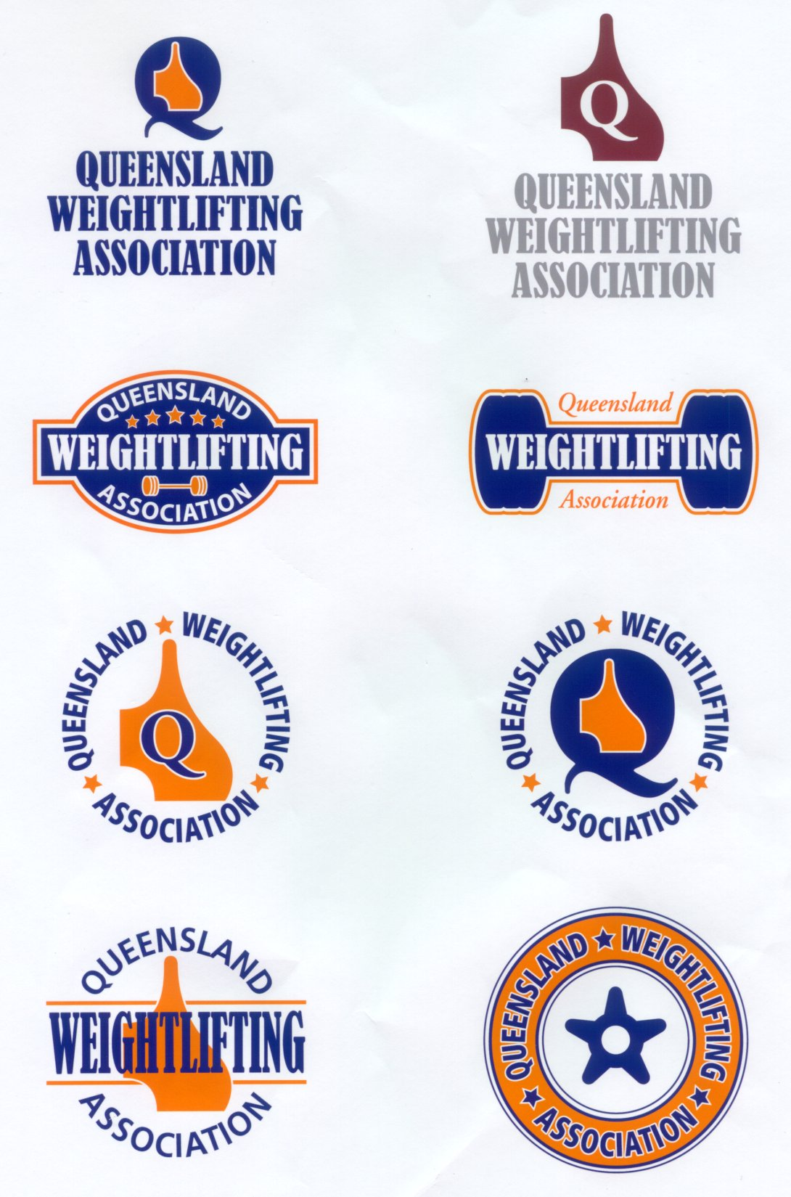
Designs by: MGA Graphics, PO Box 5443 Manly Q 4179. Copyright © 2002.

