vWeightlifting Queenslandv
.

Vol 9 No 2 Jul 2001
The Official Journal of the Queensland Weightlifting Association Inc.
PO Box 1056, Capalaba, Qld 4157
Tel: (07) 3823 1377 Fax: (07) 3823 1371

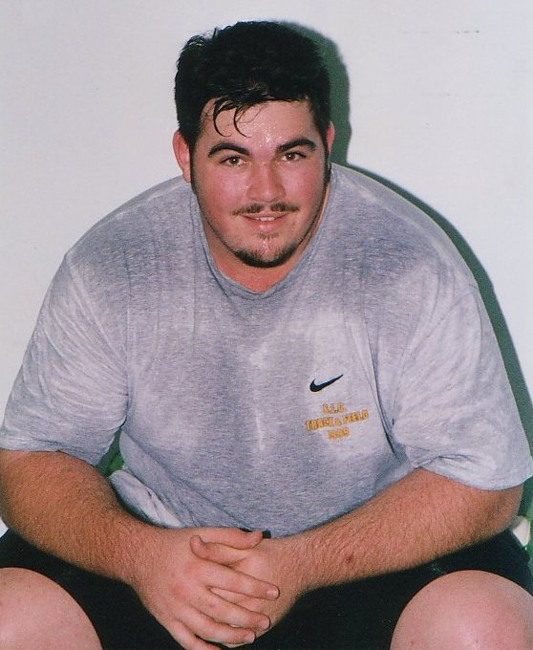
Damon Kelly was part of the Australian team for the World Junior Championships in Greece, together with fellow Queenslanders Kristie Amadio, Melissa Nightingale, Amanda Phillips and Deborah Lovely.
QWA Committee 5
Diary of a World Championships Trip 6
World Junior Championships 8
New Nudgee Weights Room 15
Lifting in the Outback 16
Qld Open and U20 Championships 18
Team Selections 19
National Championships Team 19
Movers and Shakers 21
Goodwill Games 22
National Masters Results 23
Interview with Miles Wydall 26
The Wisdom of Age 27
Ray Louden’s story 28
East Asian Games 30
SPORTSCOVER – QWA insurance 35
Proudly Supported by:




Queensland Weightlifting Association Inc.
Office: The Velodrome, The Sleeman Sports Complex,
Chandler 4155
Postal Address: PO Box 1056, Capalaba 4157
Telephone: (07) 3823 1377
Facsimile: (07) 3823 1371
Email: qwa@powerup.com.au
Web Site: http://www.qwa.org
Executive Director: Ian Moir
Administrative Officer: Kylie Booth
Development Officer: Scott Robinson
Newsletter Editor: Angela Wydall (angie@powerup.com.au)

The QWA Management Committee

Patron: Bert Hobl
President: Barry Harden
Vice President: Mike Keelan
Secretary: Jo Garner
Treasurer: Ross Gagliardi
Executive Officer: Greg Hobl
Executive Officer: Peter Thomsen
Executive Officer: Kylie Booth
Executive Officer: Brad Monk

Acknowledgement - Sponsors of the QWA
The Queensland Weightlifting Association is extremely appreciative of the financial assistance provided by the following:

Queensland Government –Sport and Recreation Queensland

CoolSpeak.Com (http://www.coolspeak.com)

Acknowledgement - Corporate Members

Gremel Promotions

Acknowledgement - Photographic Services

Be Seen Photographics

Disclaimer
The views represented in this publication do not necessarily reflect those of the editor or of the Officers or Management Committee of the QWA.

Competition Calendar

<TBODY>Date | Competition | Location
June 23 | Telstra National Masters Championships | Sunshine Coast, Qld
June 29 | TWA Open Club Competition | Toowoomba
June 29 - July 9 | World Junior Championships | Athens, Greece
July 7 | Sunshine Coast Club Open Competition | Sunshine Coast
July 28 | QWA League Round 3 & Masters H/cap Round 3 | Toowoomba
August 11 - 13 | Telstra National U20 & Open Championships | Sydney
August 24 | TWA Open Club Competition | Toowoomba
August 24 | Cougars Club Open Competition | Chandler
August 29 – Sept 1 | Goodwill Games | Brisbane
September 8 | Qld Masters H/cap Final | Sunshine Coast
September 22 | QWA League Final | Brisbane
October 6 | Sunshine Coast Club Open Competition | Sunshine Coast
October 6 - 14 | World Championships & Oceania Championships | Guam
October 12 | TWA Open Club Competition | Toowoomba
October 27-28 | National Team Challenge | Adelaide
November 3 | Qld All Schools Championships | Brisbane
November 9 - 11 | Junior International Competition | Greece
November 17 | QWA Annual Awards
November 24 | Queensland 2000 | Brisbane
December 1 | Sunshine Coast Club Open Competition | Sunshine Coast
December 7 | TWA Open Club Competition | Toowoomba
December 8 | Cougars Club Open Competition | Chandler
December 8-9 | Junior Oceania Championships | Kiribati</TBODY>

The 2001 Telstra National Age Group Team Challenge will be held in Adelaide at a date yet to be confirmed.
The closing date for lodgment of entries for all QWA events is 15 days prior to the competition date.
The minimum qualifying standard for entry to the Telstra Queensland Open Championships is C Grade.
The minimum qualifying standard for entry to the Telstra Queensland Under 20 Championships is D Grade.
There is no minimum qualifying standard for Qld Under 16, Under 18, School or Masters Championships.
The qualifying period for the Telstra Qld Open & Under 20 Championships is 1 June 2000 – 1 June 2001.
The qualifying period for the Queensland 2000 Tournament is 1 January 2001 – 30 September 2001.
Queensland Teams for National Championships will be selected 5 weeks prior to the date of the relevant event.
QWA Committee for 2001

The QWA committee meets monthly to discuss a wide variety of issues affecting the QWA - from rules and regulations, to the promotion of our sport, to funding and events. Members of the committee are voluntary and give their time outside committee meetings to carry out voluntary work that contributes to the success of our organisation.

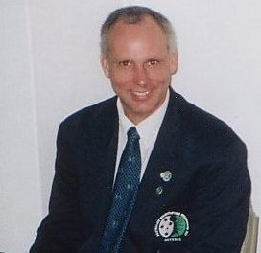  PRESIDENT  Barry Harden | 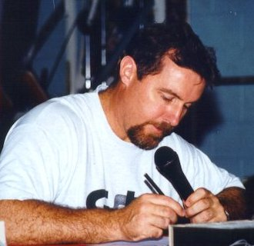  VICE PRESIDENT  Michael Keelan
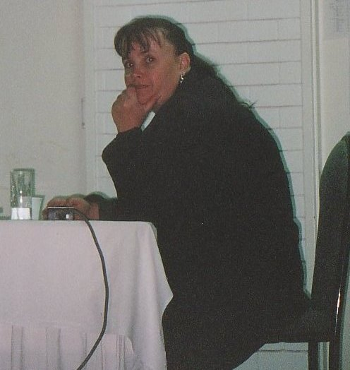  SECRETARY  Jo Garner | 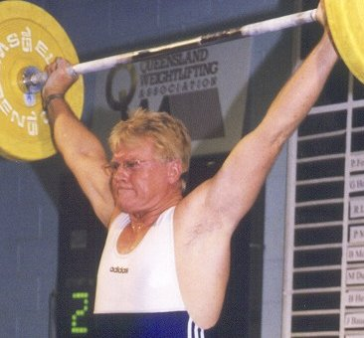  TREASURER  Ross Gagliardi
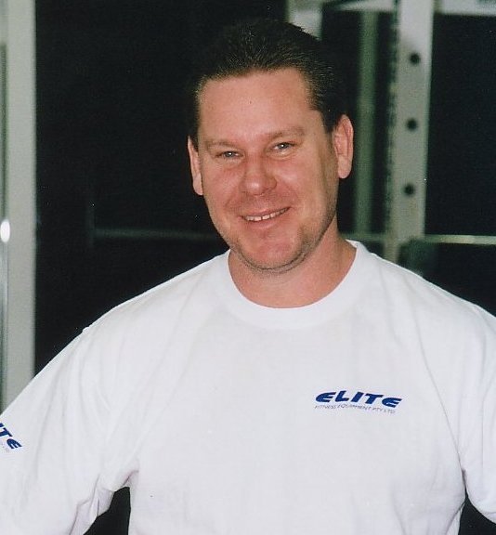  EXECUTIVE OFFICER  Peter Thomsen | 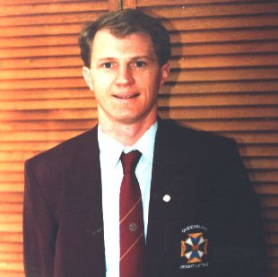  EXECUTIVE OFFICER  Greg Hobl
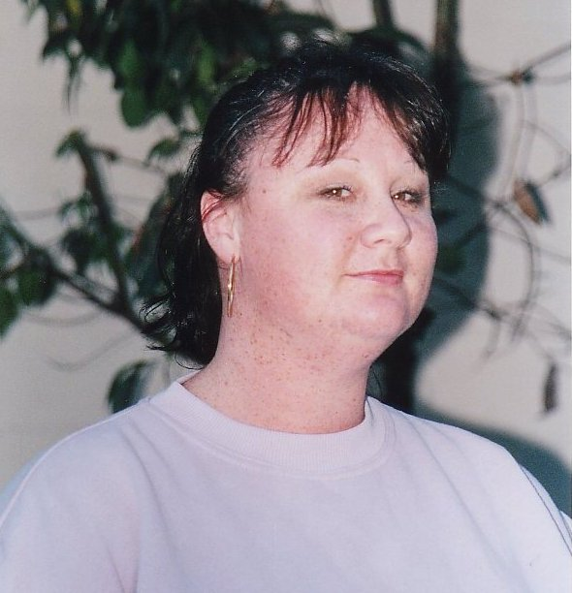  EXECUTIVE OFFICER  Kylie Booth | 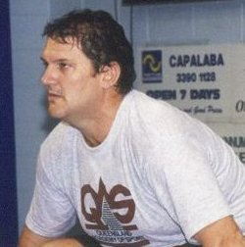  EXECUTIVE OFFICER  Brad Monk
Diary of a World Championships Trip
By Kristie Amadio

It was 5:00 PM on the 29th of June that five restless travelers boarded their Ansett flight bound for Sydney. As dubious noises began echoing around the cabin, the immediate thoughts of most passengers turned to Ansett’s recent grounding.

6:15 PM we had been traveling for an hour and already Deb, Amanda and I had managed to deplete Mel’s selection of magazines to zero. How would we pass the next 33 hrs ? We solved that problem by bursting through customs at Sydney airport and hitting the duty free stores with gusto, losing Damo in the process. We also considered trying to convince people that we were the New Zealand ping pong team but rejected the idea instead, deciding that we were team Adidas or “The Adisasians.”

Co-ordination and athleticism was displayed by us all at Athens airport while playing catch/hockey/soccer/volleyball/squash. Our skills spoke for themselves when our ball landed squarely on a not so fortunate passenger's head. Needless to say we retired from our game and I tried franticly to remove the pungent smell of Bangkok from my hair. The end result was that I eradicated the smell but then had a suspicious aroma of male cologne from Estee Lauder.

The flight from Bangkok to Athens was definitely surprising at first. As well as the human passengers there was a feline creature that we were fortunate enough to be sitting next to on the flight. The cat was very well toilet trained, 9 hrs without a peep.

Unfortunately our flight went for 9 hrs 10 minutes. Those last 10 minutes were absolute agony. Imagine our delight when boarding the plane for Thessoliniki we found that not only do Olympic airlines allow cats on board but dogs are also allowed. Luckily this dog was well briefed in the etiquette of toiletry matters and no unpleasant incidents occurred.

On disembarking the plane from Thessoloniki, it was discovered that Damo’s luggage had been lost. Further investigation revealed that it had been left in Athens. After 33 hrs of traveling he had to wait an extra 26 before he could change clothes.

Monday was spent training, checking our the venue (awesome) and sleeping. The previous night we had been issued with accreditation passes which unfortunately proved useless when we tried to enter the VIP section. We gave up and returned to the hotel to eat the first of our meals in Greece – literally. The chicken was trying unsuccessfully to swim in the dripping, the salad bar consisted of buttered carrots, cucumbers glistening with olive oil and lettuce swathed in thick dressing. After inspection of the fruit, we gave that a wide berth after a maggot was discovered making its home in an apple. Nevertheless, we are still here to tell the tale of Tuesday…

The first day of competition for the Australians. Debbie Lewis set two new Under 20 national records with her lift and I set two new Under 18 with mine. After our efforts we slept soundly to wake and watch first Melissa and then Amanda perform. Both put in credible performances and looked cool under the pressure. The following day Mel rewarded herself by buying a top that closely resembled a hazard sign. Despite this fact it proved of little use while crossing the road, the cars just kept coming. It seems pedestrians in Greece have no rights, even on the footpath. Motorbikes often careened down it scattering pedestrians left and right. One even entered a shop.
“Lovely Deb” was the next lifter to compete and finished with an Under 20 National record in the snatch despite an injured back.

Saturday was spent by the pool and cheering on two of our fellow team members – “The New Zealand Adidasians.” After all we were wearing identical tracksuits.

Finally the first and only member of the Australian male team made his debut. Somehow, the announcer had difficulty in recognizing the gender of Damon and introduced him throughout the competition as “Kelly Damon.” He refused to let that upset his performance, however a certain person filming that particular session managed to film it sideways without noticing until the end. Oops!

Tuesday – up at 5:30 am and down to the restaurant to eat our last meal in grease, sorry Greece. On the plane for the long flight home which is where I am now, passing my time by remembering the best quotes from the trip…

Amanda – “It’s too bright to wear sunglasses”
Kristie – “Does this camera take photo’s?”
Mel – “I can only eat when I’m hungry”
Damo – “I weigh this much with my boots and my shoes on”
Debbie Lewis – (referring to our accreditation passes) “If we’re not allowed in the doping rooms, how can we get doped?”
Sarah – “I can’t breathe under water for very long”
Mel – (at a restaurant trying to say …something) “a-a..e-e?”
Kristie – (to a lady talking in Greek) “I’m sorry, I don’t speak English”

Reflecting on our trip, none of it would have been possible without our dedicated and ever patient coaches, the time put into our programs and coaching has not gone unappreciated. Also, Cougars for giving us the funding and support – thank you. QWA also for the funding and organization. Our manager, Sam Coffa and team coach Jack Walls we couldn’t have managed without you. At the end of it all, this trip has inspired me, I can’t wait to do it all again next year. Minus the cat on the plane of course.

World Junior Championships Results
Greece, 26 June-9 July 2001

WOMEN 48 kg</TBODY>
Name | Born | Nation | Bwt | Snatch |  | Clean & Jerk |  | Total
PERIS Gemma | 1983 | ESP | 47.14 | 77.5 |  | 90.0 |  | 167.5
GRACIA Betzabe | 1981 | MEX | 46.76 | 72.5 |  | 92.5 |  | 165.0
KARDANOVA Rag. | 1983 | RUS | 47.00 | 72.5 |  | 90.0 |  | 162.5
TOCINO Ma Jose | 1982 | ESP | 46.82 | 70.0 |  | 80.0 |  | 150.0
HENRIQUEZ Inmara | 1981 | VEN | 47.93 | 57.5 |  | 85.0 |  | 142.5
MANSOUR Esmat | 1986 | EGY | 46.30 | 60.0 |  | 77.5 |  | 137.5
GALABAROVA Simona | 1984 | BUL | 47.37 | 62.5 |  | 75.0 |  | 137.5
DE LUCA Enrica | 1981 | ITA | 46.61 | 60.0 |  | 70.0 |  | 130.0
PERRIN Lucie | 1983 | FRA | 47.06 | 55.0 |  | 75.0 |  | 130.0
RESTREPO Marcela | 1983 | COL | 47.77 | 57.5 |  | 72.5 |  | 130.0
DOZOIS Marilou | 1986 | CAN | 47.96 | 55.0 |  | 67.5 |  | 122.5
ARIPOVA Gula | 1981 | UZB | -
AJAMBO Irena | 1982 | UGA | -
HARTATI Sri | 1984 | INA | -
ANAKEE Anthonia | 1982 | NGR | -
KRISHNA Veni M | 1982 | IND | -
UDOH Blessing | 1984 | NGR | - |  |  |  |  |  | </TBODY>

WOMEN 53kg
Name | Born | Nation | Bwt | Snatch |  | Clean & Jerk |  | Total
LIM Jung-Hwa | 1986 | KOR | 52.64 | 82.5 |  | 105.0 |  | 187.5
BAI Xia | 1983 | CHN | 51.04 | 82.5 |  | 102.5 |  | 185.0
TCHOUMADEEVA E. | 1981 | RUS | 52.94 | 80.0 |  | 97.5 |  | 177.5
VELLASMEL Sol. | 1981 | VEN | 52.58 | 77.5 |  | 97.5 |  | 175.0
KASTRITSI Char. | 1983 | GRE | 52.80 | 77.5 |  | 97.5 |  | 175.0
PARK Eun-Jin | 1985 | KOR | 52.95 | 77.5 |  | 97.5 |  | 175.0
SACHMACINSKA B. | 1983 | POL | 52.79 | 75.0 |  | 92.5 |  | 167.5
PARDO Nidia Rosa | 1983 | COL | 52.49 | 70.0 |  | 95.0 |  | 165.0
LIN Mei-Ling | 1982 | TPE | 52.61 | 70.0 |  | 95.0 |  | 165.0
LOZANO Martha | 1982 | COL | 52.28 | 67.5 |  | 90.0 |  | 157.5
TROTSENKO Natal. | 1984 | UKR | 50.63 | 70.0 |  | 85.0 |  | 155.0
DAVIS Amber | 1986 | USA | 52.46 | 70.0 |  | 85.0 |  | 155.0
BROCHU Isabelle | 1981 | CAN | 52.99 | 62.5 |  | 80.0 |  | 142.5
VRIES Portia | 1984 | RSA | 52.67 | 55.0 |  | 75.0 |  | 130.0
BAGAUTDINOVA Kam. | 1984 | KAZ | 52.16 | 55.0 |  | 70.0 |  | 125.0
JUAN Estefania | 1981 | ESP | 52.06 | -
CABIROVA Lena | 1982 | UZB | -
TEN Tatyana | 1981 | UZB | -
PRIKHODKOIYA | 1984 | KAZ | -
RENU Baia Y. | 1982 | IND | -
OKOTIEBO Sade | 1982 | NGR | -
GBODO Franca | 1982 | NGR | - |  |  |  |  |  | </TBODY>

WOMEN 58 kg</TBODY>
Name | Born | Nation | Bwt | Snatch |  | Clean & Jerk |  | Total
CHEN Guoping | 1986 | CHN | 56.77 | 87.5 |  | 117.5 |  | 205.0
KLEJNOWSKA A. | 1982 | POL | 57.74 | 90.0 |  | 115.0 |  | 205.0
BATSIUSHKA H. | 1981 | BLR | 57.95 | 90.0 |  | 102.5 |  | 192.5
GORDON Carissa | 1983 | USA | 56.30 | 80.0 |  | 100.0 |  | 180.0
VILLAR Rusmeris | 1983 | COL | 57.05 | 80.0 |  | 100.0 |  | 180.0
VIDLYVANA Mar. | 1983 | UKR | 57.52 | 80.0 |  | 100.0 |  | 180.0
MACHADO Karyn | 1981 | VEN | 55.98 | 80.0 |  | 95.0 |  | 175.0
KAWAKAMI Tomoko | 1982 | JPN | 57.91 | 75.0 |  | 97.5 |  | 172.5
SOSA Damaris | 1981 | ESA | 55.78 | 72.5 |  | 97.5 |  | 170.0
KARASSEVA Lesiya | 1982 | KAZ | 57.43 | 70.0 |  | 87.5 |  | 157.5
LEWIS Debbie | 1981 | AUS | 57.50 | 70.0 |  | 85.0 |  | 155.0
SMOSARSKA Anna | 1985 | POL | 57.91 | 65.0 |  | 90.0 |  | 155.0
OZIMAKOVA Kristina | 1984 | SVK | 57.58 | 67.5 |  | 85.0 |  | 152.5
AMADIO Kristie | 1985 | AUS | 56.87 | 67.5 |  | 80.0 |  | 147.5
MARINEAU Valerie | 1983 | CAN | 56.49 | 62.5 |  | 75.0 |  | 137.5
KIM Svetlana | 1982 | UZB | -
OZUPE Ifeoma | 1982 | NGR | -
PULEVA Dragomira | 1984 | BUL | -
NEFJI Imene | 1981 |  | -
BORJA Elizabeth | 1982 | COL | -
NAGY Szilvia | 1981 | HUN | -
EBHOMIEN Evelyn | 1981 | NGR | -
LESTARI Beti | 1984 | INA | -
NOVITA | 1984 | INA | - |  |  |  |  |  | </TBODY>

WOMEN 63 kg</TBODY>
Name | Born | Nation | Bwt | Snatch |  | Clean & Jerk |  | Total
SKAKUN Nat. | 1981 | UKR | 60.38 | 100.0 |  | 132.5 | WR | 232.5
KRUTZLER Eszter | 1981 | HUN | 62.64 | 102.5 |  | 127.5 |  | 230.0
KIM Mi-Kyung | 1981 | KOR | 62.10 | 92.5 |  | 110.0 |  | 202.5
RUE Danica | 1982 | USA | 60.54 | 85.0 |  | 105.0 |  | 190.0
BENAVIDEZ Yur. | 1983 | COL | 62.41 | 85.0 |  | 105.0 |  | 190.0
RAMADAN Nahla | 1985 | EGY | 61.09 | 80.0 |  | 105.0 |  | 185.0
HUANG Yu-Chin | 1982 | TPE | 60.09 | 75.0 |  | 107.5 |  | 182.5
PHILLIPS Am. | 1981 | AUS | 60.82 | 77.5 |  | 105.0 |  | 182.5
FERNANDEZ Tat. | 1984 | ESP | 62.10 | 85.0 |  | 97.5 |  | 182.5
MERKER Tatyana | 1983 | RUS | 60.94 | 75.0 |  | 100.0 |  | 175.0
MERAL Muslime | 1982 | FRA | 61.40 | 77.5 |  | 92.5 |  | 170.0
MIYAGI Hisako | 1983 | JPN | 62.60 | 75.0 |  | 95.0 |  | 170.0
GIRARD Christine | 1985 | CAN | 61.28 | 70.0 |  | 97.5 |  | 167.5
OROZCO Yedid | 1981 | MEX | 61.44 | 75.0 |  | 92.5 |  | 167.5
ORSAGOVA Lenka | 1983 | CZE | 60.84 | 75.0 |  | 90.0 |  | 165.0
PETKOVA Rum. | 1982 | BUL | 60.89 | 72.5 |  | 90.0 |  | 162.5
NOVELA Irma | 1983 | MEX | 60.90 | 67.5 |  | 90.0 |  | 157.5
NIGHTINGALE Mel. | 1981 | AUS | 62.43 | 67.5 |  | 82.5 |  | 150.0
SULI Gerta | 1985 | ALB | -
ONAIGHINOR R. | 1982 | NGR | -
UVAROVA Olga | 1982 | UZB | -
HARITA P. | 1982 | IND | - |  |  |  |  |  | </TBODY>

WOMEN 69 kg</TBODY>
Name | Born | Nation | Bwt | Snatch |  | Clean & Jerk |  | Total
MEDINA Angela | 1983 | COL | 67.72 | 102.5 |  | 120.0 |  | 222.5
DOMINGUEZ Cin. | 1982 | MEX | 67.82 | 90.0 |  | 105.0 |  | 195.0
SAITO Rika | 1983 | JPN | 63.41 | 82.5 |  | 105.0 |  | 187.5
GAUME Teresa | 1982 | USA | 68.51 | 82.5 |  | 105.0 |  | 187.5
CRASS Rachel | 1985 | USA | 68.98 | 82.5 |  | 102.5 |  | 185.0
RAMADAN Nagham | 1983 | EGY | 68.41 | 82.5 |  | 100.0 |  | 182.5
MILKINA Nadezda | 1982 | RUS | 66.48 | 77.5 |  | 100.0 |  | 177.5
KYRIAKIDOU Ch. | 1982 | GRE | 63.02 | 77.5 |  | 97.5 |  | 175.0
VALENTIN Lidia | 1985 | ESP | 64.07 | 77.5 |  | 97.5 |  | 175.0
KOCHLIARIDOU El. | 1981 | GRE | 63.14 | 75.0 |  | 97.5 |  | 172.5
STRANAN Sarah | 1981 | AUS | 68.18 | 77.5 |  | 92.5 |  | 170.0
MUNOZ Estrella | 1982 | ESP | 66.50 | 77.5 |  | 90.0 |  | 167.5
VELAZCO Esther | 1982 | MEX | 67.64 | 75.0 |  | 92.5 |  | 167.5
TROJCAKOVA Luc. | 1981 | SVK | 64.26 | 72.5 |  | 92.5 |  | 165.0
RAVSHANOVA T. | 1982 | UZB | -
NWATU Ijeoma | 1983 | NGR | -
YAMECHI Madel. | 1982 | CMR | - |  |  |  |  |  | </TBODY>

WOMEN 75 kg</TBODY>
Name | Born | Nation | Bwt | Snatch |  | Clean & Jerk |  | Total
YANG Houqin | 1981 | CHN | 73.40 | 102.5 |  | 130.0 |  | 232.5
GAGARINA Natalia | 1983 | RUS | 73.90 | 97.5 |  | 117.5 |  | 215.0
IOANNIDI Christina | 1982 | GRE | 73.63 | 97.5 |  | 115.0 |  | 212.5
SUAREZ Cristina | 1983 | VEN | 73.99 | 90.0 |  | 112.5 |  | 202.5
PLATONOVA D. | 1982 | UKR | 74.46 | 92.5 |  | 107.5 |  | 200.0
LEE Yi-Cheng | 1983 | TPE | 74.47 | 87.5 |  | 105.0 |  | 192.5
IMAHOKO Kazue | 1982 | JPN | 73.56 | 85.0 |  | 102.5 |  | 187.5
ATKINSON Amanda | 1982 | USA | 74.37 | 85.0 |  | 100.0 |  | 185.0
MACEACHERN C. | 1981 | CAN | 74.88 | 90.0 |  | 95.0 |  | 185.0
GALAN Veronica | 1981 | ESP | 72.33 | 80.0 |  | 100.0 |  | 180.0
SHIMOTAMARI Hit. | 1981 | JPN | 70.47 | 80.0 |  | 97.5 |  | 177.5
LOVELY Deborah | 1983 | AUS | 74.58 | 82.5 |  | 95.0 |  | 177.5
NAVARRO Veronica | 1981 | MEX | 72.37 | 75.0 |  | 90.0 |  | 165.0
KAMMENOU Dimitra | 1984 | GRE | 72.76 | 72.5 |  | 92.5 |  | 165.0
YESSIE Kara | 1982 | CAN | 71.32 | 75.0 |  | -
AIAA Boulahne | 1981 | MAR | -
PIRNAZAROVA G. | 1982 | UZB | -
GEETA Rani | 1982 | IND | -
SAILAJA P. | 1982 | IND | - |  |  |  |  |  | </TBODY>

WOMEN +75 kg</TBODY>
Name | Born | Nation | Bwt | Snatch |  | Clean & Jerk |  | Total
HAWORTH Ch. | 1983 | USA | 145.74 | 122.5 |  | 152.5 |  | 275.0
VARGA Viktoria | 1981 | HUN | 95.45 | 115.0 |  | 145.0 |  | 260.0
JANG Mi-Ran | 1983 | KOR | 100.63 | 110.0 |  | 140.0 |  | 250.0
RODITI Ekaterini | 1983 | GRE | 92.63 | 100.0 |  | 125.0 |  | 225.0
KASAPI Vassiliki | 1983 | GRE | 107.18 | 100.0 |  | 120.0 |  | 220.0
SOFFE Kesha-D. | 1982 | NZL | 102.40 | 92.5 |  | 110.0 |  | 202.5
DREGER Marta | 1984 | POL | 80.03 | 82.5 |  | 102.5 |  | 185.0
CHACON Cecilia | 1982 | MEX | 111.41 | 75.0 |  | 105.0 |  | 180.0
LOPATINA Galina | 1981 | AZE | -
SUMATI Devi | 1982 | IND | -
HILLA Grace | 1984 | NGR | - |  |  |  |  |  | </TBODY>

MEN 56kg
Name |  |  | Born |  | Nation | Bwt |  | Sn |  |  | Clean & Jerk |  |  |  | Total
FIGUEROA Oscar |  |  | 1983 |  | COL | 55.79 |  | 117.5 |  |  | 142.5 |  |  |  | 260.0
TAMRAZYAN Makar |  |  | 1981 |  | ARM | 55.47 |  | 105.0 |  |  | 132.5 |  |  |  | 237.5
ISBARA Ertan |  |  | 1982 |  | TUR | 55.72 |  | 110.0 |  |  | 127.5 |  |  |  | 237.5
KALINOV Ivo |  |  | 1982 |  | BUL | 55.72 |  | 102.5 |  |  | 125.0 |  |  |  | 227.5
SALAH Walid |  |  | 1981 |  | EGY | 55.80 |  | 97.5 |  |  | 127.5 |  |  |  | 225.0
SHAHROKHVANDI Seyed |  |  | 1982 |  | IRI | 55.64 |  | 100.0 |  |  | 122.5 |  |  |  | 222.5
ADAM Robert |  |  | 1982 |  | HUN | 55.31 |  | 95.0 |  |  | 120.0 |  |  |  | 215.0
SLABY Petr |  |  | 1983 |  | CZE | 55.89 |  | 92.5 |  |  | 122.5 |  |  |  | 215.0
ANDRIEUX Sylvain |  |  | 1981 |  | FRA | 54.93 |  | 95.0 |  |  | 117.5 |  |  |  | 212.5
KADIBERGENOV S. |  |  | 1985 |  | TKM | 55.48 |  | 100.0 |  |  | 110.0 |  |  |  | 210.0
CANTO Leonel |  |  | 1982 |  | MEX | 53.85 |  | 90.0 |  |  | 112.5 |  |  |  | 202.5
HERNANDEZ Ivan |  |  | 1983 |  | ESP | 55.34 |  | 90.0 |  |  | 112.5 |  |  |  | 202.5
MORENO Raul |  |  | 1984 |  | ESP | 55.66 |  | 92.5 |  |  | 107.5 |  |  |  | 200.0
PICHLER Mario |  |  | 1982 |  | AUT | -
MIRZOYEV Agshin |  |  | 1983 |  | AZE | -
BALINNYA Salim |  |  | 1983 |  | UGA | -
WIDANAGE Chinthana G |  |  | 1981 |  | SRI | -
OLUWAYOMI Ablodum |  |  | 1982 |  | NGR | -
SETIADI Jadi |  |  | 1985 |  | INA | -
OLUPONA Gbenga |  |  | 1981 |  | NGR | - |  |  |  |  |  |  |  |  |  |  |  | </TBODY>

MEN 62 kg</TBODY>
Name | Born |  | Nation |  |  | Bwt |  | Snatch |  |  |  | Clean & Jerk |  |  |  | Total
GHAZARYAN Ar. | 1982 |  | ARM |  |  | 61.66 |  | 130.0 |  |  |  | 165.0 |  |  |  | 295.0
LUKANIN Vlad. | 1984 |  | RUS |  |  | 60.03 |  | 132.5 |  |  |  | 160.0 |  |  |  | 292.5
DANIELYAN Artur | 1983 |  | ARM |  |  | 61.64 |  | 125.0 |  |  |  | 155.0 |  |  |  | 280.0
ALBAGIR Jafar M. | 1982 |  | KSA |  |  | 60.06 |  | 127.5 |  |  |  | 150.0 |  |  |  | 277.5
CHO Hyo-Won | 1982 |  | KOR |  |  | 61.83 |  | 122.5 |  |  |  | 155.0 |  |  |  | 277.5
ARSLAN Emrah | 1982 |  | TUR |  |  | 61.13 |  | 125.0 |  |  |  | 150.0 |  |  |  | 275.0
BRUKHAVETSKI St. | 1981 |  | BLR |  |  | 61.86 |  | 125.0 |  |  |  | 150.0 |  |  |  | 275.0
BAYRAMOV Afgan | 1983 |  | AZE |  |  | 59.88 |  | 120.0 |  |  |  | 150.0 |  |  |  | 270.0
MOHMAD Hamada | 1981 |  | EGY |  |  | 60.02 |  | 117.5 |  |  |  | 142.5 |  |  |  | 260.0
RUBIO Israel | 1981 |  | VEN |  |  | 61.38 |  | 115.0 |  |  |  | 145.0 |  |  |  | 260.0
DIAZ Hector | 1982 |  | COL |  |  | 59.61 |  | 112.5 |  |  |  | 142.5 |  |  |  | 255.0
ZAREINEJAD A. | 1981 |  | IRI |  |  | 60.13 |  | 120.0 |  |  |  | 135.0 |  |  |  | 255.0
MAKHMUDJON T. | 1983 |  | UZB |  |  | 60.86 |  | 115.0 |  |  |  | 140.0 |  |  |  | 255.0
FARKAS Atila | 1982 |  | ROM |  |  | 60.06 |  | 115.0 |  |  |  | 137.5 |  |  |  | 252.5
DEMIREV Demir | 1984 |  | BUL |  |  | 61.14 |  | 115.0 |  |  |  | 137.5 |  |  |  | 252.5
HAMED Ahmad | 1982 |  | EGY |  |  | 61.90 |  | 115.0 |  |  |  | 135.0 |  |  |  | 250.0
OPREA Stelian | 1981 |  | ROM |  |  | 59.85 |  | 110.0 |  |  |  | 135.0 |  |  |  | 245.0
BROWER Henry | 1982 |  | USA |  |  | 59.81 |  | 102.5 |  |  |  | 137.5 |  |  |  | 240.0
MOLDODOSOV Kytman | 1984 |  | KGZ |  |  | 61.64 |  | 110.0 |  |  |  | 130.0 |  |  |  | 240.0
DUB Zbynek | 1981 |  | CZE |  |  | 61.67 |  | 102.5 |  |  |  | 130.0 |  |  |  | 232.5
SMITH Ken | 1982 |  | CAN |  |  | 60.84 |  | 90.0 |  |  |  | 115.0 |  |  |  | 205.0
SANCHEZ Cristian | 1983 |  | ECU |  |  | 59.84 |  | - |  |  |  | 145.0
BAZARBAYEV V. | 1981 |  | TKM |  |  | 60.04 |  | 122.5 |  |  |  | -
SULKJA Renato | 1981 |  | ALB |  |  | 61.88 |  | 125.0 |  |  |  | -
IDROVO Julio | 1981 |  | ECU |  |  | 61.91 |  | - |  |  |  | 142.5
LANGROUDI S. | 1981 |  | IRI |  |  | 61.62 |  | -
NIKRAVESH Mahdi | 1981 |  | IRI |  |  | 84.81
LEWALIY Ibrahim K. | 1981 |  | SLE |  |  | -
KOVALAV Roman | 1982 |  | KAZ |  |  | -
EICHIE Peter | 1982 |  | NGR |  |  | -
BARDHI Rifat | 1983 |  | ALB |  |  | -
GRUJICIC Sasa | 1981 |  | YUG |  |  | -
BANGURA Leon. | 1982 |  | SLE |  |  | - |  |  |  |  |  |  |  |  |  |  |  | </TBODY>

MEN 69 kg</TBODY>
Name | Born | Nation | Bwt | Snatch |  | Clean & Jerk |  | Total
LAVRENYUK Yur. | 1982 | UKR | 68.58 | 152.5 | WR | 170.0 |  | 322.5
AMILCAR Pernia | 1981 | VEN | 68.83 | 135.0 |  | 175.0 |  | 310.0
MUN Hee-Chul | 1981 | KOR | 68.68 | 135.0 |  | 170.0 |  | 305.0
STAMATIADIS Sp. | 1981 | GRE | 68.27 | 137.5 |  | 165.0 |  | 302.5
SANOCKI Bog. | 1981 | POL | 67.77 | 127.5 |  | 170.0 |  | 297.5
SEN Ferit | 1982 | TUR | 68.37 | 130.0 |  | 167.5 |  | 297.5
MECE Armando | 1982 | ALB | 68.42 | 130.0 |  | 162.5 |  | 292.5
IBRAHIM Emad | 1981 | EGY | 68.63 | 125.0 |  | 167.5 |  | 292.5
GUIZA Jorge | 1981 | COL | 68.18 | 127.5 |  | 160.0 |  | 287.5
MUCKENHUBER M. | 1981 | AUT | 68.44 | 127.5 |  | 160.0 |  | 287.5
SAGIR Taner | 1985 | TUR | 67.25 | 130.0 |  | 155.0 |  | 285.0
PETKOV Plamen | 1981 | BUL | 68.75 | 127.5 |  | 157.5 |  | 285.0
ANGULO Edinson | 1982 | COL | 68.57 | 130.0 |  | 152.5 |  | 282.5
SHINTANI Yoshito | 1981 | JPN | 67.39 | 120.0 |  | 157.5 |  | 277.5
STAMATAKIS Nikos | 1982 | GRE | 68.32 | 117.5 |  | 160.0 |  | 277.5
YUSUPOV Sherzod | 1982 | UZB | 68.27 | 120.0 |  | 152.5 |  | 272.5
DUMBERRY Marco | 1982 | CAN | 67.53 | 120.0 |  | 145.0 |  | 265.0
REED George | 1982 | USA | 68.26 | 115.0 |  | 150.0 |  | 265.0
SCHULTZ Danny | 1981 | CAN | 68.81 | 120.0 |  | 142.5 |  | 262.5
ADILGAZIN Daulet | 1981 | KAZ | 64.14 | 120.0 |  | 140.0 |  | 260.0
BRUCE Matt | 1983 | USA | 68.93 | 115.0 |  | 145.0 |  | 260.0
SVRCEK Pavol | 1982 | SVK | 68.61 | 120.0 |  | 135.0 |  | 255.0
BRAUNS Reagan | 1982 | RSA | 67.56 | 105.0 |  | 125.0 |  | 230.0
LEAL Esteban | 1982 | MEX | 68.47 | 92.5 |  | 125.0 |  | 217.5
BARSEGHYAN Ark. | 1983 | ARM | 68.84 | 135.0 |  | -
SEIF Ali Salim | 1982 | ZAN | -
RUDEAN Igor | 1981 | MDA | -
UMASHEV Abai | 1981 | KAZ | -
KANU Baimaro | 1982 | SLE | -
RAUPOV Sukhrob | 1981 | UZB | -
ORON Magnus | 1981 | NGR | -
SUMEGI Zoltan | 1983 | HUN | -
TELE Endri | 1983 | ALB | -
EKPO Felix | 1981 | NGR | -
DABAYA Venceslas | 1981 | CMR | - |  |  |  |  |  | </TBODY>

MEN 77 kg</TBODY>
Name | Born | Nation | Bwt | Snatch |  | Clean & Jerk |  | Total
DAVTYAN Gevorg | 1983 | ARM | 75.56 | 155.0 |  | 187.5 |  | 342.5
ALEKSANYAN Gev. | 1981 | ARM | 76.48 | 155.0 |  | 182.5 |  | 337.5
INCE Izzet | 1981 | TUR | 76.34 | 155.0 |  | 180.0 |  | 335.0
TAKHUSHEV Zaur | 1981 | RUS | 76.17 | 155.0 |  | 172.5 |  | 327.5
MARTIN Michael | 1983 | USA | 76.24 | 150.0 |  | 177.5 |  | 327.5
PSOMIADIS Ir. | 1982 | GRE | 76.67 | 147.5 |  | 180.0 |  | 327.5
KIM Kwang-Hoon | 1982 | KOR | 73.73 | 145.0 |  | 180.0 |  | 325.0
SISIIAC George | 1981 | ROM | 76.36 | 145.0 |  | 180.0 |  | 325.0
NAVARRO Juan | 1981 | ESP | 76.59 | 145.0 |  | 177.5 |  | 322.5
DYDERSKI Dom. | 1982 | POL | 76.48 | 140.0 |  | 180.0 |  | 320.0
BALLESTEROS H. | 1981 | COL | 75.79 | 140.0 |  | 177.5 |  | 317.5
MARKOULAS Geor. | 1982 | GRE | 75.88 | 142.5 |  | 172.5 |  | 315.0
GORCZYCZEWSKI K. | 1983 | POL | 75.20 | 135.0 |  | 175.0 |  | 310.0
AKDENIZ Nejat | 1982 | TUR | 75.95 | 140.0 |  | 170.0 |  | 310.0
ROSU Adrian | 1982 | ROM | 76.45 | 135.0 |  | 170.0 |  | 305.0
NAZAROV Zahid | 1982 | AZE | 75.25 | 130.0 |  | 160.0 |  | 290.0
REDJEPOV M. | 1981 | TKM | 74.34 | 132.5 |  | 152.5 |  | 285.0
CENIGA Michal | 1981 | SVK | 76.65 | 125.0 |  | 152.5 |  | 277.5
DUSIC Admir | 1981 | YUG | 76.45 | 120.0 |  | 140.0 |  | 260.0
KOLOSSOVSKY P. | 1981 | ISR | 76.71 | 132.5 |  | -
LARDNER Ade Yemi | 1982 | SLE | -
BEREZOVSKI Slava | 1981 | MDA | -
TABAEV Machmud | 1983 | UZB | -
KOTENEV Vitalii | 1982 | KAZ | -
SHERIFF Omar B. | 1982 | SLE | -
GAFUROV Akobir | 1982 | UZB | -
KHALMATOV A. | 1982 | KAZ | -
EDWARD Jacob | 1982 | NGR | -
DJUMAMURADOV R. | 1981 | UZB | -
BOPDA Claude | 1982 | CMR | - |  |  |  |  |  | </TBODY>

MEN 85 kg</TBODY>
Name | Born | Nation | Bwt | Snatch |  | Clean & Jerk |  | Total
JIANG Hairong | 1983 | CHN | 82.24 | 167.5 | WR | 195.0 |  | 362.5
SOXAEV Mouk. | 1982 | RUS | 84.19 | 157.5 |  | 195.0 |  | 352.5
MAHROUS Ramzi | 1982 | KSA | 84.46 | 160.0 |  | 192.5 |  | 352.5
NAMALYAN Rudolf | 1981 | ARM | 84.14 | 160.0 |  | 187.5 |  | 347.5
RYBAKOV Andrei | 1982 | BLR | 83.15 | 165.0 |  | 180.0 |  | 345.0
OLONTSEV Maxim | 1982 | RUS | 83.54 | 155.0 |  | 190.0 |  | 345.0
PAPADOPOULOS K. | 1983 | GRE | 84.00 | 152.5 |  | 192.5 |  | 345.0
ATOYAN Gegham | 1982 | ARM | 83.78 | 155.0 |  | 187.5 |  | 342.5
USMANOV Botir | 1984 | UZB | 84.76 | 155.0 |  | 182.5 |  | 337.5
ELMALI Reyhan | 1981 | TUR | 83.49 | 150.0 |  | 180.0 |  | 330.0
CHLEBOSZ Przem. | 1981 | POL | 84.16 | 150.0 |  | 175.0 |  | 325.0
GALIPEAU Julien | 1981 | CAN | 84.62 | 145.0 |  | 180.0 |  | 325.0
SOLIS William | 1981 | COL | 83.91 | 140.0 |  | 182.5 |  | 322.5
PANGONIS Romas | 1982 | LTU | 82.86 | 140.0 |  | 180.0 |  | 320.0
NIKRAVESH Mahdi | 1981 | IRI | 84.81 | 137.5 |  | 170.0 |  | 307.5
BELLOI Antonio | 1981 | ITA | 83.63 | 130.0 |  | 165.0 |  | 295.0
HIRAOKA Yuki | 1983 | JPN | 82.25 | 125.0 |  | 165.0 |  | 290.0
HORDNES Per | 1981 | NOR | 84.38 | 117.5 |  | 150.0 |  | 267.5
HANSSON Oscar | 1982 | SWE | 82.45 | 115.0 |  | 145.0 |  | 260.0
LUNDRAXHIU Muh. | 1982 | ALB | -
MATCHAVRIANI G. | 1985 | GEO | -
AL-KADI Mahmud | 1981 | JOR | -
ALIEV Emil | 1982 | KAZ | -
ISKENDEROV Abas | 1984 | AZE | -
DANAI Kreshnik | 1983 | ALB | -
GARBA Shehu | 1982 | NGR | -
TOMMY Prince H. | 1981 | SLE | - |  |  |  |  |  | </TBODY>

MEN 94 kg</TBODY>
Name | Born | Nation | Bwt | Snatch |  | Clean & Jerk |  | Total
PASHAYEV Nizami | 1981 | AZE | 92.44 | 180.0 |  | 220.0 |  | 400.0
BRATAN Evgheni | 1981 | ROM | 93.52 | 165.0 |  | 205.0 |  | 370.0
GKARIPIS Kostas | 1981 | GRE | 92.86 | 157.5 |  | 207.5 |  | 365.0
BAYAM Talat | 1981 | TUR | 91.72 | 162.5 |  | 200.0 |  | 362.5
TSIRIDIS Athan. | 1982 | GRE | 92.92 | 157.5 |  | 200.0 |  | 357.5
AKHAEV Jabagi | 1982 | RUS | 92.38 | 157.5 |  | 190.0 |  | 347.5
SAMEDOV Alibaj | 1982 | AZE | 92.48 | 155.0 |  | 190.0 |  | 345.0
AUDZEYEV Mikhail | 1982 | BLR | 92.93 | 155.0 |  | 190.0 |  | 345.0
BIRANVAND Moh. | 1981 | IRI | 92.65 | 155.0 |  | 185.0 |  | 340.0
REMEZA Egidijus | 1983 | LTU | 93.05 | 150.0 |  | 180.0 |  | 330.0
HASAN Mohamed | 1981 | EGY | 93.46 | 150.0 |  | 177.5 |  | 327.5
JABLONSKI Marcin | 1981 | POL | 93.03 | 140.0 |  | 185.0 |  | 325.0
TAKEDA Yudai | 1981 | JPN | 93.53 | 140.0 |  | 167.5 |  | 307.5
SOLIS Jose | 1982 | COL | 90.92 | 135.0 |  | 167.5 |  | 302.5
OMORI Tsutomu | 1981 | JPN | 90.86 | 132.5 |  | 165.0 |  | 297.5
OVERKAMP Benj. | 1982 | USA | 93.65 | 130.0 |  | 160.0 |  | 290.0
GUZMAN Adrian | 1981 | MEX | 88.61 | 122.5 |  | 165.0 |  | 287.5
VASSILIOU Marios | 1983 | CYP | 93.47 | 105.0 |  | 130.0 |  | 235.0
GOGIA Besik | 1984 | GEO | -
DANUSHKA Ura | 1981 | SRI | -
STEINER Matthias | 1982 | AUT | -
LEBEDEV Oleg | 1982 | KAZ | -
NOMOFILOV Dmit. | 1982 | KAZ | -
MUHTAROV Fir. | 1981 | UZB | -
SAID Moh. Said | 1982 | ZAN | -
CHIKA Aguji | 1982 | NGR | - |  |  |  |  |  | </TBODY>

MEN 105 kg</TBODY>
Name | Born | Nation | Bwt | Snatch |  | Clean & Jerk |  | Total
DOLEGA Marcin | 1982 | POL | 103.54 | 175.0 |  | 210.0 |  | 385.0
VOROTYNTSEV S. | 1981 | UKR | 104.02 | 165.0 |  | 207.5 |  | 372.5
RYZHANKOU M. | 1984 | BLR | 100.08 | 162.5 |  | 205.0 |  | 367.5
LAPTEV Vladimir | 1982 | RUS | 102.81 | 165.0 |  | 185.0 |  | 350.0
BURGENER Casey | 1982 | USA | 104.29 | 162.5 |  | 187.5 |  | 350.0
KONSTANTINIDIS V. | 1982 | GRE | 96.26 | 152.5 |  | 190.0 |  | 342.5
HAGGAG Mohamed | 1981 | EGY | 100.50 | 145.0 |  | 180.0 |  | 325.0
RABIEI Vahid | 1982 | IRI | 102.94 | 150.0 |  | 170.0 |  | 320.0
OCORO Edwin | 1982 | COL | 103.71 | 145.0 |  | 175.0 |  | 320.0
CHEVAUX Lenny | 1981 | FRA | 104.04 | 145.0 |  | 175.0 |  | 320.0
MATYKIEWICZ T. | 1982 | CZE | 98.67 | 140.0 |  | 177.5 |  | 317.5
HERGER Edward | 1981 | USA | 99.35 | 147.5 |  | 170.0 |  | 317.5
ZARGANI Chader | 1981 | IRI | 97.18 | 145.0 |  | 165.0 |  | 310.0
BAKER Heinz | 1982 | NZL | 103.49 | 140.0 |  | 160.0 |  | 300.0
MANABE Naoyuki | 1981 | JPN | 104.54 | 130.0 |  | 170.0 |  | 300.0
SMIT Riaan | 1982 | RSA | 103.72 | 125.0 |  | 155.0 |  | 280.0
TAKHAR Rat. | 1981 | CAN | 95.95 | 115.0 |  | 150.0 |  | 265.0
RIZO Hector | 1984 | MEX | 94.52 | 125.0 |  | 135.0 |  | 260.0
LURECA Rashid | 1981 | UGA | -
JAYATILAKE D. | 1986 | SRI | -
TOSHKULOV M. | 1981 | UZB | -
BALA Isa | 1984 | ALB | -
MAMEDOV Aydin | 1982 | AZE | -
OMOGBAI Sunday | 1983 | NGR | -
GANIEV Akram | 1981 | UZB | - |  |  |  |  |  | </TBODY>

MEN +105 kg</TBODY>
Name | Born | Nation | Bwt | Snatch |  | Clean & Jerk |  | Total
KARASIOV Siarhei | 1981 | BLR | 124.76 | 185.0 |  | 225.0 |  | 410.0
TSIAMRUK Al. | 1981 | BLR | 113.09 | 180.0 |  | 225.0 |  | 405.0
KOZLOV Andrei | 1982 | RUS | 116.59 | 170.0 |  | 215.0 |  | 385.0
AN Yong-Kwon | 1982 | KOR | 139.25 | 180.0 |  | 205.0 |  | 385.0
DING Xin | 1983 | CHN | 145.30 | 175.0 |  | 202.5 |  | 377.5
LINNIK Alexei | 1982 | RUS | 119.80 | 170.0 |  | 205.0 |  | 375.0
GANZLER Gabor | 1981 | HUN | 130.84 | 165.0 |  | 200.0 |  | 365.0
BULAUSKAS A. | 1983 | LTU | 137.29 | 152.5 |  | 197.5 |  | 350.0
EHSSAN M. | 1984 | EGY | 124.10 | 150.0 |  | 195.0 |  | 345.0
KAMKAR Soheil | 1981 | IRI | 130.49 | 150.0 |  | 192.5 |  | 342.5
MOREAU J. | 1982 | USA | 119.40 | 145.0 |  | 180.0 |  | 325.0
BRAN Joel | 1981 | GUA | 122.36 | 137.5 |  | 175.0 |  | 312.5
KELLY Damon | 1983 | AUS | 143.99 | 130.0 |  | 177.5 |  | 307.5
GARZA Edgar | 1982 | MEX | 117.87 | 135.0 |  | 160.0 |  | 295.0
KOLOKOLTSEV O. | 1981 | UKR | 113.59 | - |  | 230.0
AMANO M. | 1981 | JPN | 119.86 | - |  | 192.5
LUBEGA R. | 1981 | UGA | -
CHRISTOPHER J. | 1983 | NGR | -
TSERTSVADZE A. | 1983 | GEO | - |  |  |  |  |  | </TBODY>

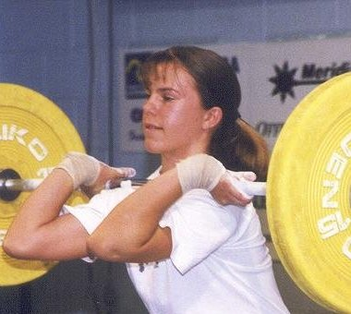 | 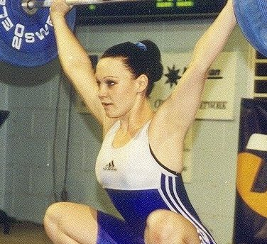 | 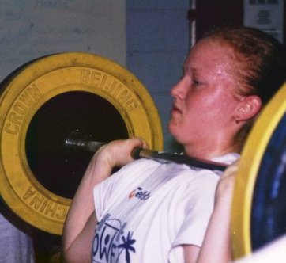
Kriste Amadio(58kg) | Melissa Nightingale(63kg) | Amanda Phillips(63kg)
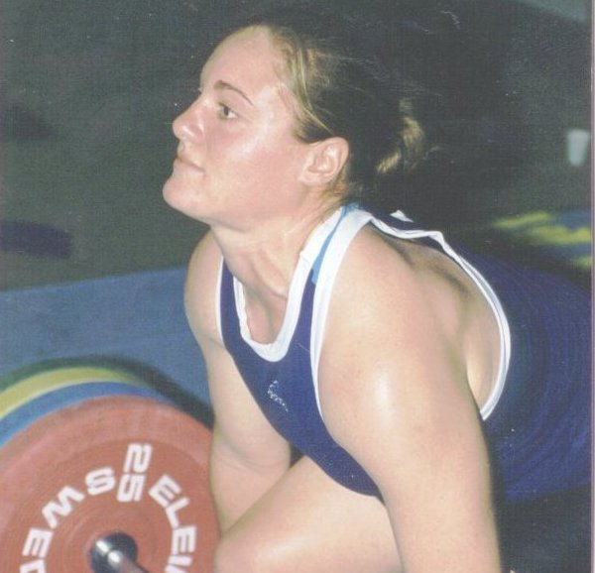 | 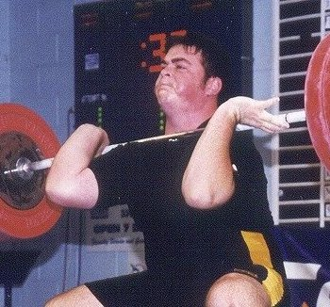 | Queensland's 2001World Junior Championships Representatives
Deborah Lovely(75kg) | Damon Kelly (105+kg)

New Nudgee Weights Room

The new weightlifting and weight training facility at Nudgee College is now open. The new gym was built at a cost of half a million dollars and is one of the best weightlifting facilities available in Australia.

The facility includes :
- 6 weightlifting platforms
- Eleiko bars and weights
- Elite fitness machines
- Dumbells
- Digital weighing scales
- Males and female showers and change facilities
- Rowing Machines
- Bikes
- Treadmill
- Swiss balls
- Punch Bags

Nudgee coach Peter Thomsen coaches a variety of lifters of all ability levels and welcomes new lifters and athletes from other sports.

Membership price for Nudgee gym is $30 /Month.

The gym is open Mon – Fri 9am-6pm, or by arrangement.
For more information contact Peter Thomsen on 3865 0590.

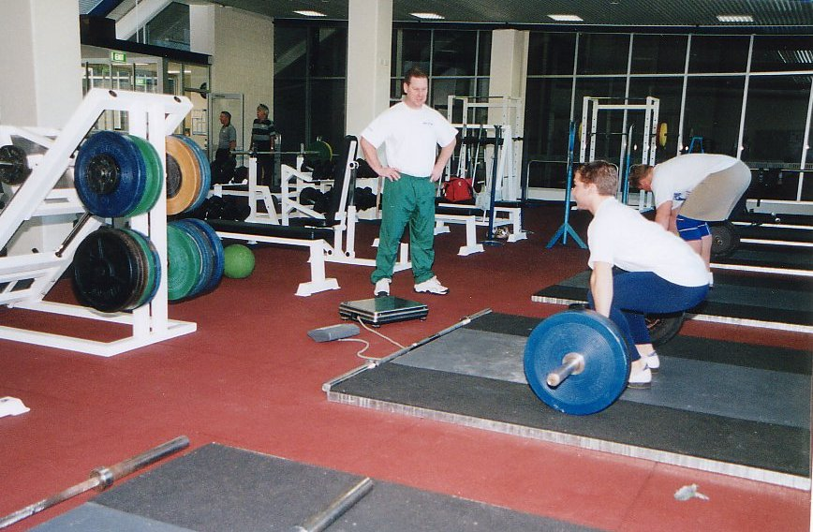

Peter Thomsen coaches David DeRose and Paul Rutherford at the Nudgee college gym.

Lifting In The Outback
By Ian Moir

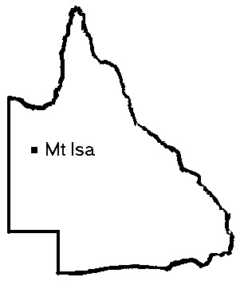
Many years ago, when I was a keen motorcyclist, the thought entered my head to take a ride out to Mount Isa – because it was there. For reasons that are now long forgotten, I never took that trip. But last month, I finally did make it to “The Isa”. Not astride a fuel-injected 1100cc suicide machine as once planned, but on board the daily Ansett flight from Brisbane (I’ll make no comparisons for fear of litigation), in the company of Mike Keelan and Joel Wilson.

The three of us were invited by the Mount Isa Weightlifting Club to spend the weekend in this outback city, which is built over the largest underground mine in the southern hemisphere, located more than 1600km from Brisbane. The aim of our visit was to provide as much assistance and encouragement as we could to the locals who are already doing a magnificent job organising weightlifting in our state’s west, and to get a handle on the challenges that they face in this isolated community as well as the opportunities that exist, so that we can work together to find practical ways to support and accelerate the development taking place in this area.

Alan Dredge and Peter Langdon coordinated things from the Mount Isa end and they met us on arrival on Friday, 1st June. Alan and Peter combine to create the driving force behind the weightlifting scene in Mount Isa, and they are ably assisted by Harry and Elizabeth Hovasapian.

With a population of around 20,000 the city of Mount Isa itself is not all that different in appearance to many regional centres except for the enormous ore processing plant that dominates the skyline, but take a few steps from the edge of town and civilisation gives way to the vast expanse of central Australia, with its dry river beds and red earth dotted with clumps of spinifex. So how did weightlifting find its way to this outpost? Well, it’s been a long time coming. Alan Dredge attended the first weightlifting coaching course run by Mike Keelan for the QWA back in 1983 when Mike was a “new Australian”. As Alan progressed through the ranks of the Police Service and the PCYC movement, he kept in touch with weightlifting, finally finding in Mount Isa a number of people who were ready and willing to support the establishment of a weightlifting club within the PCYC. Over the past few years a number of exchanges have taken place, with Alan and Peter attending QWA meetings and competitions in Brisbane, and Mike conducting coaching and referee courses in Mount Isa in 1999.

The timing of our latest visit couldn’t have been better. Over the previous 10 months or so, Peter had built up a squad of young lifters, regularly training at the PCYC. From this group came Mount Isa’s first state weightlifting representatives, in the forms of Daniel Ayers and Lawrence Cunado, who achieved 1st place and 4th place respectively at the Telstra 2001 National Under 16 Championships, held in Melbourne back in April.

Arriving around midday, we had a few hours to rest up and prepare for the busy days ahead. Our schedule included a Club Referee course on Friday evening, a competition on Saturday morning, and a coaching course from Saturday afternoon through Sunday, with a coaching clinic running simultaneously on Sunday morning.

Using the Referee training resources developed by the AWF last year, 14 participants worked through the Club Referee course on Friday night, gaining the knowledge that they will use to assist with the organisation and conduct of future competitions.

Getting an early start on Saturday morning, we prepared for the day’s event – the 2001 North West Queensland Tournament. I took up a familiar position with microphone in hand, Joel joined the seven Mount Isa lads who would be doing the hard work on the platform, and Mike and Peter set about warming them all up, while Harry, Elizabeth and Alan positioned themselves in the referees’ chairs. By the time the competition was over, five lifters had achieved a total of fourteen personal best results and Joel had put on a tremendous display that inspired all those present, narrowly missing attempts at national U16 records in both the snatch and the clean & jerk.

After a short break, Mike got the Coaching course underway and I settled into a chair at the back of the room and veged-out for a while, rising to assist with the practical sessions later in the day. Joel left the club and headed back to his billet, rejoining us later at the Carpentaria Buffalo Club for dinner, along with Peter and his wife, and Harry and Elizabeth.

The next morning Mike continued the intensive Coaching course, and Peter and I spent a few hours going over basic technique with the lifters who had managed to drag themselves back to the gym on Sunday.

By all accounts the weekend was a great success. Guided by Alan and Peter, and now with more referees and more practicing coaches, the Mount Isa club shows all the signs of growing into a vibrant centre for weightlifting. And I’m sure that in the not too distant future more and more lifters will be making the journey to Mount Isa from the south east, and many more Mount Isa lifters will be travelling far and wide to compete at higher levels. Finally, I’d like to sincerely thank Alan Dredge for his perseverance, dedication and hospitality.

2001 Queensland Open & U20 Championships
Toowoomba Weightlifting Association, Toowoomba Qld
16 July 2001

Name YOB Club Bwt Sn C&J Total Sinclair Forbes Place
Women Open U20
53kg Category
Sherry Bower 86 Windaroo Valley 48.50 45.0 52.5 97.5 133.090 628.959 1
58kg Category
Kristie Amadio 85 Cougars 57.50 62.5 83.0 145.0 176.808 176.808 1 1
Diana Loy 64 UQ 58.00 60.0 77.5 137.5 166.816 166.816 2
Bianca Gastberger 84 Windaroo Valley 56.40 45.0 55.0 100.0 123.351 896.859 2
69kg Category
Melissa Nightingale 81 Cougars 64.00 72.5 87.5 160.0 184.100 782.541 1 1
Tanya Harden 78 Sunshine Coast 63.90 55.0 75.0 130.0 149.697 826.170 Guest
Shari Cunningham 85 Cougars 67.00 52.5 62.5 115.0 129.473 782.564 2
75kg Category
Deborah Lovely 83 Cougars 74.30 80.0 95.0 175.0 188.847 188.847 1 1
75+kg Category
Melissa Bethune 79 Toowoomba 150.90 80.0 100.0 180.0 180.000 180.000 1
Rebecca Marks 84 Windaroo Valley 87.00 57.5 67.5 125.0 128.739 128.739 1

Men
56kg Category
Troy Hewkins 86 Windaroo Valley 50.80 60.0 77.5 137.5 231.231 231.231 1
62kg Category
John Yamasaki 84 Cougars 61.00 72.5 92.5 165.0 237.683 2635.842 1
69kg Category
Joel Wilson 86 Cougars 65.70 92.5 115.5 207.5 282.904 1303.434 1 1
Ryan Shinn 80 Mackay 69.00 75.0 107.5 182.5 240.535 601.606 2
77kg Category
David DeRose 82 Nudgee 71.70 90.0 117.5 207.5 266.692 618.104 1 1
James Turner 78 Cougars 75.00 77.5 115.0 192.5 240.591 240.591 2
James McIntyre 84 Vikings 75.00 75.0 97.5 172.5 215.595 215.595 3 2
85kg Category
Greg Hobl 60 Toowoomba 80.80 100.0 125.0 225.0 269.468 269.468 1
Barry Harden 59 Sunshine Coast 84.30 90.0 110.0 200.0 234.254 234.254 2
94kg Category
Ken Chandler 76 Cougars 93.00 115.0 150.0 265.0 296.452 296.452 1
Peter Thomsen 64 Nudgee 93.70 97.5 130.0 227.5 253.692 253.692 2
Robert Butler 82 Cougars 88.10 92.5 117.5 210.0 240.712 240.712 3 1
105kg Category
Paul Wheeler 71 Nudgee 97.40 117.5 145.0 262.5 288.158 288.158 1
Adam McDonald 64 Cougars 104.60 115.0 140.0 255.0 272.813 491.487 2
105+kg Category
Anthony Martin 79 WA 143.80 157.5 200.0 357.5 358.649 N/A Guest
Damon Kelly 83 Cougars 143.50 130.0 180.0 310.0 311.044 1506.619 1 1
Dallas Turnbull 78 Toowoomba 128.60 105.0 130.0 235.0 238.880 1374.763 2
Paul Ruhterford 84 Nudgee 130.40 87.5 115.0 202.5 205.393 486.291 2
Best Lifter Awards
 | Open | Under 20
Male | Damon Kelly | Damon Kelly
Female | Deborah Lovely | Deborah Lovely
William Faulkner Performance Awards
 | Open | Under 20
Male | Damon Kelly | John Yamasaki
Female | Tanya Harden | Bianca Gastberger

Records
Name | Cat | Lift | Weight | Age | Level
Kristie Amadio | 58kg | Cl & Jk | 83.0 | U16 | Qld, Aus
Kristie Amadio | 58kg | Cl & Jk | 83.0 | U18 | Qld, Aus
Kristie Amadio | 58kg | Cl & Jk | 83.0 | U20 | Qld, Aus
Troy Hewkins | 51kg | Cl & Jk | 77.5 | U16 | Qld, Aus
Troy Hewkins | 51kg | Total | 137.5 | U16 | Qld, Aus
Troy Hewkins | 51kg | Cl & Jk | 77.5 | U18 | Qld
Troy Hewkins | 51kg | Total | 137.5 | U18 | Qld
Joel Wilson | 69kg | Cl & Jk | 115.5 | U16 | Qld, Aus
Joel Wilson | 69kg | Total | 207.5 | U16 | Qld, Aus
Damon Kelly | 105+kg | Snatch | 130.0 | U18 | Qld
Damon Kelly | 105+kg | Cl & Jk | 180.0 | U18 | Qld
Damon Kelly | 105+kg | Total | 310.0 | U18 | Qld

Team Selections
By Mike Keelan

I have been in weightlifting a long time now, and it was a great experience for me recently to work alongside two respected colleagues, Greg Hobl and Peter Thomsen, on the QWA Selection Committee. Our mission was to select the best weightlifters in Queensland to represent our great state (sounds like Peter Beattie) at the forthcoming National Championships which will take place in Sydney on 11-12 August 2001.

As you can imagine, much debate and deliberation took place to reach consensus, and at the end of it all I believe we selected the strongest and best qualified QWA Open and Junior teams ever assembled to contest the National Championships.

With only 30 team spots up for grabs the competition, as expected, was fierce among the lifters. Likewise, only four coaching positions and one Manager position had to be filled. So how does the QWA go about selecting lifters, coaches and managers?

The process has to be fair, equitable and accountable, it also has to be clearly understood by all parties. To this end the QWA has developed Team Selection and Coach/Manager Selection Policies. These policies were included in the last issue of the QWA newsletter. These polices are like true `dynamic’ documents which can and will be changed to produce better future outcomes for one and all if needed.

During the selection process it became obvious that the QWA, as a result of its coach education and training development program, has a plethora of coaches capable of being selected for respective team positions. And, it has also become apparent for the need to look at possible changes to the existing policies to further strengthen our future teams.

I will begin with the lifter’s responsibilities. A good performance at the Nationals can only emanate from proper preparation, which means adherence to a sound and scientific training and competition program. Accordingly, in the future should we expect lifters to follow prescribed programs, attend Squad Meets and lift in nominated competitions within the `qualifying period’ where they will be able to express their lifting talent and at the same time have their improvement monitored? If the answer to this question is yes, then the QWA will need to consider putting team coaches in place one year before the event. These coaches would nominate a respective squad of lifters and nurture the individual talents of those Squad lifters by assisting them with all matters concerned with reaching potential – nutrition, mental preparation, recovery, technique enhancement, goal setting etc…

Team coaches in the above case would obviously do more than just look after the lifters in the competition warm-up and on the platform during the `big’ day. Instead the coaches would play and integral role in the development of the individuals and the ultimate team performance.

Future team coaches will need to demonstrate to the Selection Committee that they have the skills, knowledge and experience that extend above the existing Coach Selection Criteria contained within the Policy. During the preparation period appointed coaches, in conjunction with the lifters’ personal coaches, will need to:
- Assist lifters to follow sound, scientific training programs.
- Enhance lifter’s skills by employing video analysis for example.
- Provide nutritional advice.
- Discuss the most appropriate bodyweight categories that lifters should aim to compete in during the next National Championship.
- Ensure lifters are aware of, understand and employ appropriate recovery methods.
- Discuss the competition program leading up to the Nationals.
- Ensure lifters are aware of, understand and employ core stability training methods.
- Work with lifters and personal coaches to establish SMART goals.
- Work with all lifters and their personal coaches to establish `team cohesion’ and support mechanisms.
- Become a `Coach Mentor’ to lifters personal coaches.
- Be an active deliverer of topics contained within the QWA’s Coach Education and Training Program.

During the competition coaches will need to:
- Assist the lifter to make weight for the agreed bodyweight category.
- Administer appropriate rehydration methods.
- Provide massage.
- Administer specific warm up techniques.
- Arouse the lifter to optimum performance levels and provide motivation.
- Administer first aid in the unfortunate occurrence of injury.
- Refer the lifter to medical professionals if required.

This list is by no means exhaustive and more thought would have to be given to come up with the best possible program. If you have any ideas please let the QWA know!

In essence what this tells us is that future coaches and lifters will need to demonstrate the commitment, skills, competencies and experience that are required to obtain the best possible results on the day of the National Championships which will hopefully lead to greater opportunities for one and all.

The QWA will need to ensure that coaches continue to access education and training that will ensure that personal development is enhanced. The QWA will therefore continue to assist our affiliated clubs and their coaches to obtain funding for this education and training through the Queensland Government’s Community Sport, Recreation and Development Program. Or the QWA will allocate funding aimed at identified individuals who have demonstrated a commitment to coaching and wish to improve their competencies.

The QWA looks forward to hearing reader’s views.

National Championships Team

The QWA Selection Committee has nominated the following team for the 2001 National Open & Under 20 Championships - Sydney 11 & 12 August 2001:

Men - Open  62kg John Yamasaki  69kg Ben Turner  69kg Joel Wilson  77kg Jason Power  94kg Ken Chandler  105kg Paul Wheeler  105kg Adam McDonald  +105kg Damon Kelly  Reserves: Troy Hewkins; David DeRose | Men - U20  56kg Troy Hewkins  62kg John Yamasaki  69kg Joel Wilson  69kg Ben Turner  77kg Jason Power  77kg David DeRose  94kg Robert Butler  +105kg Damon Kelly  Reserves: Paul Rutherford, James McIntyre

Men's Team Coaches
Miles Wydall
Peter Thomsen

Women - Open  48kg Karuna Jones  58kg Kristie Amadio  58kg Diana Loy  63kg Melissa Nightingale  69kg Amanda Phillips  75kg Deborah Lovely  +75kg Melissa Bethune  Reserves: Sherry Bower, Tanya Harden | Women - U20  48kg Sherry Bower  58kg Kristie Amadio  63kg Melissa Nightingale  69kg Amanda Phillips  69kg Shari Cunningham  75kg Deborah Lovely  +75kg Rebecca Marks  Reserve: Bianca Gastberger

Women’s Team Coaches
Michael Keelan (Head Coach of Delegation)
Scott Robinson

Manager
Ian Moir

Movers and Shakers

Welcome back to Anthony Martin, who has returned to Queensland after nearly two years in Western Australia. Although he’ll be lifting for WA at the 2001 national championships, Anthony’s dusting off his maroon tracksuit in preparation for next year.

And a welcome back of sorts to Bill Faulkner who has made a full recovery from his recent bout of ill health and is rapidly getting back into his old routine – working 8 days a week.

Steve and Michelle Kettner are two new additions to the QWA membership this year. Steve is the Sport Competition Supervisor for the 2001 Goodwill Games and has been living in Brisbane since last December. Although the Kettners will be moving on at the end of the year, as we all know, ‘tis better to have been a Queenslander for a year, than never to have been a Queenslander at all (apologies to Mr Shakespear). Welcome aboard Steve and Michelle, even if only for a short time.

Bon voyage to Laurence Chalip who’s returning to his native America in August to take a new job in Texas. Laurence was President of the QWA for four years from 1997. It’s always sad to farewell a friend, but we wish Laurence and his lovely wife Pamela well in their future endeavours states-side.

Farewell for now to Jim Turner. Just when we thought Jim was going to settle in at the Nudgee club, coaching with Thommo, he’s decided to go and swan about in England for a while. Ah, the impulsiveness of youth. Have a great time Jim, and see if you can find Tim Oberg over there and try to keep him out of trouble.

Goodwill Games

2001 Goodwill Games organisers have reassured there are plenty of seats still up for grabs for the August-September sporting spectacular. The news comes on the back of a huge rush for tickets after they went on sale on Friday, April 20. Tickets were selling at more than 120 per minute during the first few hours of trading, with Weightlifting being one of the most popular events.

2001 Goodwill Games Chief Executive Campbell Rose stressed plenty of tickets were still available to sessions in every sport, including Weightlifting. "We still have more than 70% per cent of our tickets for sale,'' Mr Rose said. "However, because tickets to all events are selling so fast, we urge patrons to buy their tickets early, so as to avoid disappointment.''

The Weightlifting competition for the 2001 Goodwill Games will run over three days from Thursday, August 30 to Saturday, September 1 and see 16 of the world's top men and 16 of the world's best women striving for Goodwill Games glory. A total of four events will be contested - women's super heavyweight (+75kg), men's super heavyweight (+105kg), men's 85kg and women's 69kg. Weightlifting is one of six sports being staged at the BCEC - in the heart of the Goodwill Games' Hub at South Bank.

Tickets for the Games can be purchased through the games’ official ticketing agent, ticketek on 133 877 or through their website at www.ticketek.com.au.

For further information on the 2001 Goodwill Games, go to www.goodwillgames.com, or register directly for their e-newsletter by sending an e-mail to enews@2001gwgbrisbane.com.au. This electronic newsletter will keep you all informed about the latest developments concerning the 2001 Goodwill Games.

Masters Lifting at Discovery Beach
By Jo Garner

This year the National Masters Championship was held at the Discovery Beach Resort on the Sunshine Coast. This meant that QLD was able to field a huge contingent of lifters in the attempt to win the team trophy.

I’m beginning to really enjoy masters lifting as a separate entity from the other competitions. There is a real feel of everyone in together and supporting each other with a laid back, but definite competitive drive.

The early session saw the first of a series of records set with Chris Holt of SA taking records with his second and third attempts in snatch and clean and jerk in the 65-69 age group. The second session had a couple of tussles with two lifters in each of three groups. Ross Gagliardi set a record in the snatch. The third session saw the women come out, all 4 of us. It was great to see Debbie Keelan on the platform. Because of my recent-ish arrival in the sport, this was the first time I have seen her compete. Fighting a nasty bronchitis, Debbie set records with every lift. Session 4 saw more men of the platform and a number of great lifts. The last session motored on at the end with a huge finale. Julio Melo of Victoria, having missed a lift in the clean and jerk jumped 20 kilos for the last attempt, was successful and danced across the platform with the bar still raised. The final lift gave Peter Thomsen another record in the clean and jerk.

After the final session, everyone stayed on for dinner at the resort. It was really great to see the number of lifters and families that were there. The conversation flowed with the lifts that might have been before presentation of the team trophy to QLD and the best lifter awards. Congratulations to Diana Loy and Charles Henderson for their success on the day.

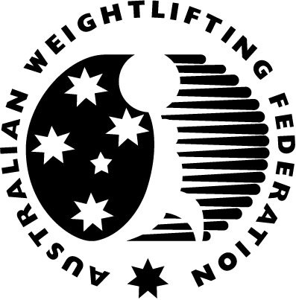
AWF National Masters Championships
Discovery Beach Resort, Sunshine Coast, Qld
23rd June 2001
Name Born State Bwt Snatch Cl&Jk Total Sinclair MMS Place
+80 Years
62kg
Vic Younger 12 VIC 60.36 32.5 40.0 72.5 105.294 374.743 1
75-79 Years
62kg
Charles Henderson 22 NSW 60.25 50.0 60.0 110.0 159.985 399.962 1
85kg
Rube Howes 22 QLD 83.50 57.5 75.0 132.5 155.952 389.880 1
70 - 74 Years
85kg
John McBay 30 WA 83.05 57.5 72.5 130.0 153.438 307.183 1
65 - 69 Years
69kg
Chris Holt 36 VIC 74.70 60.0 80.0 140.0 175.400 286.954 1
85kg
David Richardson 36 SA 81.55 40.0 57.5 97.5 116.190 190.087 1
Abbey Brown 35 NSW 78.00 42.5 47.5 90.0 109.924 183.683 2
60 - 64 Years
77kg
Keith Forbes 41 QLD 74.80 60.0 60.0 120.0 150.221 226.684 1
85kg
Barry Allen 40 NSW 83.55 67.5 95.0 162.5 191.203 293.688 1
Roy Davies 40 SA 78.75 62.5 82.5 145.0 176.141 270.553 2
105kg
Warwick Selvey 39 QLD 101.20 65.0 75.0 140.0 151.498 236.489 1
55 - 59 Years
69kg
Robert Kennedy 46 QLD 68.70 87.5 115.0 202.5 267.679 361.366 1
Maxwell Bristow 44 NSW 67.35 75.0 90.0 165.0 221.083 313.275 2
77kg
Robert Henderson 43 QLD 76.80 65.0 92.5 157.5 194.097 281.246 1
85kg
Ray Louden 45 QLD 81.25 75.0 100.0 175.0 208.959 289.199 1
Milos Trnka 43 VIC 83.80 65.0 95.0 160.0 187.972 272.372 2
94kg
Brian Sheehan 45 QLD 90.10 70.0 117.5 187.5 212.701 294.379 1
105kg
Ross Gagliardi 46 QLD 95.20 75.0 90.0 165.0 182.788 246.763 1
50 - 54 Years
77kg
Noel Matis 50 NSW 73.40 75.0 110.0 185.0 234.288 294.032 1
85kg
Ludek Prokes 49 NSW 78.05 75.0 85.0 160.0 195.349 248.289 1
94kg
George Capsis 47 NSW 85.30 90.0 120.0 210.0 244.512 322.511 1
+105kg
Ben Grzes 50 QLD 137.75 70.0 100.0 170.0 171.206 214.864 1
45 - 49 Years
85kg
Trevor Walz 52 QLD 84.25 77.5 107.5 185.0 216.750 267.469 1
Robert Mitchell 55 NSW 84.45 75.0 107.5 182.5 213.564 257.772 2
94kg
Malcolm Irwin 53 QLD 87.20 85.0 115.0 200.0 230.373 282.437 1
Dean Pascoe 56 SA 92.20 70.0 95.0 165.0 185.272 221.400 2
105kg
Gary Langford 53 QLD 103.55 117.5 135.0 252.5 271.055 332.313 1
+105kg
Harry Grzes 56 QLD 123.15 70.0 90.0 160.0 163.922 195.887 1
40-44 Years
69kg
Paul McBride 58 QLD 67.75 72.5 100.0 172.5 230.193 269.325 1
85kg
Greg Hobl 60 QLD 80.25 97.5 122.5 220.0 264.462 303.338 1
94kg
Barry Harden 59 QLD 85.95 85.0 110.0 195.0 226.195 261.934 1
+105kg
Neville Branson 60 NSW 128.80 70.0 110.0 180.0 182.926 209.816 1
35 - 39 Years
85kg
Phil Maunder 65 SA 83.85 97.5 125.0 222.5 261.319 284.054 1
94kg
Peter Thomsen 64 QLD 93.75 105.0 146.0 250.0 278.720 306.592 1
John Bauer 63 QLD 92.65 85.0 100.0 185.0 207.292 230.716 2
105kg
Adam McDonald 64 QLD 103.85 115.0 142.5 257.5 276.152 303.767 1
Mark Duckworth 64 QLD 96.80 100.0 110.0 210.0 231.086 254.195 2
+105kg
Julio Melo 63 VIC 116.40 100.0 145.0 245.0 254.162 282.882 1
Women
35 - 39 Years
58kg
Diana Loy 65 QLD 57.70 62.5 80.0 142.5 173.406 188.492 1
+75kg
Jo Garner 66 QLD 83.70 37.5 45.0 82.5 85.773 91.948 1
40 - 44 Years
58kg
Coral Quinell 57 NT 52.70 50.0 67.5 117.5 151.319 179.011 1
+75kg
Debra Keelan 61 QLD 100.90 60.0 70.0 130.0 130.709 148.485 1
Team Points
Men |  |  | Women
QLD | 72 |  | QLD | 27
NSW | 68 |  | NT | 9
VIC | 34
SA | 30
WA | 9
Best Lifter Awards
Male | Charles Hendersen | 399.962 MMS pts
Female | Diana Loy | 188.492 MMS pts

National Masters Records
Name | Bwt Cat | Lift | Weight | Age
Chris Holt | 77kg | Snatch | 56.0 | 65 - 69
Chris Holt | 77kg | Snatch | 60.0 | 65 - 69
Chris Holt | 77kg | Cl & Jk | 76.0 | 65 - 69
Chris Holt | 77kg | Cl & Jk | 80.0 | 65 - 69
Chris Holt | 77kg | Total | 135.0 | 65 - 69
Chris Holt | 77kg | Total | 140.0 | 65 - 69
Peter Thomsen | 94kg | Cl & Jk | 146.0 | 35 - 39
Ross Gagliardi | 105kg | Snatch | 75.0 | 55 - 59
Debra Keelan | +75kg | Snatch | 55.0 | 40 - 44
Debra Keelan | +75kg | Snatch | 57.5 | 40 - 44
Debra Keelan | +75kg | Snatch | 60.0 | 40 - 44
Debra Keelan | +75kg | Cl & Jk | 65.0 | 40 - 44
Debra Keelan | +75kg | Cl & Jk | 67.5 | 40 - 44
Debra Keelan | +75kg | Cl & Jk | 70.0 | 40 - 44
Debra Keelan | +75kg | Total | 125.0 | 40 - 44
Debra Keelan | +75kg | Total | 127.5 | 40 - 44
Debra Keelan | +75kg | Total | 130.0 | 40 - 44

Words from AWF Masters Coordinator, Lawrie Towsend
On behalf of the AWF I would like to congratulate Barry Harden and the QWA on conducting the extremely successful 2001 Australian Masters Championship in Mudjimba. The success of the competition was a great example of the commitment the QWA has for Masters weightlifting and provides a fine example for other states to follow. The standard of the lifting in Queensland is very much due to this strong commitment and congratulations to the Queensland team for winning the Bill Keir Team Trophy. I look forward to seeing a formidable Australian team with strong Queensland representation at next years World Masters Games in Melbourne

Lawrie Townsend
AWF Masters Coordinator

World Masters Games 2002

The 2002 World Masters Games will be held in Melbourne from 5-13 October.

The weightlifting competition will be held from 7-13 October at the Victorian Weightlifting Stadium, Hawthorn.

The competition is open to men and women aged 35 and older on 31Dec 2002.

For more information, visit the World Masters Games web site at http://www.2002worldmasters.org

Interview with Miles Wydall

Q – You are one of Australia’s most active coaches and are currently coaching 12 lifters, What do you enjoy most about coaching?

Most of all I enjoy watching my lifters getting PB’s on the platform, I feel its the reward for their work and mine. When they have produced these PB’s to qualify for a team selection or win a title that feeling is even more special – and quite emotional.

I also enjoy being part of the Queensland Weightlifting Association and knowing the many fine people involved with Weightlifting in Queensland.

Q – One of your lifters Damon Kelly was recently selected for the World Junior Championships. Getting a lifter to this level is your highest coaching achievement to date. What else do you hope to achieve in coaching?

Well I would like to get a few more Australian reps at Oceania and World level and maybe if I am fortunate get somebody to a Commonwealth or Olympic Games.

Q – As a coach at the Cougars Club what do you think are the strengths and weaknesses of the Cougars coaching structure?

Having a coach of Mike’s experience in the gym is a great asset. He exchanges ideas on programming and fault correction with the other coaches and brings in consultants for seminars to further aid coach education.

Another strength is that the head coach Michael Keelan does not take all the best lifters for himself but gives most of them to the other five coaches in the gym. This has helped us retain our coaches and grow as a Club.

Also since there are 5 other coaches in the gym there is always somebody else to exchange ideas on programming and technique with, and this is a stimulating coaching environment.

We have also benefited greatly from the QWA development program run by the Scott Robinson as this has brought many new talented lifters into the gym.

Q – Who and what has most inspired you in Weightlifting?

Well Leo Isaac got me involved in coaching and was a great mentor in my first few years in the sport.

Nowadays Mike is my mentor, his knowledge, unlimited enthusiasm and sheer love of the sport is a great inspiration. I also have a lot of respect for Ian Moir who has shaped the QWA into an organisation that you can be proud to be part of.

The Wisdom of Age

By Mal Irwin

Weightlifting involves the whole being. The old “Strength and Health” magazine used to emphasise this, even in the 1960’s (when people like Trevor Walz and myself were juniors. Greg Hobl probably hadn’t heard of weightlifting).

Thus I have always taken an interest in factors affecting my general well-being, which might benefit my lifting performances.

An interesting theological program is offered by the ABC on Sunday evening, just when the commercials show their popular movies. It would be interesting to see how many lifters watch “Compass” relative to the proportion in the general public.

The topics cover all aspects of, basically, how humans relate to the world. I don’t follow it that much, but often there are fascinating insights into how legends, myths and even the moral concepts we now take for granted arose in the transition from clan to tribal living.

“Compass” recently ran a BBC series called “Mind-Story”, discussing scientific research into the mind-brain connection. Mind-Story investigated the relationship between ageing and deterioration (ie emphasis on smaller more focussed aspects of the world) of mental faculties. The emphasis on the study of ageing mental facilities was to provide further input into the internal workings of the mind.

Something clicked in my mind. {It could just be a joint in my neck, or a blood vessel in the brain. Hopefully it isn’t a filling about to come out. The former alternatives are more attractive, being either A) cheap to fix, or B) completely terminal, making all other things irrelevant. C) would be painful, expensive and enduring}.

Remember the old chestnut about life beginning at forty? Anyone under that age would probably be inclined to think that the 40+s seem to be losing it. There is new evidence to back up the old theory.

The program showed an interesting experiment carried out by German researchers. Sextagenerians were paced around a track with low obstacles where they had to stretch to step over. At the same time, a series of single, clearly spoken words were pronounced through head-phones. At the end of the test, most words were forgotten by older people, whereas younger people were able to recall many words, if not in order.

The capper was that older people were able to recall words at the same rate when sitting still as younger people do. It is as though the mental software for motor tasks interferes with language recall. The researcher got his inspiration from a hiking incident. His friends were on a trail, going along having a voluble discussion when they came to a pile of rocks. The discussion ceased until they climbed over the rocks, then resumed on the level trail. Thus the design of the experiment. (In the bush, I only cease talking when I run out of breath. Maybe lifting compartmentalises the brain)

To summarise, the getting of wisdom with age, quite apart from experience, is that older minds tend to focus on particular parts of problems being posed. You can’t rush an oldie, because they can only handle one thing at a time, but once they have had a moment to think things out, healthy people well into their eighties (in my experience) can provide insights into what appear to be very difficult problems, simply because they have so much experience.

Now the relevance of all this to you younger people might be still a vague and hazy image, but, I now present my argument.

There is probably a different story for every successful lifter. But starting to train again as a Master’s lifter past that magic age has brought some of the issues into focus. Remarkably, although my average total has slid back inexorably every year, my power movements have actually improved, until very recently. After squatting 170X3, I have seemed to have a set-back in terms of energy levels through the hot summer of 2000-2001.

When I first started prior to the 1994 World Master’s games, it was a shock to find how heavy the weights had become. But there was another thing. It was a real effort to concentrate on the technique of the lifts. Formerly I was able to visualise the weight arriving overhead at the start of the lift, and just pull hard, now it seems that I have to feel the bar coming up all the way. The spring from the bottom of the squat clean is all but gone, and jerks are 100% unreliable. Every now and then they pop into place nicely. I used to drive them forward, but I could feel it happening in those days. Now it seems a matter of chance.

So what keeps me going? Other lifters of greater achievement than mine have stopped. Some do go on, like Gary Langford and Bob Kennedy. Our lifts are so poor, we don’t jerk what we could once snatch. I guess that part of the challenge lies outside the realm of purely competitive weightlifting, measured in terms of absolute results. We have Sinclair and Forbes formulae to inform us of our relative capability, but I think the yardstick which has most effect is an individual’s past performance. Obviously not distant past as in Senior’s lifting, but either progress or maintenance of standards as a Master’s lifter.

At least after six years of competition, I am now wise enough to know that any higher goals are unrealistic.

Ray Louden’s Story

I began training when I was 13 years of age and was introduced to Body Building by a friend in our neighbourhood. He had a set of weights at home and as soon as I picked them up and did a set of barbell curls, I was hooked.

I needed building up, my height was 5'10" and weight about 91/2 stone with poor genetics for sport, but I never gave up, and slowly but surely, I improved. I was more predisposed for athletics, and was a good middle distance runner and high jumper, holding the school records, but I wasn't that keen. I began reading Strength & Health magazine and the old Joe Weider Muscle Builder. From this I worked out my training programs. These were the only means of information in those days.

I had trouble developing my legs, due to a genetic fault, my legs were badly twisted at birth and I had to wear leg irons for 18 months. I noticed in the Strength & Health magazine that the weightlifters had good legs and were doing lots of squats. At this time, I joined the B.A.W.L.Club at the Sportsman’s Gym in the Valley, Brisbane, in the early 1960's.

I enjoyed the weightlifting and switched to it exclusively, and managed to develop some leg size and strength, but always found it hard going and still do today. My best Squat was 320lbs in those days.

Other guys in my weight division were doing 400 plus. We all have our weaknesses and strengths, my strength was in my pulling power, and even today, I can power clean 105kg.
Diet was important but the only thing around in those days was Complan Baby Formula. I drank it by the gallon and put on around 1 1/2 stone in 6 months. I began training at home in addition to the Gym on an exercise bar and two 50lb rimmed edged Plates from Bill Brown's Sports Store in George St. Brisbane.
I carried them home in the tram from the City to Moorooka and by the time I had walked from the Tram Stop my hands were down by my feet.

I squat snatched 154lbs with this set and front squatted 250lbs, those squats nearly killed me and I never did it again at home.

Rothmans Cigarette Company bought to Australia the Hungarian Coach, Bakos, and he helped me with my training programs. Even in those days they were training twice daily in Hungary, my training was mainly Squat, Front and Back Pulls, Rack Jerks and Seated Presses.

The Press was one of the Olympic lifts at that time and my best was about 80 to 85kgs, I wasn't a very good Presser and was better at the Snatch and Clean and Jerk, my best Snatch was about 90kgs and Clean and Jerk 105-110kgs. I was only a lightweight or middle weight (65 to 75kgs).

I won the Queensland title in 1963 as a lightweight (67.5kg) and I cannot remember all the guys back in those days. Those I do remember, Bob Henderson, Allan Drew, Brian Driscoll, Clive Morrison, Bill Gadsby, Peter Phillips, Ross Gagliardi, Maurie & Dale Carmichael, Brian Sheehan (a rookie Cop back then), John Devietti (a dentist; deceased), Trevor Walz, Mal Irwin, Larry Gartenstein.

We had some great times at the Sportsman's Gym. We also did some training at the Queensland Uni. and underneath a shop at Taringa. We all trained hard, played hard, drank a lot of beer and smoked too many cigarettes.

In 1973 I married, gave up drinking and training, bought my first home and lived the lazy life for a couple of years. I was then 26 years old. Over this period of time I accumulated quite a collection of books and magazines from that era, and began a real study of weightlifting and bodybuilding. My programs all stemmed from these publications.

The main sources of reference were Strength & Health; Iron Man; Reg Park Journal and Weightlifting Newsletters from the U. S. A.

Whilst on the subject of magazines, the magazines published today aren't worth the paper they are printed on. They are full of garbage and bad training advice and pushing their own wheelbarrow. These magazines would be the main reason the young people today give the game away in 6 to 12 months completely disillusioned. I probably would have never gained the inspiration and enthusiasm for the Sport if all I had to rely on back then, was what is printed today. The only magazine, in my opinion worth paying for is 'MILO' magazine from Ironmind Ent. U.S.A. No rubbish, no false claim advertising, just good honest information.

In 1976 I moved to the Sunshine Coast to manage the Coast Store for the firm I was working. I was still not training. I divorced and began breeding Show Horses. I remarried in 1978; we raised and sold Australian Champion Paint Horses. 1980 saw the birth of my daughter and we began our own retail business after the break up of the firm, for which I worked. I gave away the horses and concentrated on the business and raising a family. I was now beginning to show the signs of a non-active life and started to think seriously about training again. I set up a Gym at home and trained 2-3 times a week for 1 hour each session. The exercises were Squats, Bench Press, Dead lifts, Chins, Dips, Curls and Abb work. I built a wooden Power rack and Pulldown machine and dragged all my old weights out. Some were being used as flowerpot stands and some were holding down the tin roof on the old stables. I bought these weights from Clive Morrison back in 1962. They are still being used today at Muscle Beach Gym. I paid 6 pence a pound for them, thank you Clive! I hope you are still with us. You probably don't realise how you changed my life.

In 1992 I could not handle standing behind a counter any longer and left my wife to run the Shop whilst I concentrated on opening "Muscle Beach Gym" at Coolum. After 6 months the business outgrew the premises and we moved to Mudjimba, where the business is still powering along.

There are a number of Gym's on the Coast but they are mainly fitness and health orientated. Muscle Beach is the only Gym that caters for heavy lifting. Although the majority of members tend to be fitness and health conscious, we have a great success in all forms of Body building, Body shaping and other sporting competitions. Per head of membership Muscle Beach Gym would be the most successful Gym in Australia, producing more State, National and International Champions. We also train major sporting teams, e.g. Outrigger teams, Football, Surfing, Surf Lifesaving to name a few, and specific sports people.

The Gym also does a lot of work with Physio's and Work Care, with Injury rehabilitation. The New Zealand Track and Field team trained prior to the Olympics along with Les Mills and his wife. The Australian Baseball team and Korean Baseball team also trained here prior to the Olympic Games.
I continued Bodybuilding and competed and won the State and National Titles in my age division (drug free, as all our competitors are.) When I found out there was a Masters division in Weightlifting I decided to give it a go. I contacted Barry Harden and joined the Sunshine Coast W/Lifting Club.

Training was very different back in the 70's, it has become very scientific now, but I studied very hard, picked peoples brains and devised a training programme that suited me and I worked at it hard.

My current program is:
Mon Tuesday Thurs Saturday
Squats (Back Rack Jerk Squats (Back) Snatch 85%
Pcl.@PushPress Hang Snatch Box Snatch Clean@Jerk 85%

Afternoon Afternoon Afternoon
Snatch Clean&Jerk P.CleanJerk(Split)
Snatch Pulls Clean Pulls Romanian Deadlift

I train as hard as I can, depending on how I feel on the day. Some days I can go maximum and others only 78%. Six weeks out from competition, I drop back to 70% on all exercises and work up to 100% or more on the day of Competition. I don't train for more than 45min each session because testosterone levels drop after this time and strength diminishes. This is the reason for 2 sessions a day. Recuperation is quicker also: when you recuperate quicker, you can train more often, which is better for the older blokes.

My diet is supplemented with a high grade Protein drink twice a day. (morning and after the afternoon workout.) I take 30grams of Creatine a day for 1 week before Competition and my main supplement is 'LIFE PAK', a multi vitamin, mineral and antioxidant with herbs, taken twice daily. It's the best on the market worldwide: Independent tests have been done across the board, comparing it with other brands and none come close.

Remember for a supplement to work you have to be able to absorb all the nutrients, LIFE PAK is so comprehensive that it achieves this. Having been in the business for 40 years I have tried and tested every supplement on the market. 95% of most supplements are worthless, so don't waste your money, I have spent thousands of dollars over the years. I've been on 'LIFE PAK' for 2 years now, and have never felt as fit and healthy as I do now, I have not had a cold for over 2 years. I am such a believer in this product that I recommend and sell it now to my membership, and have seen some fantastic results from hard-core bodybuilders through to my aged members, who want maximum fitness and wellness for their age. 'LIFE PAK' it the only multi vitamin used by the U.S.A. Olympic Team and endorsed by the Medical Advisory board of the Australian Surf Lifesaving Assoc.

My supplement recommendation is:

'LIFE PAK' (multi vitamin, mineral, antioxidant and herb formula). The manufacturer has so much faith in its product that it has a full money back guarantee.
A good 3 way Protein powder for muscle recuperation after training and creatine for strength gains.

If you need more information on 'LIFE PAK' contact Muscle Beach Gym...07-54488890.

The muscle beach web site is at http://www.musclebeach.1shop.com.au

Results of the East Asian Games
Osaka, Japan
Women
48kg
Li Zhuo CHN 47.65 85.0 95.0 180.0 1
Imaoka Masumi JPN 47.62 75.0 92.5 167.5 2
Lee Kung-sook KOR 47.86 72.5 95.0 167.5 3
53kg
Choi Myung-shik KOR 52.91 82.5 105.0 187.5 1
Matsumiah Kumie JPN 51.62 72.5 100.0 172.5 2
Barker Natasha AUS 52.90 75.0 *95.0 170.0
Bagautdinova Kamilya KAZ 52.50 65.0 72.5 137.5 3
58kg
Song Zhijuan CHN 57.75 100.0 115.0 215.0 1
Nakaga Mari JPN 57.24 85.0 112.5 197.5 2
Ling I-hua TPE 55.46 82.5 107.5 190.0 3
Liao Ching-chan TPE 57.01 85.0 105.0 190.0 4
Bayarmaa Namkhaidorj MGL 57.70 80.0 110.0 190.0 5
Lee Heon-jeong KOR 57.98 82.5 105.0 187.5 6
Takahashi Yuriko JPN 57.29 80.0 105.0 185.0 7
Warthold Meagan AUS 57.62 72.5 90.0 162.5
Lewis Debbie AUS 57.17 67.5 80.0 147.5
63kg
Xiong Meiying CHN 62.95 107.5 127.5 235.0 1
Kuo Ping-chun TPE 62.20 100.0 120.0 220.0 2
Huang Yu-chin TPE 61.67 82.5 110.0 192.5 3
Okura Taeko JPN 61.36 80.0 110.0 190.0 4
Dandukova Svetlana KAZ 62.43 80.0 102.5 182.5 5
69kg
Shang Shichun CHN 68.81 105.0 137.5 242.5 1
Huang Shih-chun TPE 68.59 107.5 122.5 230.0 2
Kang Mi-suk KOR 68.48 102.5 120.0 222.5 3
Shi Sun-hee KOR 68.85 95.0 125.0 220.0 4
Saito Rika JPN 66.73 80.0 102.5 182.5 5
Phillips Amanda AUS 68.11 75.0 100.0 175.0
75kg
Kim Soon-hee KOR 74.69 107.5 140.0 247.5 1
Xu Jiao CHN 74.86 110.0 125.0 235.0 2
Lovely Deborah AUS 74.28 77.5 97.5 175.0
75kg+
Zhang Nan CHN 129.93 120.0 155.0 275.0 1
Mun Kyung-ae KOR 93.77 112.5 135.0 247.5 2
Hsieh Su-hua TPE 109.15 105.0 137.5 242.5 3
Pileggi Caroline AUS 83.79 87.5 112.5 200.0
Tsuruno Yuko JPN 85.97 85.0 110.0 195.0 4
Williams Saree AUS 83.85 85.0 105.0 190.0
Chen Hsiao-lien TPE 97.60 115.0 0.0 0.0 -

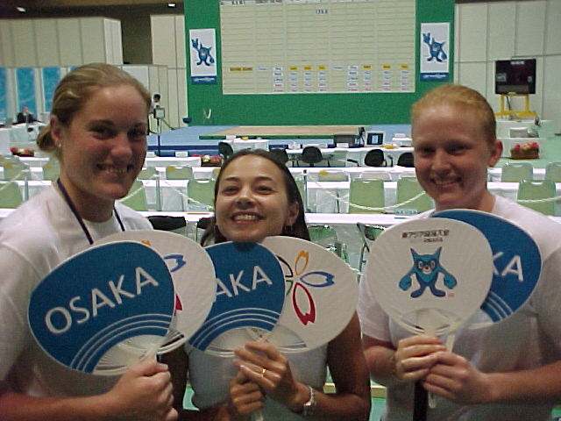
Queenslanders Deb Lovely (75kg), Karuna Jones(spectator) and Amanda Phillips in Osaka.

Men
56kg
Wu Wenxiong CHN 55.92 122.5 165.0 287.5 1
Wang Shin-yuan TPE 56.00 125.0 160.0 285.0 2
Kim Se-hyuk KOR 55.56 120.0 147.5 267.5 3
Masaharu Yamada JPN 55.67 107.5 150.0 257.5 4
62kg
Wu Jian CHN 61.85 140.0 160.0 300.0 1
Kim Young-tae KOR 61.93 120.0 155.0 275.0 2
Tominaga Kenji JPN 61.70 0.0 0.0 0.0 -
69kg
Wang Yao CHN 68.67 155.0 185.0 340.0 1
Lee Bae-young KOR 68.84 145.0 180.0 325.0 2
Okhremenko Alexandr KAZ 68.60 132.5 165.0 297.5 3
Sarkisian Yurik AUS 65.05 120.0 140.0 260.0
77kg
Li Hongli CHN 76.94 *168.0 195.0 362.5 1
Lee Kang-suk KOR 76.86 160.0 190.0 350.0 2
Kisogawa Akira JPN 76.80 145.0 170.0 315.0 3
Hsu Ying-hsi TPE 76.70 130.0 170.0 300.0 4
Blythman Craig AUS 76.95 130.0 160.0 290.0
* Asian record
85kg
Chakhoyan Sergo AUS 84.17 175.0 200.0 375.0
Kim Jong-shik KOR 83.88 167.5 202.5 370.0 1
Galkin Konstantin KAZ 84.47 157.5 192.5 350.0 2
Suzuki Kazumi JPN 83.64 150.0 190.0 340.0 3
Samoilov Pavel KAZ 83.74 150.0 180.0 330.0 4
Campbell Robert AUS 84.54 137.5 170.0 307.5
Wang Hailong CHN 84.76 165.0 0.0 0.0 -
94kg
Qin Guang CHN 93.28 170.0 200.0 370.0 1
Makarov Andrey KAZ 93.28 170.0 190.0 360.0 2
Karapetyn Alex AUS 93.99 160.0 200.0 360.0
Higa Toshihiko JPN 93.89 147.5 190.0 337.5 3
Chiu Yen-chun TPE 93.07 147.5 187.5 335.0 4
105kg
Cui Wenhua CHN 102.69 180.0 205.0 385.0 1
Choi Jong-kun KOR 103.16 165.0 200.0 365.0 2
Inagaki Eiji JPN 103.55 140.0 190.0 330.0 3
105kg+
Kim Tae-hyun KOR 128.58 185.0 230.0 415.0 1
Lee Woo-sung KOR 127.01 175.0 232.5 407.5 2
Han Wenliang CHN 127.13 180.0 227.5 407.5 3
Iwazaki Takanobu JPN 120.69 165.0 220.0 385.0 4
Shevchenko Sergey KAZ 123.62 167.5 210.0 377.5 5
Morita Munehiro JPN 113.78 160.0 205.0 365.0 6
Hocking Corran AUS 146.12 160.0 202.5 362.5
Martin Anthony AUS 142.58 160.0 200.0 360.0

Australian Commonwealth Games Squad

In preparation for the 2002 Commonwealth Games, the AWF aims to put in place a program along the lines of the former Olympic Athlete Program (OAP), utilising funds available through the Australian Sports Commission (ASC), the Australian Commonwealth Games Association (ACGA) and the Australian Olympic Committee (AOC).

An initial squad of fifteen athletes has been selected, based on results registered between, and including, the 2000 Olympic Games and 30 June 2001. Considered for inclusion in the squad were athletes who have exceeded the qualifying totals for next year’s Commonwealth Games (The 2002 Commonwealth Games Selection Criteria document has previously been circulated. Please contact the AWF if you do not have a copy).

The 15 selected athletes are listed below, ranked in order of % over the qualifying totals:

MEN WOMEN
85 KG - Sergo Chakhoyan VIC 377.5 (122.76%) 63 KG - Amanda Phillips QLD 190.0 (113.43%)
94 KG – Alex Karapetyn VIC 382.5 (118.60) 58 KG – Natasha Barker NSW 180.0 (112.50)
94 KG – Kiril Kounev VIC 375.0 (116.28) 58 KG – Meagan Warthold NSW 175.0 (109.38)
62 KG – Yurik Sarkisian VIC 290.0 (114.85) +75 KG - Caroline Pileggi WA 205.0 (105.12)
77 KG – Damian Brown VIC 320.0 (109.40)
+105 KG – Anthony Martin WA 375.0 (104.90)
+105 KG – Corran Hocking VIC 370.0 (103.50)
85 KG – Robert Campbell NSW 317.5 (103.25)
94 KG – Simon Heffernan VIC 330.0 (102.33)
56 KG – Mehmet Yagci NSW 235.0 (101.08)
77 KG – Craig Blythman VIC 295.0 (100.85)

PLEASE NOTE
- Squad size is limited to 15 (Based on 8 men and 7 women). Where less than 8 men or 7 women have reached the qualifying total, the squad can include more athletes of either gender who have qualified, eg. 10 men + 5 women, if only 5 women have qualified. The next 2 highest qualifiers from the men are then included to make up the fifteen.
- The squad is ranked in % over the 2002 Commonwealth Games Trials qualifying total.
- Squad to be selected six monthly
- Squad to be monitored quarterly, with continued inclusion in the squad dependent on the athlete’s commitment to training and the AWF program. Athletes can be removed from the squad for any breaches of AWF rules.
- Payments are made quarterly unless otherwise specified.*

* Funding will be available to support squad members’ participation at World and Regional Championships and it is also anticipated that athletes will also receive funding in a direct assistance scheme. The formula to be used in allocating funding, and actual amount available, will be announced after discussion with the ASC, ACGA and AOC.

Queensland Top 10
10 biggest snatches, clean and jerks and totals so far in 2001

Snatches
MEN |  | WOMEN
Damon Kelly | 130.0 | Deborah Lovely | 85.0
Ken Chandler | 120.0 | Amanda Phillips | 80.0
Paul Wheeler | 117.5 | Melissa Bethune | 80.0
Gary Langford | 117.5 | Melissa Nightingale | 72.5
Adam McDonald | 115.0 | Kristie Amadio | 67.5
Peter Thomsen | 105.0 | Diana Loy | 65.0
Dallas Turnbull | 105.0 | Angela Wydall | 65.0
Greg Hobl | 100.0 | Debra Keelan | 60.0
Robert Butler | 100.0 | Tanya Harden | 55.0
Mark Duckworth | 100.0 | Karuna Jones | 52.5

Clean & Jerks
MEN |  | WOMEN
Damon Kelly | 180.0 | Amanda Phillips | 105.0
Ken Chandler | 155.0 | Deborah Lovely | 100.0
Peter Thomsen | 145.0 | Melissa Bethune | 100.0
Paul Wheeler | 145.0 | Melissa Nightingale | 87.5
Adam McDonald | 142.5 | Kristie Amadio | 83.0
Gary Langford | 135.0 | Diana Loy | 80.0
Dallas Turnbull | 130.0 | Angela Wydall | 80.0
Greg Hobl | 125.0 | Tanya Harden | 75.0
Cameron Anderson | 120.0 | Ellen Stanton | 70.0
Ben Turner | 117.5 | Debra Keelan | 70.0

Totals
MEN |  | WOMEN
Damon Kelly | 310.0 | Deborah Lovely | 185.0
Ken Chandler | 275.0 | Amanda Phillips | 182.5
Paul Wheeler | 262.5 | Melissa Bethune | 180.0
Adam McDonald | 257.5 | Melissa Nightingale | 160.0
Gary Langford | 252.5 | Kristie Amadio | 145.0
Peter Thomsen | 250.0 | Diana Loy | 145.0
Dallas Turnbull | 235.0 | Angela Bentley | 145.0
Greg Hobl | 225.0 | Tanya Harden | 130.0
Mark Duckworth | 215.0 | Debra Keelan | 130.0
Ben Turner | 210.0 | Rebecca Marks | 125.0

