vWeightlifting Queenslandv
.

Vol 7 No 1 Apr 2001
The Official Journal of the Queensland Weightlifting Association Inc.
PO Box 1056, Capalaba, Qld 4157
Tel: (07) 3823 1377 Fax: (07) 3823 1371

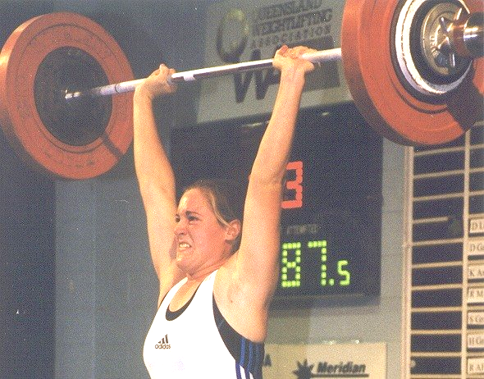
Deborah Lovely snatched 85kg and Clean and Jerked 100kg to win a silver medal at the Nauru International Cup. Report and Results inside.
Nauru International Cup 2001 7
East Asian Games 11
Stretching 11
Dealing with Winning and Losing 12
Lou Barrie 12
Queensland U16 U18 13
Attitude 15
National U16 & U18 Championships 12



Core Stability 20
Goodwill Games 21
Coaching at Nudgee 21
Girls Girls Girls 21
Qld Masters Championships 18
QWA Selection Committee 19
QWA Selection Policies 20
Queensland Records 27
Proudly Supported by:



Queensland Weightlifting Association Inc.
Office: The Velodrome, The Sleeman Sports Complex,
Chandler 4155
Postal Address: PO Box 1056, Capalaba 4157
Telephone: (07) 3823 1377
Facsimile: (07) 3823 1371
Email: qwa@powerup.com.au
Web Site: http://www.qwa.org
Executive Director: Ian Moir
Adminstrative Officer: Kylie Booth
Development Officer: Scott Robinson
Newsletter Editor: Angela Bentley (angie@powerup.com.au)

The QWA Management Committee

Patron: Bert Hobl
President: Barry Harden
Vice President: Mike Keelan
Secretary: Jo Garner
Treasurer: Ross Gagliardi
Executive Officer: Greg Hobl
Executive Officer: Peter Thomsen
Executive Officer: Kylie Booth
Executive Officer: Brad Monk

Acknowledgement - Sponsors of the QWA
The Queensland Weightlifting Association is extremely appreciative of the financial assistance provided by the following:

Queensland Government –Sport and Recreation Queensland

CoolSpeak.Com (http://www.coolspeak.com)

Telstra

Acknowledgement - Corporate Members

Gremel Promotions

Acknowledgement - Photographic Services

Be Seen Photographics

Disclaimer
The views represented in this publication do not necessarily reflect those of the editor or of the Officers or Management Committee of the QWA.

Competition Calendar

<TBODY>Date | Competition | Location
<SMALL>March 30</SMALL> | <SMALL>TWA Open Club Competition</SMALL> | <SMALL>Toowoomba</SMALL>
<SMALL>April 7</SMALL> | <SMALL>Telstra Qld Masters Championships</SMALL> | <SMALL>Rockhampton</SMALL>
<SMALL>April 12</SMALL> | <SMALL>Cougars Club Open Competition</SMALL> | <SMALL>Chandler</SMALL>
April 21 - 22 | Telstra National Under 16 & Under 18 Championships | Melbourne, Vic
<SMALL>April 27</SMALL> | <SMALL>Cougars Club Open Competition</SMALL> | <SMALL>Chandler</SMALL>
<SMALL>May 2</SMALL> | <SMALL>Sunshine Coast Club Open Competition</SMALL> | <SMALL>Sunshine Coast</SMALL>
<SMALL>May 4</SMALL> | <SMALL>TWA Open Club Competition</SMALL> | <SMALL>Toowoomba</SMALL>
May 20 - 24 | East Asian Games | Osaka, Japan
<SMALL>May 19</SMALL> | <SMALL>QWA League Round 2 & Masters H/cap Round 2</SMALL> | <SMALL>Brisbane</SMALL>
<SMALL>June 1</SMALL> | North West Qld Tournament | Mount Isa<SMALL></SMALL>
<SMALL>June 8</SMALL> | <SMALL>Cougars Club Open Competition</SMALL> | <SMALL>Chandler</SMALL>
June 9 - 10 | World Championships For University & College Students | Slovakia
<SMALL>June 16</SMALL> | <SMALL>Telstra Qld U20 & Senior Championships</SMALL> | <SMALL>Toowoomba</SMALL>
<SMALL>June 23</SMALL> | <SMALL>Telstra National Masters Championships</SMALL> | <SMALL>Sunshine Coast, Qld</SMALL>
<SMALL>June 29</SMALL> | <SMALL>TWA Open Club Competition</SMALL> | <SMALL>Toowoomba</SMALL>
June 29 - July 9 | World Junior Championships | Athens, Greece
<SMALL>July 7</SMALL> | <SMALL>Sunshine Coast Club Open Competition</SMALL> | <SMALL>Sunshine Coast</SMALL>
<SMALL>July 28 </SMALL> | <SMALL>QWA League Round 3 & Masters H/cap Round 3</SMALL> | <SMALL>Toowoomba</SMALL>
<SMALL>August 11 - 13</SMALL> | <SMALL>Telstra National U20 & Open Championships</SMALL> | <SMALL>Sydney</SMALL>
<SMALL>August 24</SMALL> | <SMALL>TWA Open Club Competition</SMALL> | <SMALL>Toowoomba</SMALL>
<SMALL>August 24</SMALL> | <SMALL>Cougars Club Open Competition</SMALL> | <SMALL>Chandler</SMALL>
August 29 – Sept 1 | Goodwill Games | Brisbane, Qld
<SMALL>September 8</SMALL> | <SMALL>Qld Masters H/cap Final</SMALL> | <SMALL>Sunshine Coast</SMALL>
<SMALL>September 22 </SMALL> | <SMALL>QWA League Final</SMALL> | <SMALL>Brisbane</SMALL>
<SMALL>October 6</SMALL> | <SMALL>Sunshine Coast Club Open Competition</SMALL> | <SMALL>Sunshine Coast</SMALL>
October 6 - 14 | World Championships & Oceania Championships | Republic of Nauru
<SMALL>October 12</SMALL> | <SMALL>TWA Open Club Competition</SMALL> | <SMALL>Toowoomba</SMALL>
<SMALL>November 3</SMALL> | <SMALL>Qld All Schools Championships</SMALL> | <SMALL>Brisbane</SMALL>
<SMALL>November 17</SMALL> | <SMALL>QWA Annual Awards</SMALL> | Brisbane
<SMALL>November 24</SMALL> | <SMALL>Queensland 2000</SMALL> | <SMALL>Brisbane</SMALL>
<SMALL>December 1</SMALL> | <SMALL>Sunshine Coast Club Open Competition</SMALL> | <SMALL>Sunshine Coast</SMALL>
<SMALL>December 7</SMALL> | <SMALL>TWA Open Club Competition</SMALL> | <SMALL>Toowoomba</SMALL>
<SMALL>December 8</SMALL> | <SMALL>Cougars Club Open Competition</SMALL> | <SMALL>Chandler</SMALL></TBODY>
December 8 - 9 | Telstra Oceania & South Pacific Junior Championships | Kiribati

The 2001 Telstra National Age Group Team Challenge will be held in Adelaide at a date yet to be confirmed.
The closing date for lodgment of entries for all QWA events is 15 days prior to the competition date.
The minimum qualifying standard for entry to the Telstra Queensland Open Championships is C Grade.
The minimum qualifying standard for entry to the Telstra Queensland Under 20 Championships is D Grade.
There is no minimum qualifying standard for Qld Under 16, Under 18, School or Masters Championships.
The qualifying period for the Telstra Qld Open & Under 20 Championships is 1 June 2000 – 1 June 2001.
The qualifying period for the Queensland 2000 Tournament is 1 January 2001 – 30 September 2001.
Queensland Teams for National Championships will be selected 5 weeks prior to the date of the relevant event.

2001 Nauru International Cup
By Ian Moir

As a result of the exchanges between the QWA and the Nauru Weightlifting Federation in the past few years, most QWA members would by now have a rough idea of where Nauru is, and in January another group of intrepid travellers left Brisbane on the four-and-a-half hour flight to the Republic of Nauru to participate in the 2001 Nauru Cup Tournament.

When asked the question, “what is Nauru like?” I invariably answer, “interesting”, for while this island nation isn’t what you might call a tropical paradise in the picture postcard sense, it does have an undeniable charm. And you can always be assured of bringing home memories of things that just don’t happen anywhere else. For example, on the 2000 tour, the President of Nauru invited us all into his office and personally signed a calendar for each and every member of the group.

In all there were twelve in this year’s QWA contingent – Karuna Jones, Desiree Gagliardi, Kristie Amadio, Melissa Nightingale, Amanda Phillips, Deborah Lovely, Kylie Booth, Mike Keelan, Ross Gagliardi, Andrew McGough, Brad Monk and me. A few of us had been to Nauru a couple of times before, but for Karuna, Kristie, Deborah, Andrew and Brad, this was their first visit to the place the Nauruans call Pleasant Island.

Our expedition got off to a shaky start. Air Nauru’s Boeing 737 had been held over for repairs in Guam earlier in the week, delaying our departure from Brisbane by two days. Although the competition schedule was changed to accommodate this unfortunate delay, we were nevertheless disappointed to have less time to enjoy the “Nauru experience”. Leaving Brisbane on Friday night, we disembarked in Nauru at around 5am Saturday. Weightlifters are always assured of a warm welcome in Nauru for three reasons: 1) Nauruans are friendly people; 2) weightlifting is Nauru’s national sport; and 3) at 5am the temperature is already nudging 30 degrees.

Met at the airport by our good friends Trent Dabwido and Matthew Curtin, we were whisked away to the Menen Hotel, our home away from home for the next four days. After grabbing a couple of hours sleep, Mike, Kylie, Ross, Andrew, Brad, Vince Butros (NSW) and I headed down to the offices of the Nauru 2001 World Weightlifting Championships for the technical meeting. Here we met some more familiar faces, including Paul Coffa of course, and Quake Raddock from Fiji, and the Kiribati coaches Taoroba Tamuera and Toare Toaneti. Following the technical meeting, Paul informed us that Nauru’s television organisation, Sport Pacific Network, would be covering the 2001 Nauru Cup, and that video highlights of the event would be included on the World Weightlifting Championships web site (wwc.nauru01.nr). Mike agreed to provide commentary for the coverage of the men’s sessions, but he had coaching commitments in all of the women’s groups. The next thing I knew, I had agreed to fill in for Mike at those times and co-present with Lilli Coffa , hoping upon hope that my inane mumblings would be edited out of the final package to be “webcast” to the world.

After lunch it was time to rally the lifters and head out to Centennial Hall for the start of the competition. Karuna and Desiree were the only two Queenslanders to compete on Saturday, and their session commenced at 6:00pm. At the venue our physio, Andrew McGough, spied a spare table leaning against a wall and while he scouted the warm up area for a suitable place to set it up, I borrowed some bright yellow bunting to throw over the top, thus creating a functional, though somewhat makeshift, massage/treatment table.

Karuna lifted extremely well in her first big event and finished second in the 48kg category. Desiree (a.k.a Antionette) performed up to expectations and placed third in the 53kg class. After the girls’ session, Mike returned to his commentary position and I lent Stephen Haldun (Vic) a hand in the warm up room, counting the attempts on the board while Steve’s team mate, Tim Fry, kept an eye on his warm up. Although I don’t claim to have contributed much to Steve’s success, I did get a buzz out of being involved in the action when the competition heated up between Steve and Jalon Doweiya of Nauru.

Competing in sporting contests on Sundays is forbidden in Nauru and so the next day was a rest day. Half of the group went out fishing with some of the locals, while the rest of us took a tour of the island by bus. For most of us, the highlight of the tour was the panoramic view from Nauru’s highest point, but for Desiree it must have been the discovery of the road-side shop from which she purchased chocolate in myriad forms. Judging by her squeals of delight as she chomped her way through a bag full of sugar-charged delicacies on the way back to the hotel, I’d say that the girl is a confirmed choc-aholic. But here’s a tip, Desiree – next time go for the M&M’s with peanuts, that way you’ll get a bit of fibre in your diet too.

By Sunday afternoon Andrew and I must have acclimatised, because we were starting to feel as though our hotel room resembled a large refrigerator. In fact we began taking things out of the fridge and leaving them on the bench to cool. It was about then that we discovered that there were no controls for our incredibly efficient air conditioning unit, just a mark on the wall where the thermostat had once been. We couldn’t turn it down and we couldn’t turn it off, so the flow of sub-zero air continued uninterrupted, 24 hours a day. No doubt the Menen Hotel staff are still laughing about the crazy Australian who asked for a blanket, thirty kilometres from the Equator! Finally Andrew suggested that we leave the door to the balcony open to let some warm tropical air in – problem solved.

On Monday afternoon the tournament got underway again, and Kristie, Melissa and Amanda were all in the first group. Kristie had a good day. Competing against much more experienced lifters in the 58kg class, she achieved a new personal best in the clean & jerk and equalled her best total. Melissa was in pretty good shape after the snatches, leading the 63’s on bodyweight. However she was outgunned in the clean & jerk by Nauru’s Sheba Deireragea and relegated to second place. Amanda put in a typically solid performance and was never really challenged for the gold medal in the 69kg category. She was however also competing for the overall Best Lifter award and as it turned out, she came second to Megan Warthold (NSW) by just one half of a point. Mike and I had done some figuring before the competition, but we made the mistake of overestimating Megan’s form, and we were convinced that Amanda would be competing for second or third place overall. Mike expected Megan to lift more than she did and we failed to recalculate her point score after she had finished. Would Amanda have succeeded with an extra 2.5kg clean & jerk on her third attempt? No one can know for sure, but there is definitely a lesson to be learned from the result, and that is, “it ain’t over ‘till it’s over”.

Deborah Lovely competed in the final session of the tournament on Monday night. Deborah snatched well and, similar to Melissa Nightingale, she held the lead in her category at the break. Unfortunately for Deborah she was up against Nauru’s Reanna Solomon, who was reported to have power cleaned 120kg. Deborah finished second, but with personal bests in snatch, clean & jerk and total.

And so ended the 2001 Nauru Cup. After a quick trip back to the hotel to freshen up and change we headed off to the function at Paul and Lilli Coffa’s place. Once again, our general lack of talent became obvious when Trent Dabwido grabbed a microphone and invited each group onto the stage to perform an “item”. In reply to Nauruan hakas and traditional songs from the Kiribati guys and girls, the best that we Queenslander’s could come up with was a rendition of Advance Australia Fair. But then again, this is the Centenary of Federation and, all modesty aside, our effort was better than the hatchet job Matt Curtin, Tim Fry and Steve Haldun did on Sinatra’s New York, New York.

Returning to the hotel in the wee small hours, I once again thumbed my nose at common sense and saw yet another Nauruan sunrise before having breakfast and then going to bed. I was awoken shortly thereafter by a knocking on the door, and the news that a number of our party were sick, including my room mate (okay, so I’m not the most observant guy in the world). The symptoms and sudden onset of the illness, which affected about half the group, indicated food poisoning, and Ross Gagliardi came to the rescue with Imodium and Lomotil tablets. As the time of our departure approached, a few of those affected weren’t showing signs of improvement, so I borrowed a car and drove down to Paul Coffa’s office to let him know what was going on, and to see if he could get a doctor to come to the hotel. Paul sent me with one of his staff around to Dr Kieran Keke’s house and, after hearing about our predicament, Kieran stocked up his medicine bag and met me back at the hotel. Doing the rounds, Kieran examined and treated five people, getting them into good enough shape to travel on the 6pm flight back to Brisbane. One “patient” was so dehydrated that he required a drip, and after seeing what he went through, I’d take a fractured cheek bone over food poisoning any day (in-joke).

To finish this account on a more positive (and less yucky) note, I’ll refer back to my statement in the opening paragraphs about Nauru being the kind of place where things that are out of the ordinary happen. The runway at Nauru airport backs on to an edge of the island and between the end of the runway and the Pacific ocean is a road. As we taxied out onto the runway and prepared to say farewell to Nauru, the pilot’s voice came over the cabin speakers, “Ladies and gentleman, we can’t take off just yet as there are apparently some children on the road behind the aircraft. We’ll just turn around and take a look.” And with that the pilot put the plane into a complete 360 degree turn so that he could see what was going on behind him before lining up again for take off. Now, you don’t see that every day.

Nauru Cup International Weightlifting Tournament
Republic of Nauru, 27 & 29 January 2001

WOMEN
48kg Category | YOB | Nation | B/wt | Snatch | C&J | Total | Sinclair
Ebonette Deigaeruk | 83 | NRU | 45.50 | 55.0 | 70.0 | 125.0 | 179.171
Karuna Jones | 75 | AUS | 47.50 | 52.5 | 62.5 | 115.0 | 159.438
Ebony Deigaeruk | 86 | NRU | 47.20 | 45.0 | 57.5 | 102.5 | 142.792
Kirnar Tung | 89 | KIR | 45.65 | 32.5 | 42.5 | 75.0 | 107.223
53kg Category | YOB | Nation | B/wt | Snatch | C&J | Total | Sinclair
Edes Batsiua | 83 | NRU | 52.80 | 55.0 | 60.0 | 115.0 | 147.914
Tinahnee Dongobir | 87 | NRU | 51.90 | 45.0 | 57.5 | 102.5 | 133.365
Antionette Gagliardi | 84 | AUS | 50.55 | 37.5 | 50.0 | 87.5 | 115.936
58kg Category | YOB | Nation | B/wt | Snatch | C&J | Total | Sinclair
Meagan Warthold | 72 | AUS | 56.50 | 72.5 | 92.5 | 165.0 | 203.311
Tyoni Batsiua | 81 | NRU | 57.70 | 70.0 | 90.0 | 160.0 | 194.701
Atata Raitinia | 82 | KIR | 57.75 | 65.0 | 75.0 | 140.0 | 170.277
Twylite Smith | 86 | NRU | 56.10 | 57.5 | 67.5 | 125.0 | 154.689
Kristie Amadio | 85 | AUS | 55.80 | 50.0 | 70.0 | 120.0 | 148.990
63kg Category | YOB | Nation | B/wt | Snatch | C&J | Total | Sinclair
Sheba Deireragea | 86 | NRU | 62.80 | 65.0 | 85.0 | 150.0 | 174.246
Melissa Nightingale | 81 | AUS | 62.35 | 65.0 | 77.5 | 142.5 | 166.147
Onetati Teitoi | 82 | KIR | 59.60 | 60.0 | 72.5 | 132.5 | 158.279
Cyzrist Daniel | 85 | NRU | 62.80 | 50.0 | 65.0 | 115.0 | 133.588
69kg Category | YOB | Nation | B/wt | Snatch | C&J | Total | Sinclair
Amanda Phillips | 81 | AUS | 68.95 | 80.0 | 102.5 | 182.5 | 202.876
Thelma Raidinen | 86 | NRU | 68.90 | 65.0 | 85.0 | 150.0 | 166.800
Moaniti Matia | 86 | KIR | 66.00 | 55.0 | 72.5 | 127.5 | 144.546
75kg Category | YOB | Nation | B/wt | Snatch | C&J | Total | Sinclair
Mary Diringa | 83 | NRU | 72.20 | 70.0 | 92.5 | 162.5 | 177.265
Lesuma Eongen | 83 | NRU | 75.00 | 65.0 | 85.0 | 150.0 | 161.323
Karewe Teiwaki | 82 | KIR | 73.80 | 55.0 | 75.0 | 130.0 | 140.635
+75kg Category | YOB | Nation | B/wt | Snatch | C&J | Total | Sinclair
Reanna Solomon | 81 | NRU | 126.65 | 85.0 | 110.0 | 195.0 | 195.000
Deborah Lovely | 83 | AUS | 81.75 | 85.0 | 100.0 | 185.0 | 193.571
Shilo Tamakin | 87 | NRU | 93.10 | 80.0 | 102.5 | 182.5 | 185.463
Jamila Boutros | 84 | AUS | 97.05 | 77.5 | 87.5 | 165.0 | 166.640
Tebaoti Kirataruru | 80 | KIR | 78.90 | 57.5 | 77.5 | 135.0 | 142.750
Bodika Dongobir | 83 | NRU | 78.60 | 55.0 | 65.0 | 120.0 | 127.041
MEN
56kg Category | YOB | Nation | B/wt | Snatch | C&J | Total |  | Sinclair
Dirk Dageago | 83 | NRU | 55.50 | 97.5 | 130.0 | 227.5 |  | 353.780
Chako Daniel | 82 | NRU | 55.90 | 85.0 | 112.5 | 197.5 |  | 305.268
Kabure Teibiroa | 87 | KIR | 55.50 | 65.0 | 80.0 | 145.0 |  | 225.486
Starron Dowobobo | 83 | NRU | 45.30 | 60.0 | 75.0 | 135.0 |  | 253.639
Tekaei Temeake | 86 | KIR | 51.75 | 50.0 | 60.0 | 110.0 |  | 181.882
Legon Scotty | 88 | NRU | 33.55 | 32.5 | 47.5 | 80.0 |  | 211.430
62kg Category | YOB | Nation | B/wt | Snatch | C&J | Total |  | Sinclair
Etsiit Cook | 83 | NRU | 61.55 | 95.0 | 122.5 | 217.5 |  | 311.157
Nabuka Nariki | 85 | KIR | 60.80 | 65.0 | 85.0 | 150.0 |  | 216.624
Tanentda Kaibunang | 80 | KIR | 59.95 | 65.0 | 77.5 | 142.5 |  | 208.065
69kg Category | YOB | Nation | B/wt | Snatch | C&J | Total |  | Sinclair
Yukio Peter | 84 | NRU | 68.95 | 115.0 | 155.0 | 270.0 |  | 356.033
David Katoatau | 84 | KIR | 68.55 | 85.0 | 115.0 | 200.0 |  | 264.765
Jhon Teainga | 83 | KIR | 67.25 | 87.5 | 105.0 | 192.5 |  | 258.196
Ringo Scotty | 64 | NRU | 65.60 | 82.5 | 95.0 | 177.5 |  | 242.265
77kg Category | YOB | Nation | B/wt | Snatch | C&J | Total |  | Sinclair
Stephen Haldun | 70 | AUS | 76.45 | 117.5 | 150.0 | 267.5 |  | 330.539
Jalon Doweiya | 83 | NRU | 75.10 | 115.0 | 147.5 | 262.5 |  | 327.816
Eken Kamaraia | 76 | KIR | 73.20 | 112.5 | 142.5 | 255.0 |  | 323.486
Rutherford Jeremiah | 82 | NRU | 72.80 | 105.0 | 145.0 | 250.0 |  | 318.231
Niito Rawito | 83 | KIR | 75.45 | 100.0 | 127.5 | 227.5 |  | 283.316
85kg Category | YOB | Nation | B/wt | Snatch | C&J | Total |  | Sinclair
Quincy Detenamo | 79 | NRU | 84.35 | 130.0 | 175.0 | 305.0 |  | 357.129
Terrance Cook | 82 | NRU | 83.60 | 105.0 | 145.0 | 250.0 |  | 294.068
Rioli Peo | 84 | NRU | 82.15 | 97.5 | 120.0 | 217.5 |  | 258.184
Daniel Susanto | 84 | AUS | 84.80 | 85.0 | 110.0 | 195.0 |  | 227.716
Toawea Nawaia | 81 | KIR | 82.70 | 85.0 | 107.5 | 192.5 |  | 227.707
94kg Category | YOB | Nation | B/wt | Snatch | C&J | Total |  | Sinclair
Marea Thomas | 80 | KIR | 89.15 | 122.5 | 162.5 | 285.0 |  | 324.879
Jaxson Jeremiah | 78 | NRU | 92.65 | 110.0 | 140.0 | 250.0 |  | 280.124
Bodie Buramen | 84 | NRU | 89.20 | 102.5 | 140.0 | 242.5 |  | 276.360
105kg Category | YOB | Nation | B/wt | Snatch | C&J | Total |  | Sinclair
Samuel Dongobir | 84 | NRU | 104.70 | 125.0 | 145.0 | 270.0 |  | 288.769
Itte Detenamo | 86 | NRU | 99.35 | 110.0 | 140.0 | 250.0 |  | 272.367
Koteti Teannako | 69 | KIR | 102.65 | 100.0 | 130.0 | 230.0 |  | 247.643
+105kg Category | YOB | Nation | B/wt | Snatch | C&J | Total |  | Sinclair
Timothy Fry | 77 | AUS | 112.55 | 130.0 | 165.0 | 295.0 |  | 308.703
Dawson Agege | 77 | NRU | 114.40 | 120.0 | 160.0 | 280.0 |  | 291.741
Kabure Beia | 77 | KIR | 130.60 | 0.0 | 0.0 | 0.0 |  | 0.000
Best Female Lifter: Meagan WARTHOLD (AUS) 203.311 Sinclair points
Best Male Lifter: Quincy DETENAMO (NRU) 357.129 Sinclair points

East Asian Games Team

The following team was announced at the conclusion of the Telstra Boroondara 2001 and will be nominated to the Australian Olympic Committee for selection in the Australian team to the East Asian Games in Osaka, Japan –

Women - Natasha Barker, Meagan Warthold, Debbie Lewis, Amanda Phillips, Deborah Lovely, Caroline Pileggi, Saree Williams. Reserves: Sarah Stranan, Rebecca Rush

Men - Yurik Sarkisian, Craig Blythman*, Sergo Chakhoyan, Alex Karapetyn, Robert Campbell, Kiril Kounev, Anthony Martin, Corran Hocking. Reserves: Chris Eastwell, Matthew Williams.

Manager: Bob Hemery, Coaches: Luke Borreggine, Martin Leach, Jack Walls.

LOU BARRIE
By Mike Keelan

QWA members were saddened and shocked to hear of Lou Barrie’s premature death. Lou will be remembered as a friend and the consummate professional he was. Lou's involvement with the QWA spanned over 15 years - as a coach, as a coach educator and as a mentor.

In the mid 1980's Lou was an active QWA coach and competitor. He gave his all on the platform, as he did with every task he took on in life. Lou was a great ambassador for our sport and he promoted Weightlifting at every given opportunity forming QWA clubs in the suburbs of Springwood and Toowong.
Lou always encouraged athletes from other disciplines to incorporate Weightlifting movements and principles into their training programs, some of these people even entered QWA competitions as a result of his recruitment drives.

Lou had a charismatic personality and a body to match, he won several International Body Building competitions and always lived and lead by example. In recent years after leaving his Physical Training Instructor post in the Australian Air Force. Lou formed his own company and also became an international presenter for all matters surrounding fitness. Lou quickly gained the respect of the Fitness Industry and soon became known as one of the most entertaining and thought provoking presenters on many topics including weight-training, body mechanics, nutrition, body-building, motivation, personal fitness training, programming - the list goes on.

Lou made lasting impressions on the many, many people with whom he came into contact. He lead by example, was extremely knowledgeable, a brilliant communicator, great motivator and a comedian bringing laughter into lots of other lives.

Lou your presence will live on, your aura will continue to light the way for others to follow and we thank you from the bottom of our hearts for the legacy of the life that you shared with us.

Telstra 2001 Queensland U16 & U18 Championships
Cougars Weightlifting Club, Chandler, Brisbane
3 March 2001

Name YOB Club Bwt Sn C&J Total Sinclair Forbes Place
Women U16 U18
44kg Category
Emma Bauer 88 Toowoomba 43.35 27.5 38.0 65.0 96.914 206.318 1 1
48kg Category
Karuna Jones (guest) 75 Cougars 46.95 52.5 65.5 117.5 164.353 807.808 Guest
Desiree Gagliardi 84 Cougars 47.60 40.0 47.5 87.5 121.119 121.119 1
Sherry Bower 86 Windaroo Valley 46.95 35.0 45.0 80.0 111.900 111.900 1 2
Naomi Hassett 86 Windaroo Valley 45.50 22.5 32.5 55.0 78.835 78.835 2 3
53kg Category
Rachel Affleck 86 Windaroo Valley 49.60 32.5 47.5 80.0 107.435 107.435 1 1
Christine Watkins 88 Sunshine Coast 52.85 35.0 47.5 82.5 106.045 1946.080 2 2
58kg Category
Kristie Amadio 85 Cougars 56.95 55.0 73.0 127.5 156.357 705.069 1 1
Bianca Gastberger 84 Windaroo Valley 56.75 32.5 45.0 77.5 95.241 331.255 2
Kathryn White 86 Windaroo Valley 54.70 20.0 35.0 55.0 69.140 69.140 2 3
69kg Category
Susan Graham 84 Toowoomba 63.45 40.0 55.0 95.0 109.781 109.781 1
Shari Cunningham 85 Cougars 66.05 42.5 52.5 95.0 107.663 107.663 1 2
75+kg Category
Deborah Lovely 83 Cougars 78.20 80.0 92.5 172.5 182.917 182.917 1
Rebecca Marks 84 Windaroo Valley 90.45 57.5 67.5 125.0 127.693 281.377 1

Men
51kg Category
Troy Hewkins 86 Windaroo Valley 47.85 57.5 72.5 130.0 231.334 231.334 1 1
56Kg Category
Kyle Woodlock 85 Toowoomba 51.25 47.5 57.5 105.0 175.154 2491.242 1 1
62kg Category
John Yamasaki 84 Cougars 62.00 60.0 82.5 142.5 202.734 2743.098 1
Brendan Corones 85 Vikings 61.40 60.0 72.5 132.5 189.910 189.910 1 2
Russell Bauer 84 Toowoomba 58.25 52.5 62.5 115.0 171.808 171.808 3
David Pearce 86 Toowoomba 59.55 40.0 52.5 92.5 135.774 135.774 2 4
69kg Category
Joel Wilson 86 Cougars 64.75 92.5 107.5 200.0 275.541 2224.961 1 1
George Mylne 85 Toowoomba 65.40 60.0 67.5 127.5 174.401 765.582 2 2
Daniel Ahern 86 Windaroo Valley 65.15 52.5 --- --- 0.000 0.000
77kg Category
Cameron Andersen 83 Cougars 71.60 90.0 115.0 205.0 263.714 727.867 1
James McIntyre 84 Vikings 72.55 70.0 97.5 167.5 213.676 213.676 2
Bowen Stuart 86 Sunshine Coast 70.15 60.0 75.0 135.0 175.987 175.987 1 3
Ronald Watkins 86 Sunshine Coast 69.35 45.0 55.0 100.0 131.355 2678.553 2 4
85kg Category
Alex Reichman 83 Vikings 82.70 60.0 82.5 142.5 168.563 726.949 1
Grant Kingston 84 Vikings 78.95 55.0 80.0 135.0 163.760 3218.064 1
94kg Category
Darcy Craddock 86 Cougars 86.10 60.0 80.0 140.0 162.258 162.258 1 1
Trent Holder 86 Cougars 90.05 55.0 70.0 125.0 141.837 1878.860 2 2
105kg Category
Tim Varitimos 84 Vikings 98.20 77.5 110.0 187.5 205.177 797.981 1
105+kg Category
Damon Kelly 83 Cougars 145.35 120.0 155.0 275.0 275.683 275.683 1
Paul Rutherford 84 Nudgee 130.40 75.0 105.0 180.0 182.571 4000.357 2
Urs Furrer 83 Vikings 111.85 70.0 80.0 150.0 157.237 157.237 3
Best Lifter Awards William Faulkner Performance Awards
 | Under 16 | Under 18 |  |  | Under 16 | Under 18
Male | Joel Wilson | Damon Kelly |  | Male | Ronald Watkins | Paul Rutherford
Female | Kristie Amadio | Deborah Lovely |  | Female | Christine Watkins | Bianca Gastberger
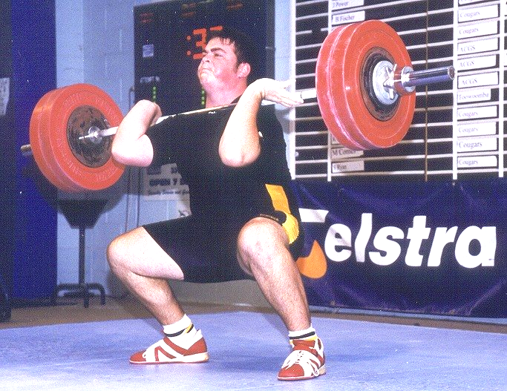
Damon Kelly – best U18 Male lifted a comfortable 275kg total in the 105+kg category.
Three weeks later, at the Sunshine Coast Open competition, Damon achieved a 300kg total.
ATTITUDE
Thanks to Mike Keelan for submitting this poem

The longer I live, the more I realize
the impact of attitude on life.
It is more important than education,
than money, than circumstances, than failures,
than successes,
than whatever anyone might say or do.
It is more important than
appearances, giftedness or skill.
The remarkable thing is that
we have the choice to create
the attitude we have for that day.
We cannot change our past.
We cannot change the way people act.
We cannot change the inevitable.
The one thing we can change
is the only thing we have control over,
and that is out attitude.
I'm convinced that life is
10 per cent what actually happens to us,
and 90 per cent how we react to it.
YOU have total choice when it comes to how you feel. No ifs or buts. You are in the pilot's seat.

Telstra National Under 16 & 18 Championship
Mermet Victorian Weightlifting Stadium - Hawthorn Melbourne
April 21st & 22nd

LIFTER | YOB | STATE | B/WT | SNATCH | JERK | TOTAL | SINCLAIR | PLACE
FEMALE |  |  |  |  |  |  |  | U16 | U18
44 kg Class
Wilson, Tennille | 1988 | TAS | 41.20 | 35.0 | 50.0 | 85.0 | 132.38 | 1 | 1
48 kg Class
Tresize, Josephine | 1983 | VIC | 47.20 | 40.0 | 50.0 | 90.0 | 125.38 |  | 1
Bower, Sheridan | 1986 | QLD | 47.40 | 42.5 | 47.5 | 90.0 | 124.98 | 1 | 2
Robins, Emily | 1986 | VIC | 47.65 | 20.0 | 30.0 | 50.0 | 69.16 | 2 | 3
53 kg class
Crosswell, Tara | 1987 | TAS | 52.30 | 50.0 | 73.0 | 122.5 | 158.56 | 1 | 1
Tsoukalis, Maria | 1987 | NT | 52.75 | 50.0 | 60.0 | 110.0 | 141.57 | 2 | 2
Barnes, Bobbi-Lee | 1986 | TAS | 52.95 | 37.5 | 55.0 | 92.5 | 118.75 | 3 | 3
Watkins, Christine | 1988 | QLD | 51.95 | 32.5 | 47.5 | 80.0 | 104.02 | 4 | 4
58 kg Class
Amadio, Kristie | 1985 | QLD | 57.30 | 65.0 | 80.0 | 145.0 | 177.17 | 1 | 1
Dewar, Jade | 1984 | NSW | 57.10 | 47.5 | 57.5 | 105.0 | 128.56 |  | 2
Saville, Caroline | 1984 | VIC | 56.10 | 45.0 | 55.0 | 100.0 | 123.75 |  | 3
Brooke, Rebecca | 1987 | NT | 56.70 | 45.0 | 55.0 | 100.0 | 122.96 | 2 | 4
LIFTER | YOB | STATE | B/WT | SNATCH | JERK | TOTAL | SINCLAIR | PLACE
Gastberger, Bianca | 1984 | QLD | 54.85 | 42.5 | 50.0 | 92.5 | 116.08 |  | 5
Williams, Katherine | 1985 | SA | 56.65 | 42.5 | 50.0 | 92.5 | 113.80 | 3 | 6
Harvey, Serena | 1986 | VIC | 56.65 | 32.5 | 40.0 | 72.5 | 89.19 | 4 | 7
63 kg Class
Myers, Jenna | 1986 | TAS | 59.40 | 55.0 | 70.0 | 125.0 | 149.60 | 1 | 1
Webb, Katherine | 1985 | TAS | 62.50 | 50.0 | 67.5 | 117.5 | 136.83 | 2 | 2
Graham, Susan | 1984 | QLD | 62.95 | 50.0 | 60.0 | 110.0 | 127.62 |  | 3
Ellicott, Mary | 1986 | VIC | 61.75 | 40.0 | 47.5 | 87.5 | 102.54 | 3 | 4
Fong, Khay | 1986 | VIC | 61.75 | 25.0 | 37.5 | 62.5 | 73.24 | 4 | 5
69 kg Class
Constantinidis, Maria | 1983 | NSW | 68.10 | 60.0 | 75.0 | 135.0 | 150.89 |  | 1
Fogagnolo, Camila | 1986 | TAS | 64.05 | 55.0 | 70.0 | 125.0 | 143.77 | 1 | 2
van Tienen, Belinda | 1986 | TAS | 67.25 | 52.5 | 72.5 | 125.0 | 140.49 | 2 | 3
Cunningham, Shari | 1985 | QLD | 66.55 | 50.0 | 55.0 | 105.0 | 118.58 | 3 | 4
75 kg Class
Lovely, Deborah | 1983 | QLD | 74.20 | 77.5 | 92.5 | 170.0 | 183.54 |  | 1
75+ kg Class
Boutros, Jamila | 1984 | NSW | 99.95 | 77.5 | 90.0 | 167.5 | 168.58 |  | 1
Eipper, Karina | 1984 | VIC | 88.40 | 30.0 | 40.0 | 70.0 | 71.84 |  | 2
Marks, Rebecca | 1984 | QLD | 87.75 | 0.0 | 67.5 | 0.0 | 0.00
Hogg, Rachel | 1987 | WA | 125.75 | 40.0 | 0.0 | 0.0 | 0.00

MALE
47 kg Class
Webley, Andrew | 1985 | VIC | 46.40 | 35.0 | 50.0 | 85.0 | 155.90 | 1 | 1
Chatfield, Michael | 1987 | NSW | 42.35 | 30.0 | 40.0 | 70.0 | 141.07 | 2 | 2
Lane, Michael | 1987 | VIC | 46.60 | 27.5 | 37.5 | 65.0 | 118.71 | 3
51 kg Class
Hulleza, Michael | 1984 | WA | 50.80 | 57.5 | 80.0 | 137.5 | 231.23 |  | 1
Hewkins, Troy | 1986 | QLD | 47.50 | 55.0 | 72.5 | 127.5 | 228.51 | 1 | 2
Polglaze, Stefan | 1986 | WA | 50.70 | 52.5 | 67.5 | 120.0 | 202.17 | 2 | 3
Decru, Daniel | 1986 | VIC | 50.95 | 45.0 | 65.0 | 110.0 | 184.48 | 3
Vasiliades, William | 1987 | NSW | 50.40 | 40.0 | 55.0 | 95.0 | 160.93 | 4 | 4
56 kg Class
Woodlock, Kyle | 1985 | QLD | 51.55 | 52.5 | 62.5 | 115.0 | 190.82 | 1 | 1
Manning, Mark | 1983 | SA | 55.00 | 50.0 | 62.5 | 112.5 | 176.30 |  | 2
Georgopoulos, Nick | 1986 | SA | 56.00 | 42.5 | 60.0 | 102.5 | 158.19 | 2
Kelsey, Austin | 1986 | SA | 56.00 | 42.5 | 60.0 | 102.5 | 158.19 | 3 | 3
Pollock, Gerard | 1985 | NSW | 54.35 | 35.0 | 47.5 | 82.5 | 130.62 | 4 | 4
62 kg Class
Sarkisian, David | 1986 | VIC | 61.95 | 85.0 | 110.5 | 195.0 | 277.60 | 1 | 1
Yamasaki, John | 1984 | QLD | 61.10 | 67.5 | 90.0 | 157.5 | 226.59 |  | 2
Katz, Sam | 1983 | VIC | 61.60 | 70.0 | 87.5 | 157.5 | 225.18 |  | 3
Burdon, Daniel | 1985 | TAS | 60.15 | 70.0 | 85.0 | 155.0 | 225.73 | 2 | 4
Corones, Brendan | 1985 | QLD | 61.10 | 67.5 | 85.0 | 152.5 | 219.40 | 3 | 5
Jacquier, Tyson | 1985 | SA | 59.45 | 57.5 | 72.5 | 130.0 | 191.07 | 4 | 6
Griffiths, David | 1985 | VIC | 57.40 | 50.0 | 72.5 | 122.5 | 185.22 | 5
Chatfield, Alex | 1989 | NSW | 59.65 | 37.5 | 50.0 | 87.5 | 128.27 | 6 | 7
LIFTER | YOB | STATE | B/WT | SNATCH | JERK | TOTAL | SINCLAIR | PLACE
69 kg Class |  |  |  |  |  |  |  | U16 | U18
Turner, Ben | 1984 | QLD | 67.45 | 92.5 | 117.5 | 210.0 | 281.09 |  | 1
Wilson, Joel | 1986 | QLD | 66.10 | 90.0 | 115.0 | 205.0 | 278.30 | 1 | 2
McCoy, Simon | 1983 | VIC | 67.30 | 80.0 | 112.5 | 192.5 | 258.06 |  | 3
Castiglione, Robert | 1985 | WA | 66.85 | 75.0 | 95.0 | 170.0 | 228.96 | 2 | 4
Mylne, George | 1985 | QLD | 66.60 | 65.0 | 75.0 | 140.0 | 189.05 | 3
Johns, Josh | 1985 | VIC | 62.25 | 50.0 | 67.5 | 117.5 | 166.66 | 4
Jones, Scott | 1986 | SA | 68.40 | 50.0 | 62.5 | 112.5 | 149.15 | 5 | 5
Saba, Cory | 1985 | SA | 68.90 | 40.0 | 50.0 | 90.0 | 118.74 | 6 | 6
77 kg Class
Burdon, David | 1983 | TAS | 72.40 | 92.5 | 120.0 | 212.5 | 271.44 |  | 1
Ciancio, Chris | 1984 | VIC | 72.10 | 92.5 | 112.5 | 205.0 | 262.55 |  | 2
Dalsanto, Max | 1985 | SA | 74.30 | 85.0 | 107.5 | 192.5 | 241.96 | 1 | 3
Latif, Adam | 1984 | NSW | 75.05 | 85.0 | 105.0 | 190.0 | 237.37 |  | 4
Hewson, Dean | 1984 | VIC | 74.60 | 82.5 | 105.0 | 187.5 | 235.10 |  | 5
McIntyre, James | 1984 | QLD | 71.75 | 72.5 | 97.5 | 170.0 | 218.40 |  | 6
Klinkert, Daniel | 1985 | SA | 75.20 | 70.0 | 85.0 | 155.0 | 193.41 |  | 7
Zivkovic, Richard | 1986 | SA | 76.15 | 67.5 | 85.0 | 152.5 | 188.88 | 2
Stuart, Bowen | 1986 | QLD | 71.00 | 65.0 | 82.5 | 147.5 | 190.78 | 3
Cunado, Lawrence | 1985 | QLD | 71.95 | 55.0 | 72.5 | 127.5 | 163.51 | 4
85 kg Class
Dib, Anthony | 1983 | VIC | 84.95 | 100.0 | 115.0 | 215.0 | 250.85 |  | 1
Fogagnolo, Priscus | 1983 | TAS | 83.50 | 85.0 | 115.0 | 200.0 | 235.40 |  | 2
Kolokas, John | 1984 | SA | 85.00 | 85.0 | 107.5 | 192.5 | 224.53 |  | 3
Ellis, Alan | 1983 | VIC | 77.65 | 70.0 | 90.0 | 160.0 | 195.92 |  | 4
Seidel, Daniel | 1986 | SA | 83.05 | 65.0 | 90.0 | 155.0 | 182.95 | 1 | 5
Chambers, Brodie | 1986 | SA | 78.25 | 57.5 | 70.0 | 127.5 | 155.44 | 2
94 kg Class
Montaldo, Robbie | 1984 | WA | 86.45 | 107.5 | 132.5 | 240.0 | 277.60 |  | 1
Strevett, Luke | 1983 | WA | 93.25 | 110.0 | 130.0 | 240.0 | 268.18 |  | 2
Susanto, Daniel | 1984 | NSW | 87.80 | 85.0 | 117.5 | 202.5 | 232.49 |  | 3
Ayres, Daniel | 1985 | QLD | 91.50 | 62.5 | 85.0 | 147.5 | 166.18 | 1
Craddock, Darcy | 1986 | QLD | 86.25 | 60.0 | 85.0 | 145.0 | 167.91 | 2
Aslan, Mehdi | 1984 | SA | 85.05 | 55.0 | 75.0 | 130.0 | 151.59 |  | 4
Kelly, Sam | 1986 | VIC | 93.20 | 52.5 | 70.0 | 122.5 | 136.91 | 3
105 kg Class
Shmait, Abdullah | 1983 | NSW | 103.80 | 105.0 | 132.5 | 237.5 | 254.74 |  | 1
Varitimos, Timothy | 1984 | QLD | 98.85 | 77.5 | 112.5 | 190.0 | 207.39 |  | 2
Smith, Adam | 1983 | VIC | 96.70 | 67.5 | 100.0 | 167.5 | 184.39 |  | 3
Harris, William | 1985 | NSW | 100.15 | 72.5 | 87.5 | 160.0 | 173.80 | 1 | 4
Falcone, Mathew | 1987 | VIC | 103.55 | 65.0 | 80.0 | 145.0 | 155.66 | 2
Symons, Daniel | 1987 | SA | 100.85 | 20.0 | 35.0 | 55.0 | 59.59 | 3
Sweeney, Wayne | 1984 | WA | 103.15 | 85.0 | 0.0 | 0.0 | 0.00
105+ kg Class
Kelly, Damon | 1983 | QLD | 142.45 | 127.5 | 177.5 | 305.0 | 306.20 |  | 1
Moulton, Byron | 1983 | NSW | 131.45 | 110.0 | 125.0 | 235.0 | 238.07 |  | 2
Derrick, Jon | 1984 | VIC | 138.10 | 100.0 | 120.0 | 220.0 | 221.50 |  | 3
Rutherford, Paul | 1984 | QLD | 129.55 | 82.5 | 115.0 | 197.5 | 200.52 |  | 4
Falcone, Daniel | 1985 | VIC | 137.20 | 87.5 | 107.5 | 195.0 | 196.47 | 1
Broekate, Adrian | 1985 | VIC | 118.70 | 62.5 | 90.0 | 152.5 | 157.47 | 2
RECORDS BROKEN
Michael HULLEZA | Australian Under 18, 51 kg Class Cl & Jk record |  |  |  | 80.0 kg
Michael HULLEZA | Australian Under 18, 51 kg Class Total record |  |  |  | 137.5 kg
David SARKISIAN | Australian Under 16, 62 kg Class Cl & Jk record |  |  |  | 110.5 kg
Joel WILSON | Australian Under 16, 69 kg Class Total record |  |  |  | 202.5 kg
Joel WILSON | Australian Under 16, 69 kg Class Total record |  |  |  | 205.0 kg
Tenille WILSON | Australian Under 16, 44 kg Class Cl & Jk record |  |  |  | 50.0 kg
Tenille WILSON | Australian Under 16, 44 kg Class Total record |  |  |  | 82.5 kg
Tenille WILSON | Australian Under 16, 44 kg Class Total record |  |  |  | 85.0 kg
Tara CROSSWELL | Australian Under 16, 53 kg Class Cl & Jk record |  |  |  | 73.0 kg
Kristie AMADIO | Australian Under 16, 58 kg Class Snatch record |  |  |  | 62.5 kg
Kristie AMADIO | Australian Under 16, 58 kg Class Snatch record |  |  |  | 65.0 kg
Kristie AMADIO | Australian Under 16, 58 kg Class Cl & Jk record |  |  |  | 77.5 kg
Kristie AMADIO | Australian Under 16, 58 kg Class Cl & Jk record |  |  |  | 80.0 kg
Kristie AMADIO | Australian Under 16, 58 kg Class Total record |  |  |  | 137.5 kg
Kristie AMADIO | Australian Under 16, 58 kg Class Total record |  |  |  | 142.5 kg
Kristie AMADIO | Australian Under 16, 58 kg Class Total record |  |  |  | 145.0 kg
Jenna MYERS | Australian Under 16, 63 kg Class Cl & Jk record |  |  |  | 70.0 kg
Jenna MYERS | Australian Under 16, 63 kg Class Total record |  |  |  | 145.0 kg

TEAM POINTS
Under 16 Women | Pts |  | Under 18 Women | Pts
TAS | 56 |  | TAS | 53
QLD | 29 |  | QLD | 45
VIC | 23 |  | VIC | 39
NT | 14 |  | NSW | 25
SA | 6 |  | NT | 12
NSW | 0 |  | SA | 3
WA | 0 |  | WA | 0
Under 16 Men | Pts |  | Under 18 Men | Pts
VIC | 68 |  | QLD | 68
QLD | 66 |  | VIC | 67
SA | 63 |  | NSW | 52
NSW | 29 |  | SA | 46
WA | 14 |  | WA | 36
TAS | 7 |  | TAS | 21
NT | 0 |  | NT | 0

BEST LIFTER AWARDS
Best Under 16 Female Kristie Amadio Qld
Best Under 18 Female Deborah Lovely Qld
Best Under 16 Male Joel Wilson Qld
Best Under 18 Male Damon Kelly Qld
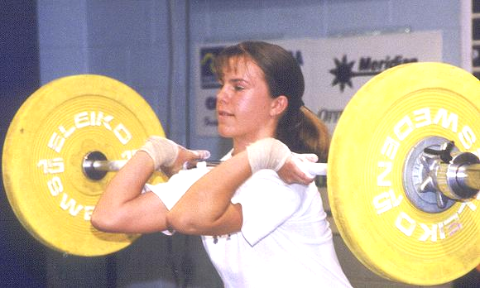
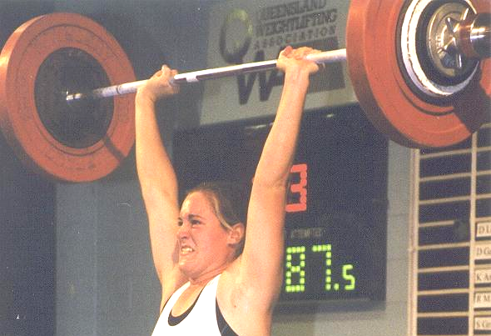
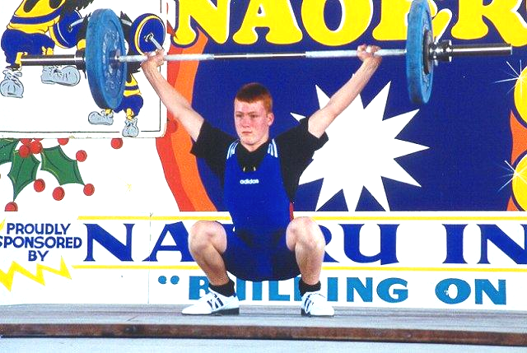
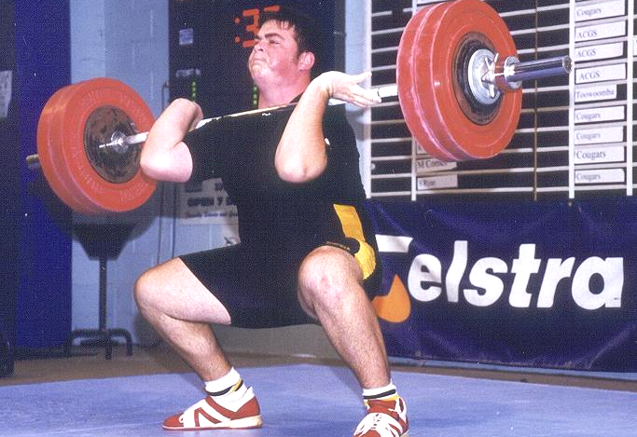
Kristie Amadio
Deborah Lovely
Joel Wilson
Damon Kelly
Core Stability

Strong abdominals are essential in weightlifting. Every weightlifter should make exercises such as these a regular part of their training program.

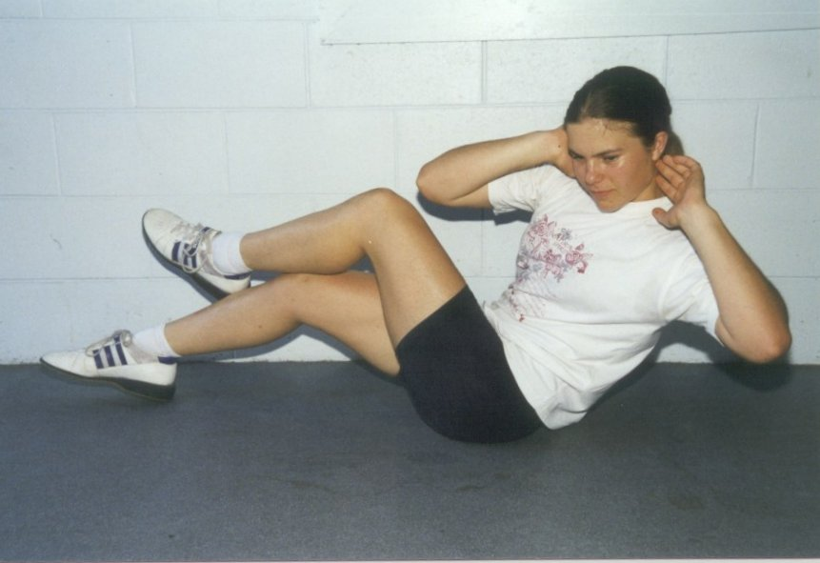 | - Lie on back, flex right knee to 90 degrees and place right foot flat on floor.  - Cross left leg over right.  - Place hands behind head.  - Lift both shoulder blades off the floor and twist so that the right elbow taps the left knee. Hold for a count of one.  - Return to the starting position.  - Continue on the same side for a whole set.  - Repeat on other side.
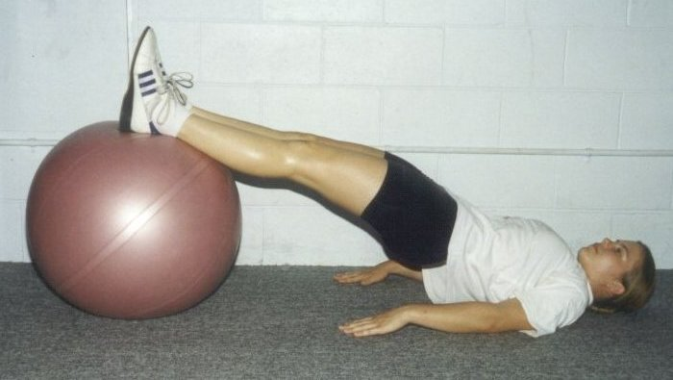 | - Lie on floor with entire spine in contact with floor.  - Flex knees and hips to 90 degrees and place heels on ball.  - Slowly extend both legs.  - Keep abdominal and lower back muscles tight throughout.  - Hold for 10 seconds.  - Return to starting position and repeat.
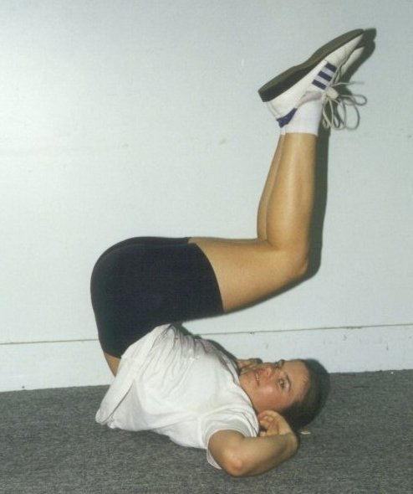 | - Lie on back, flex knees to 90 degrees.  - Keep feet flat on floor, tuck chin to chest and place hands behind head.  - Concentrating on the lower abs, rock the legs back toward the chest, simultaneously thrusting the pelvis toward the ceiling.  - Control the contraction, slowly lowering the pelvis and legs back down to the start position.  - Tap feet on floor and repeat the movement.

2001 Goodwill Games Brisbane

Tickets are now on sale for the Goodwill games and can be purchased through Ticketek.

Phone – 133 877
Web site - www.ticketek.com.au

Session 1  Women 75+kg | Thu 30 Aug  7pm-9pm
Session 2  Men 85kg | Fri 31 Aug  7pm-9pm
Session3  Women 69kg  Men 105+kg | Sat 1 Sep  1pm-5pm

Venue - Brisbane Convention and Exhibition Centre

Weightlifting Tickets
Adult $49.20, $42.20; Junior $34.20, $29.20; Concession $34.20, $29.20

Coaching at Nudgee
By Peter Thomsen

The Nudgee College Weights Room is nearing completion. I will be holding some coaching days in the future. I hope to be able to provide video analysis of lifters who attend. This would be a good opportunity for all lifters to be shown what they are doing wrong and how they can improve. I will not be telling them anything their coach does not already know, but sometimes it has to come from another source for it to sink in.

Masters Lifting
I know this will upset some of you old blokes but, some of your techniques are painful to watch. You are obviously strong the way you muscle up your lifts. I intend to hold a special day for masters at Nudgee pointing out technical errors and once again show you videos of your training sessions so we can all see why you get red lights.

GIRLS GIRLS GIRLS

Kylie Booth and Amanda Phillips recently upgraded to National level referees. Congratulations to both of them.
Deb Keelan recently celebrated her 40th birthday – they say life begins at 40.
Several of the Queensland Girls lifted at the Nauru International. Karuna Jones entered the International arena in style with a silver medal performance in the 48kg class. Deb Lovely, Kristie Amadio, Desiree Gagliardi, Amanda Phillips and Melissa Nightingale all produced medal winning performances on the day – Congratulations to all.
Melissa Bethune has been ill and spent several weeks in hospital recently. We wish her a speedy recovery.
Judy Fischer got engaged recently – Congratulations.
Amanda Phillips (69kg) and Deborah Lovely (75kg) have been selected in the Australian team for the East Asia Games, Osaka Japan, May 19 - 27.
Welcome back to Ellen Stanton, who returned to the platform for the Queensland Masters Championships in Rocky.
National Masters Coordinator

Lawrie Townsend has been appointed by the AWF to the honorary position of National Masters Coordinator. Lawrie’s involvement in weightlifting spans more than 25 years and his dedication to our sport, and in particular Masters lifting, is recognised both here and overseas. Congratulations Lawrie<!DOCTYPE HTML PUBLIC "-//IETF//DTD HTML//EN">.

Telstra Queensland Masters Championships
Norm’s Gym, Rockhampton
7 April 2001

Name Born Club Bwt Snatch C&J Total MMS Forbes Points
Women
35-39 yrs
58kg
Diana Loy 65 UQ 58.00 65.0 80.0 145.0 191.220 191.220
69kg
Ellen Stanton 65 Rockhampton 68.90 50.0 70.0 120.0 145.049 2078.567
+75kg
Jo Garner 66 Cougars 83.10 30.0 45.0 75.0 83.748 83.748
Men
Ryan Shinn (Guest) 80 Mackay 72.30 77.5 105.0 182.5 N/A N/A
30-34 yrs
105kg
Ken Harvey 68 Mackay 104.70 75.0 105.0 180.0 200.791 5490.145
35-39 yrs
94kg
John Bauer 63 Toowoomba 92.30 80.0 102.5 182.5 227.971 1011.933
105kg
Mark Duckworth 64 Cougars 100.10 100.0 115.0 215.0 256.941 256.941
40-44 yrs
69kg
Paul McBride 58 Cougars 68.60 72.5 97.5 170.0 263.179 587.572
85kg
Greg Hobl 60 Toowoomba 81.00 100.0 122.5 222.5 305.237 305.237
45-49 yrs
85kg
Trevor Walz 52 Rockhampton 82.50 75.0 100.0 175.0 255.771 255.771
105kg
Gary Langford 53 Mackay 103.70 115.0 135.0 250.0 328.862 8878.783
+105kg
Harry Grzes 56 Cougars 121.60 72.5 90.0 162.5 199.462 199.462
50-54 yrs
+105kg
Ben Grzes 50 Cougars 136.40 70.0 97.5 167.5 211.936 211.936
55-59 yrs
69kg
Bob Kennedy 46 Rockhampton 68.40 90.5 118.0 207.5 371.386 551.278
85kg
Ray Louden 45 Sunshine Coast 80.30 72.5 97.5 170.0 282.734 282.734
60-64 yrs
77kg
Keith Forbes 41 Toowoomba 75.70 60.0 60.0 120.0 225.062 225.062
105kg
Warwick Selvey 39 Gold Coast 101.10 65.0 75.0 140.0 236.573 236.573
75-79 yrs
94kg
Rube Howes 22 Cougars 85.60 57.5 80.0 137.5 399.546 399.546
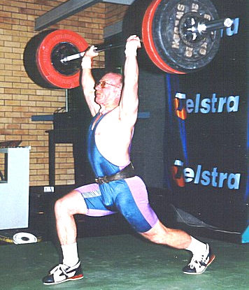

Bob Kennedy lifted weights in excess of the World Masters Records, 55-59 years 69kg category, at the Telstra Qld Masters Championships held in Rockhampton.

QWA Selection Committee

Applications for positions on the QWA Selection Committee are invited from all QWA members who are actively engaged in the coaching of QWA lifters and who hold a minimum Level 2 Weightlifting NCAS accreditation.

The QWA Selection Committee is responsible for the selection of athletes and coaches to QWA representative teams. This committee consists of three members who must be active accredited coaches, with not more than one member from any one Club. All positions are honorary and the term of the committee is 12 months. The QWA Management Committee will appoint members to the Selection Committee from nominations received.

Applications should address the selection criteria and be forwarded to the Executive Director, QWA,
PO Box 1056, Capalaba Qld 4157, by Friday 11 May 2001.

Selection Criteria

SC1
Knowledge and understanding of the QWA’s policies relating to Team Selection and Coach Selection.

SC2
Demonstrated ability to adhere to policy guidelines in decision making.

SC3
Knowledge and understanding of the requirements of state representative teams competing in national events.

SC4
Demonstrated knowledge of the rules and regulations applied at national events.

SC5
Demonstrated understanding of the AWF's current Coach's Code of Ethics and the QWA's Membership Protection Policy.

Queensland Weightlifting Association Inc
Team Selection Policy and Procedures

- Selectors Obligations
  - To select the competitor(s) with weightlifting abilities of the highest commensurate standard and who are the most competent to contest the competition being conducted at the time of selections, so as to provide the best possible chance of success or best results in the competition.
- Nominations - Queensland Representative Teams
  - Nominations are to be called for all QWA representative teams. In this regard full details of team make-up, dates, location, financial and other responsibilities need to be provided in the nominations.
  - The nomination form should be in the format of an “expression of interest”, with an opportunity for nominees to attach full details relative to their nomination. The expression of interest form should be endorsed (or otherwise) in the usual manner, by the region and the club.
  - The nomination form should be sent to all affiliated clubs and all QWA registered lifters who are not attached to an affiliated club Eight (8) weeks before the event. The team announcement should be made not less than Three (3) weeks before the event.
  - If the Selectors so desire they can approach a member who has not nominated (on a non-commitment basis) if they consider such action to be in the best interests of the QWA.
  - Any such nomination sought must be confirmed in writing and the endorsement of the member by the club, region obtained prior to confirmation and announcement of the team
  - The QWA believes that this procedure is the fairest means of team selection in that:-
    - The nomination process is simplified (i.e. Expression of interest or non-availability is all that is required);
    - Members have the opportunity to express, if they so desire, full details relative to their claim for selection;
    - Selectors may legitimately seek out a member to nominate; and
    - The endorsement of the relative higher authority(s) will ensure an early confirmation of and announcement of the selected team.
- Eligibility for Selection
  - Any QWA Member selected in a QWA Representative Team must be in good standing with his/her club, region and QWA. This process is achieved by ensuring that the endorsement of the member by the club/region is obtained prior to the announcement of the team;
  - Any QWA Member selected in a QWA Representative Team must be actively engaged in training according to a specific program designed by an NCAS accredited weightlifting coach to develop and enhance their weightlifting capabilities. This will ensure that team members are correctly prepared for their participation in events and minimise the risk associated with athletes attempting maximal performances.
  - Selectors should also be confident that all members recommended for selection will comply with the direction of the appointed team Manager/Coach and/or be capable of discussing and reaching consensus on all relevant issues relating to participation in the team (eg. attitude, training, attendance at squad meets, personal care, competition etc).
  - NOTE: Selectors should research thoroughly if there is any concern in this respect. Discreet reference to clubs, coaches, officials and other relevant persons, QWA records, performance in past teams and even personal interviews etc, are all means by which suitability can be determined. If there are any unknown factors, the benefit of the doubt should be given and demonstrated lifting performance be the determining factor.
- Qualifying Competitions
  - Only performances made in designated qualifying competitions, refereed by three accredited referees, will be considered for selection purposes. Such tournaments may be at a international, national, state, regional and club level.
- Selectors Duties
  - Publish an annual calendar of qualifying competitions.
  - Be aware of the competition rules and conditions being contested by the individual or teams being selected;
  - Not be biased in respect of CLUB or REGION or PERSONAL ASSOCIATION with the member under consideration for selection and to declare any interest prior to selection of the individual or team under consideration;
  - Attend where possible, the respective State Championships, trials and any other appropriate QWA events;
  - Investigate the performances and other details of members under consideration of selection by talking with fellow selectors, officials, coaches, competitors and other relevant parties;
  - Be prepared to approach members when necessary to nominate for a QWA team; but to make clear to the QWA member that the approach is not a guarantee of selection;
- Team Selection
  - Selectors are to determine and recommend the most appropriate team combination to achieve the best possible result in the competition to be contested. In this regard, where appropriate, selectors are to:-
  - Draw up a table with age and weight classes depicting anticipated team placings.
  - Prior to, and at selection meetings, pencil in, delete and reinstate and otherwise allocate names of members to the competitions to be conducted. By this process the recommended QWA team and suggested competitions will be determined by the Selection Panel; and
  - Recommend a Captain of the team selected.
  - NOTE: Smaller teams or selection of individual members to represent the QWA eg. Interstate or overseas such as NZ, are to be based on the specific requirement of the competition to be contested, Selectors should utilise the appropriate sections of this policy to provide their recommendation.
- Team Management Involvement
  - Selectors may at their discretion, include the appointed team Manager and coach in their discussions. However, the actual selection process remains the sole responsibility of the selectors.
- Confirmation/Announcement of Selections
  - Ratification of the team is the responsibility of the QWA. If not practicable, the team may be confirmed following agreement between the President, SA , SDC and one other M/C member. Such an agreeement is to be ratified at the next M/C meeting.
  - No announcement of the team or advice to recommended team members is to be made prior to confirmation/ratification of the team being effected. Announcement of teams is to be by way of a press release with the team manager and SA having the responsibility of telephoning faxing team members in the first instance to advise selection and any initial requirements/arrangments for the team.
- Public Comment
  - No comments publicly, on any individual or team selections, can be made by selectors or team management. Only QWA authorised personnel can comment.

QWA Coach Selection Policy
The specific needs of the weightlifting team and individual weightlifters are the primary concerns when selecting coaching staff.
The coaching staff will be selected on their perceived compatibility and ability to cooperate in achieving team goals and individual requirements relative to successful performance. Applications will be called from current active Queensland coaches who are accredited in the National Coaching Accreditation Scheme of the AWF and Australian Coaching Council. All applications will be reviewed by the selection committee which will be a standing committee appointed by the management committee of the QWA.
In addition to the appointment of Head Coaches, wherever possible the selection committee will provide for new and up and coming active coaches to obtain selection as Assistant Coaches.
In relation to the assessment criteria below, applicants must be the “active” coach of the named weightlifter/s. An “active” coach is defined as the coach responsible for preparing and supervising the training and competition programs for the named weightlifter/s.
The priority for selection of team coaches will be related to the following criteria standards:
- Coach’s current NCAS accreditation level
- Coach’s athletes’ current or previous years Queensland sinclair ranking
- Coach’s athletes’ current open Australian sinclair ranking
- Coach’s athletes’ current Australian age group ranking
- Number of weightlifters of the coach who are selected in the respective team
- Demonstrated experience as a state squad coach
- Previous performance at National, State and/or Regional events
- Demonstrated ability to work as an integral team member
- Participation in Regional, State and National team training camps
- Officiating and administrative qualifications
The weighting of the above criteria will be at the discretion of the Selection Committee.
Nominations will be presented to the QWA Management Committee for ratification.

QWA Records 23/04/01
Open Female 48Kg
Sn Qld Record Std 55.0 - -
C & J Karuna Jones 65.5 3/03/01 Chandler
Total Qld Record Std 120.0 - -
Open Female 53Kg
Sn Justine Hartwig 65.0 6/05/00 Sunshine Coast
C & J Justine Hartwig 87.5 6/05/00 Sunshine Coast
Total Justine Hartwig 152.5 6/05/00 Sunshine Coast
Open Female 58Kg
Sn Angela Bentley 72.51 1/07/98 Toowoomba Qld
C & J Angela Bentley 85.0 21/02/98 Toowoomba, Qld
Total Angela Bentley 157.5 11/07/98 Toowoomba Qld
Open Female 63Kg
Sn Amanda Phillips 82.5 15/09/00 Sydney
C & J Amanda Phillips 107.5 15/09/00 Sydney
Total Amanda Phillips 190.0 15/09/00 Sydney
Open Female 69Kg
Sn Amanda Phillips 82.5 29/01/00 Nauru
C & J Amanda Phillips 105.0 2/07/99 Savannah, USA
Total Amanda Phillips 187.5 29/01/00 Nauru
Open Female 75Kg
Sn Amanda Phillips 80.0 7/08/98 Chandler
C & J Amanda Phillips 105.0 6/11/99 Chandler
Total Amanda Phillips 185.0 26/11/99 Athens Greece
Open Female 75+Kg
Sn Melissa Bethune 95.0 12/05/00 Nauru
C & J Melissa Bethune 117.5 29/01/00 Nauru
Total Melissa Bethune 212.5 12/05/00 Nauru
U20 Female 48Kg
Sn Qld Record Std 47.5 - -
C & J Qld Record Std 60.0 - -
Total Qld Record Std 107.5 - -
U20 Female 53Kg
Sn Qld Record Std 57.5 - -
C & J Qld Record Std 67.5 - -
Total Qld Record Std 125.0 - -
U20 Female 58Kg
Sn Kristie Amadio 65.0 21/04/01 Hawthorn Vic
C & J Kristie Amadio 80.0 21/04/01 Hawthorn Vic
Total Kristie Amadio 145.0 21/04/01 Hawthorn Vic
U20 Female 63Kg
Sn Amanda Phillips 82.5 15/09/00 Sydney
C & J Amanda Phillips 107.5 15/09/00 Sydney
Total Amanda Phillips 190.0 15/09/00 Sydney
U20 Female 69Kg
Sn Amanda Phillips 82.5 29/01/00 Nauru
C & J Amanda Phillips 105.0 2/07/99 Savannah (USA)
Total Amanda Phillips 187.5 29/01/00 Nauru
U20 Female 75Kg
Sn Amanda Phillips 80.0 7/08/98 Chandler
C & J Amanda Phillips 105.0 6/11/99 Chandler
Total Amanda Phillips 185.0 26/11/99 Athens Greece
U20 Female 75+Kg
Sn Melissa Bethune 92.5 4/12/99 Chandler
C & J Melissa Bethune 115.0 16/10/99 Chandler Brisbane
Total Melissa Bethune 205.0 20/11/99 Chandler
U18 Female 40Kg
Sn Qld Record Std 32.5 - -
C & J Qld Record Std 40.0 - -
Total Qld Record Std 72.5 - -
U18 Female 44Kg
Sn Emma Bauer 28.0 17/02/01 Toowoomba
C & J Emma Bauer 38.0 3/03/01 Chandler
Total Qld Record Std 65.0 - -
U18 Female 48Kg
Sn Kerry Timms 43.0 5/09/98 Chandler
C & J Desiree Gagliardi 55.5 20/11/99 Chandler
Total Kerry Timms 97.5 11/07/98 Toowoomba Qld
U18 Female 53Kg
Sn Kristie Amadio 50.0 8/07/00 Chandler
C & J Kristie Amadio 67.5 4/08/00 South Bank Brisbane
Total Kristie Amadio 117.5 4/08/00 South Bank Brisbane
U18 Female 58Kg
Sn Kristie Amadio 65.0 21/04/01 Hawthorn Vic
C & J Kristie Amadio 80.0 21/04/01 Hawthorn Vic
Total Kristie Amadio 145.0 21/04/01 Hawthorn Vic
U18 Female 63Kg
Sn Melissa Nightingale 67.5 13/08/99 Melbourne
C & J Melissa Nightingale 82.5 13/08/99 Melbourne
Total Melissa Nightingale 150.0 13/08/99 Melbourne
U18 Female 69Kg
Sn Amanda Phillips 80.0 5/09/98 Chandler
C & J Amanda Phillips 105.0 2/07/99 Savannah (USA)
Total Amanda Phillips 185.0 2/07/99 Savannah (USA)
U18 Female 75Kg
Sn Amanda Phillips 80.0 7/08/98 Chandler
C & J Amanda Phillips 105.0 6/11/99 Chandler
Total Amanda Phillips 185.0 26/11/99 Athens Greece
U18 Female 75+Kg
Sn Deborah Lovely 85.0 27/01/01 Nauru
C & J Deborah Lovely 100.0 27/01/01 Nauru
Total Deborah Lovely 185.0 27/01/01 Nauru
U16 Female 40Kg
Sn Erika Yamasaki 32.5 4/11/00 Toowoomba
C & J Qld Record Std 40.0 - -
Total Qld Record Std 70.0 - -
U16 Female 44Kg
Sn Emma Bauer 28.0 17/02/01 Toowoomba
C & J Emma Bauer 38.0 3/03/01 Chandler
Total Qld Record Std 65.0 - -
U16 Female 48Kg
Sn Desiree Gagliardi 42.5 4/12/99 Chandler
C & J Desiree Gagliardi 55.5 20/11/99 Chandler
Total Desiree Gagliardi 97.5 4/12/99 Chandler
U16 Female 53Kg
Sn Kristie Amadio 50.0 8/07/00 Sleeman Sports Center
C & J Kristie Amadio 67.5 4/08/00 South Bank Brisbane
Total Kristie Amadio 117.5 4/08/00 South Bank Brisbane
U16 Female 58Kg
Sn Kristie Amadio 65.0 21/04/01 Hawthorn Vic
C & J Kristie Amadio 80.0 21/04/01 Hawthorn Vic
Total Kristie Amadio 145.0 21/04/01 Hawthorn Vic
U16 Female 63Kg
Sn Susan Graham 45.5 2/09/00 Toowoomba
C & J Susan Graham 60.0 8/07/00 Chandler
Total Susan Graham 102.5 8/07/00 Chandler
U16 Female 69Kg
Sn Rachel Trigger 55.0 9/12/00 Chandler
C & J Rachel Trigger 70.0 9/12/00 Chandler
Total Rachel Trigger 125.0 9/12/00 Chandler
U16 Female 75Kg
Sn Deborah Lovely 62.5 20/11/99 Chandler
C & J Deborah Lovely 85.0 20/11/99 Chandler
Total Deborah Lovely 147.5 20/11/99 Chandler
U16 Female 75+Kg
Sn Deborah Lovely 70.0 4/12/99 Chandler
C & J Deborah Lovely 87.5 4/12/99 Chandler
Total Deborah Lovely 157.5 4/12/99 Chandler
Open Men 56Kg
Sn Qld Record Std 85.0 - -
C & J Qld Record Std 105.0 - -
Total Qld Record Std 190.0 - -
Open Men 62Kg
Sn Qld Record Std 95.0 - -
C & J Brad Peters 120.0 27/06/98 Chandler
Total Qld Record Std 210.0 - -
Open Men 69Kg
Sn Qld Record Std 102.5 - -
C & J Qld Record Std 127.5 - -
Total Qld Record Std 230.0 - -
Open Men 77Kg
Sn Alex Goodyear 117.5 18/04/98 Toowoomba
C & J Alex Goodyear 142.5 18/04/98 Toowoomba
Total Alex Goodyear 260.0 18/04/98 Toowoomba
Open Men 85Kg
Sn Alex Goodyear 122.5 27/06/98 Chandler
C & J Qld Record Std 145.0 - -
Total Alex Goodyear 267.5 8/05/99 Toowoomba
Open Men 94Kg
Sn Qld Record Std 125.0 - -
C & J Qld Record Std 152.5 - -
Total Qld Record Std 277.5 - -
Open Men 105Kg
Sn Qld Record Std 130.0 - -
C & J Qld Record Std 160.0 - -
Total Qld Record Std 290.0 - -
Open Men 105+Kg
Sn Anthony Martin 155.0 9/05/98 Nudgee
C & J Anthony Martin 200.0 5/09/98 Chandler
Total Anthony Martin 355.0 5/09/98 Chandler
U20 Men 56Kg
Sn Fred Buchanan 77.5 13/06/98 Perth
C & J Fred Buchanan 97.5 17/10/98 Chandler
Total Fred Buchanan 175.0 17/10/98 Chandler
U20 Men 62Kg
Sn Qld Record Std 82.5 - -
C & J Qld Record Std 100.0 - -
Total Qld Record Std 182.5 - -
U20 Men 69Kg
Sn Patrick Alldridge 92.5 11/07/98 Toowoomba Qld
C & J Patrick Alldridge 120.0 11/07/98 Toowoomba Qld
Total Ben Turner 210.0 21/04/01 Hawthorn Vic
U20 Men 77Kg
Sn Jason Power 102.5 18/11/00 Chandler
C & J Jason Power 130.0 21/10/00 Malvern Victoria
Total Jason Power 230.0 21/10/00 Malvern Victoria
U20 Men 85Kg
Sn Tim Oberg 112.5 21/02/98 Toowoomba, Qld
C & J Tim Oberg 140.0 14/03/98 Chandler, Qld
Total Tim Oberg 250.0 21/02/98 Toowoomba, Qld
U20 Men 94Kg
Sn Tim Oberg 115.0 5/09/98 Chandler
C & J Tim Oberg 142.5 20/09/98 Alexandra Hills
Total Tim Oberg 252.5 1/08/98 Adelaide
U20 Men 105Kg
Sn Qld Record Std 112.5 - -
C & J Qld Record Std 137.5 - -
Total Qld Record Std 250.0 - -
U20 Men 105+Kg
Sn Anthony Martin 155.0 9/05/98 Nudgee
C & J Anthony Martin 200.0 5/09/98 Chandler
Total Anthony Martin 355.0 5/09/98 Chandler
U18 Men 47Kg
Sn Troy Hewkins 52.5 7/10/00 Chandler
C & J Troy Hewkins 70.0 4/11/00 Toowoomba
Total Troy Hewkins 122.5 4/11/00 Toowoomba
U18 Men 51Kg
Sn Troy Hewkins 57.5 3/03/01 Chandler
C & J Troy Hewkins 75.0 12/04/01 Chander
Total Qld Record Std 132.5 - -
U18 Men 56Kg
Sn Fred Buchanan 77.5 13/06/98 Perth
C & J Fred Buchanan 97.5 17/10/98 Chandler Brisbane
Total Fred Buchanan 175.0 17/10/98 Chandler Brisbane
U18 Men 62Kg
Sn Cameron Andersen 80.0 29/01/00 Nauru
C & J Cameron Andersen 100.0 29/01/00 Nauru
Total Cameron Andersen 180.0 29/01/00 Nauru
U18 Men 69Kg
Sn Joel Wilson 92.5 3/03/01 Chandler
C & J Ben Turner 117.5 19/01/01 Chandler
Total Ben Turner 210.0 21/04/01 Hawthorn Vic
U18 Men 77Kg
Sn Jason Power 102.5 18/11/00 Chandler
C & J Jason Power 130.0 21/10/00 Malvern Victoria
Total Jason Power 230.0 21/10/00 Malvern Victoria
U18 Men 85Kg
Sn Qld Record Std 90.0 - -
C & J Qld Record Std 112.5 - -
Total Qld Record Std 202.5 - -
U18 Men 94Kg
Sn Qld Record Std 95.0 - -
C & J Qld Record Std 117.5 - -
Total Qld Record Std 212.5 - -
U18 Men 105Kg
Sn Qld Record Std 100.0 - -
C & J Qld Record Std 125.0 - -
Total Qld Record Std 225.0 - -
U18 Men 105+Kg
Sn Damon Kelly 127.5 22/04/01 Hawthorn Vic
C & J Damon Kelly 177.5 22/04/01 Hawthorn Vic
Total Damon Kelly 305.0 22/04/01 Hawthorn Vic
U16 Men 47Kg
Sn Troy Hewkins 52.5 7/10/00 Chandler
C & J Troy Hewkins 70.0 4/11/00 Toowoomba
Total Troy Hewkins 122.5 4/11/00 Toowoomba
U16 Men 51Kg
Sn Troy Hewkins 57.5 3/03/01 Chandler
C & J Troy Hewkins 75.0 12/04/01 Chander
Total Troy Hewkins 132.5 12/04/01 Chander
U16 Men 56Kg
Sn Matthew Cornes 68.0 17/10/98 Chandler Brisbane
C & J Dion Wood 82.5 9/05/98 Nudgee
Total Dion Wood 150.0 9/05/98 Nudgee
U16 Men 62Kg
Sn Dion Wood 72.5 13/06/98 Perth
C & J Joel Wilson 100.0 7/10/00 Chandler
Total Dion Wood 160.0 13/06/98 Perth
U16 Men 69Kg
Sn Joel Wilson 92.5 3/03/01 Chandler
C & J Joel Wilson 115.0 21/04/01 Hawthorn Vic
Total Joel Wilson 205.0 21/04/01 Hawthorn Vic
U16 Men 77Kg
Sn John Ryan 78.0 14/12/99 Toowoomba
C & J Jason Power 102.5 7/11/98 Toowoomba
Total Jason Power 177.5 7/11/98 Toowoomba
U16 Men 85Kg
Sn Qld Record Std 80.0 - -
C & J Mark Newman 100.0 7/11/98 Toowoomba
Total Qld Record Std 175.0 - -
U16 Men 94Kg
Sn Qld Record Std 85.0 - -
C & J Qld Record Std 100.0 - -
Total Qld Record Std 185.0 - -
U16 Men 105Kg
Sn Bryan Fischer 92.5 28/08/99 Chandler
C & J Bryan Fischer 112.5 4/12/99 Chandler
Total Bryan Fischer 202.5 28/08/99 Chandler
U16 Men 105+Kg
Sn Damon Kelly 102.5 20/11/99 Chandler
C & J Damon Kelly 127.5 20/11/99 Chandler
Total Damon Kely 230.0 20/11/99 Chandler<div align="center"></div>

