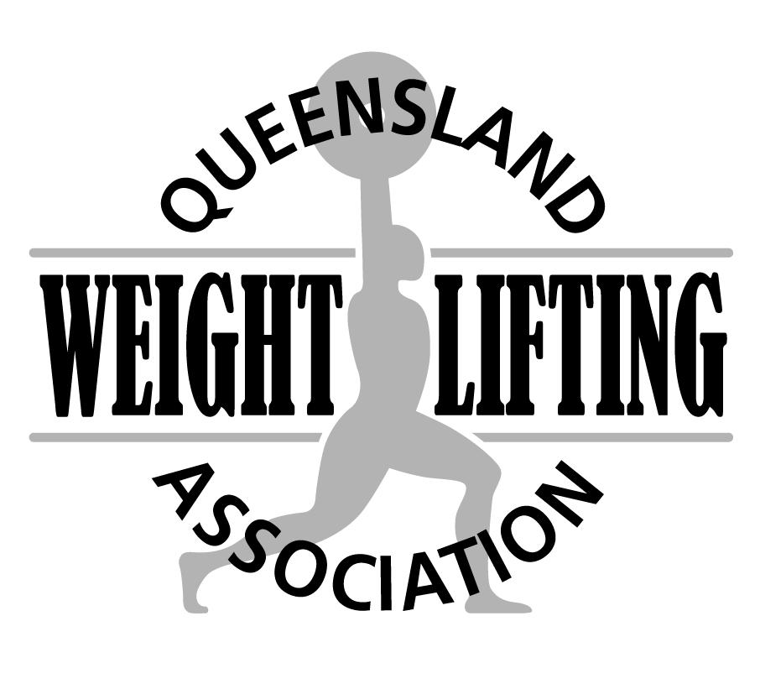
QWA members are invited to nominate for the following event:
State Team Manager
Application

The Event: | 2022 National Masters Championships
Event Date: | 9-11 September 2022
Place: | Hawthorn, Melbourne
Closing date for applications: | Friday 5th August 2022
Type in the shaded fields and use the Tab key to move to the next field or click to select. The fields will expand as you type
First Name: _____ Surname:
Address: City: Post code:
Telephone: Email:

Effective management of representative teams contributes significantly to their overall performance. Team Managers are required to work in close cooperation with the QWA administration, Team Coaches and athletes, to ensure a successful competition for the Team as a whole.

Applicants who have previous experience as a Weightlifting Team Manager or Weightlifting Team Coach will have an advantage.
Please explain how you meet each of the following selection criteria.

1. Demonstrated ability to work within a team environment in both leading and supporting roles

2. Sound knowledge of weightlifting competition regulations and protocols

3. Sound knowledge of sport anti-doping regulations and procedures

4. Possess high level communication skills across a variety of modalities

Send completed applications to:

Email: qwa@qwa.org

